**Html5**

**HEAD section(meta):**

* This section describes about the webpage.

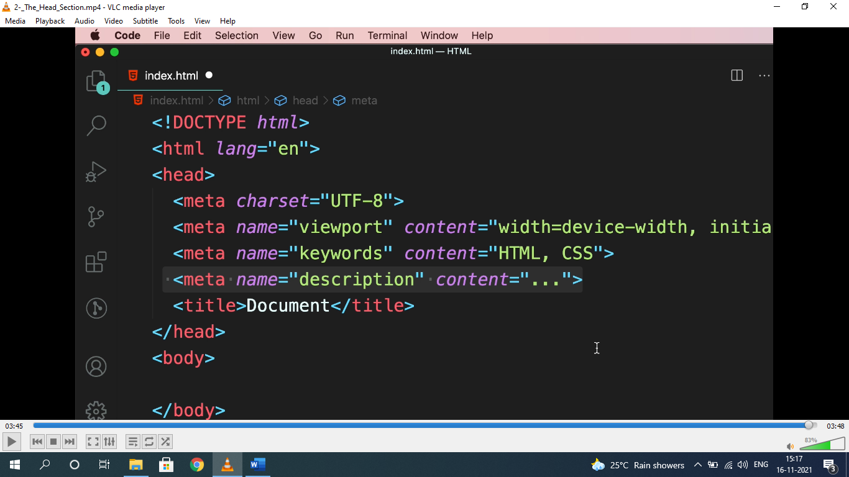

* Viewport=display size of device. Used to display content properly.

**<h1..h6>, <strong>, <em>:**

* Heading should be used in hierarchy.

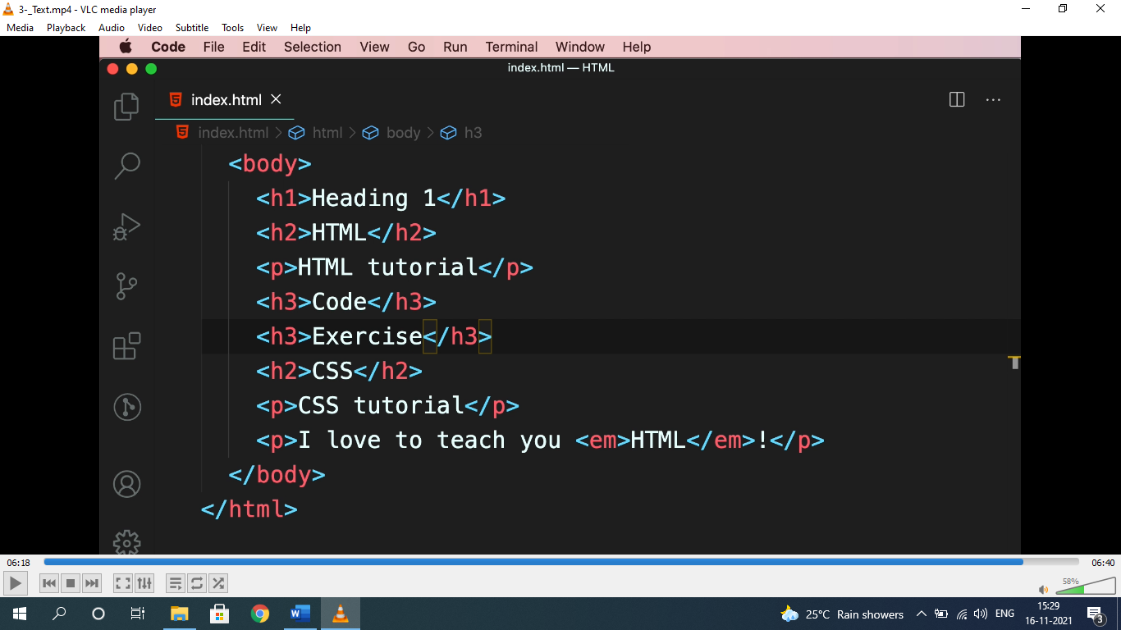

* <em> used for emphasizing and <strong> used for highlight.

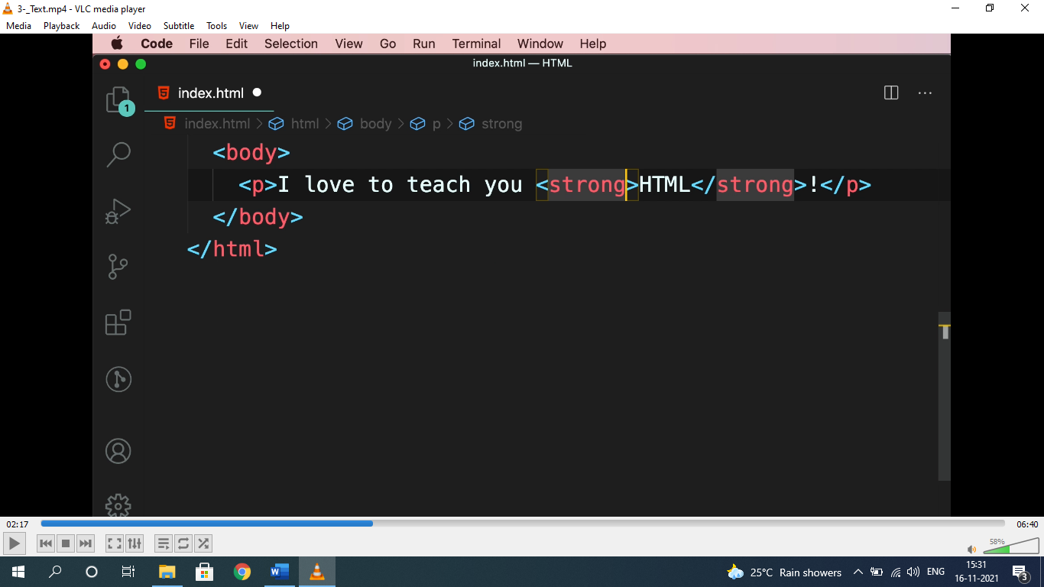

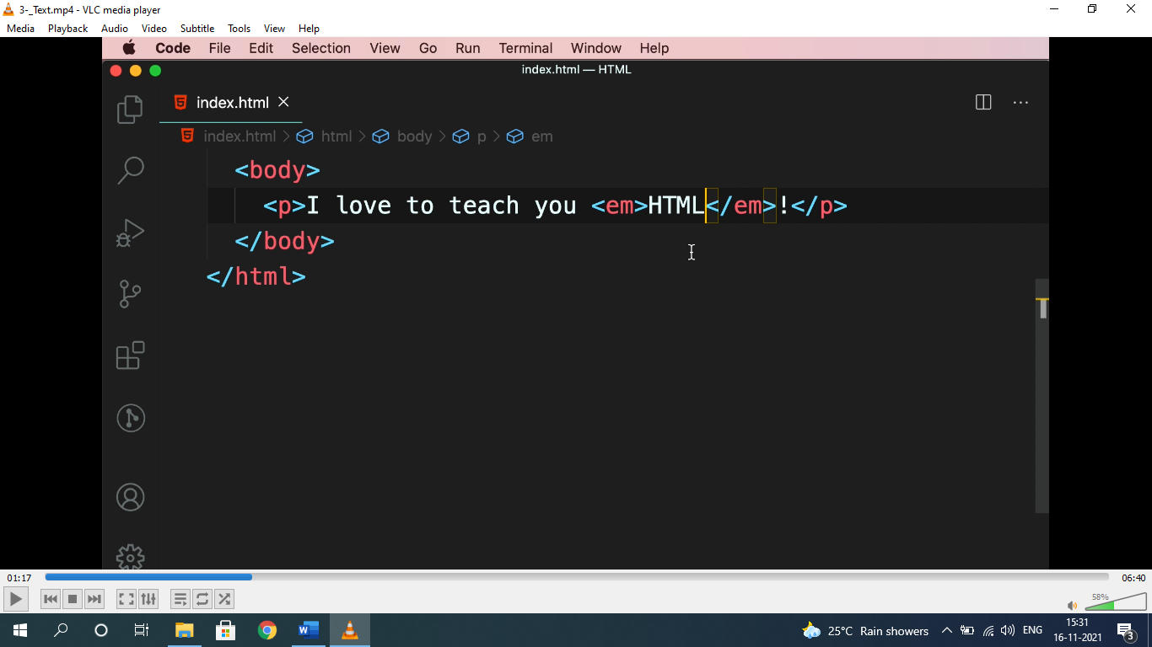

**ENTITIES(&;):**

* To represent elements, symbols as it is, it should be written within HTML entities i.e “&…;”.

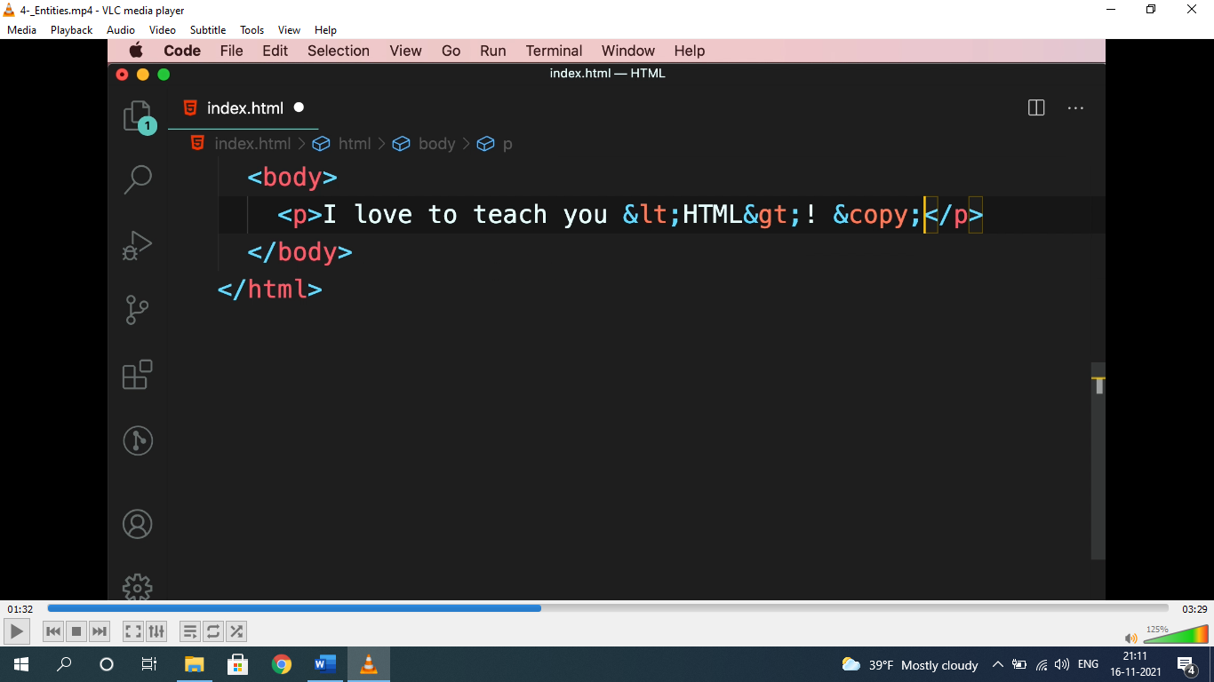

* For entities: ***search html entities in google.***

**HYPERLINK(href):-**

* used to navigate to links, images, download, pages etc.

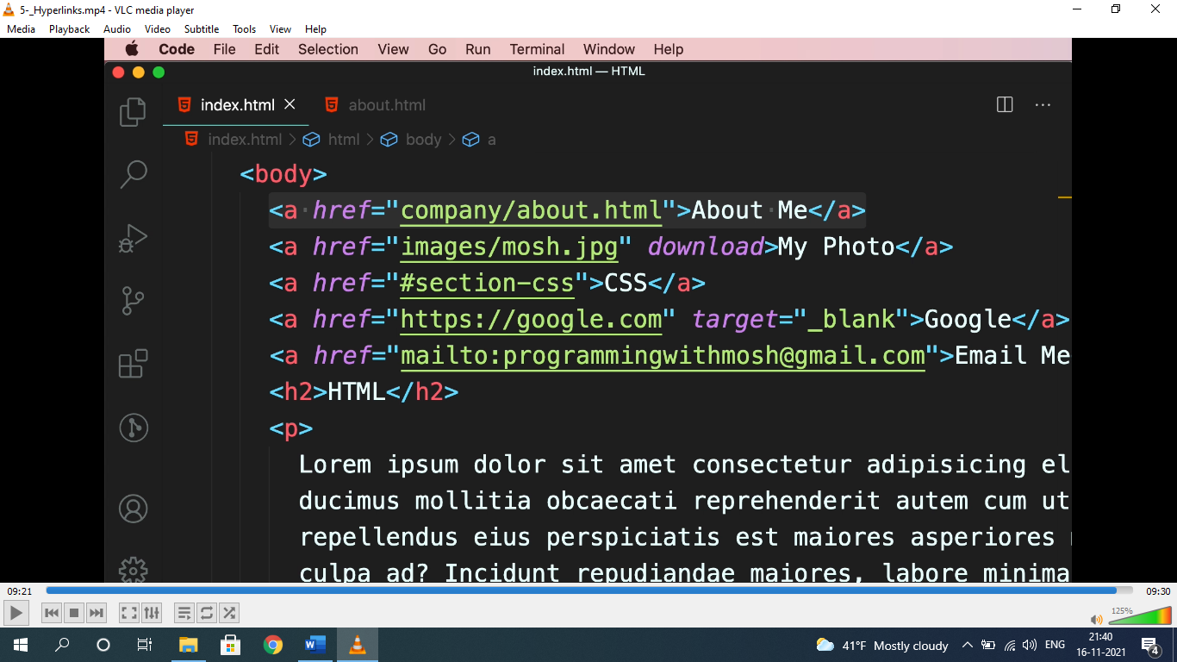

* “about me” is to navigate a page, “my photo” is to navigate to a photo with “download” attribute to download, CSS is to navigate to a ID “#section-css”. Google is to navigate to google home page.
* “**go to top**” can be done by assigning ID to “#”.

**IMAGES:**

* setting image height and width without cropping or compressing “object-fit: cover” property is used.

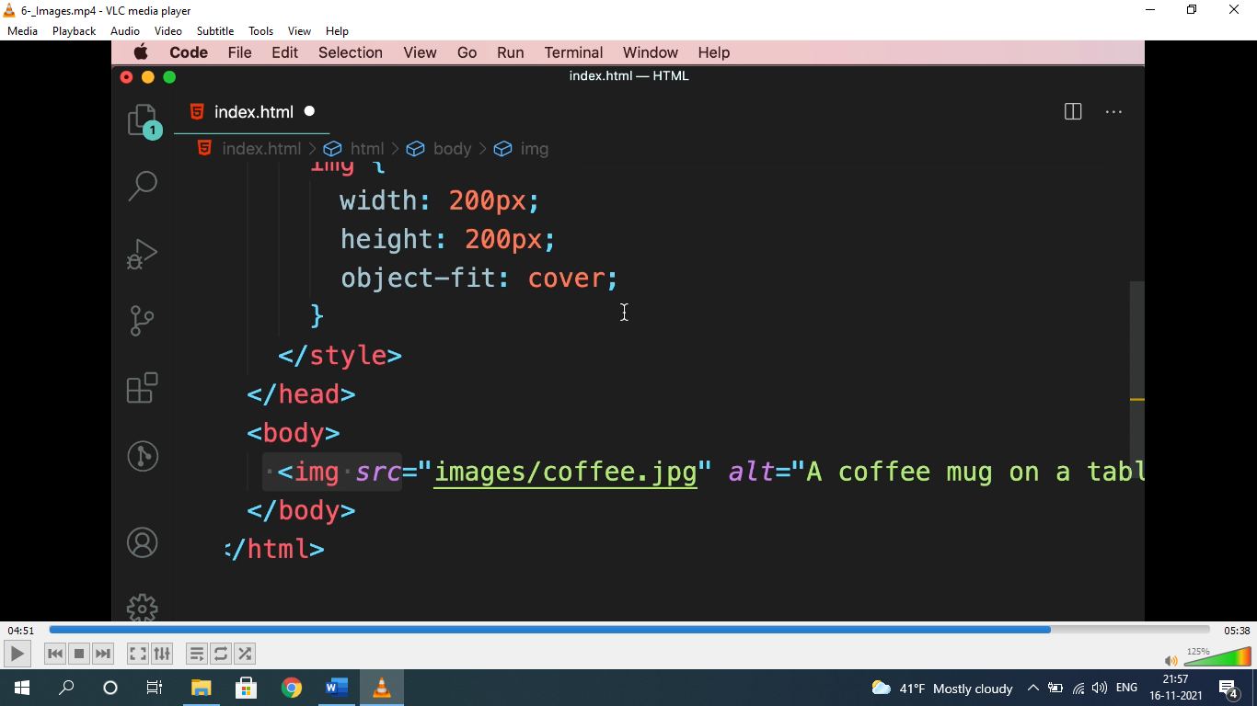

* for free images: ***unsplash.com***

**<video> & <audio>:**

* used to show video and audio.

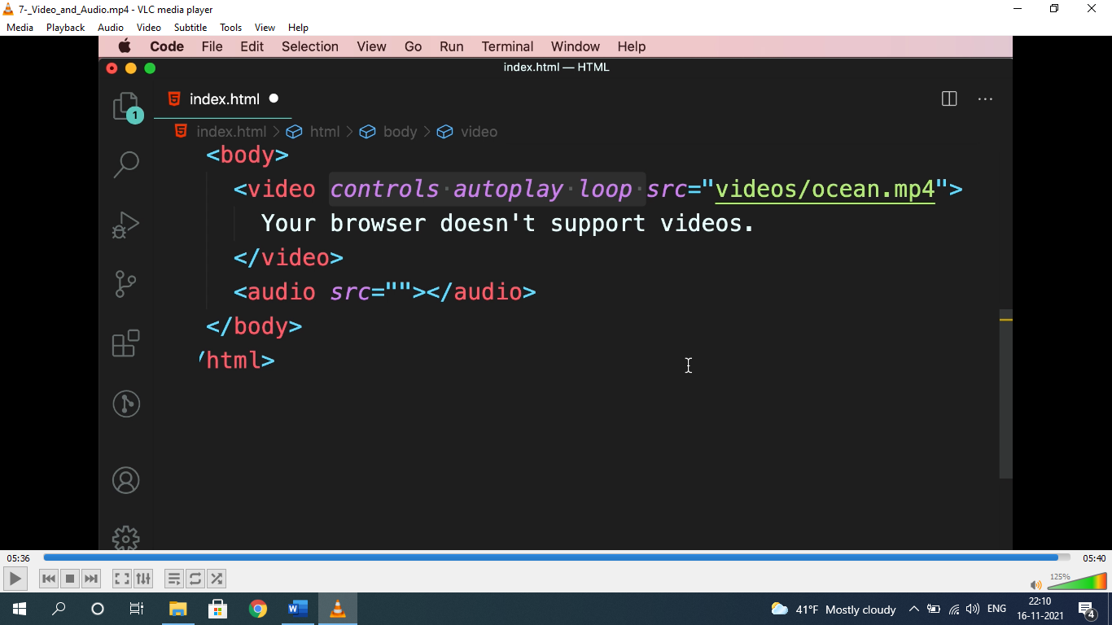

* “your browser doesn’t support videos” will only render when browser doesn’t support video.
* Attribute for video and audio are same.
* For free audio and videos: ***pexels.com***

**LISTS (<ul>, <ol>, <dl>);**

* Used to represent list, nav items etc.

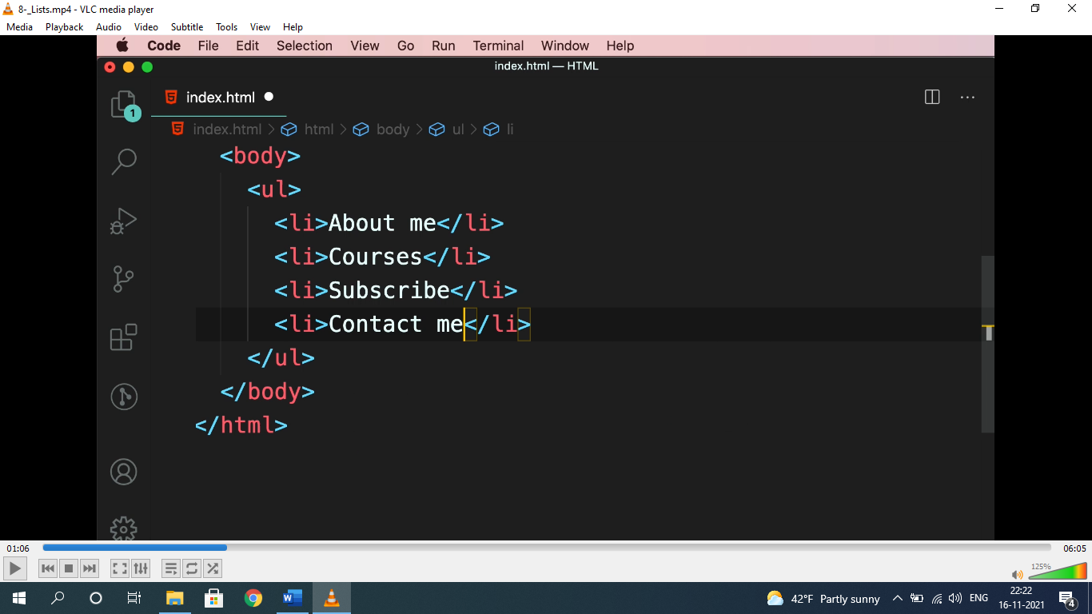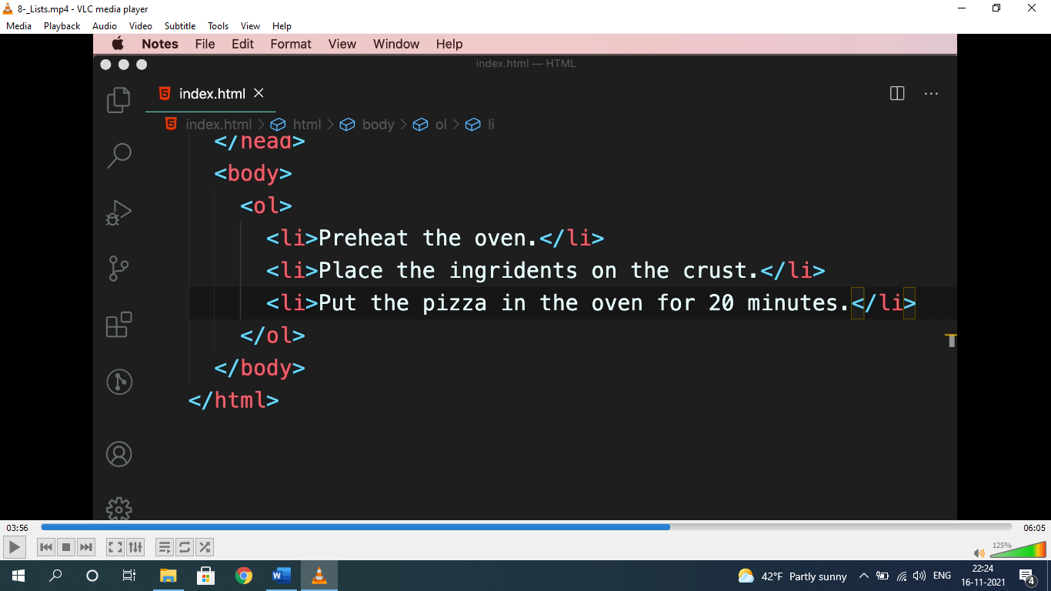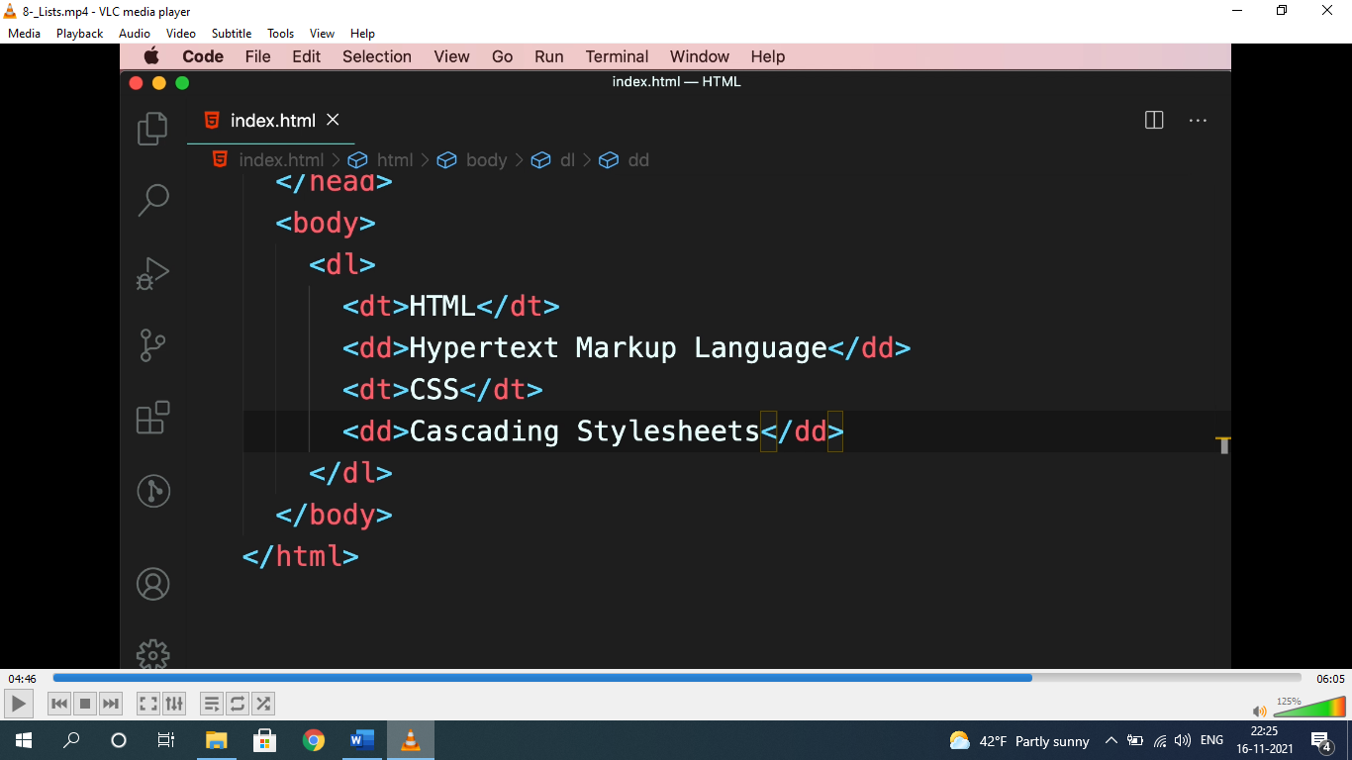

* dl= description list, dt= description term, dd= description details.

**TABLES:-**

* used to represent data in tabular format.

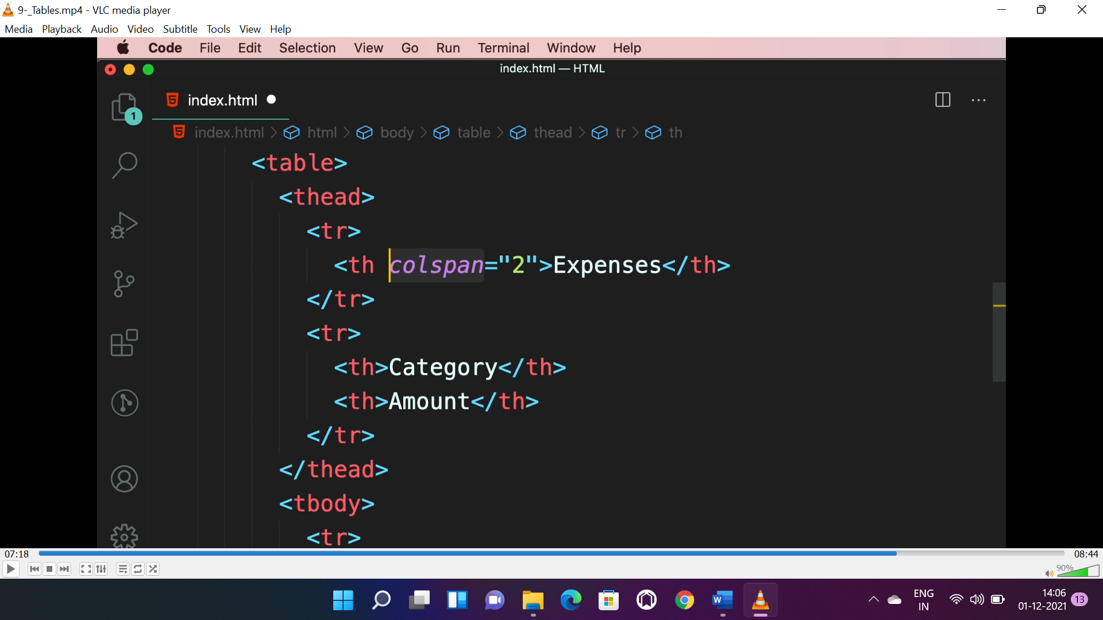

* **<thead> -** for table header, **<tbody> -** for table body, **<tfoot> -** for table footer.
* **Colspan –** no. of cols to be collapsed, **rowspan –** no. of rows to be collapsed.

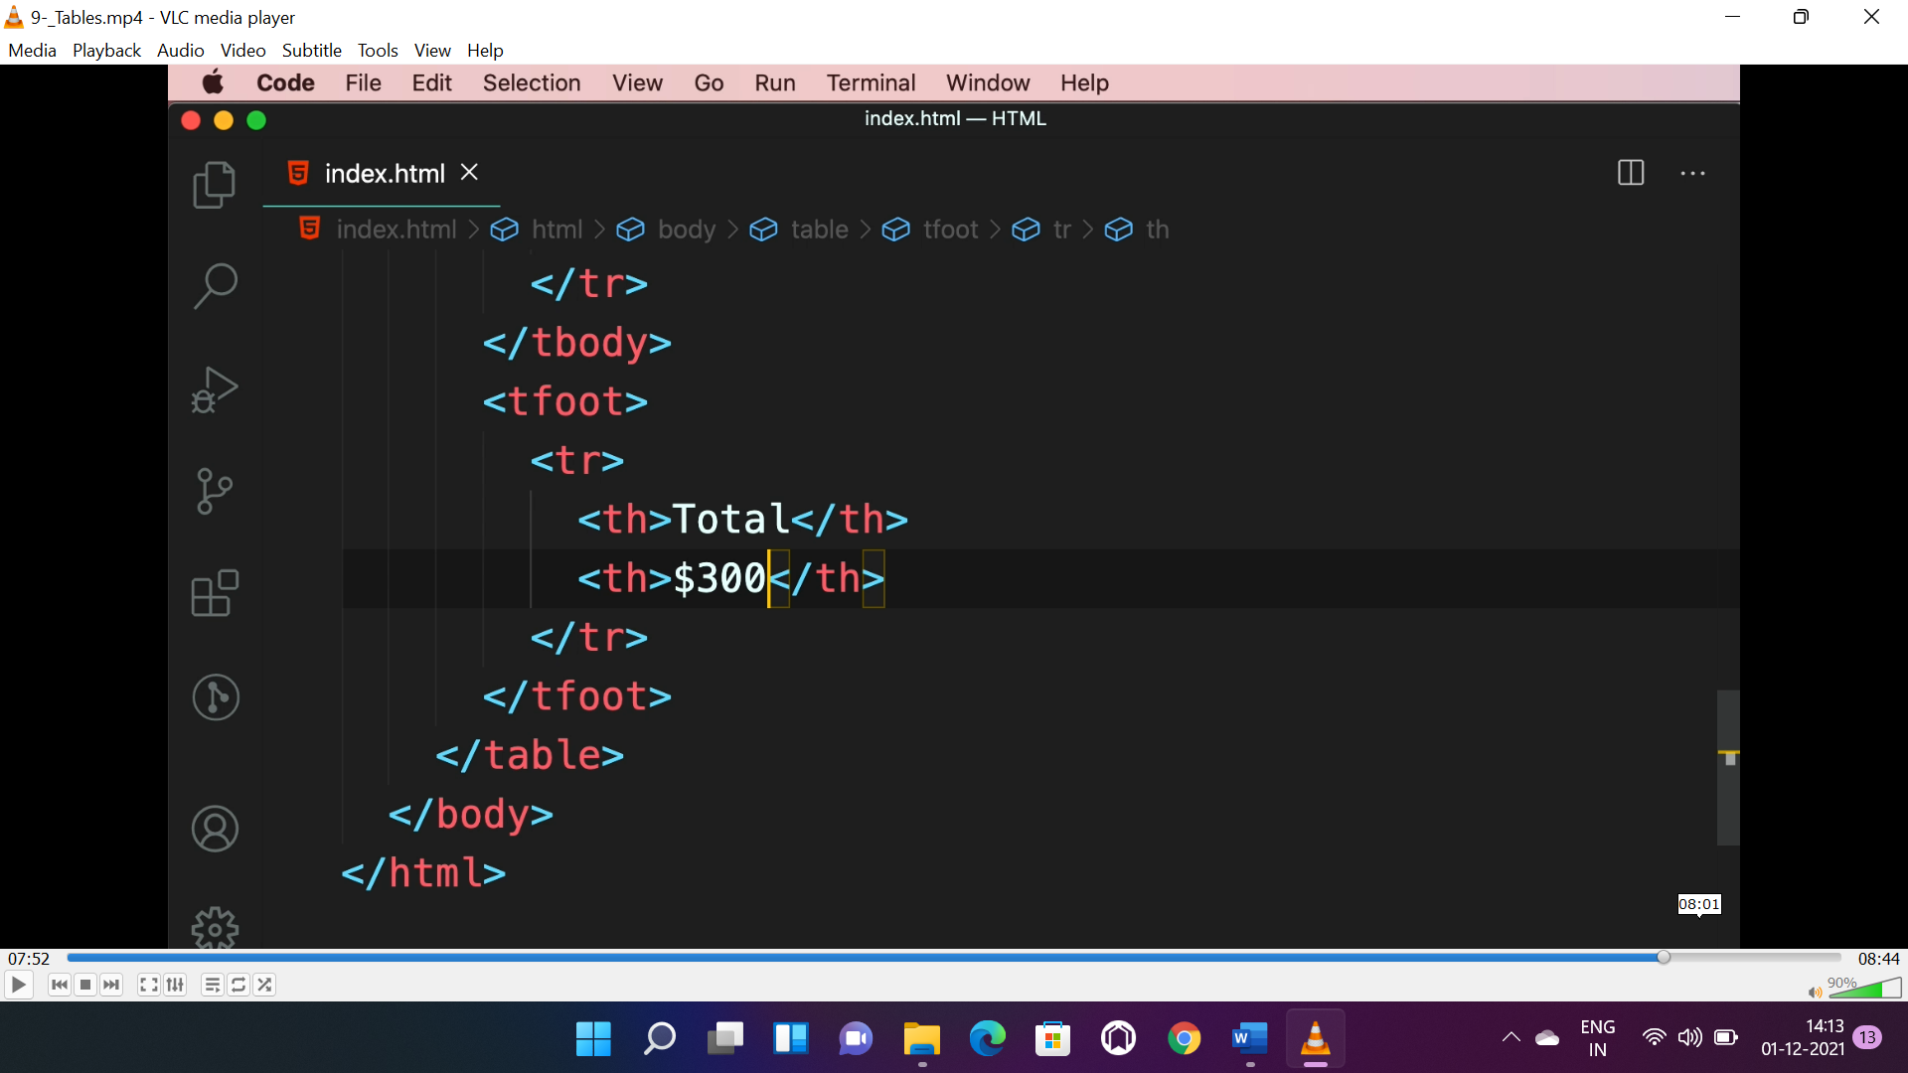

**CONTAINERS(<div>, <span>):**

* <div> is block level element, will cover full screen width, <span> is inline element will cover required width.

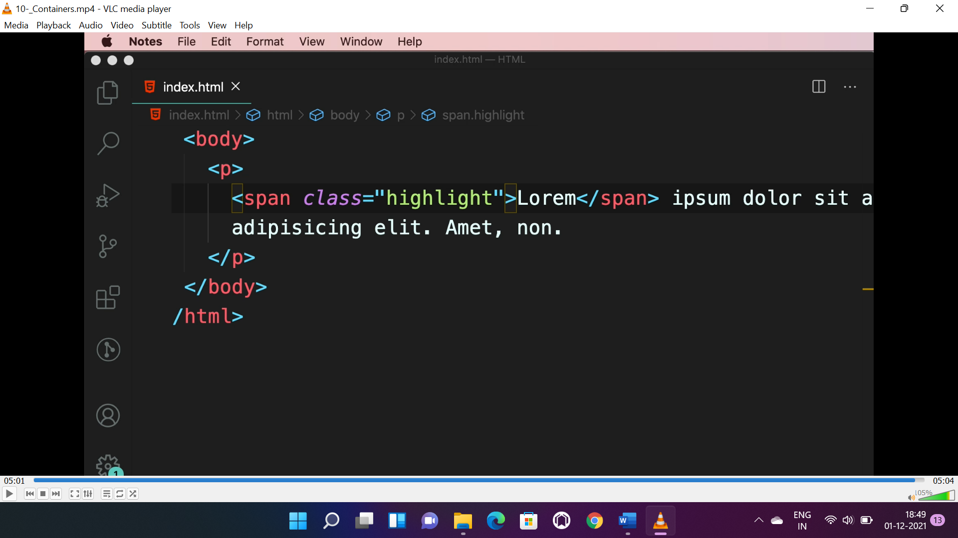

**HTML-5-CONTAINERS:**

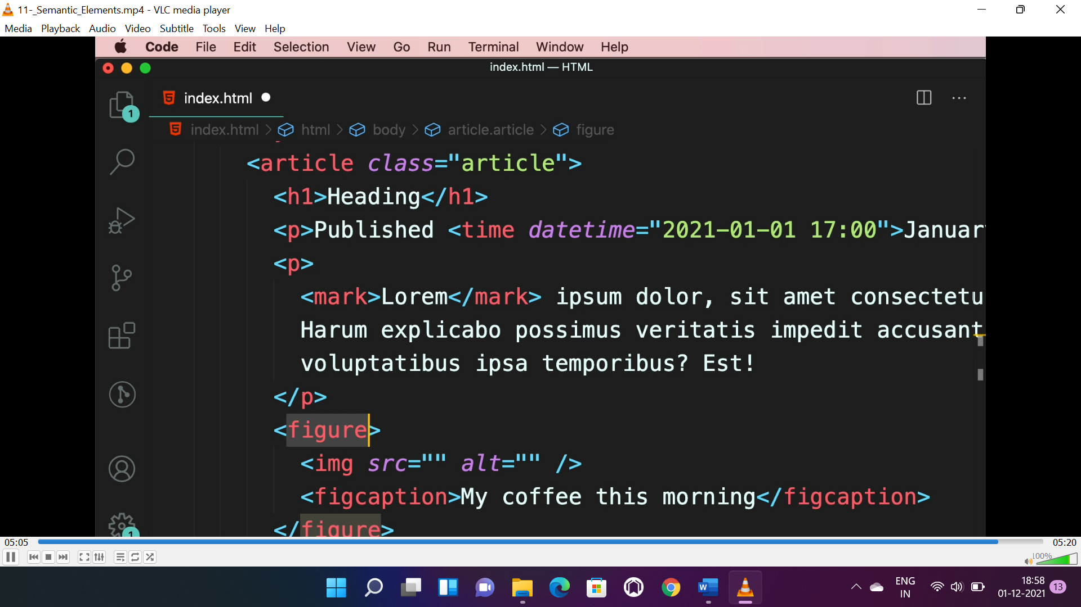

* <article> - for articles(more meaningful, easy for search engines to search)
* <time> - for representing time.
* <mark> - for highlighting text.
* <figure> - for images.
* <figcaption> - for defining details of that images.

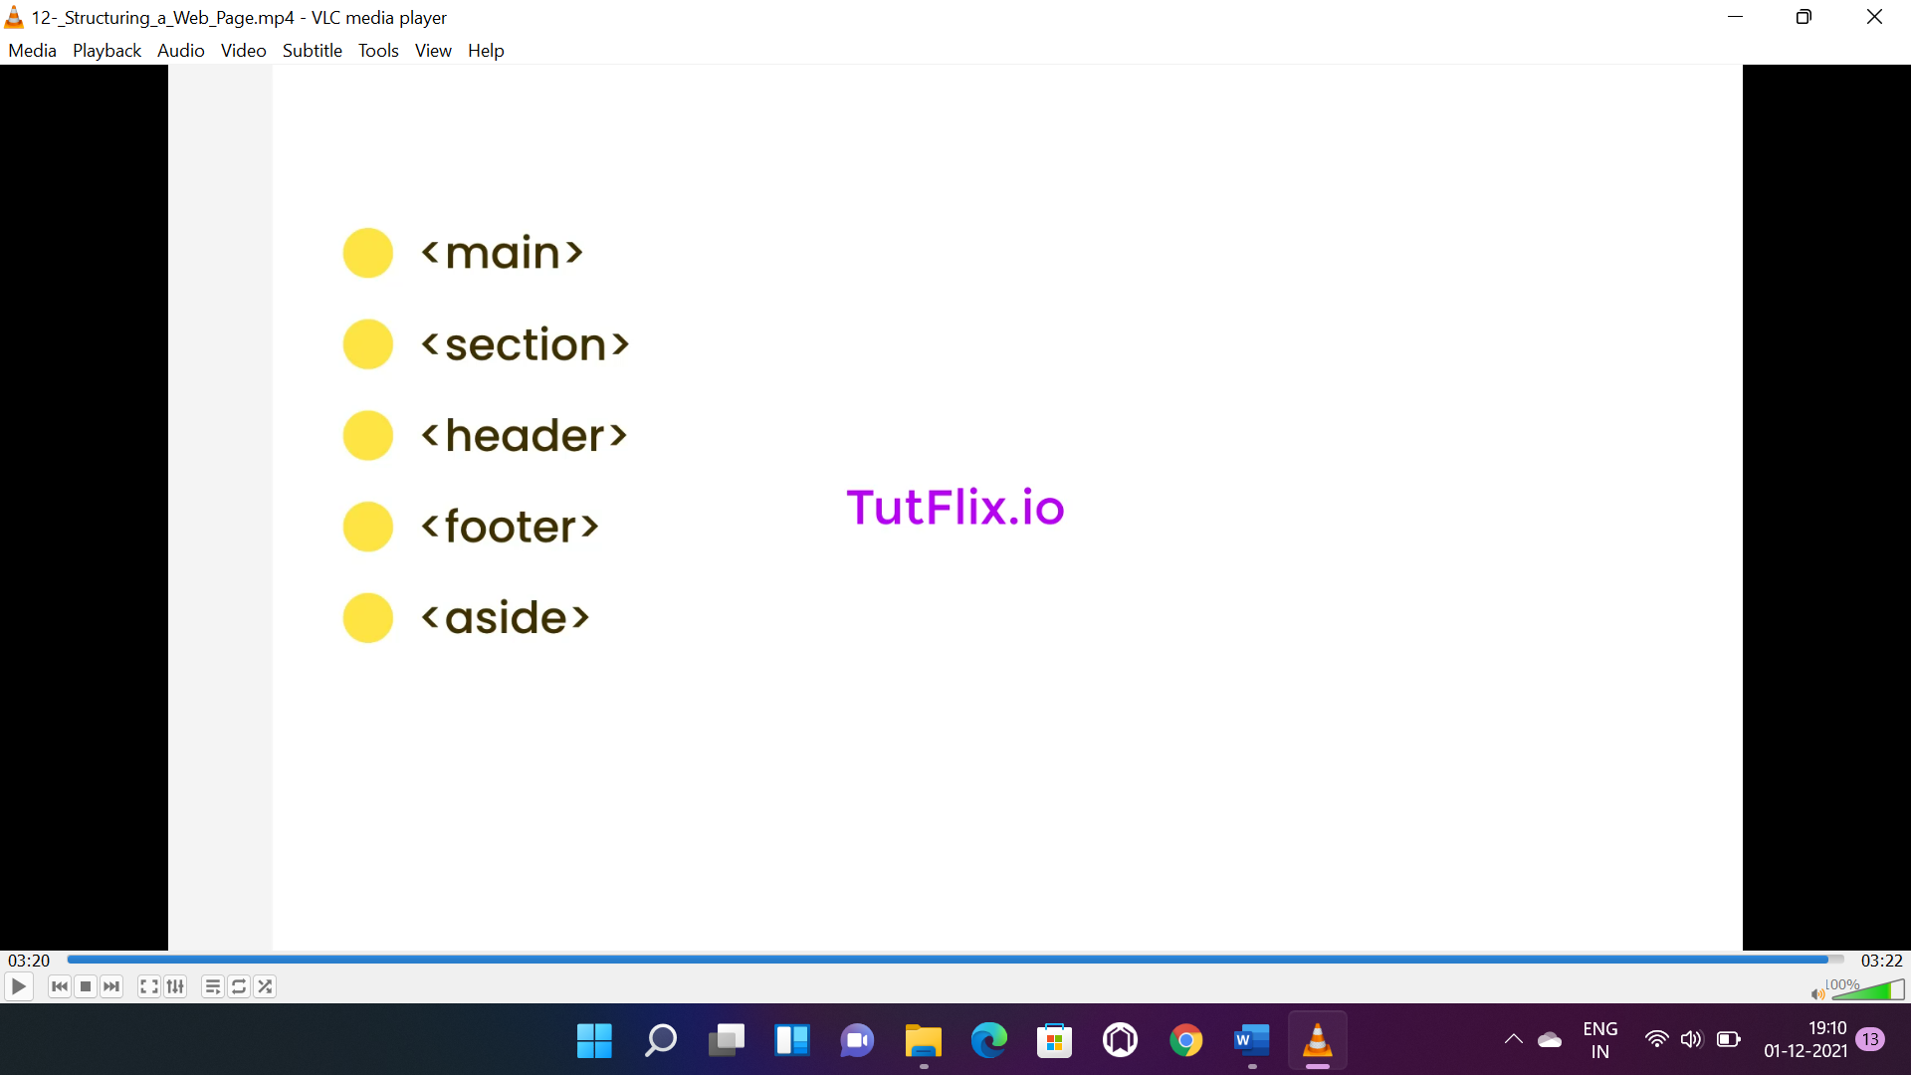

* <main> - is the main content of page and can be used only once.
* <section> - used for group of related elements.
* <header> - used for navigation bars.
* <footer> - for footer of the page.
* <aside> - for side bar and content related to main element.

**CSS**

**BASIC SELECTORS:**

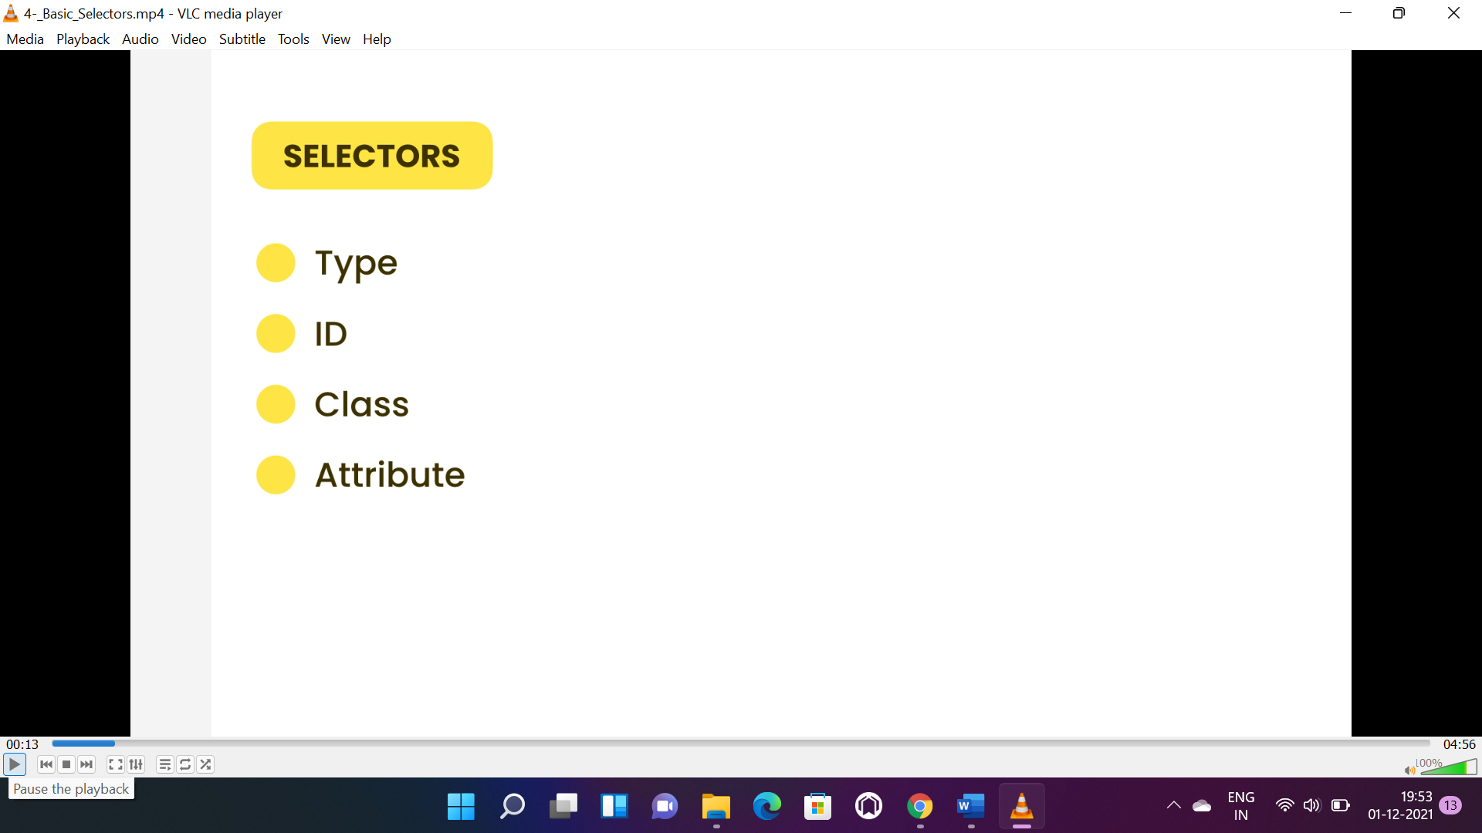

* Type selector is <div>, <span>, <h1>, <p>.
* Id selector is #id_name.
* Class selector is .class_name.
* Attribute selector is href, src etc.

**RELATIONAL SELECTORS(>, +, ~):**

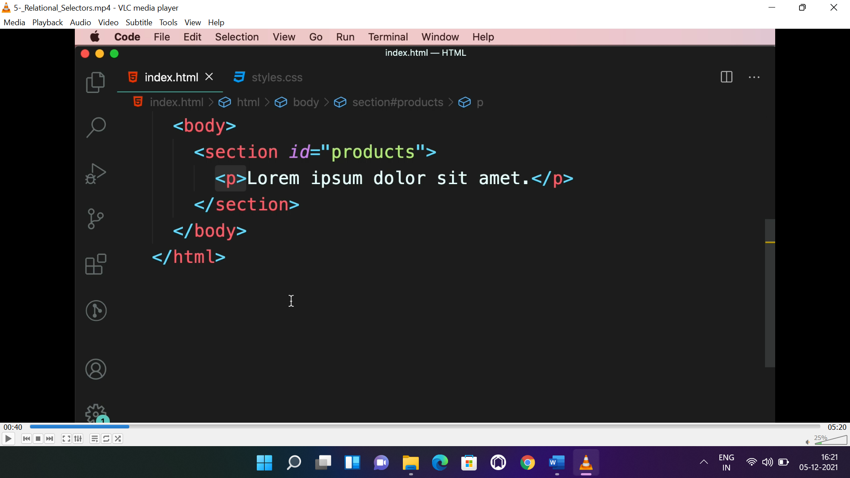

* To select all paragraph inside <section>, the selectors will be like:

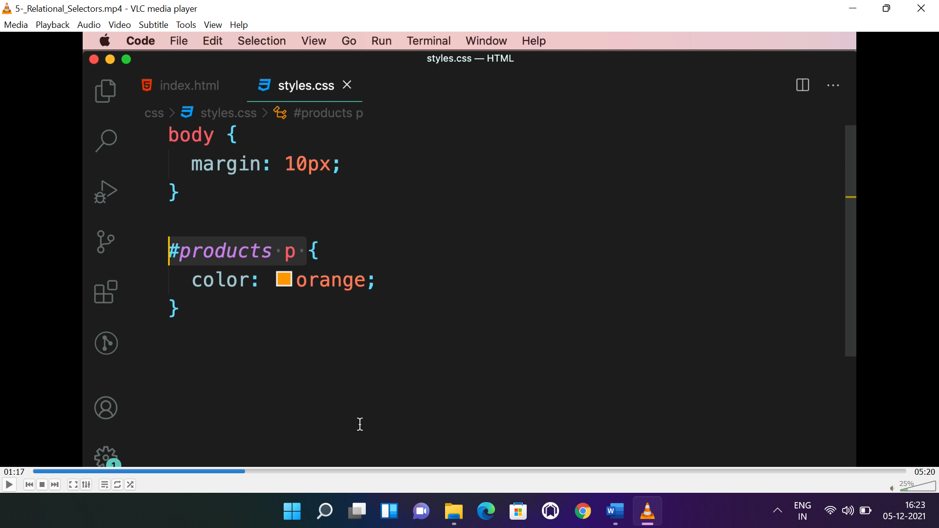

* To select 1st paragraph inside <section>, the selectors will be like:

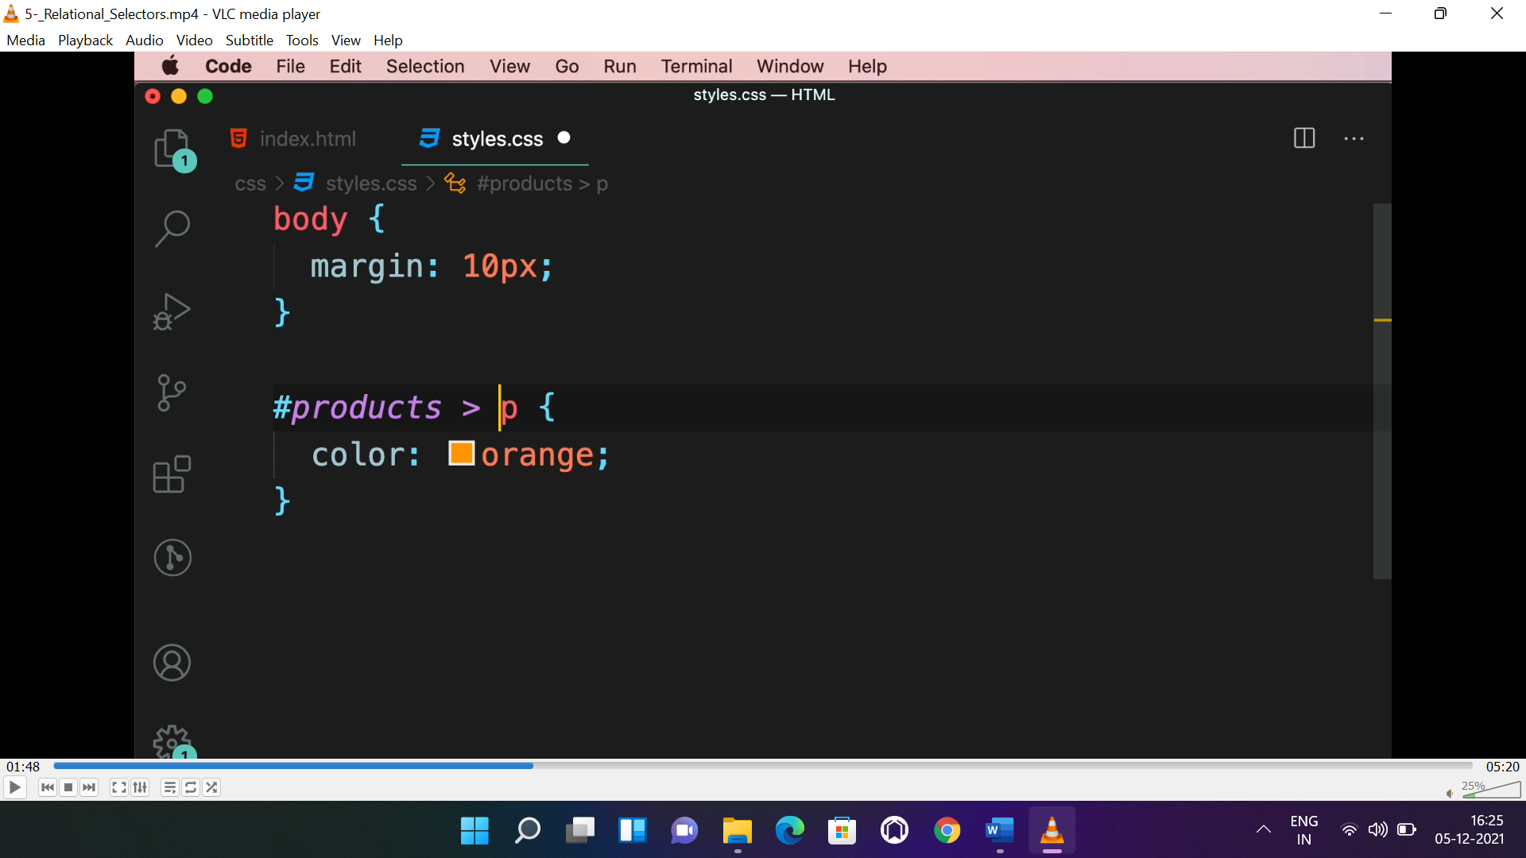

* To select the para right after the <section>, the selector will be like:

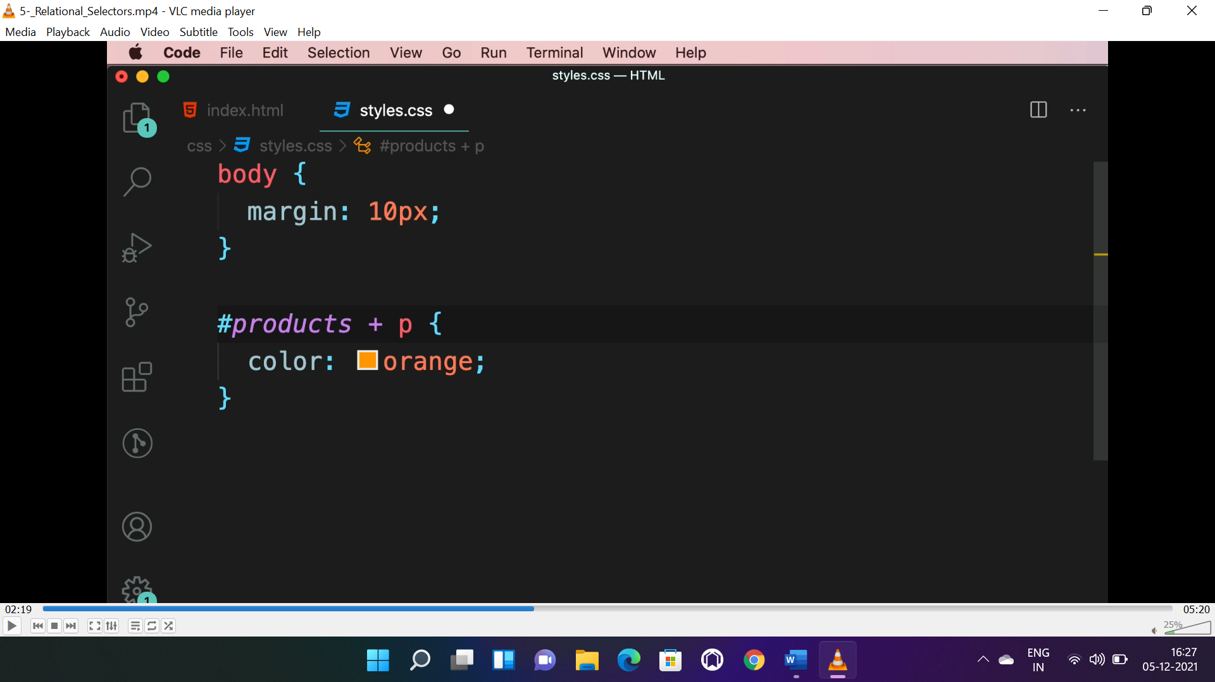

* To select all para right after the <section>, the selector will be like:

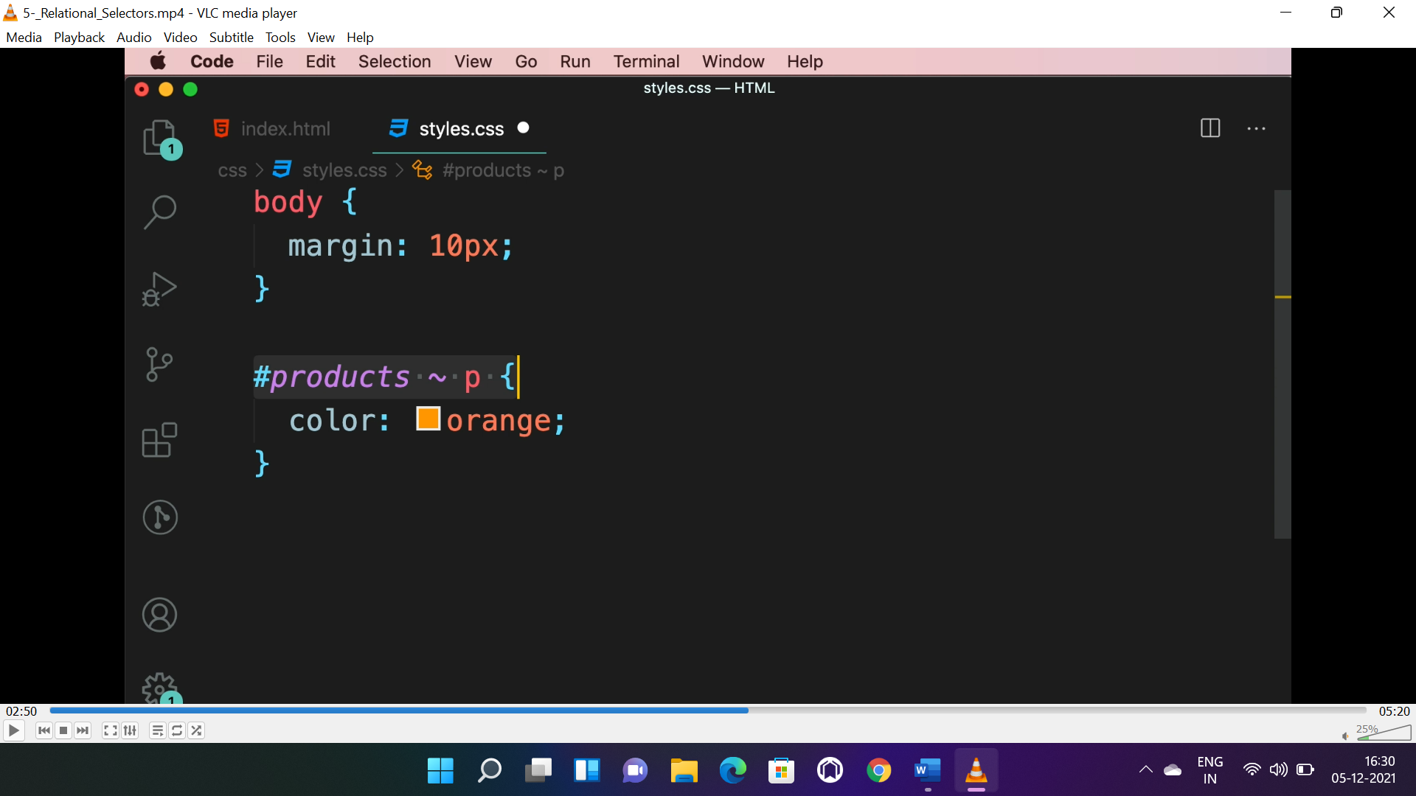

**PSEUDO CLASS:**

* These classes are applied automatically by the browser, not needed to define.
* **Ex:-:first-child, :first-of-type, :last-child, :last-of-type, :hover, :focus, :visited, :link etc..**

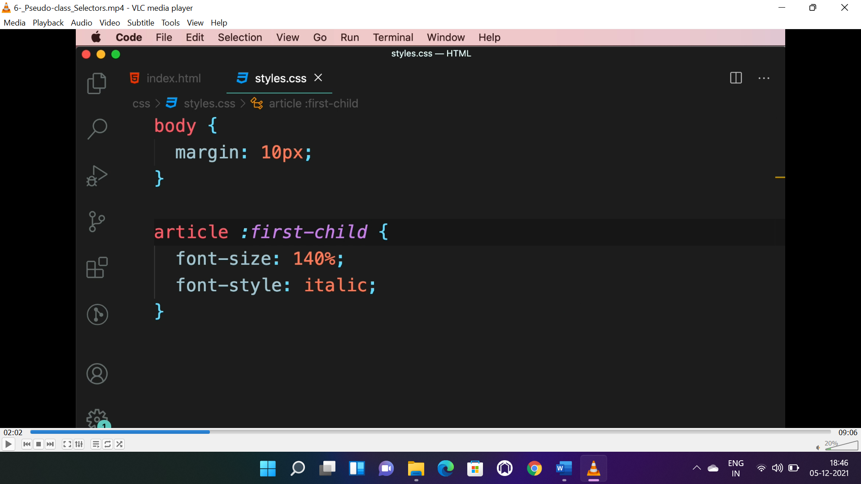

* It will apply to the 1st child element.

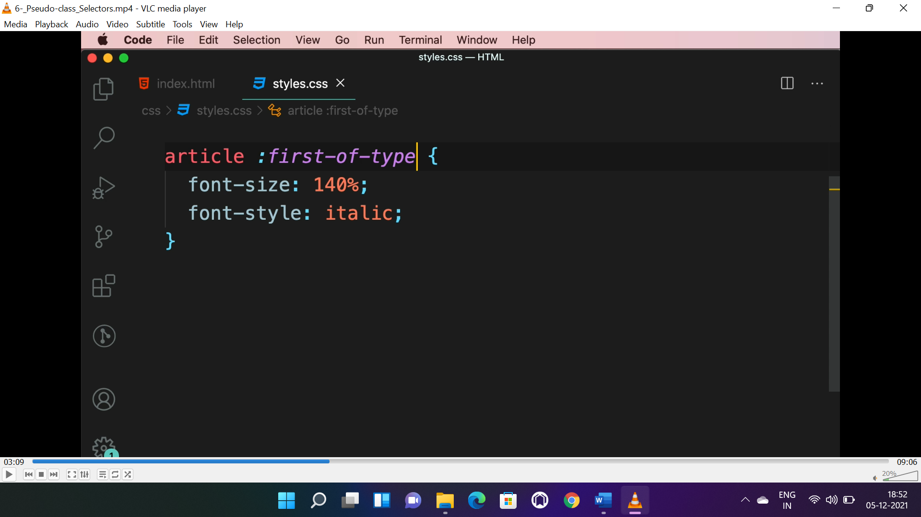

* It will apply to the 1st element of all type element.

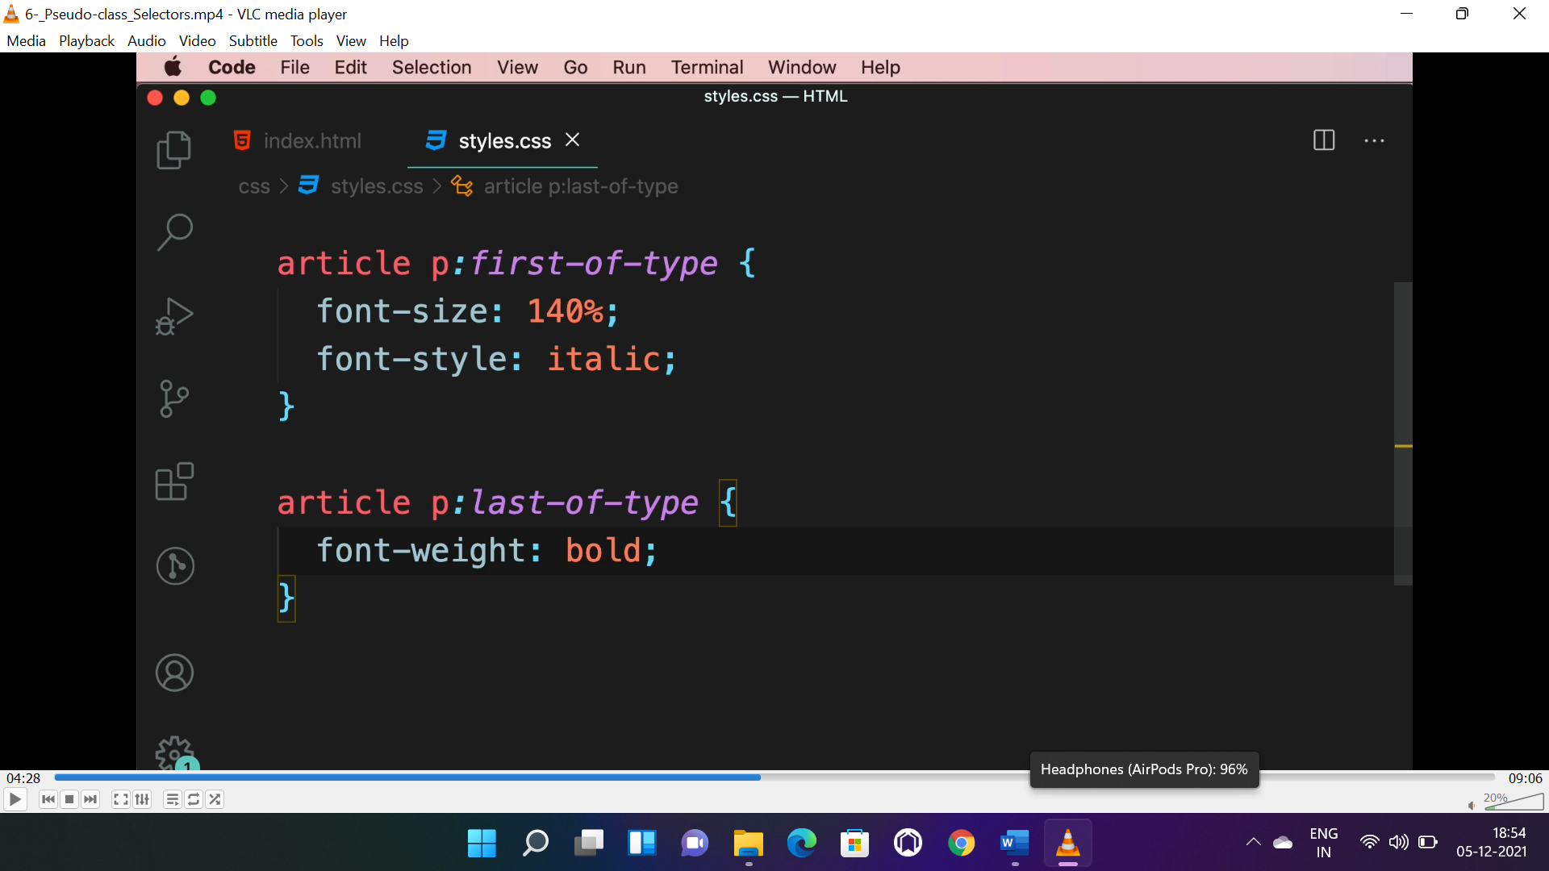

* It will apply to specific element and it is “<p>” here.

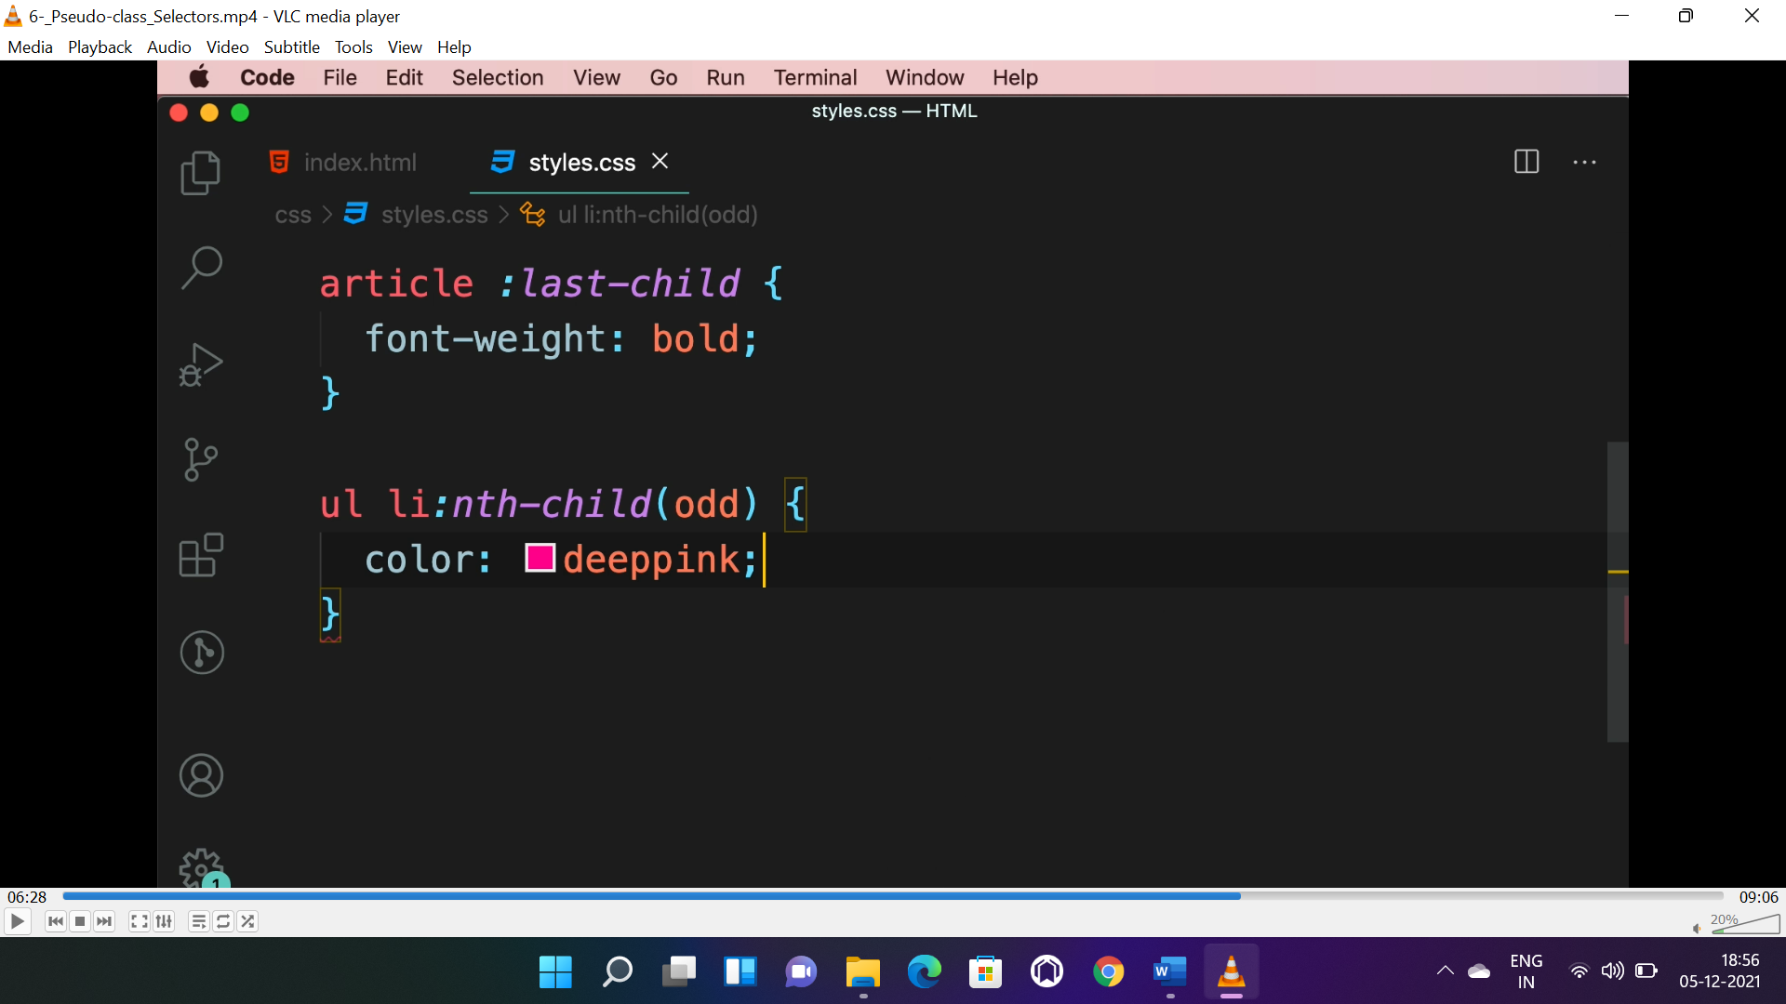 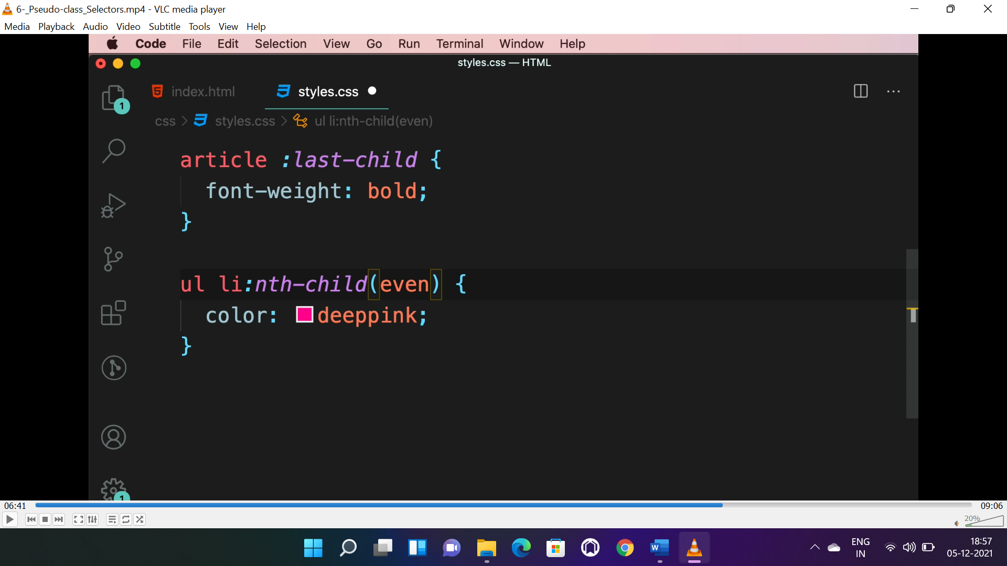 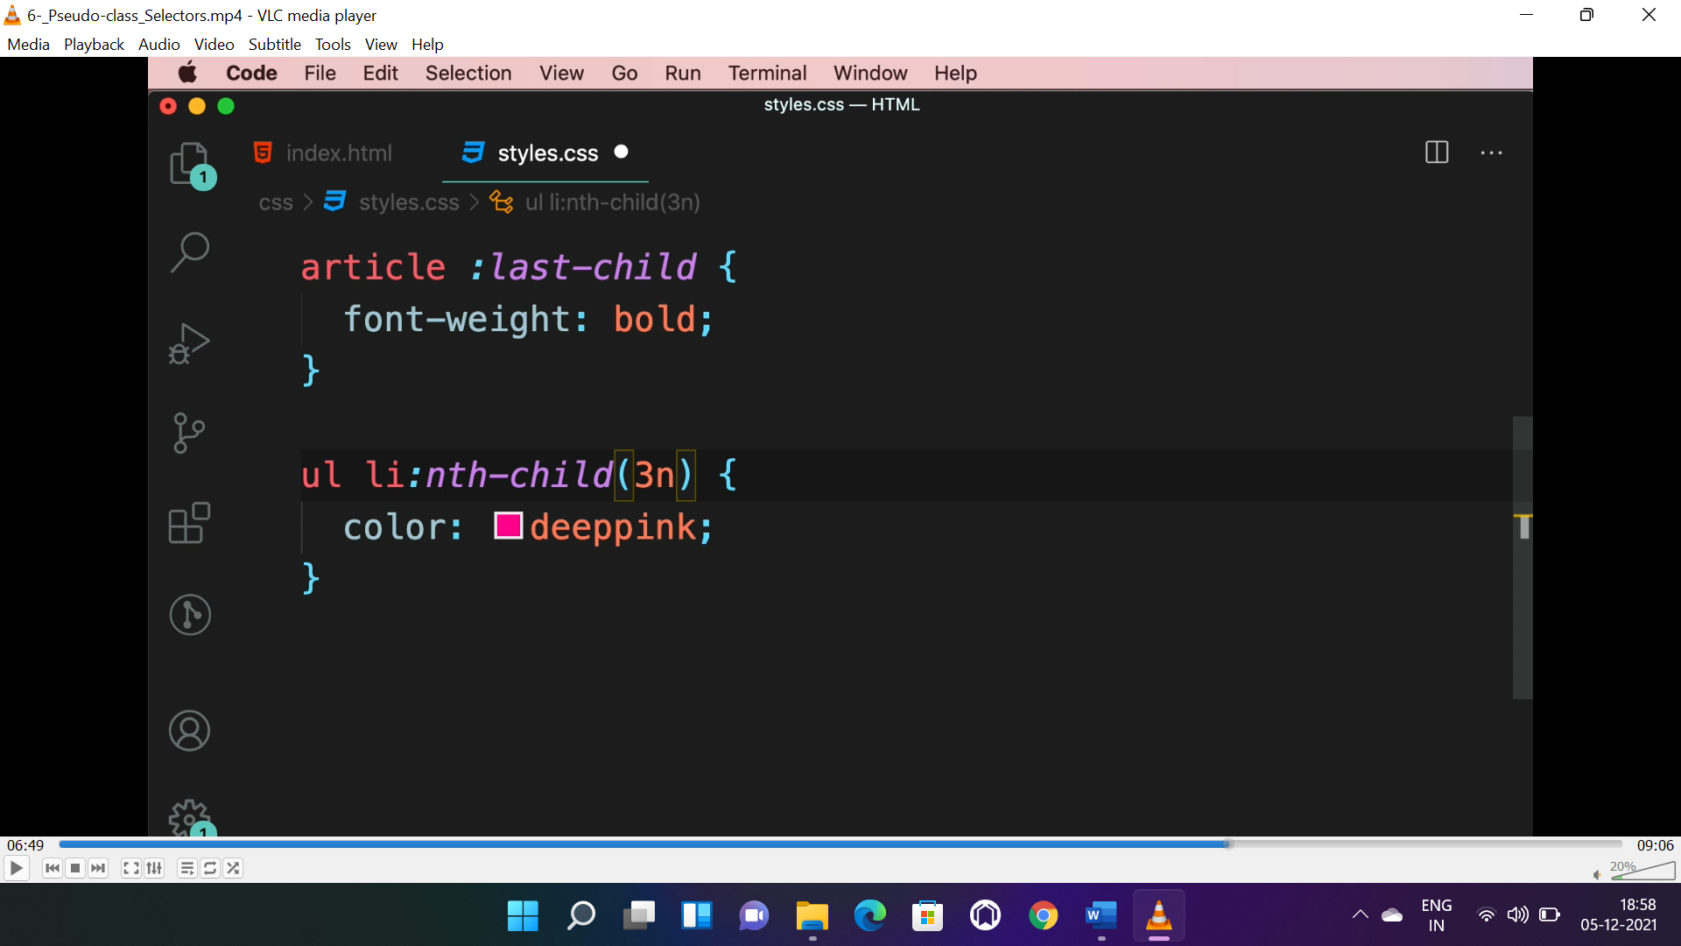

* Here “nth-child()” is a function, used to style particular element of “<li>” element here.

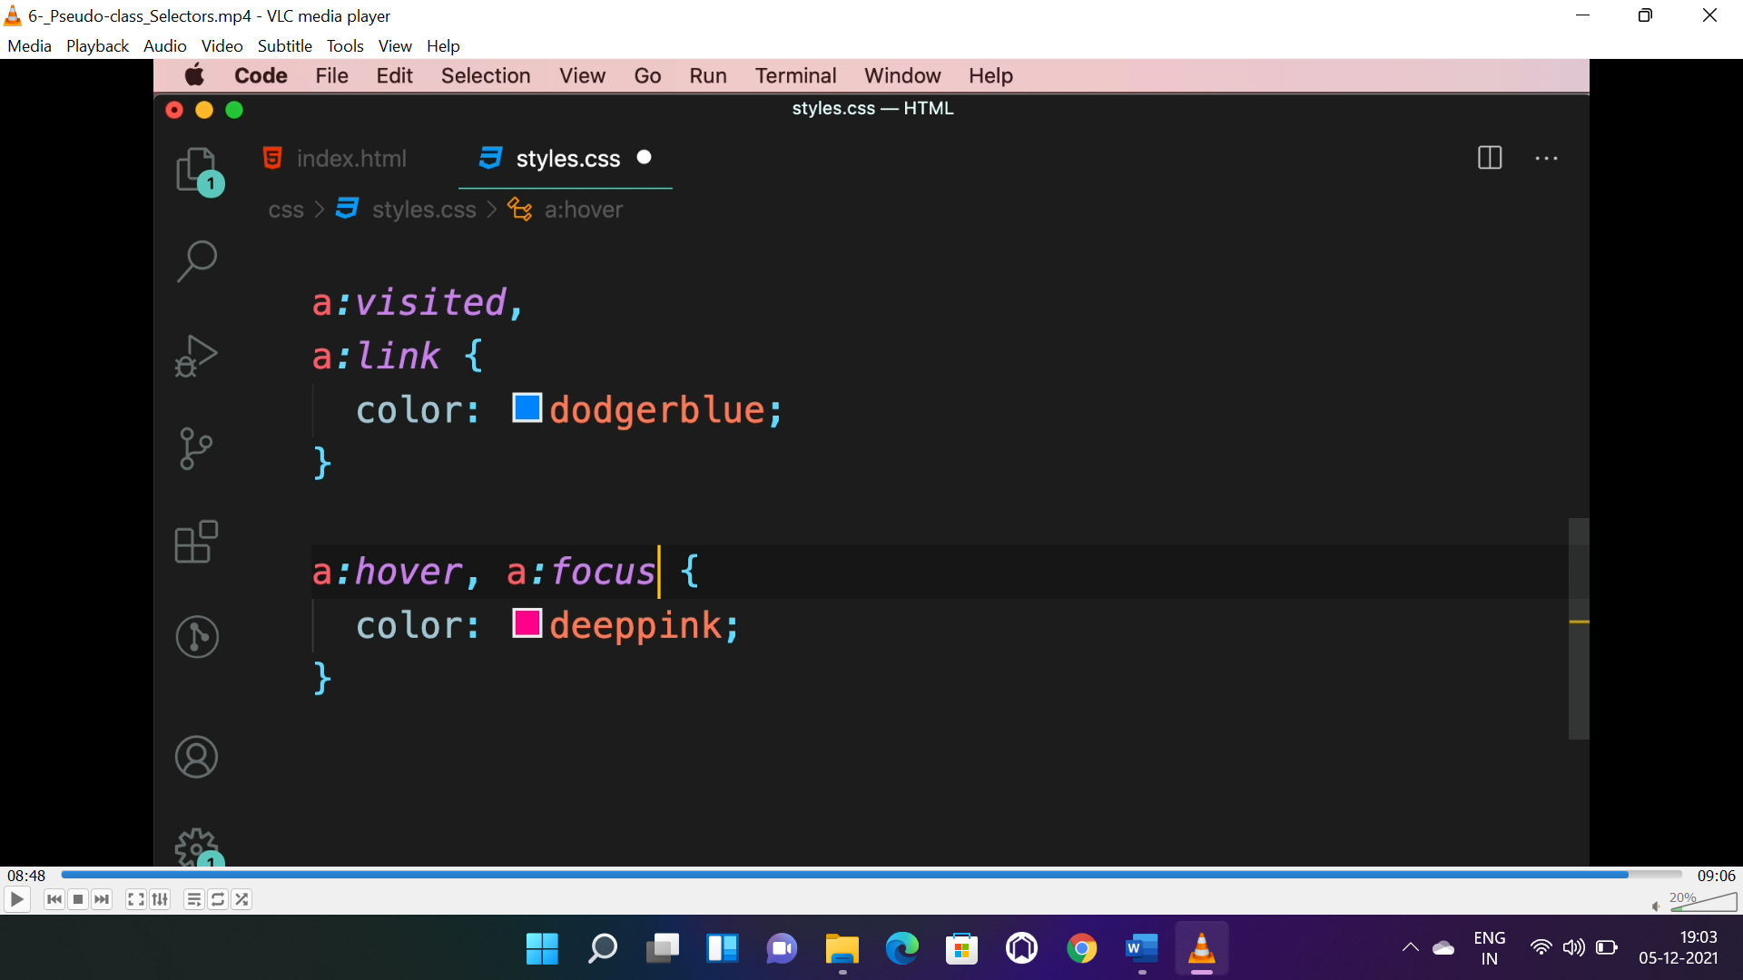

* To deal with “**hyperlink**” the above pseudo classes are used.

**SELECTOR SPECIFICITY:**

* !important> ID selector> class selector> element selector

**PUEUDO ELEMENT SELECTOR:**

* Used to style a part of an element.

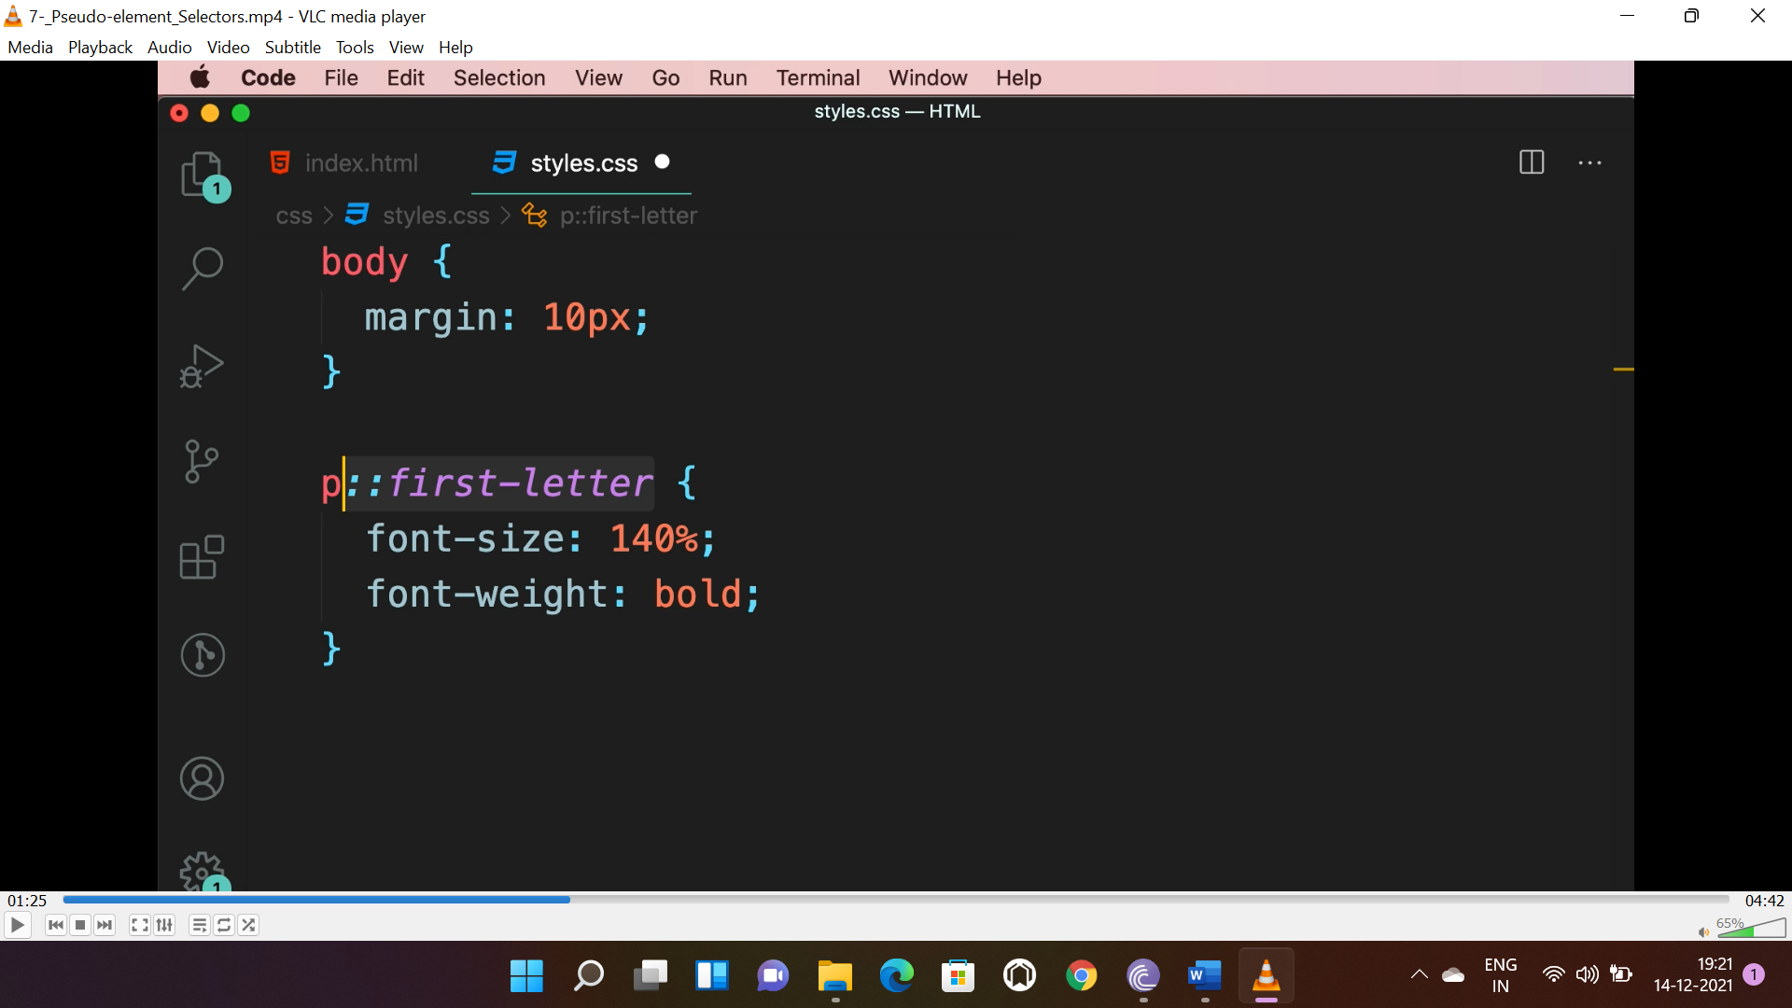

* The above selector targets the 1st letter of a para.

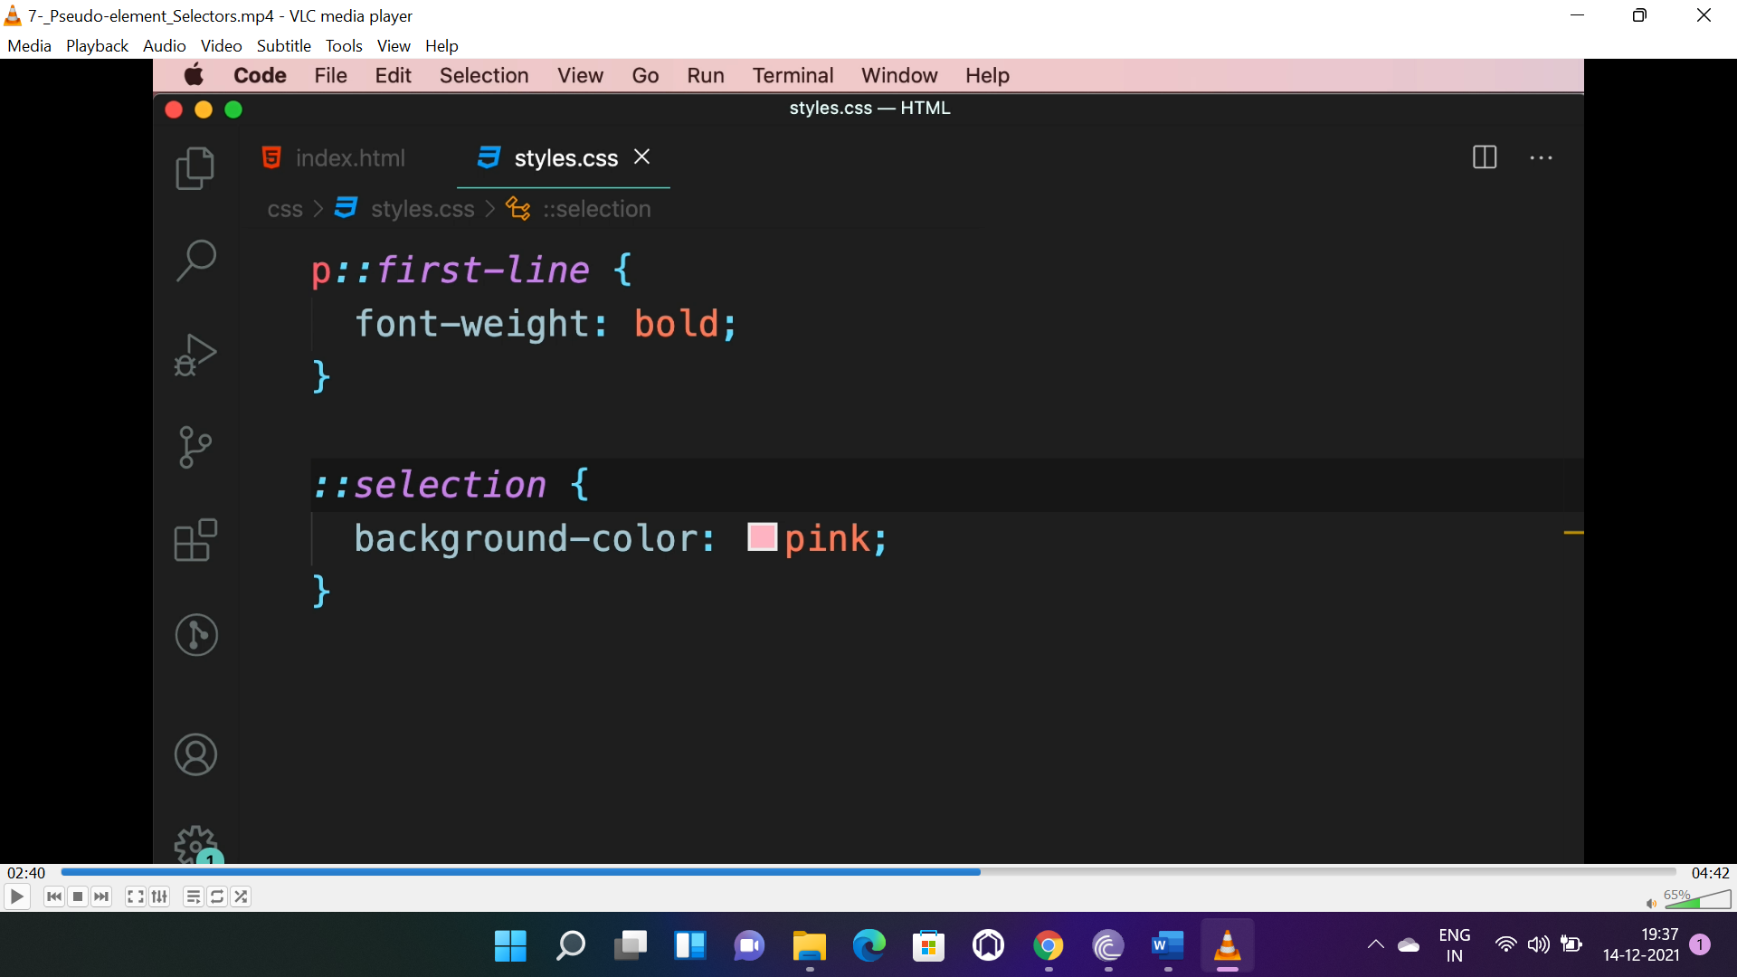

* The above selectors targets the “first-line” and “selection” respectively.

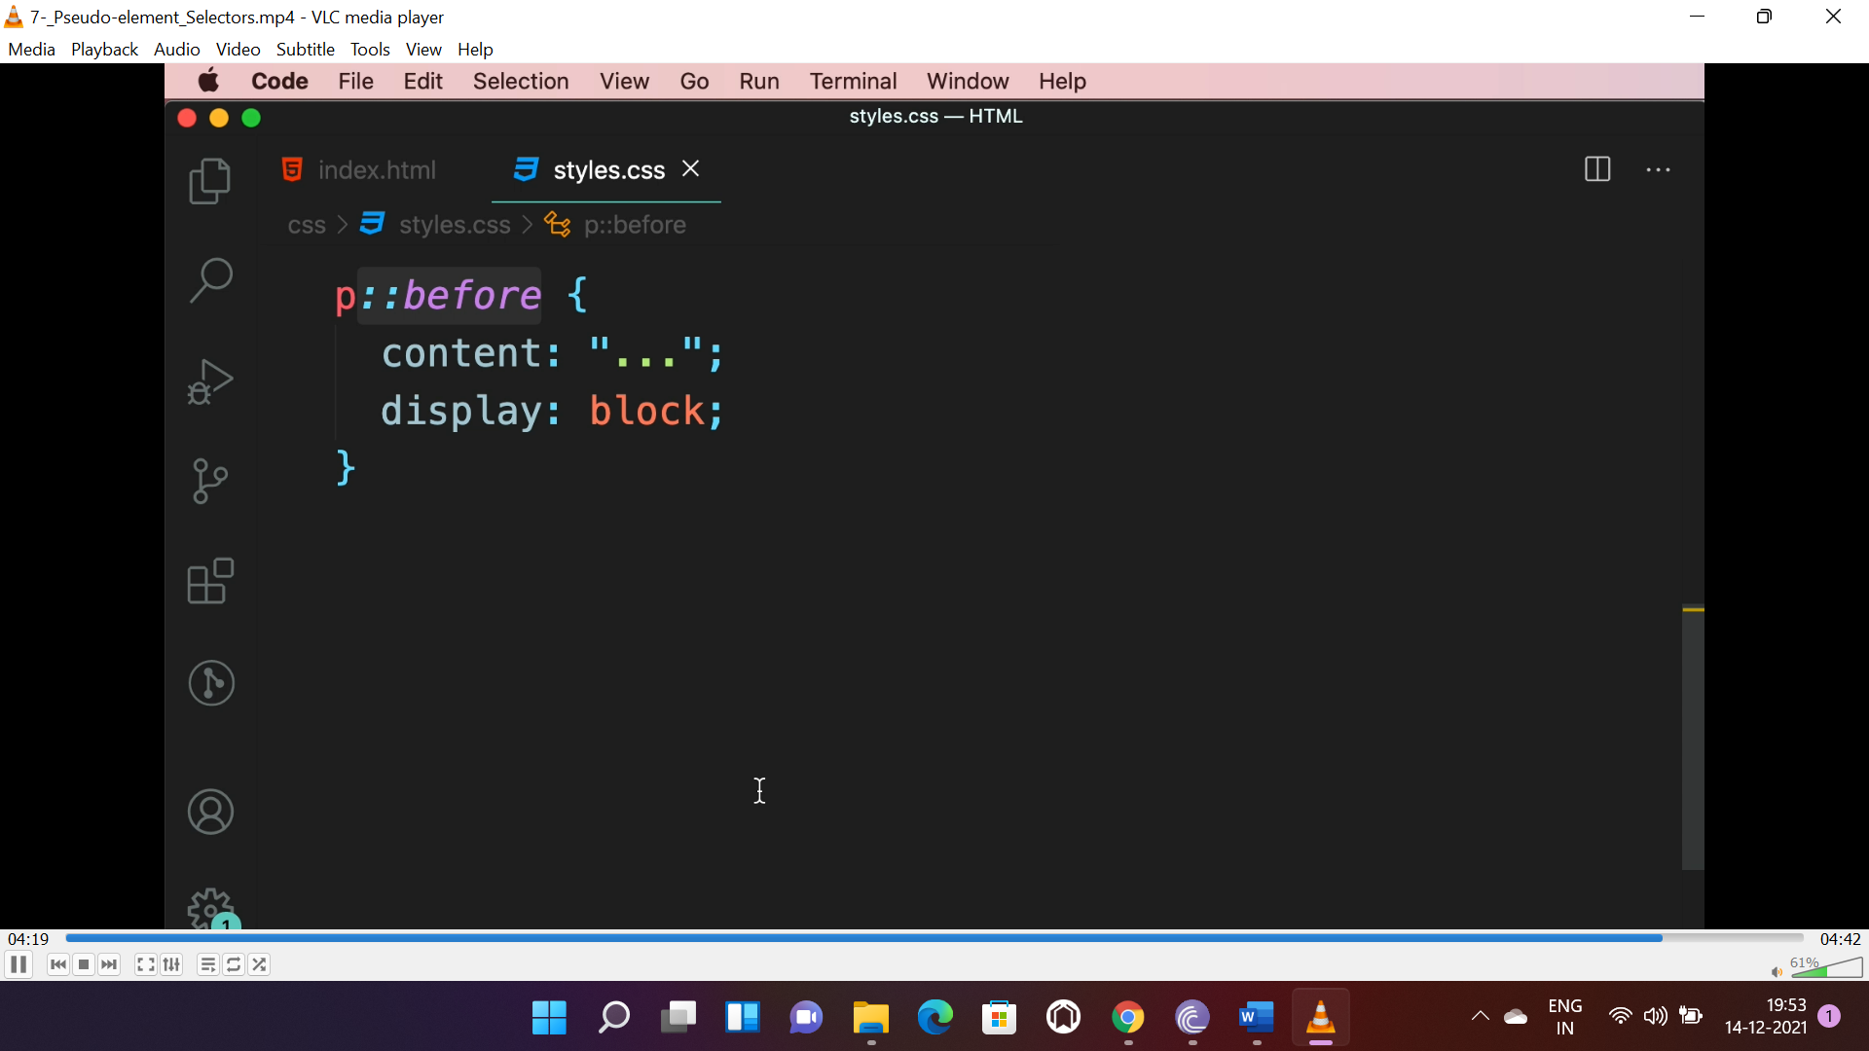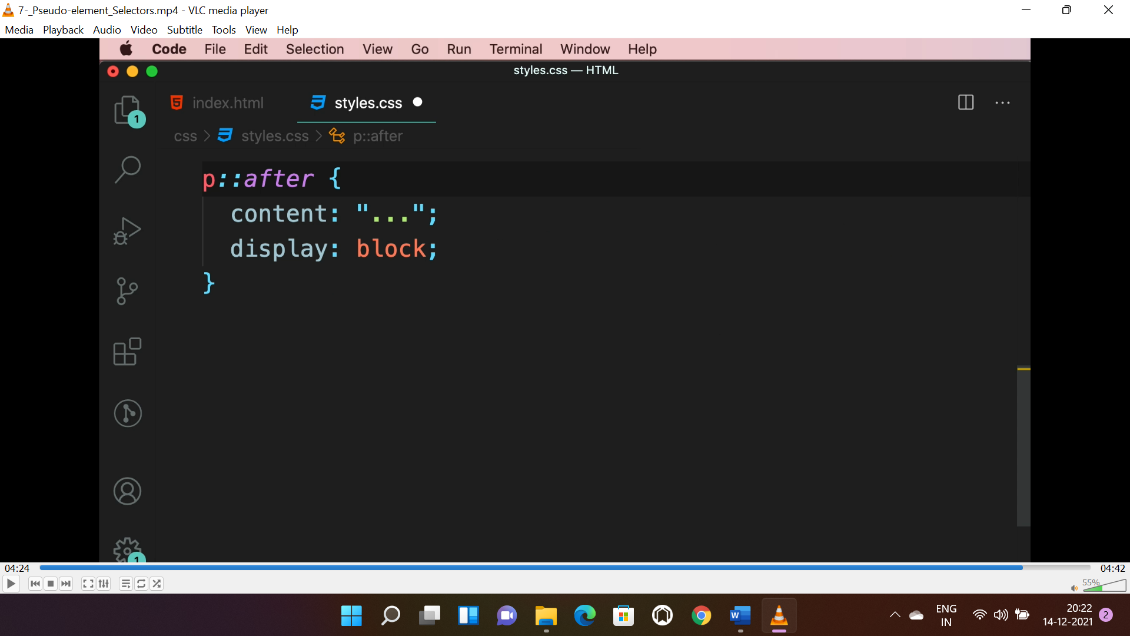

* The above selector targets before and after the para.

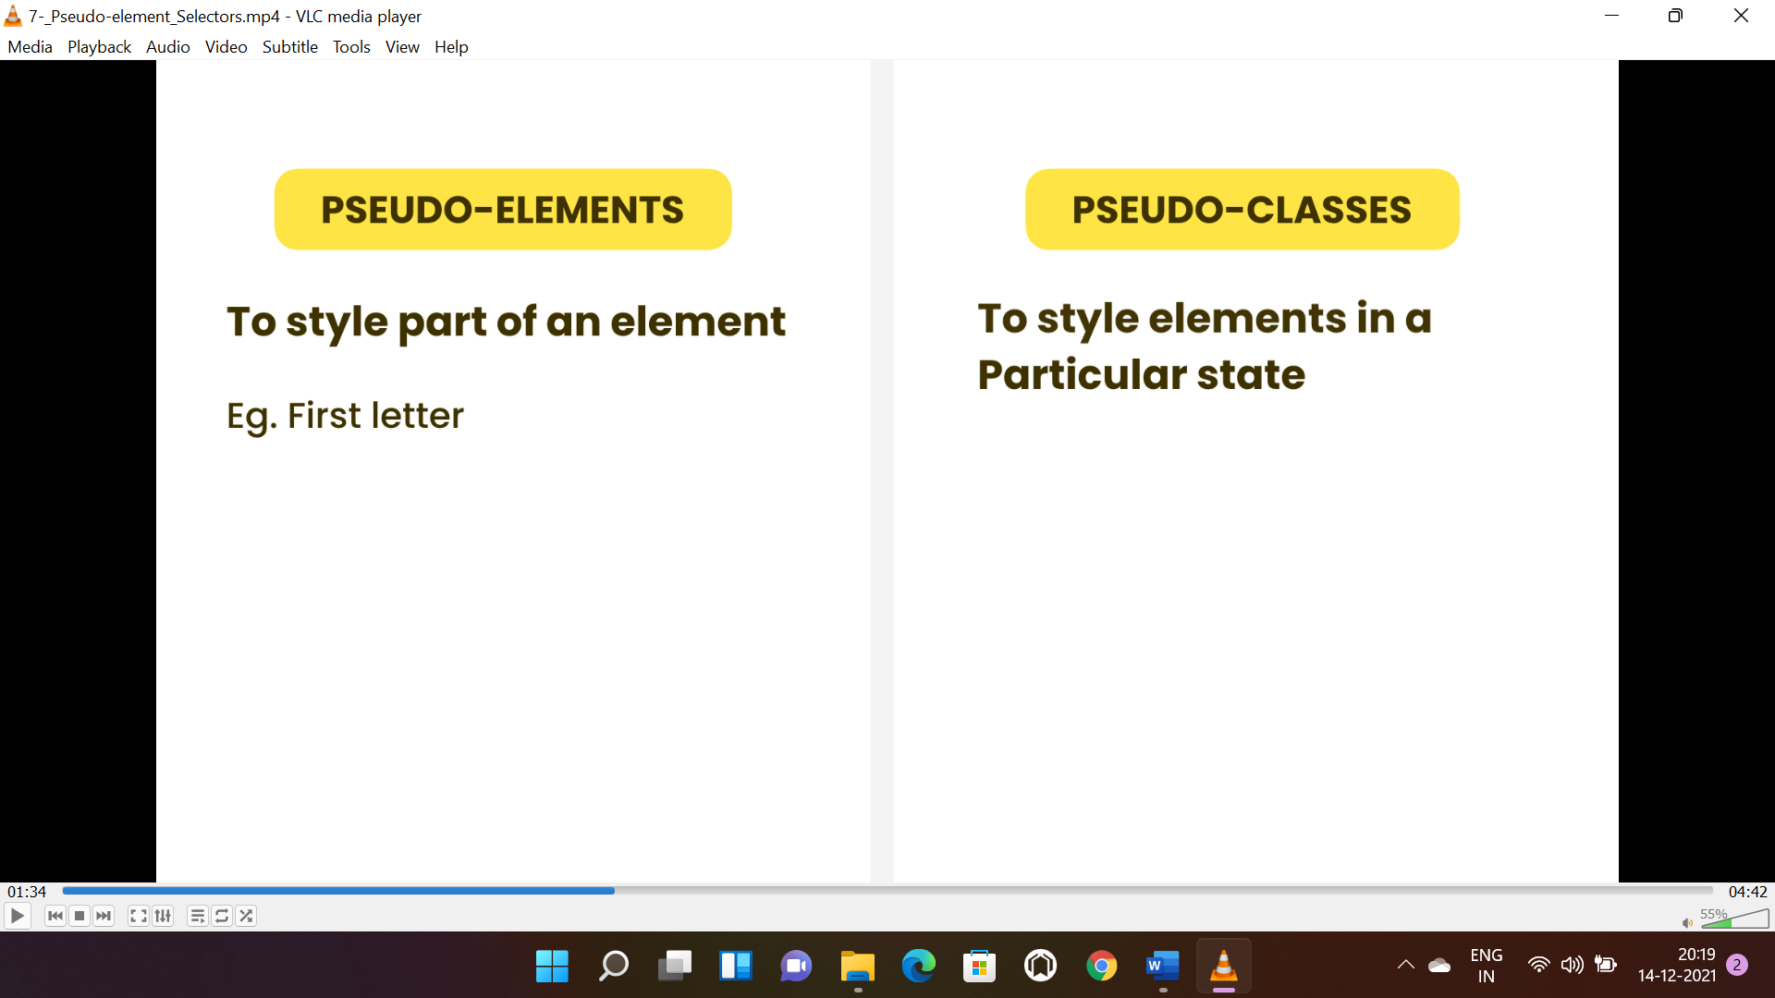

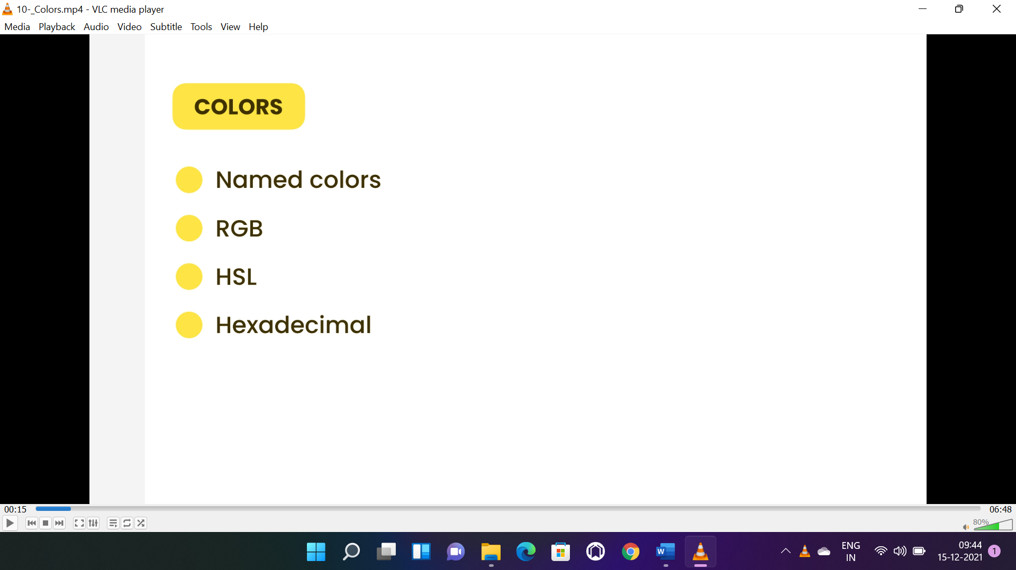

**RGB:**

* R=red, g=green, b=blue, a=alpha(transparency which stands between 0 and 1).

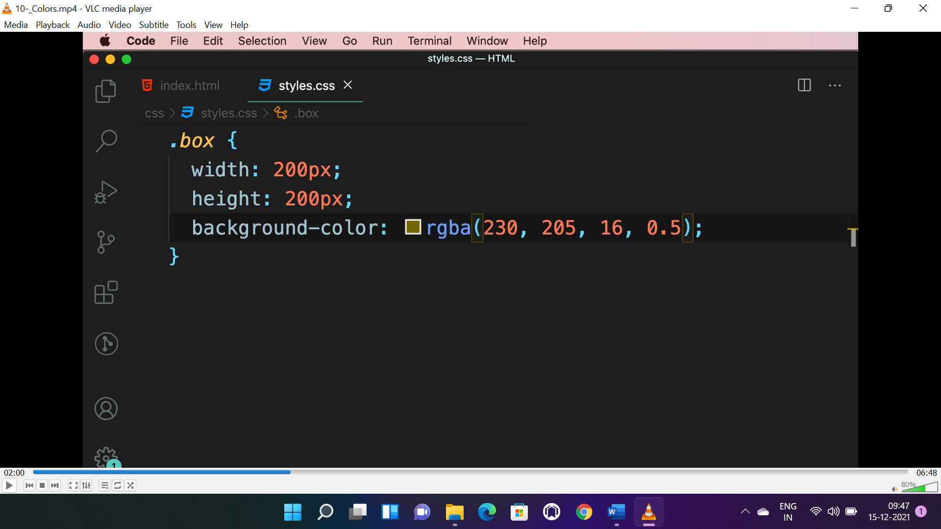

* Same background colour can be used above a image to blur it by using alpha.

**HSL:**

* H=hue(in degree), s=saturation(0-100%), l=lightening(0-100%), a=alpha, it is similar to RGB.

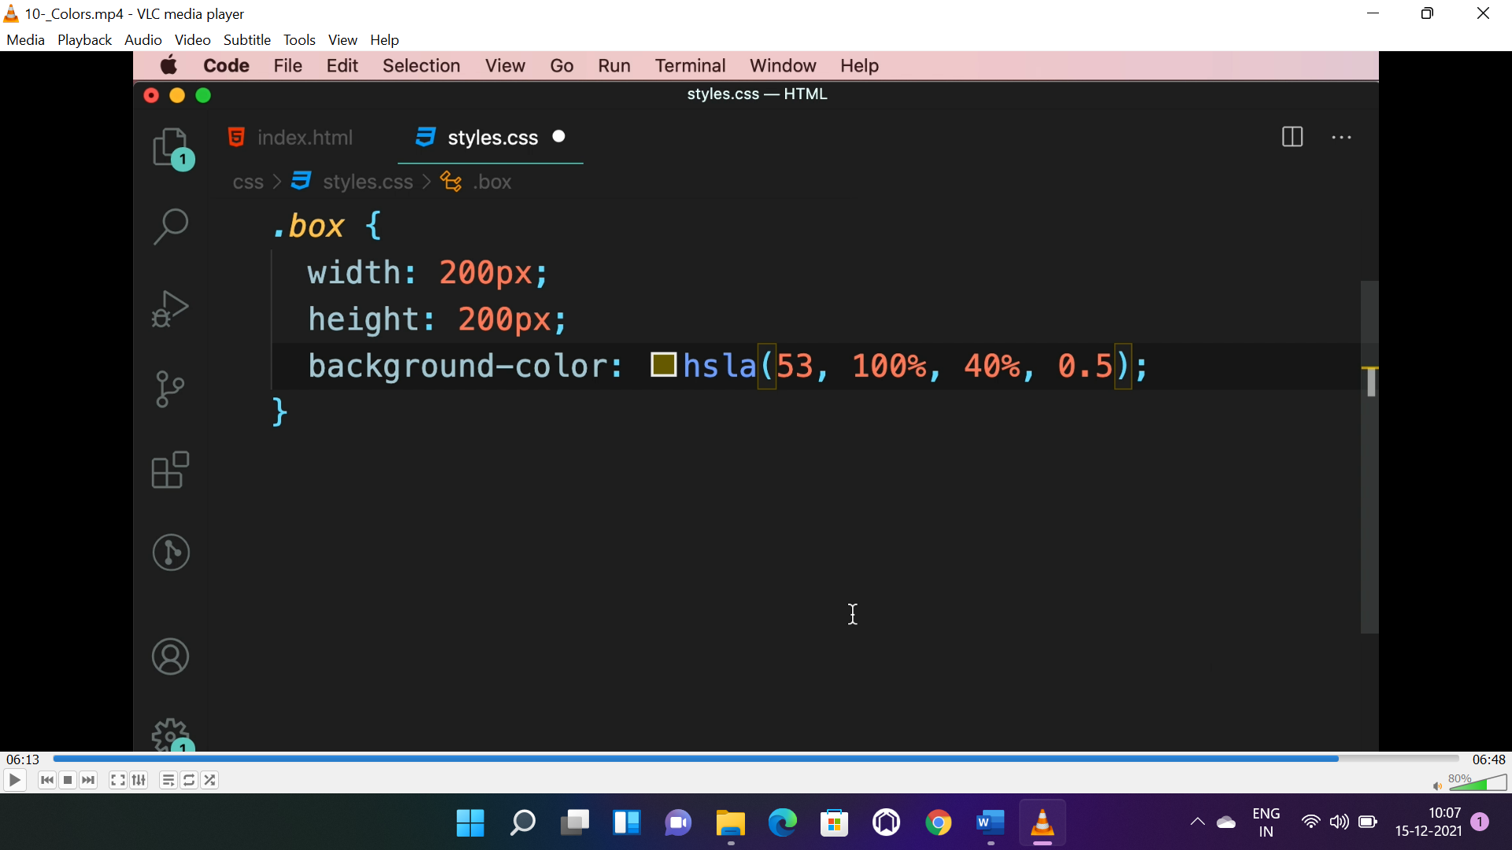

**HEXA DECIMAL:**

* Combination of number and letter. It can’t apply blur.

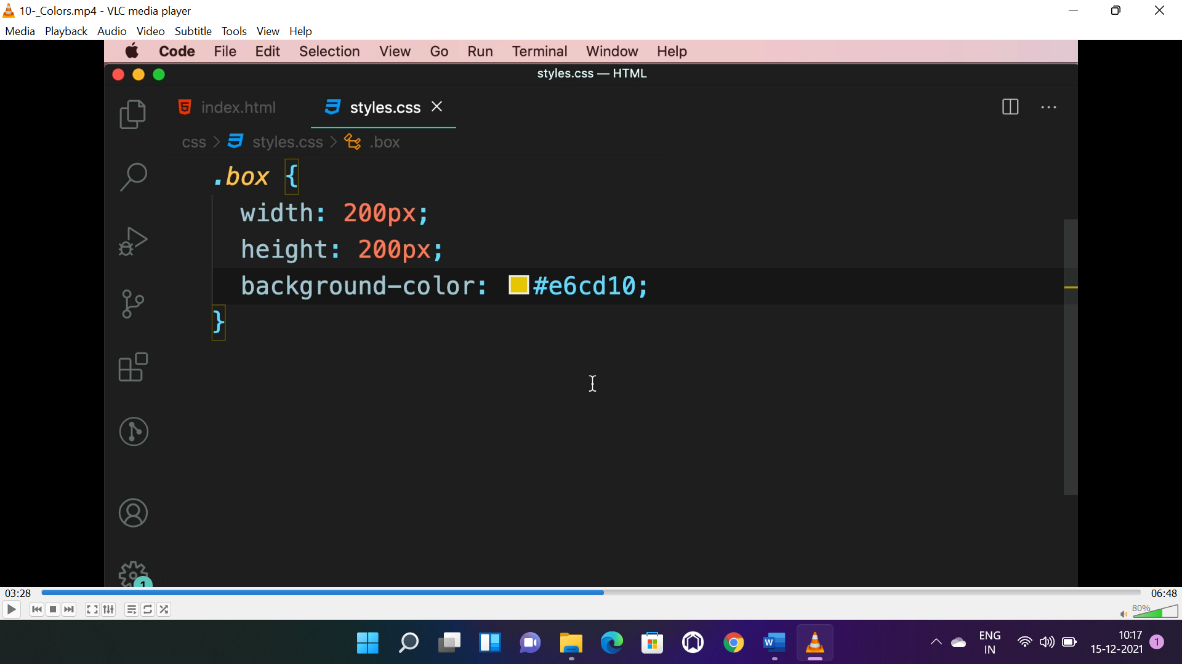

**GRADIENT:**

* Transition between two or more colours.
* Property: background-image or background.

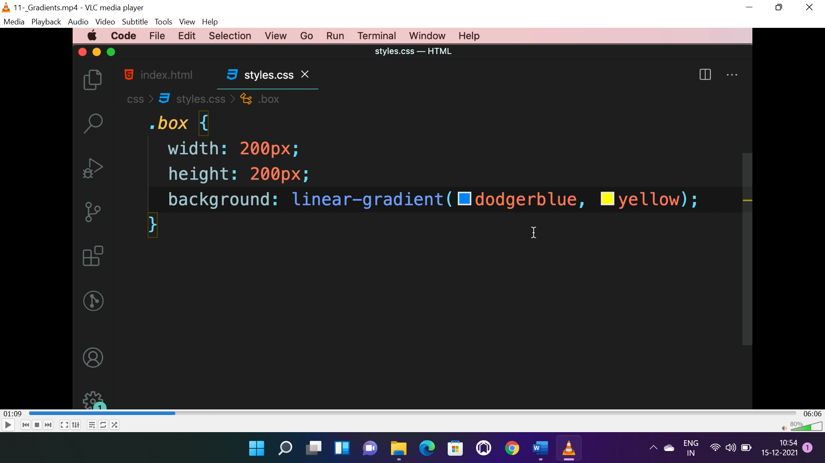

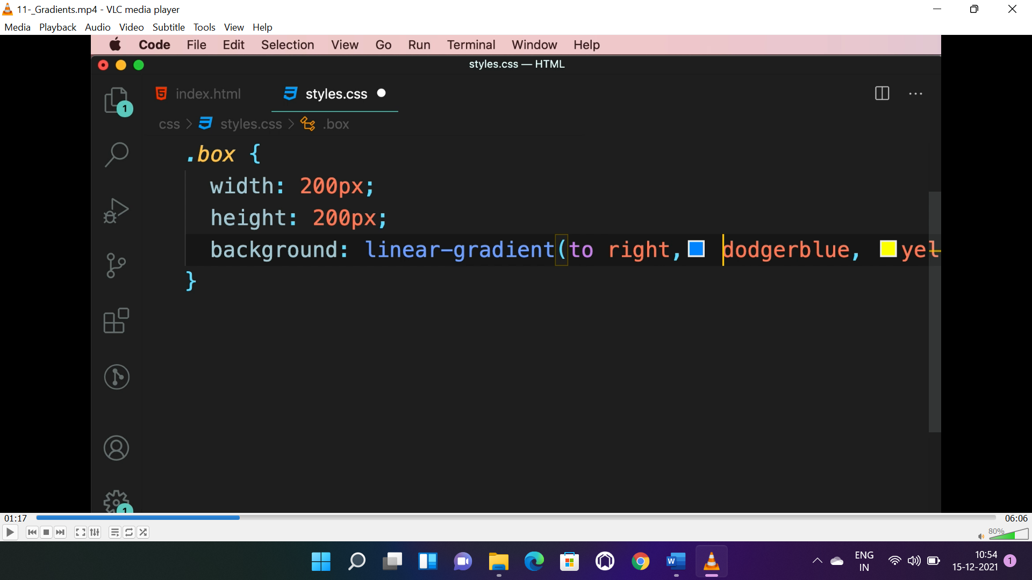

* To right=direction of gradient.

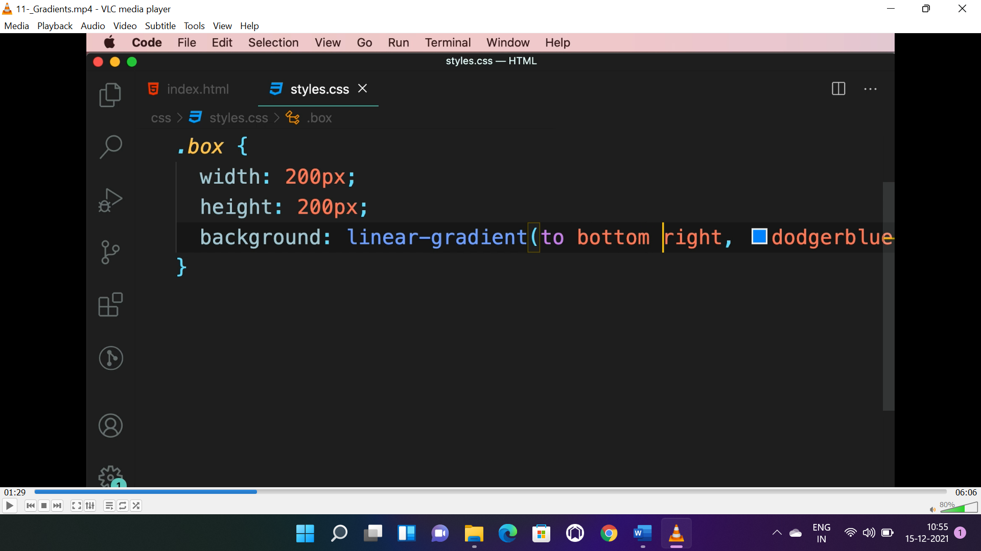

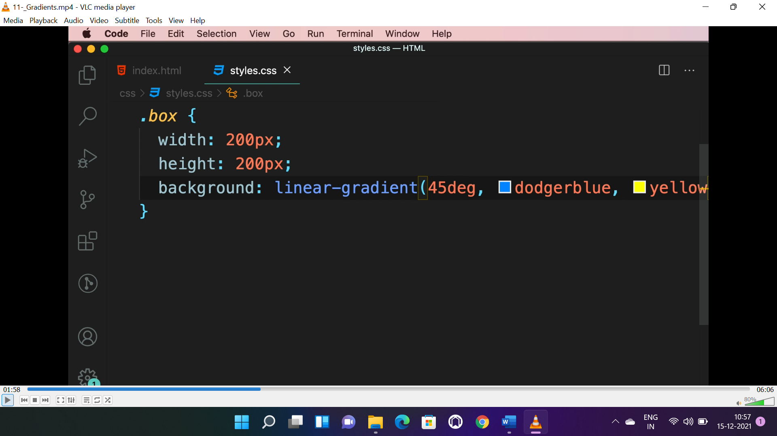

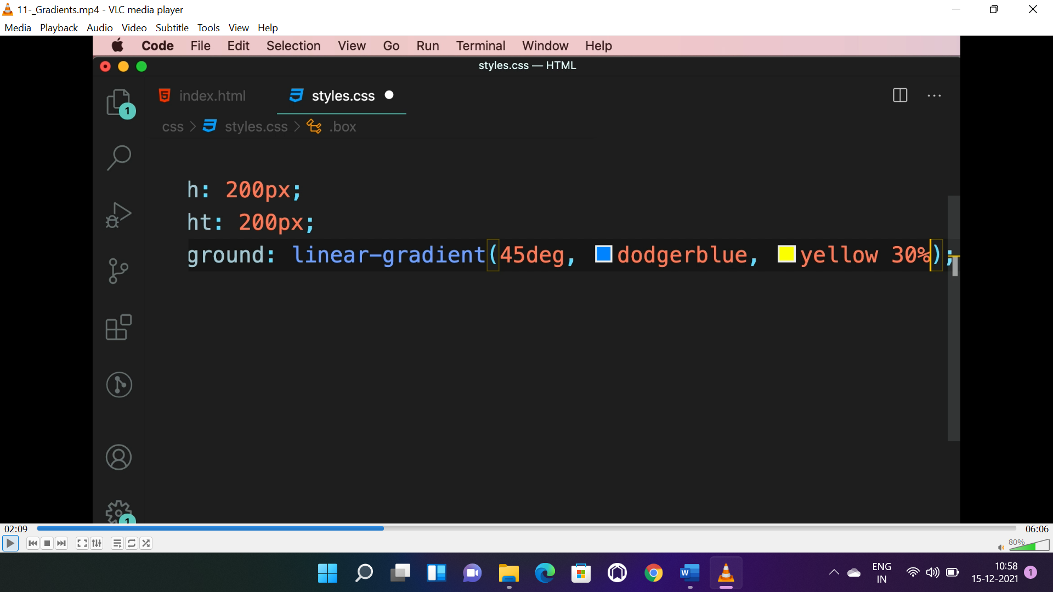

* Yellow will cover all except 30%.

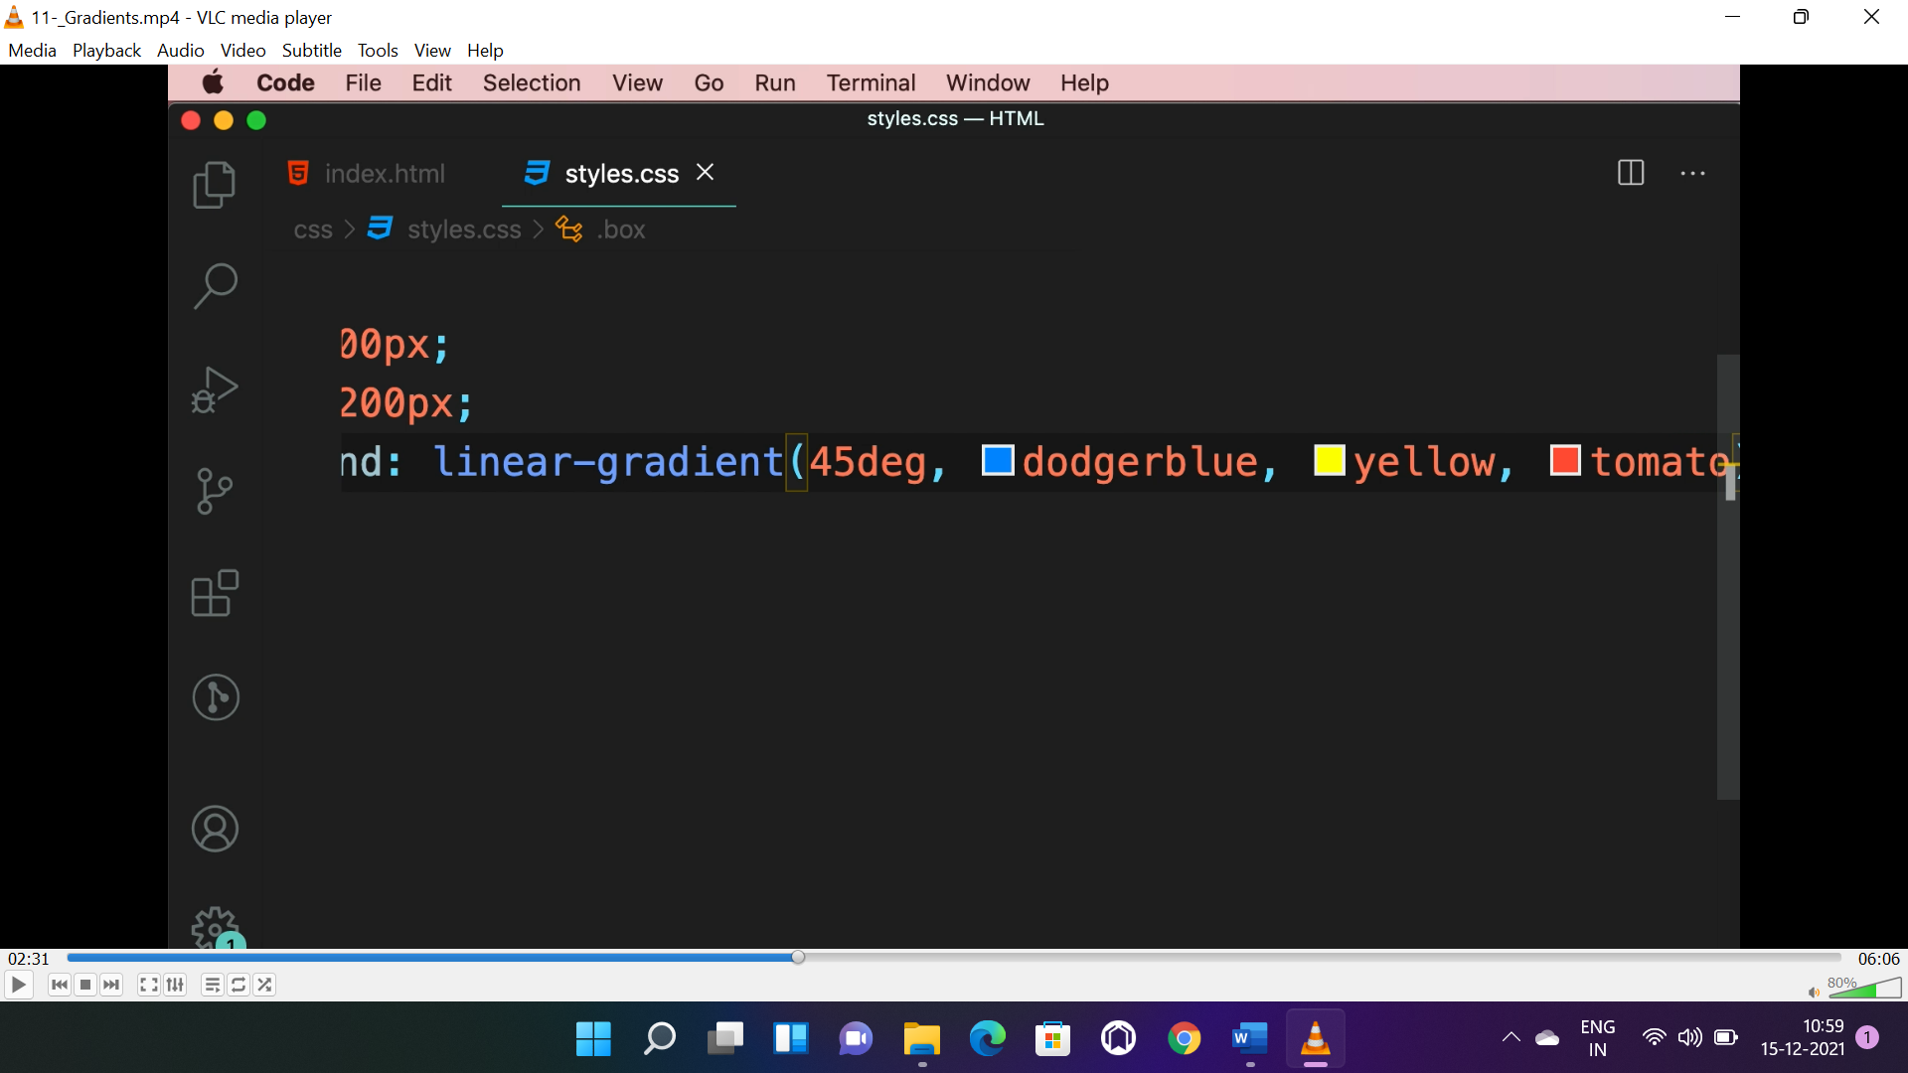

* Tomato is 3rd colour in the gradient.

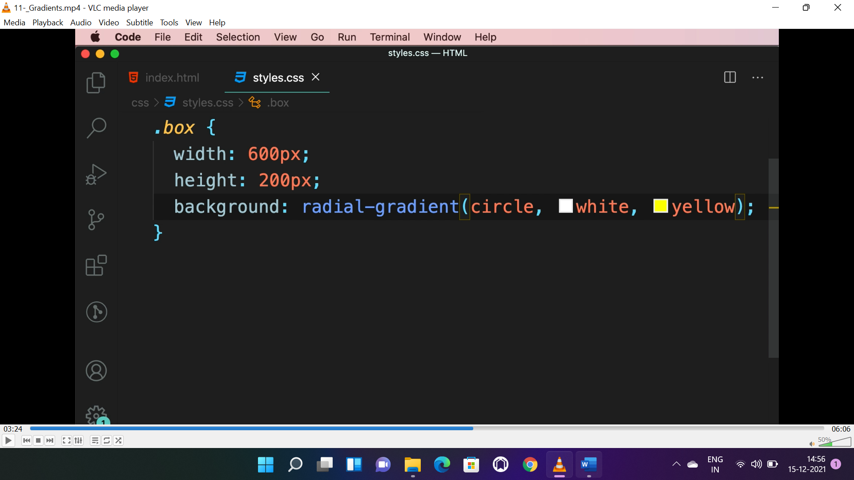

* Radial gradient is circular, “circle” as 1st parameter.

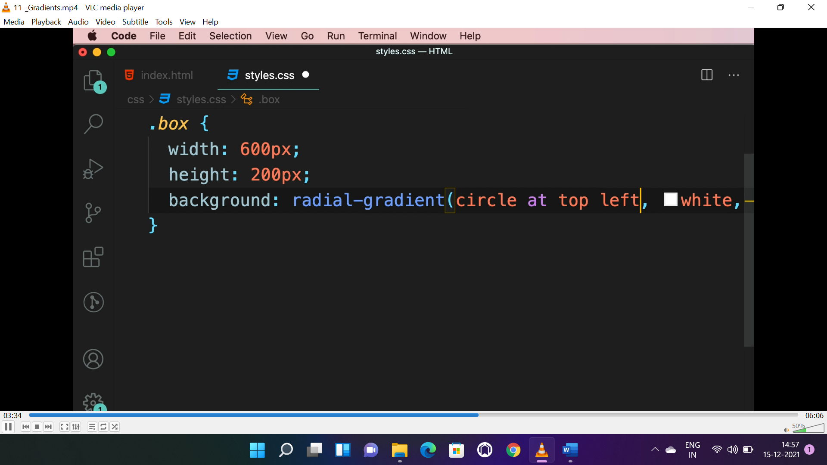

* Circle will be on top left.
* **To generate css gradient-> search “gradient generator”->cssgradient.io**

**BORDER: (props: border, border-radius)**

* 3 properties to be given, size, type, colour.

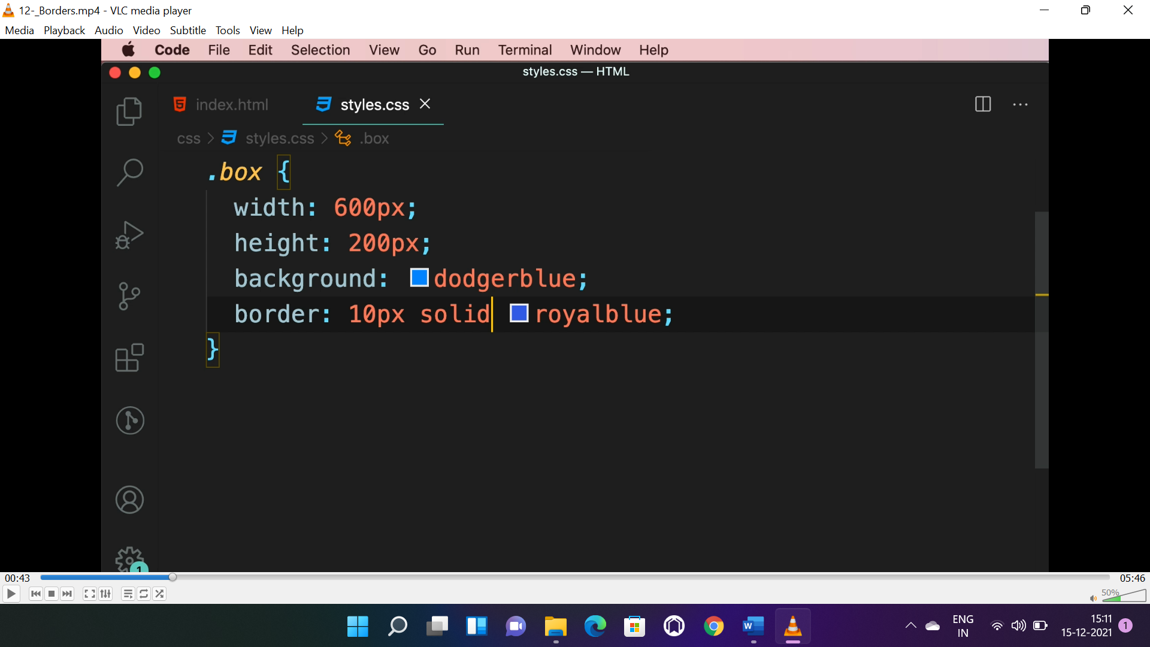

* Type can be solid, dotted, dashed etc..

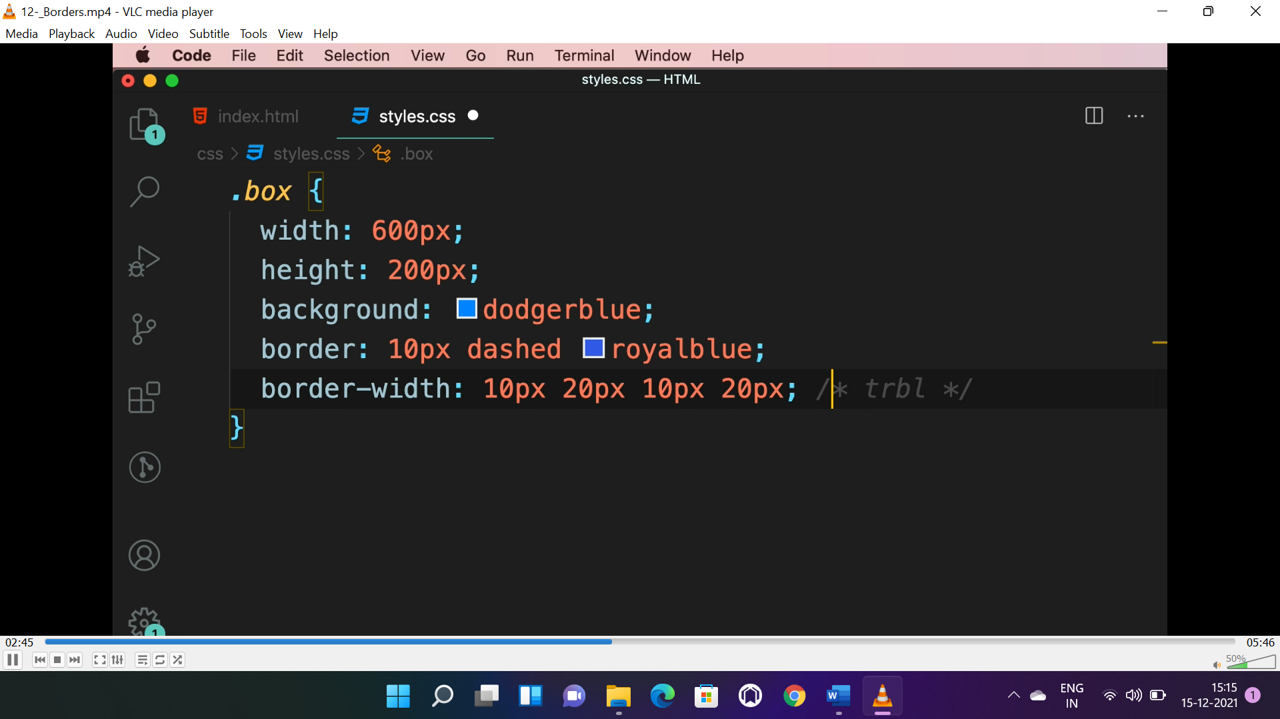

* The order for “border-width” is top->right->bottom->left.
* Similarly we have “border-top”, “border-right”, “border-bottom” and “border-left” properties.
* Similarly we have “border-style” and “border-colour” property.

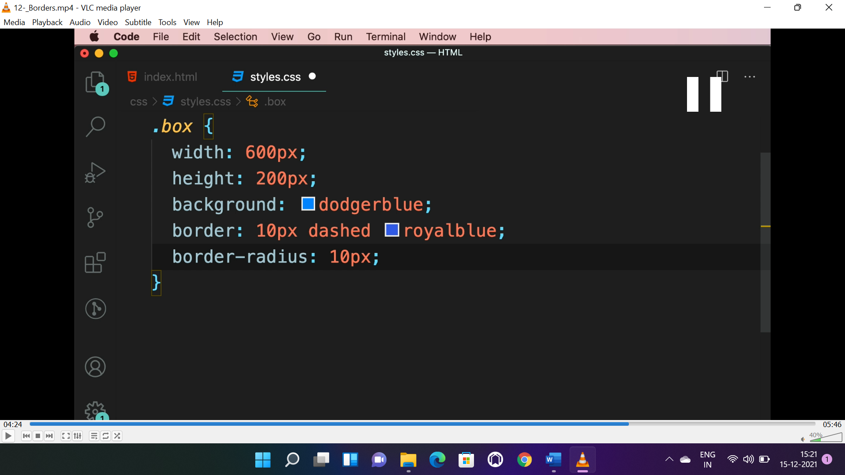

* **To make the corners round “border-radius” property is used.**
* To make complete circle “border-radius” should be 100%.
* For more shapes search “css shapes”->css-tricks.com

**SHADOW: (prop: box-shadow, text-shadow)**

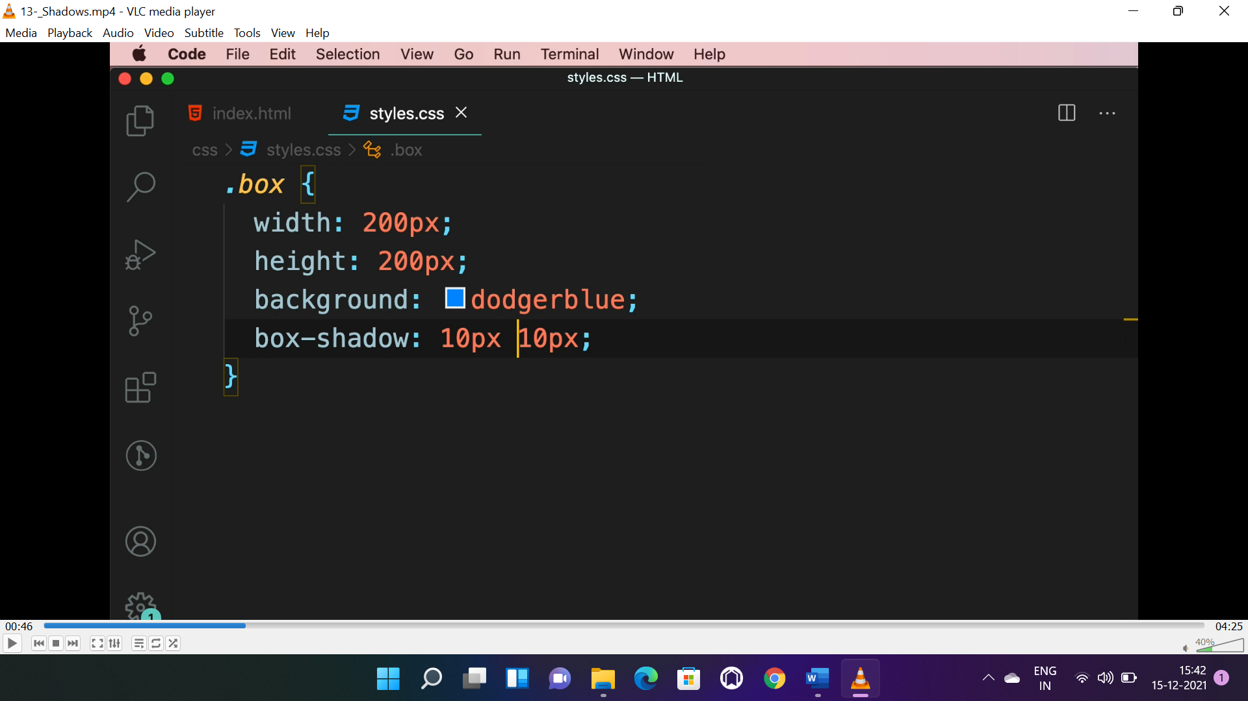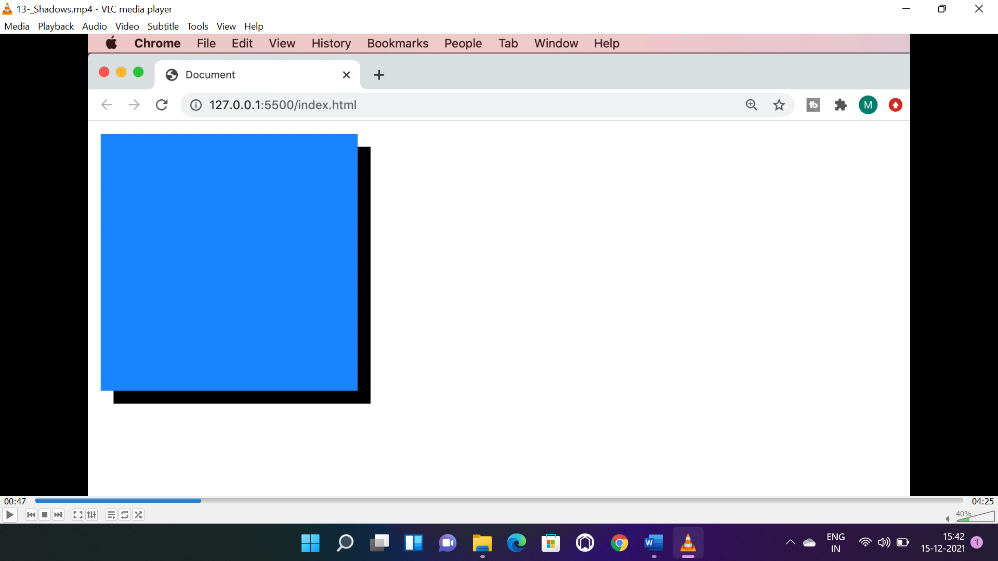

* “box-shadow” property for container shadow.
* 1st 10px is for right and 2nd for down shadow.

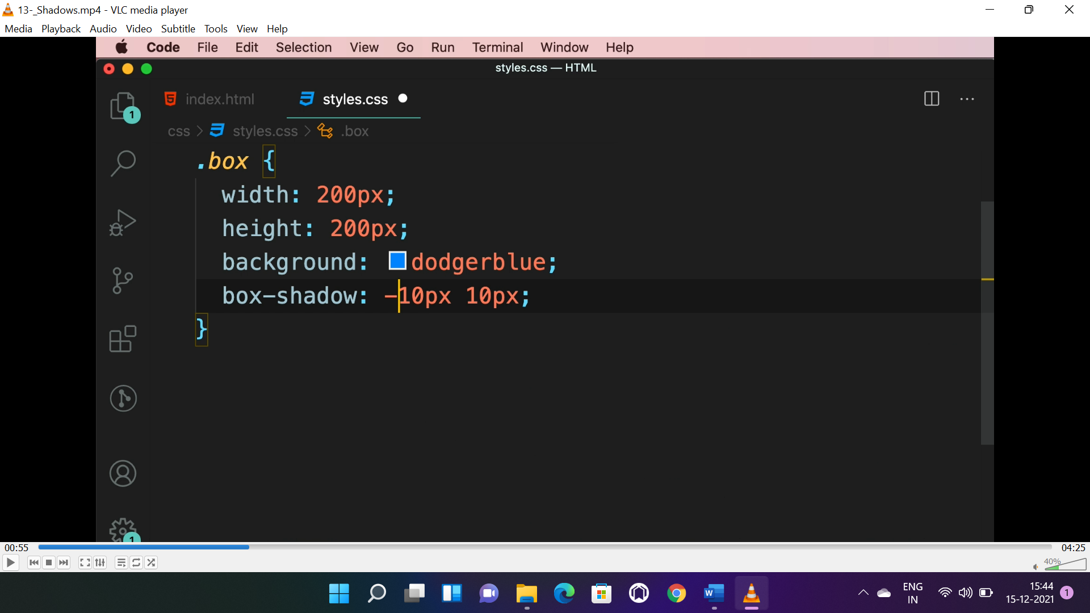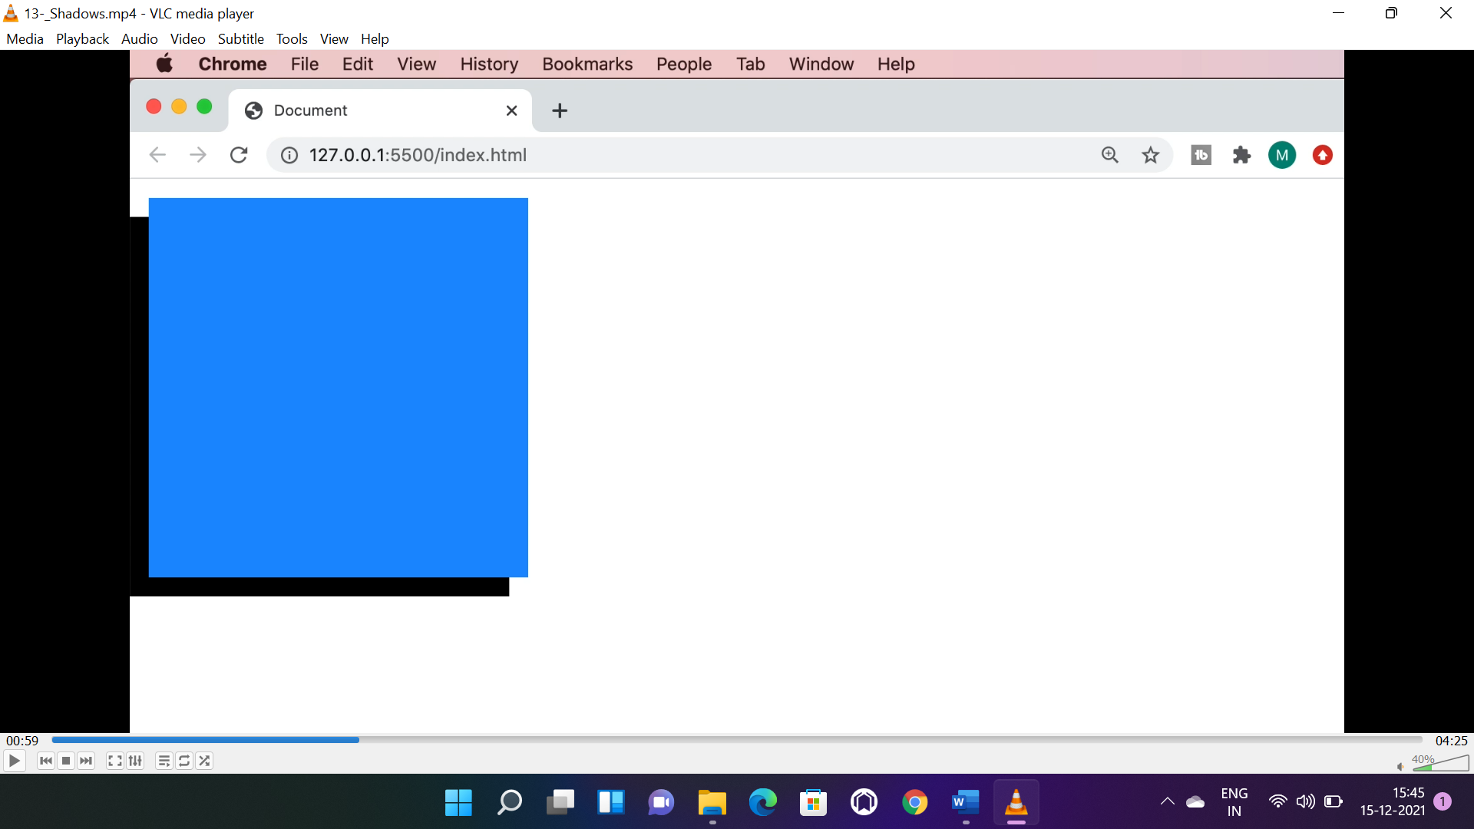

* -10px will move shadow to left and 2nd -10px will move shadow to top.

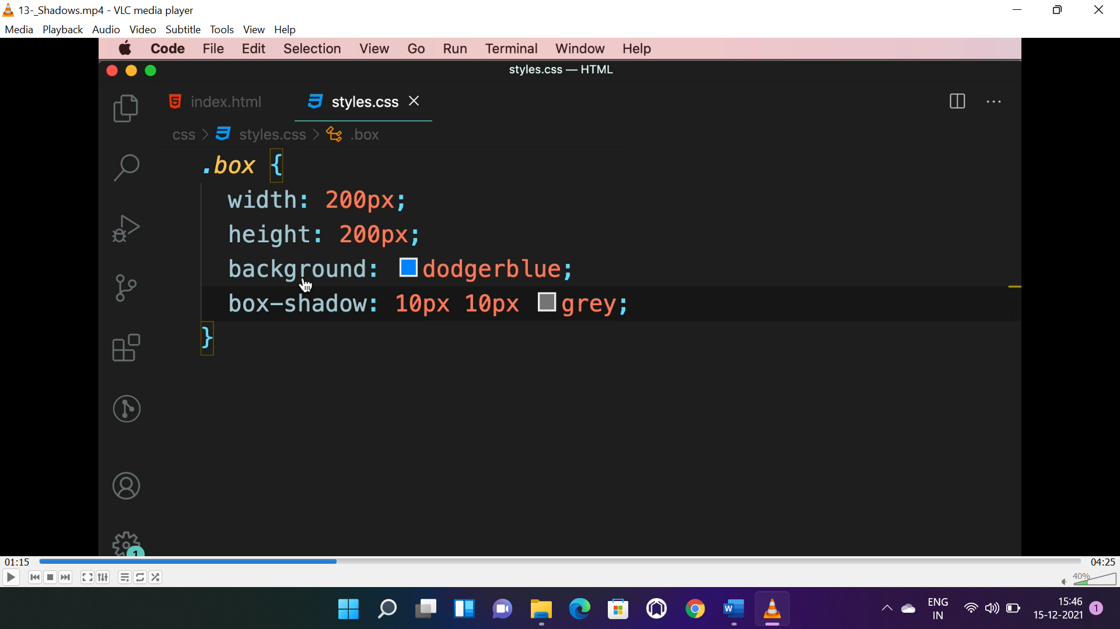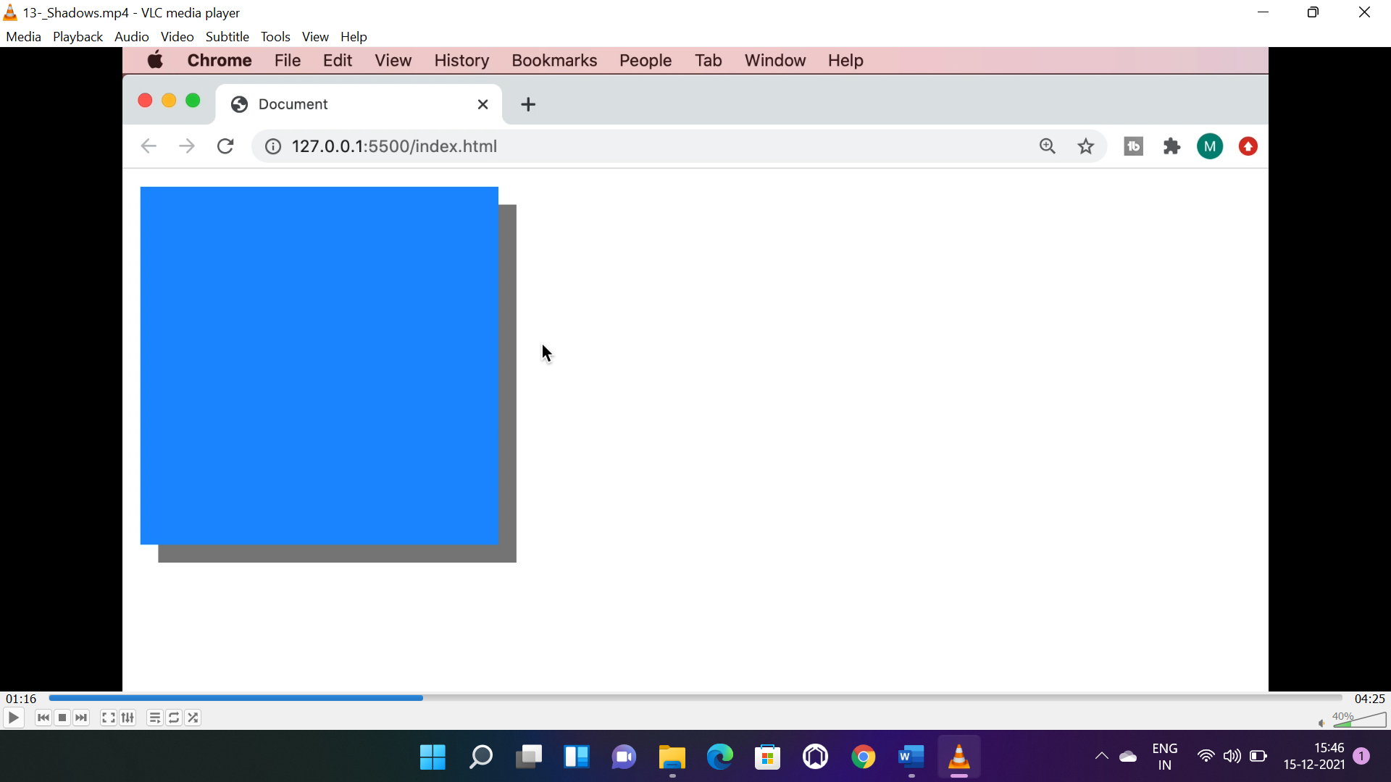

* Grey is colour of shadow.

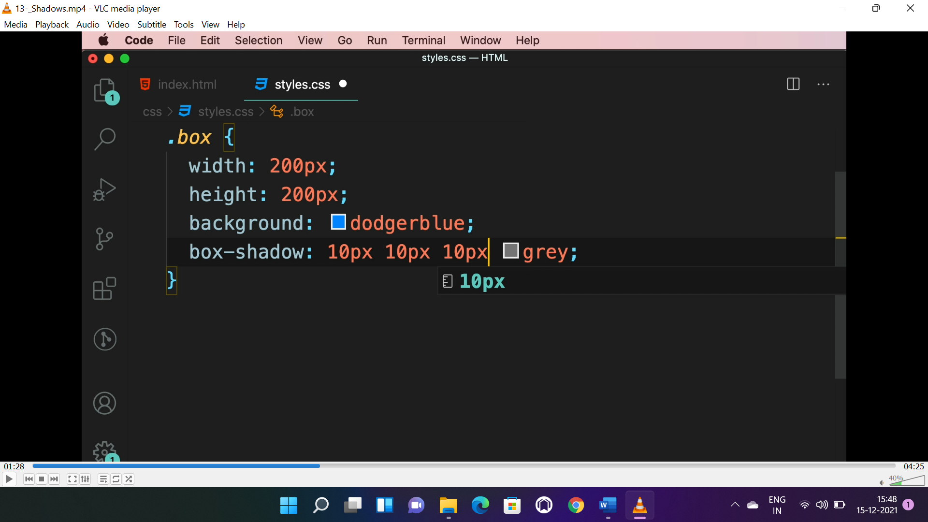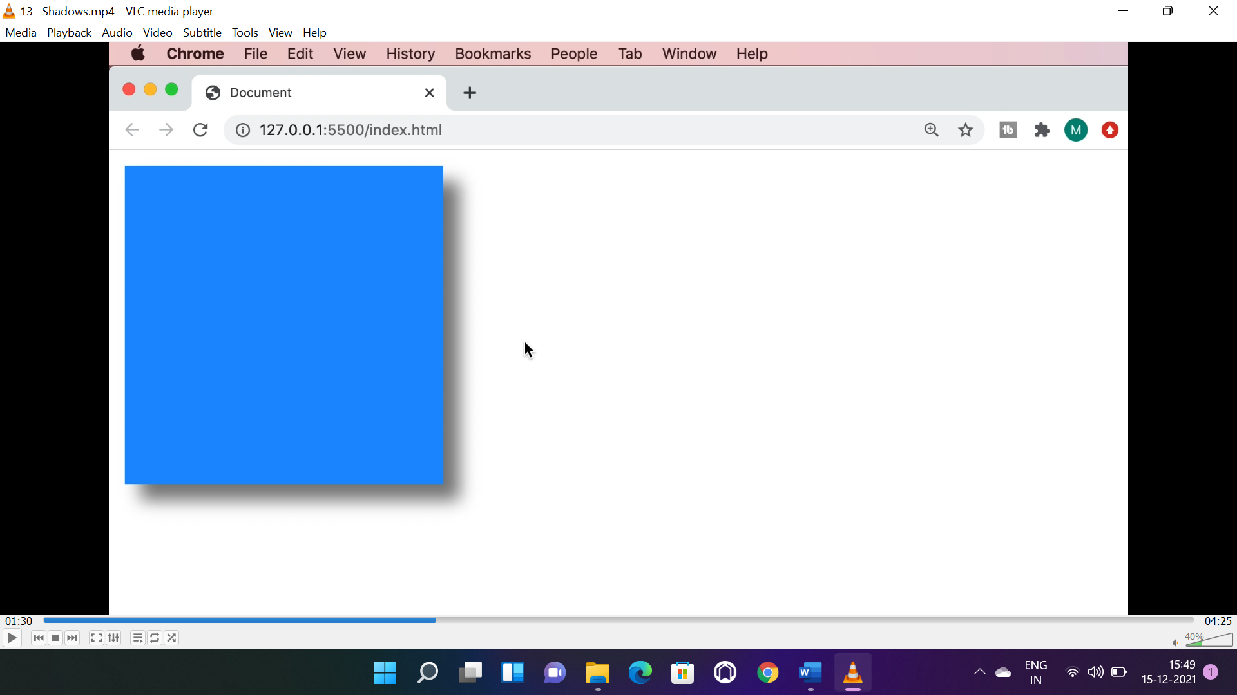

* 3rd 10px is for blurring the shadow.

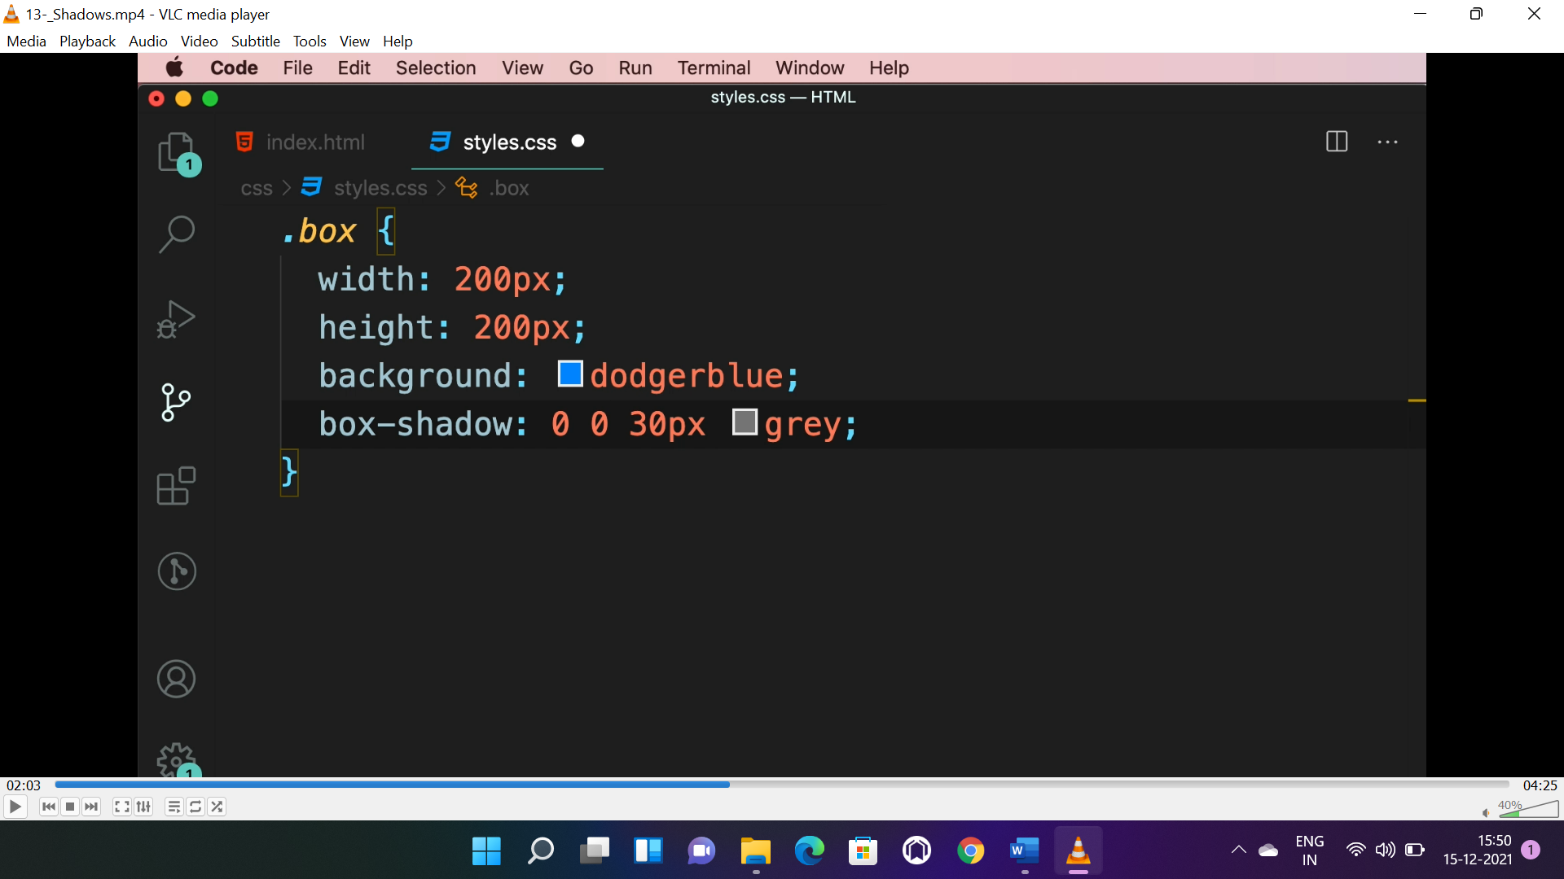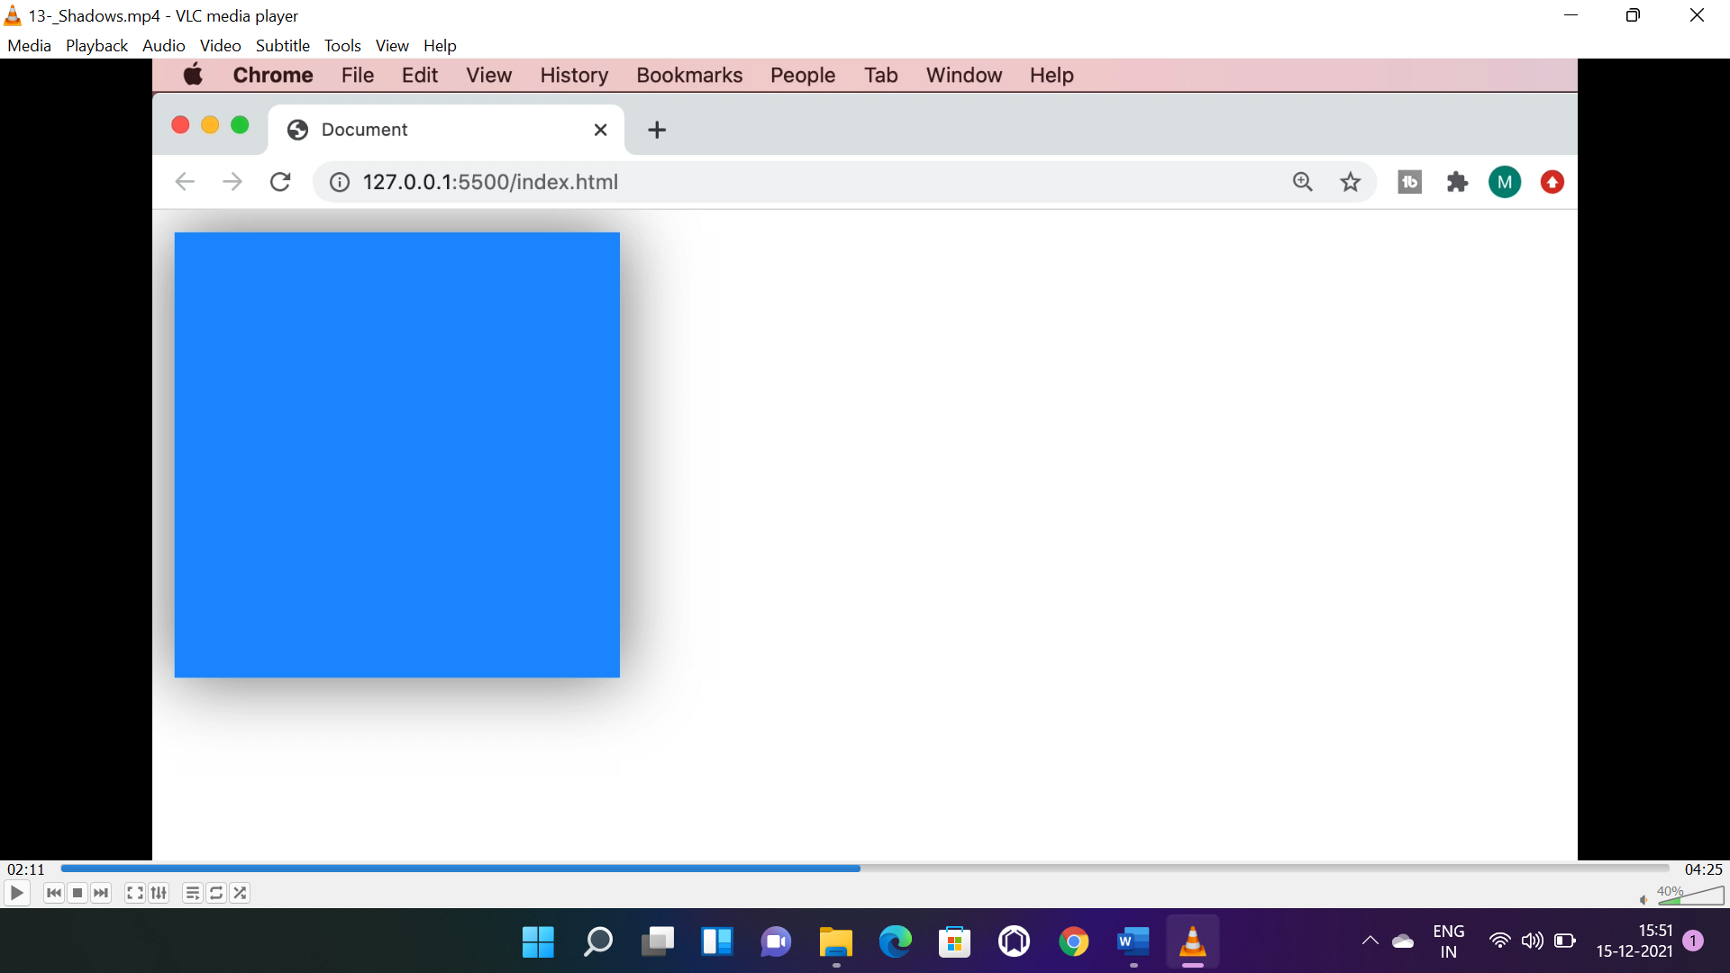

* 1st and 2nd zero is to keep shadow under the box, 30px is for blurring.

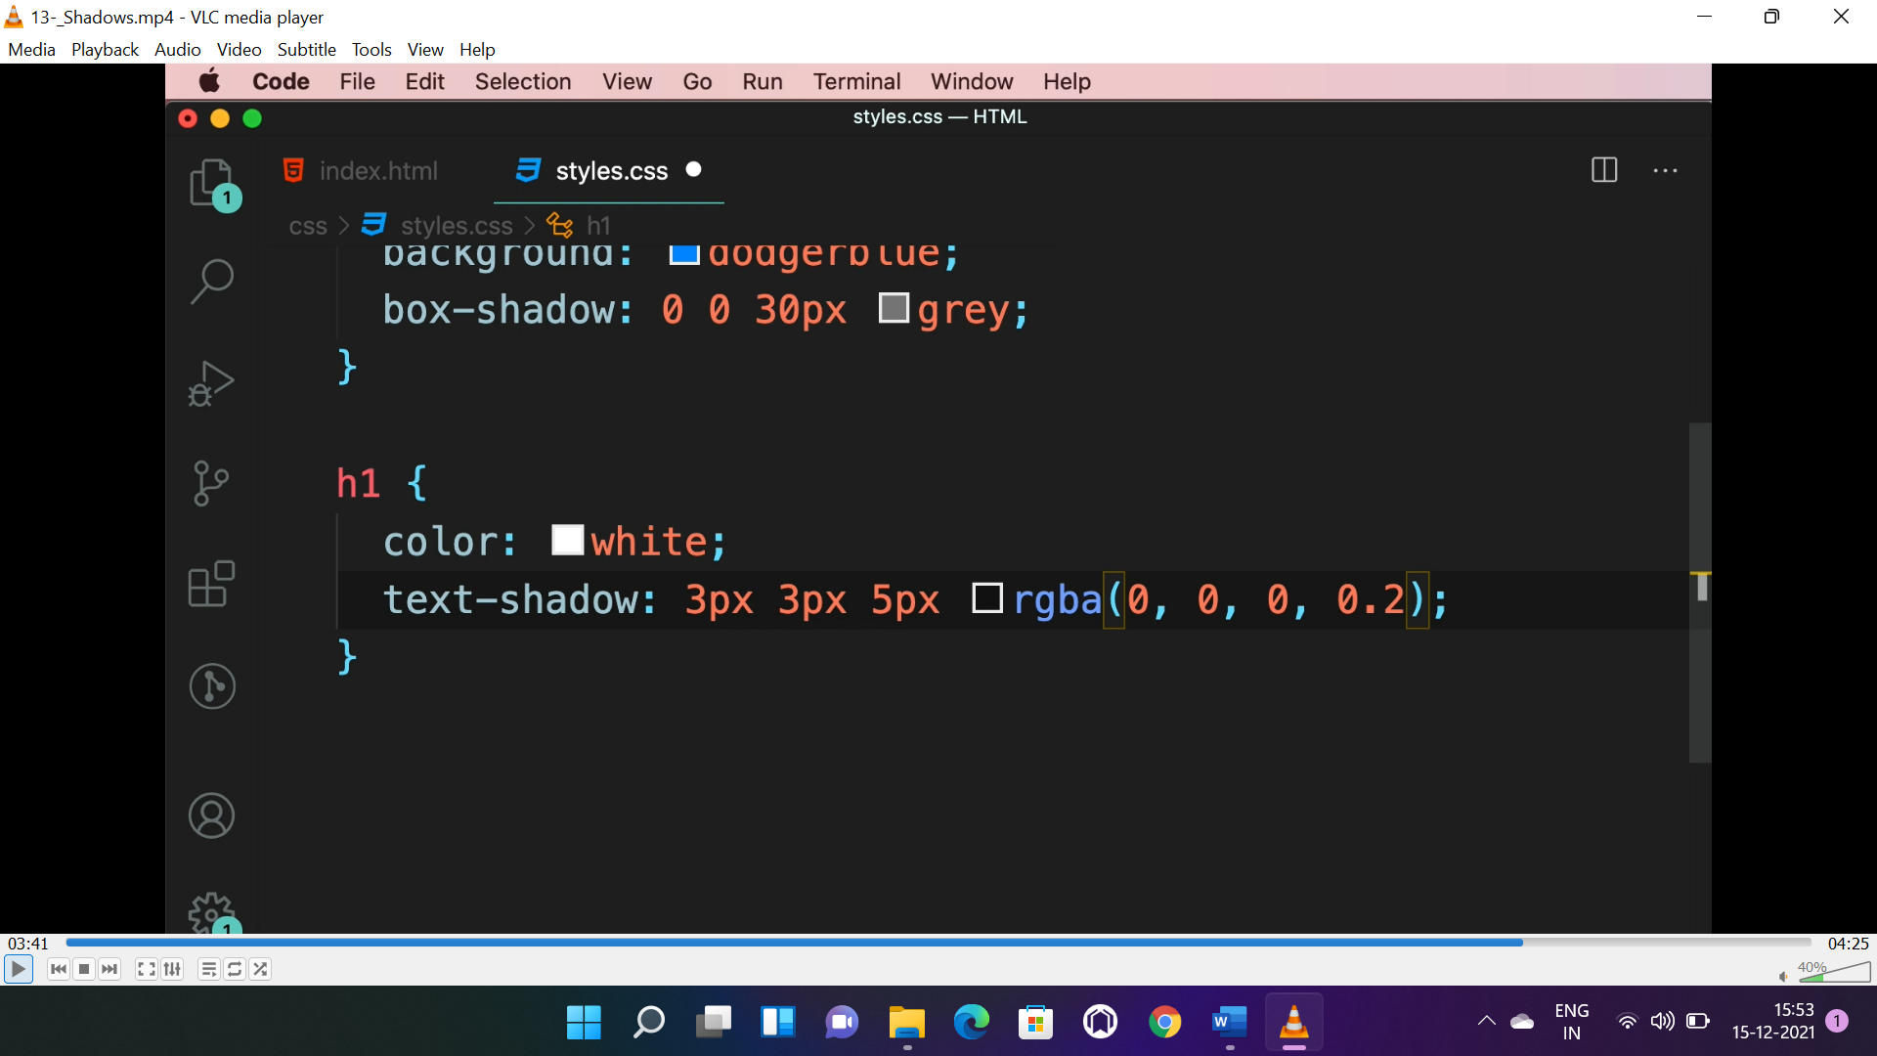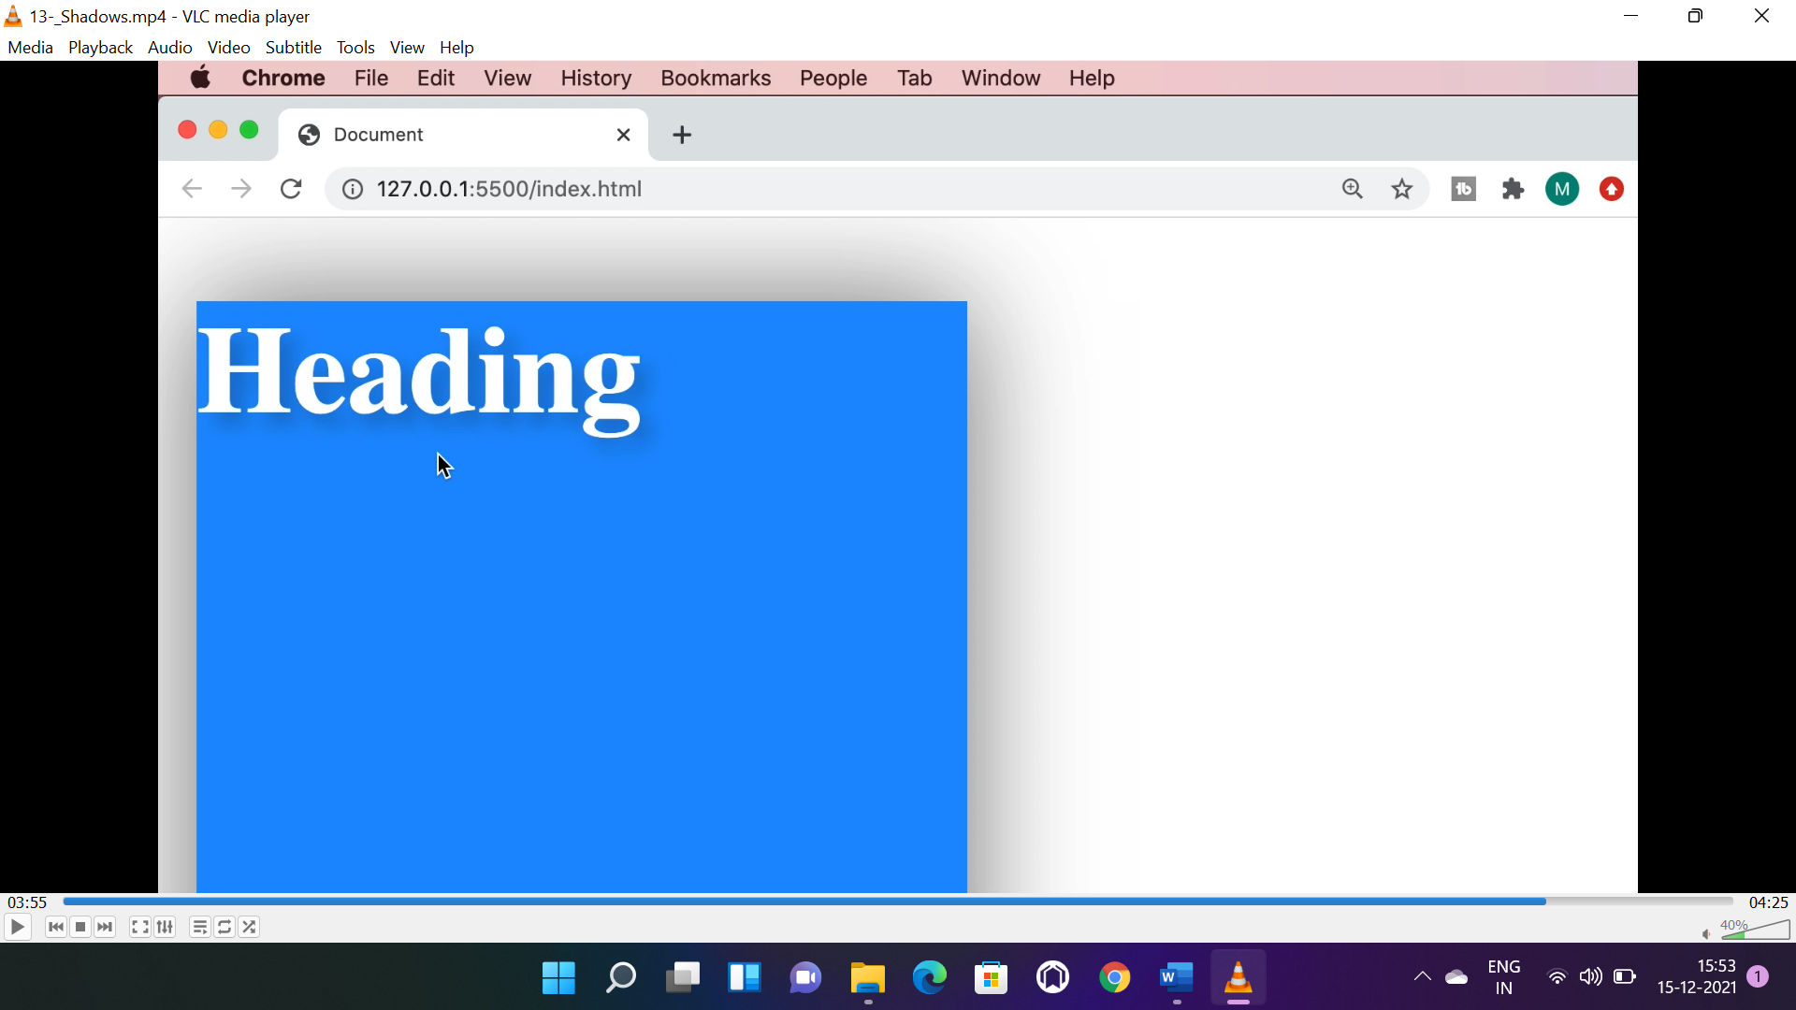

* “text-shadow” is for text shadowing, rgba(0, 0, 0, 0.2) is for black with “0.2” transparency to blend shadow properly with all colours.

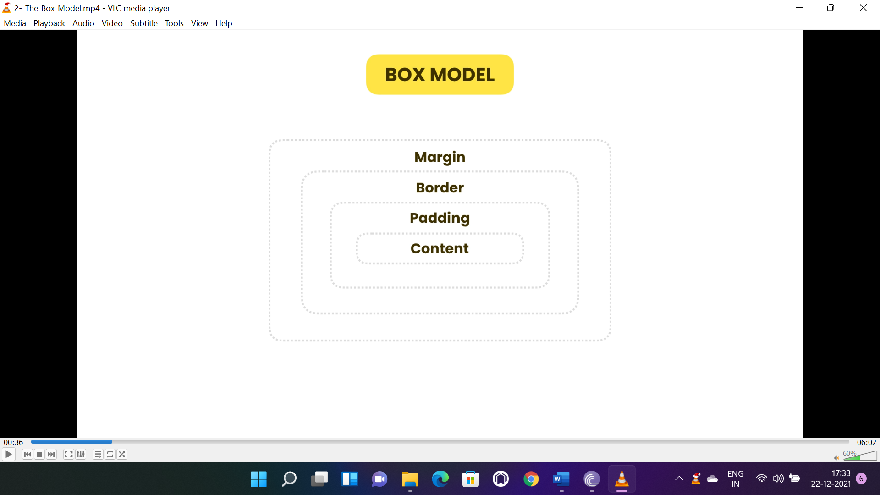

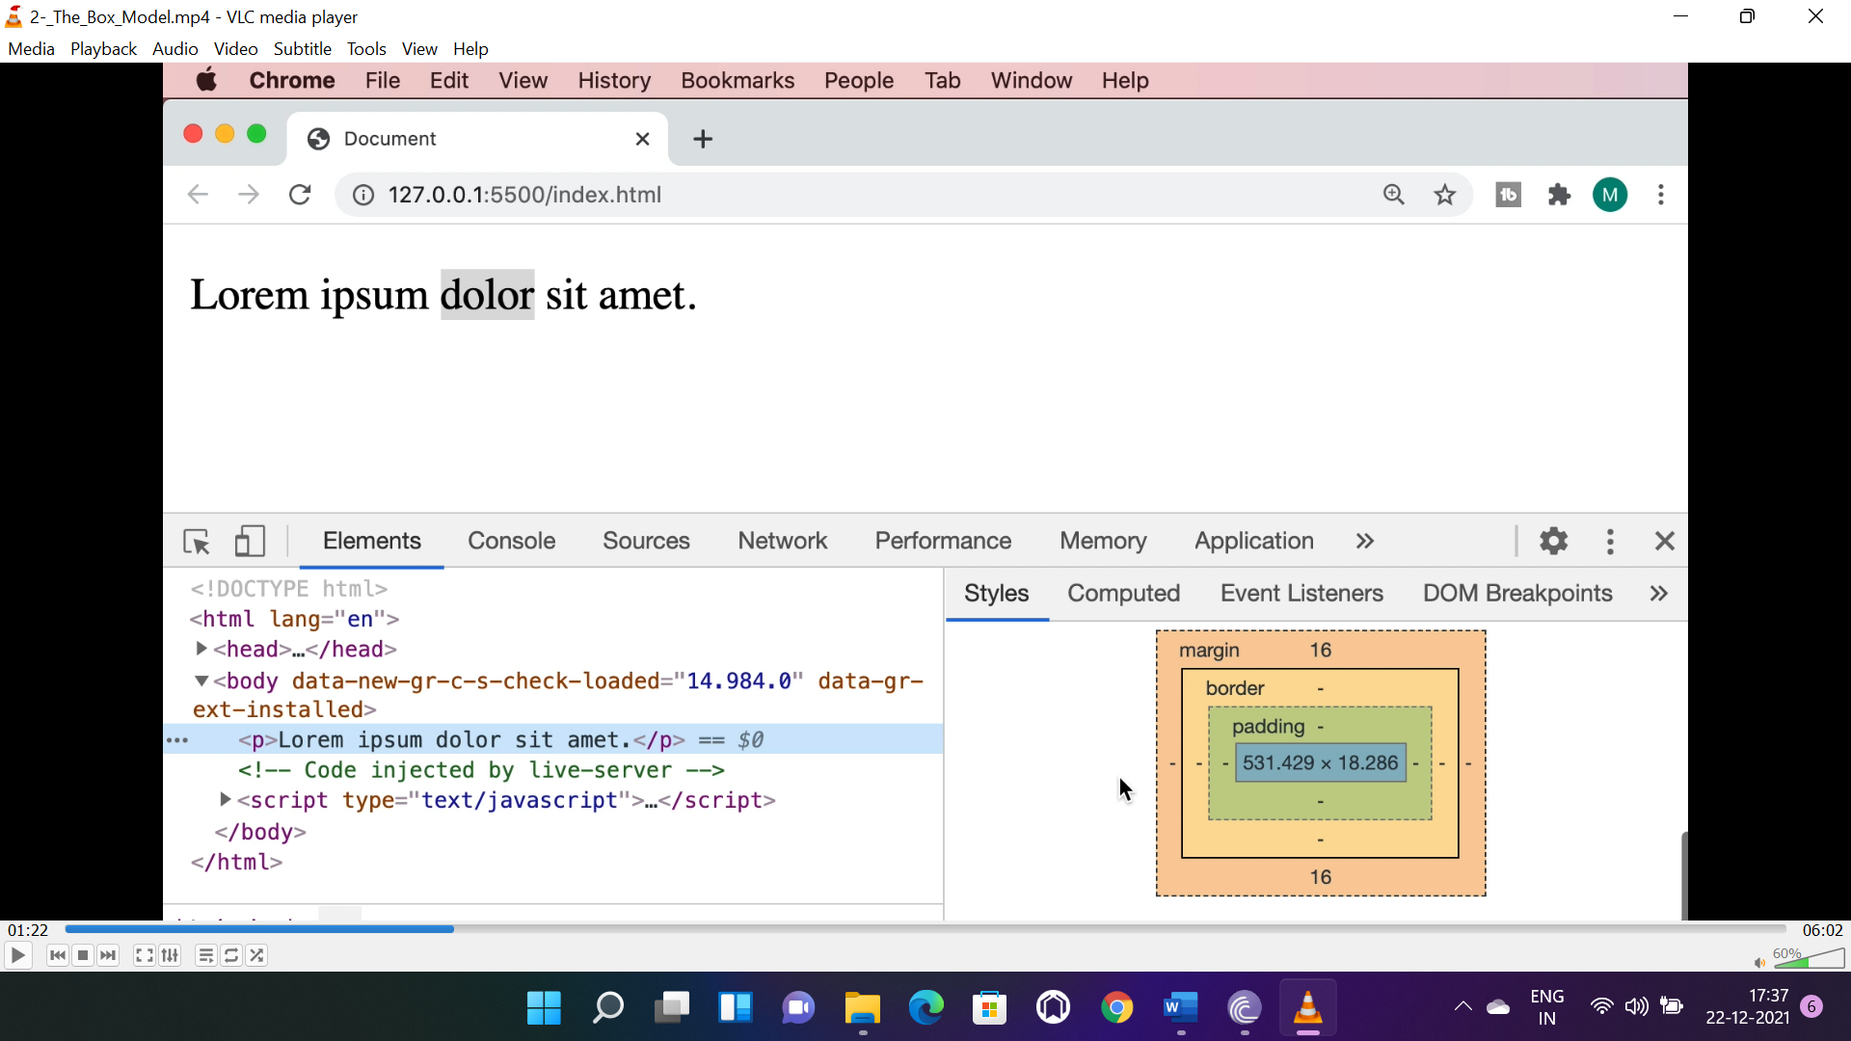

The area between content and border is called as “**padding**”, the area between border and next element is called margin. Content, padding, border, margin together called the box model.

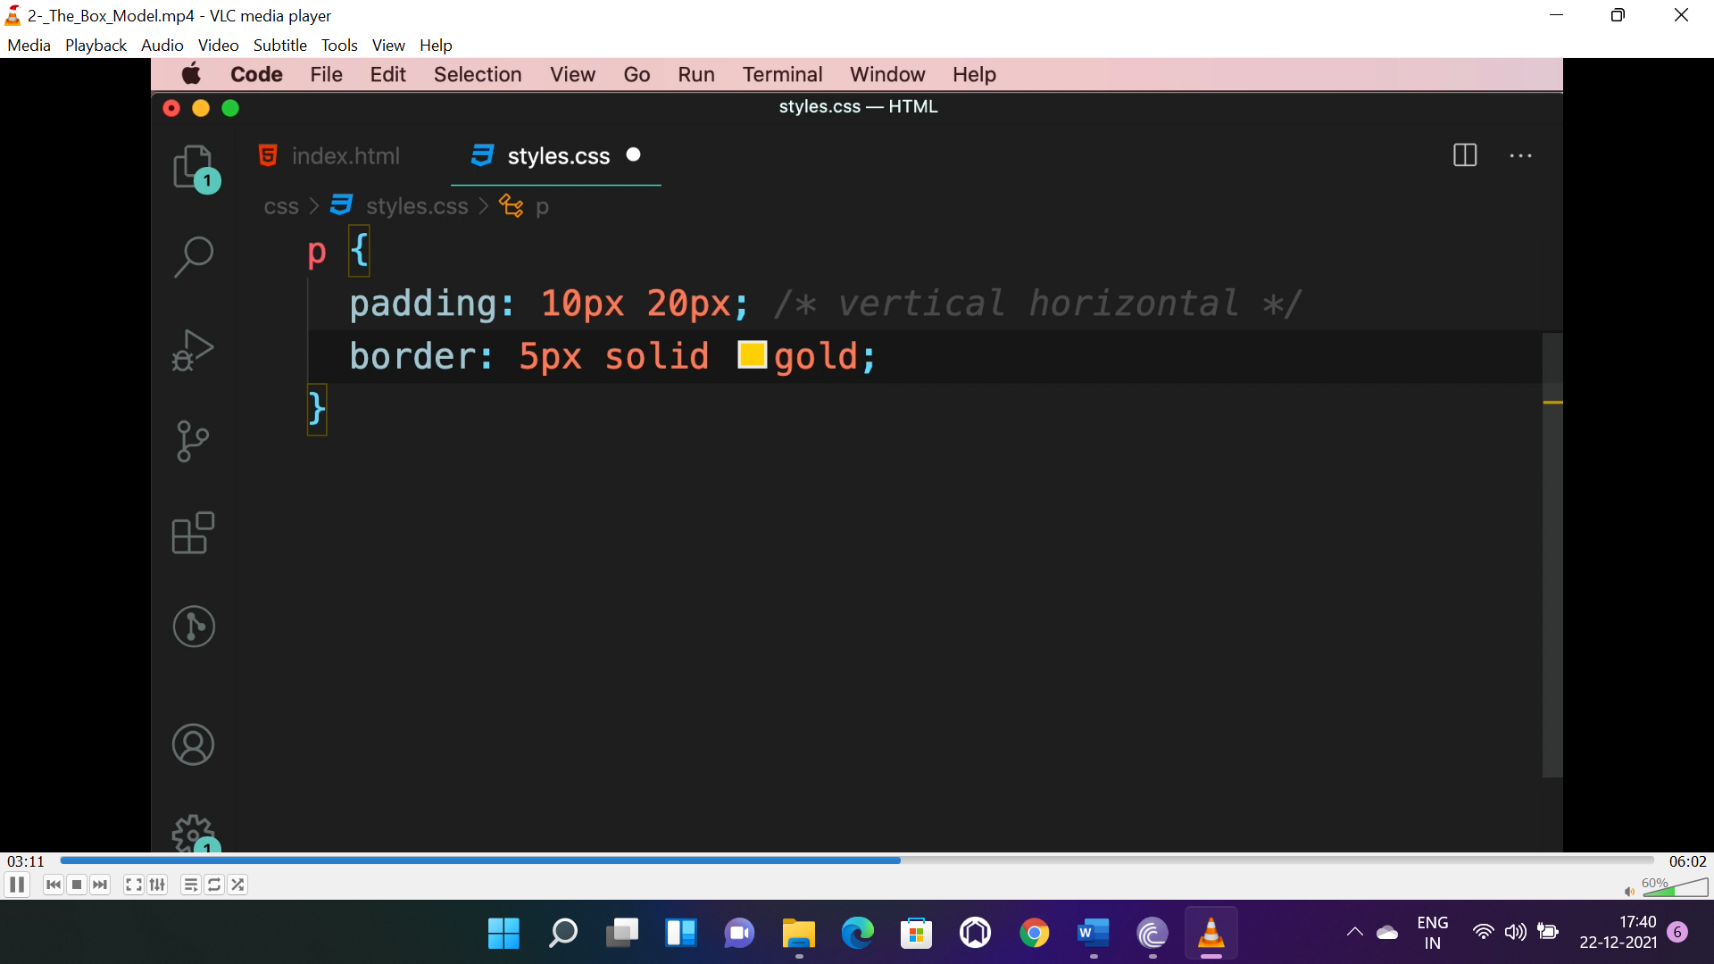

* Margin property two elements side by side or one below one collapse to one margin, where padding doesn’t.

**BOX-SIZING:**

* When we apply “**padding**”, “**border**” on a box, box size will increase(problematic).
* So to avoid it and make box sizing remain same even after applying “**padding**” and “**border**”, we need to use “**box-sizing**” property with “**border-box**” value, which is “**content-box**” by default.
* We can use universal selector to set all box value to “**content-box**”(recomanded).

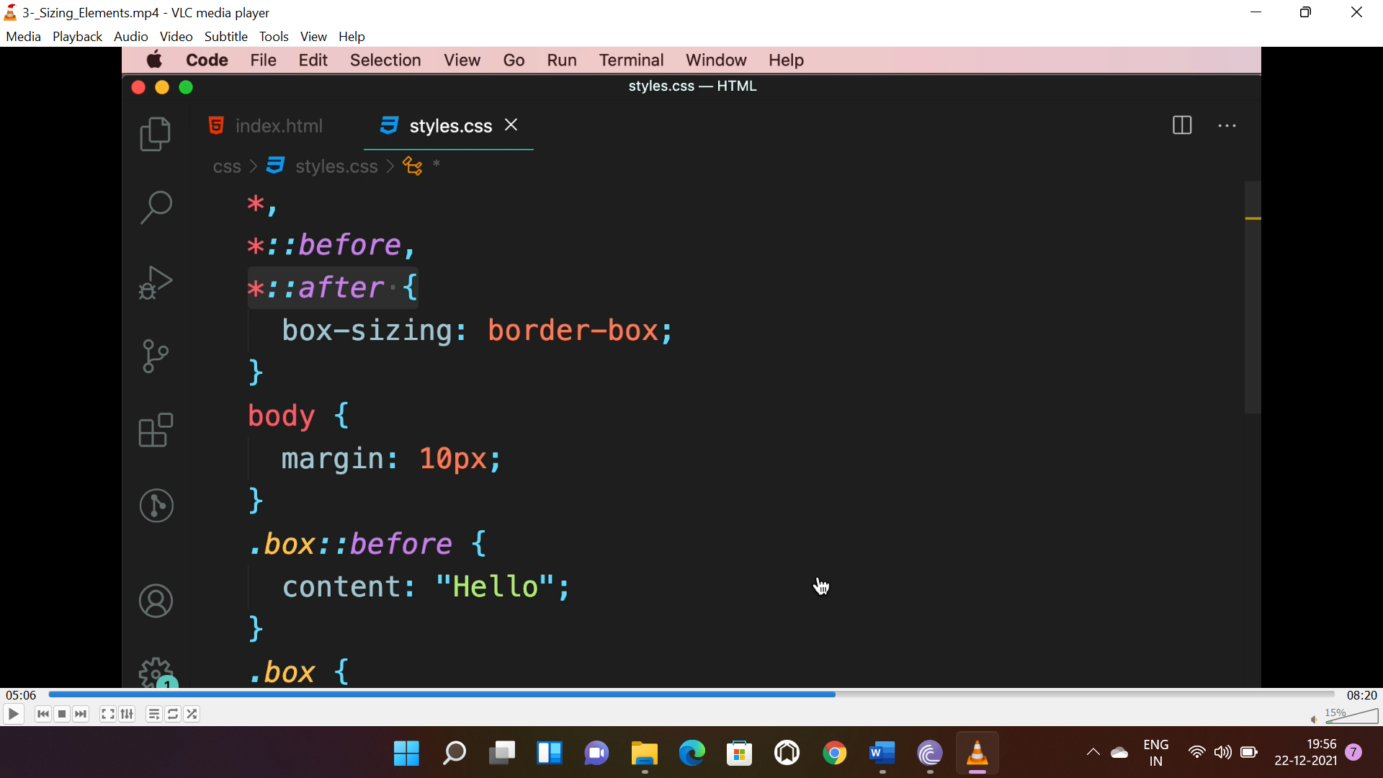

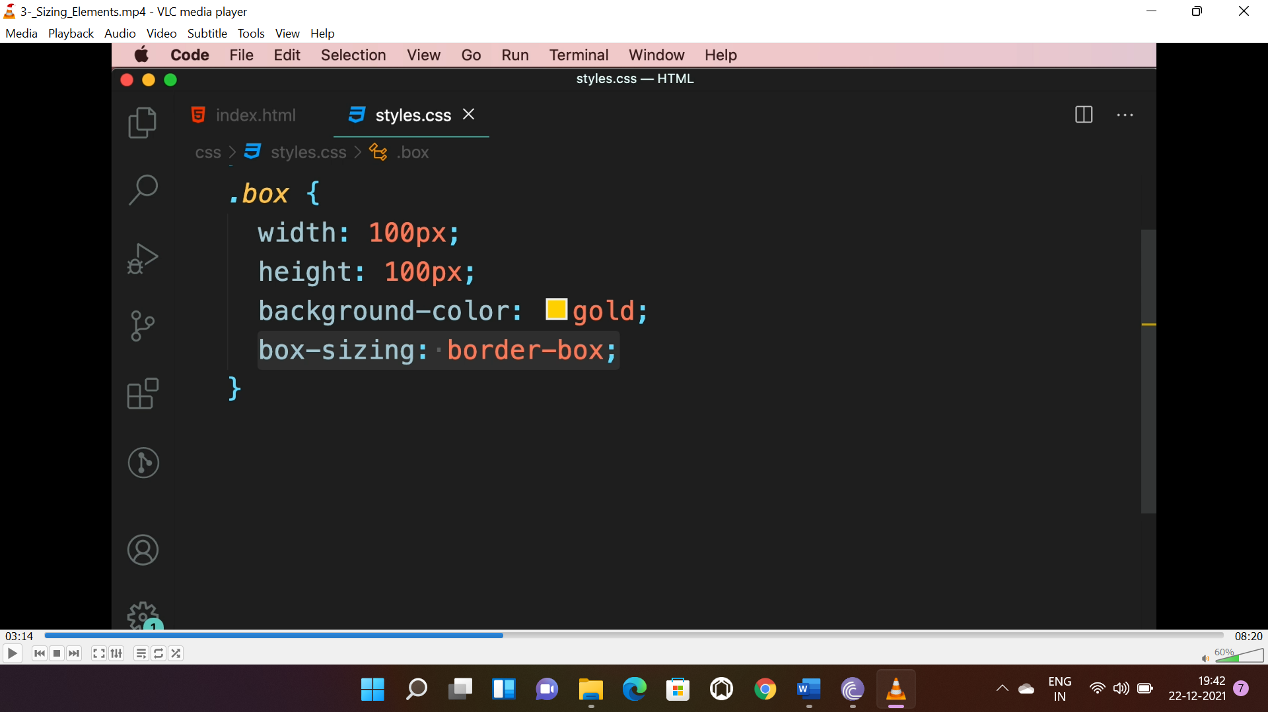

* Inline elements <span> don’t obey hight and width(dimension), so to apply dimension we use “**display**”: “**inline-block**”.

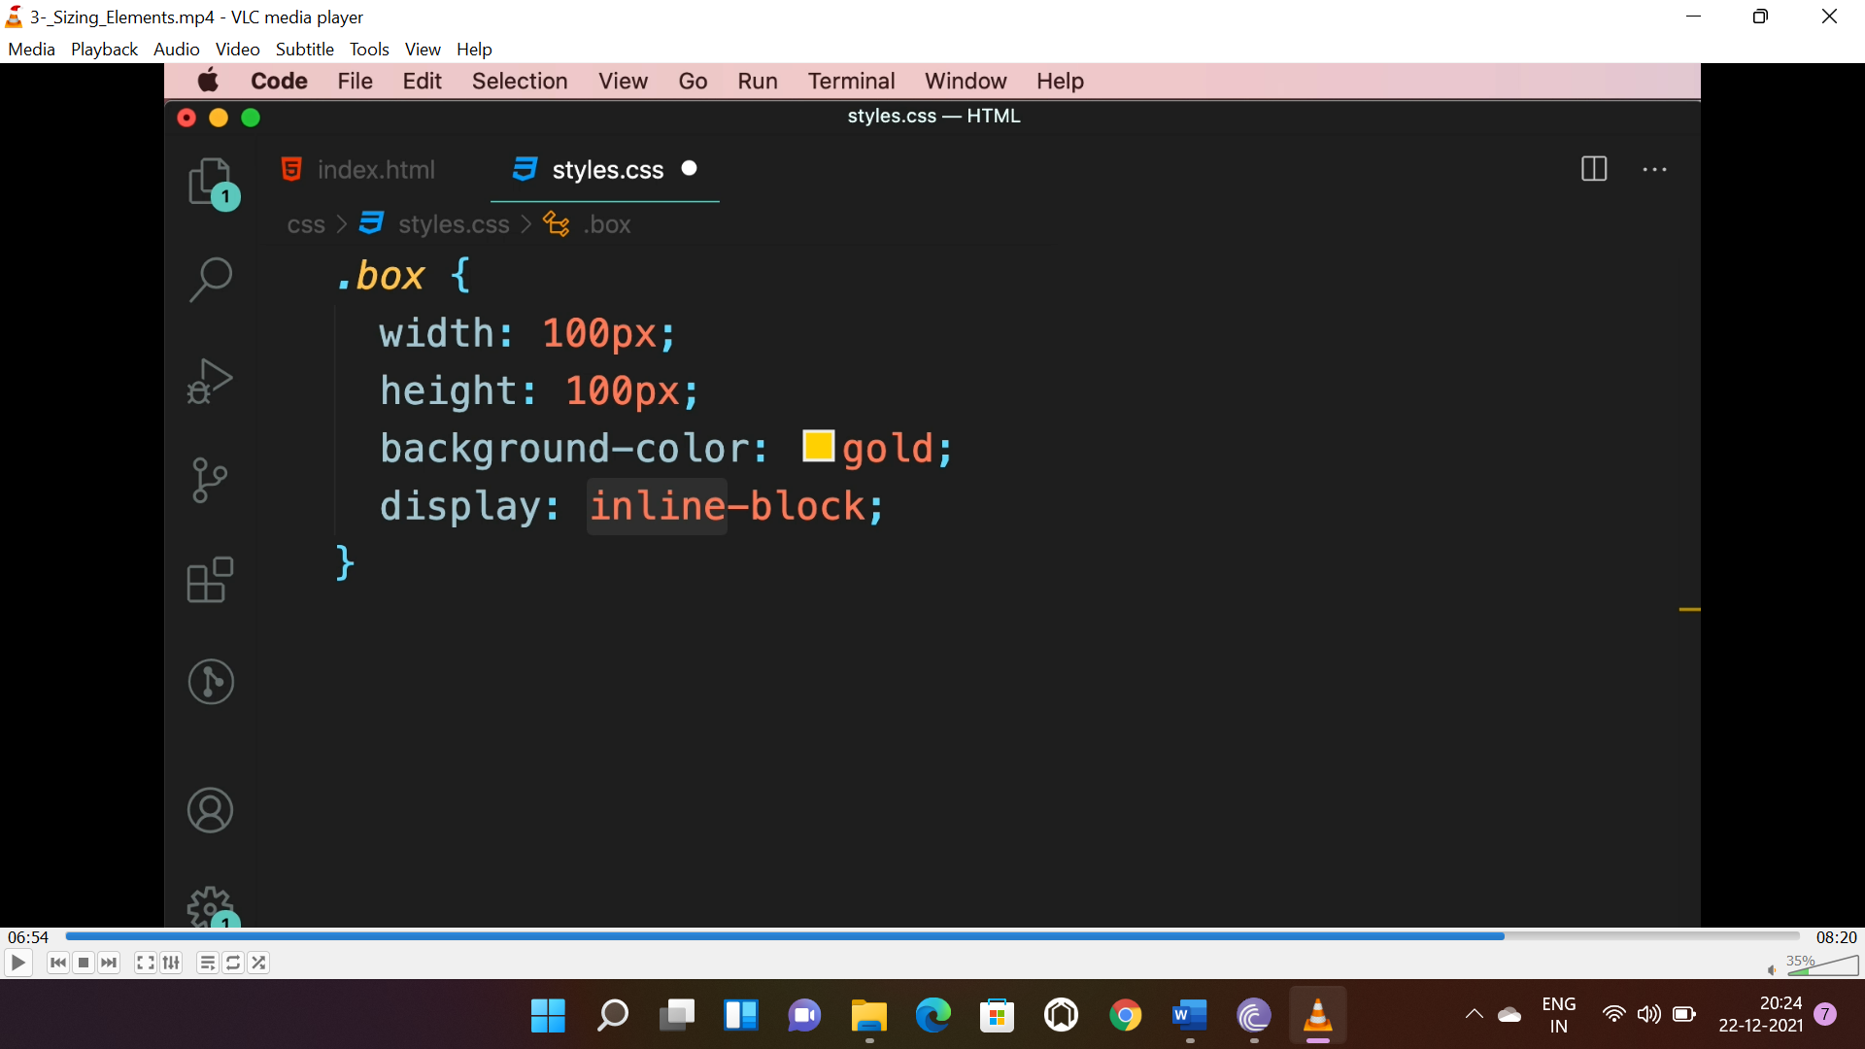

**OVERFLOW:**

* When the content doesn’t fit in the container we use “**overflow**” property.

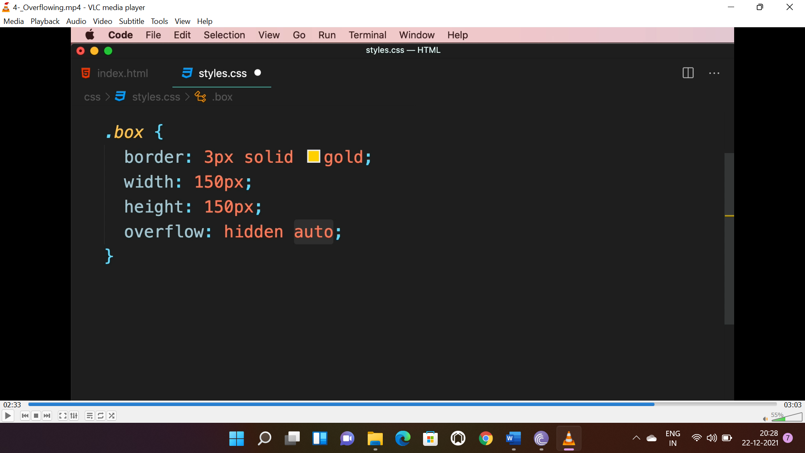

* For horizontal axis it is “**hidden**” and for vertical its “**auto**” means it will apply when content overflow.

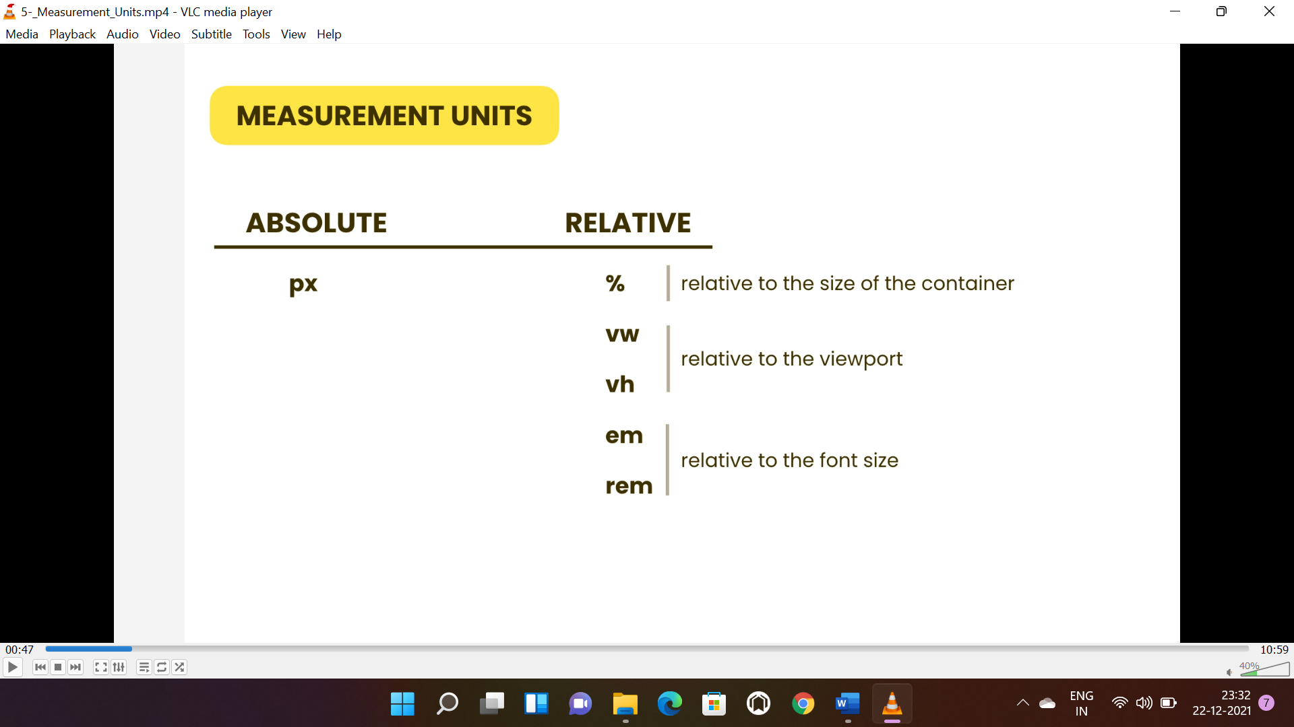

* “%” is related to the size of the parent element. (in percentage 0-100)
* “vw” & “vh” is related to the size of the view port(display). (in percentage 0-100)
* “rem” is related to the font size of the browser. (**unit will be multiplied to font size**)

**POSITIONING:**

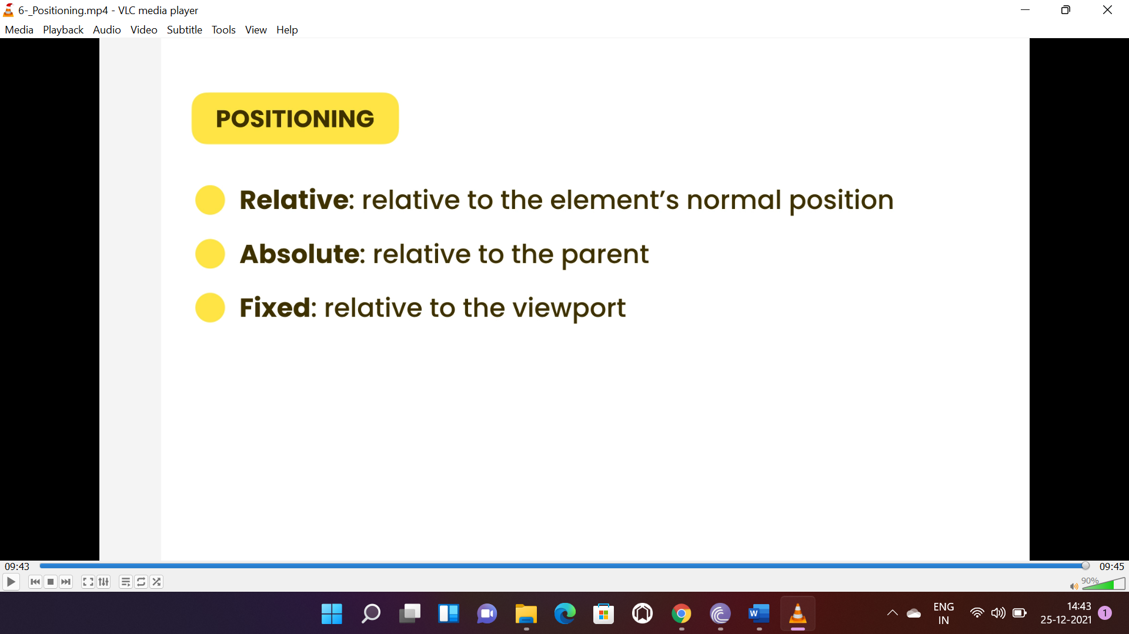

***by default all boxes are set to “static” positioning.***

* **Relative positioning moves box relative to its original position.**
* “left” (4rem space between the original position and the left of the box).
* “right” (4rem space between the original position and the right of the box).
* “z-index” (+ve value puts the box on the top and -ve value puts it to the bottom and zero on the ).

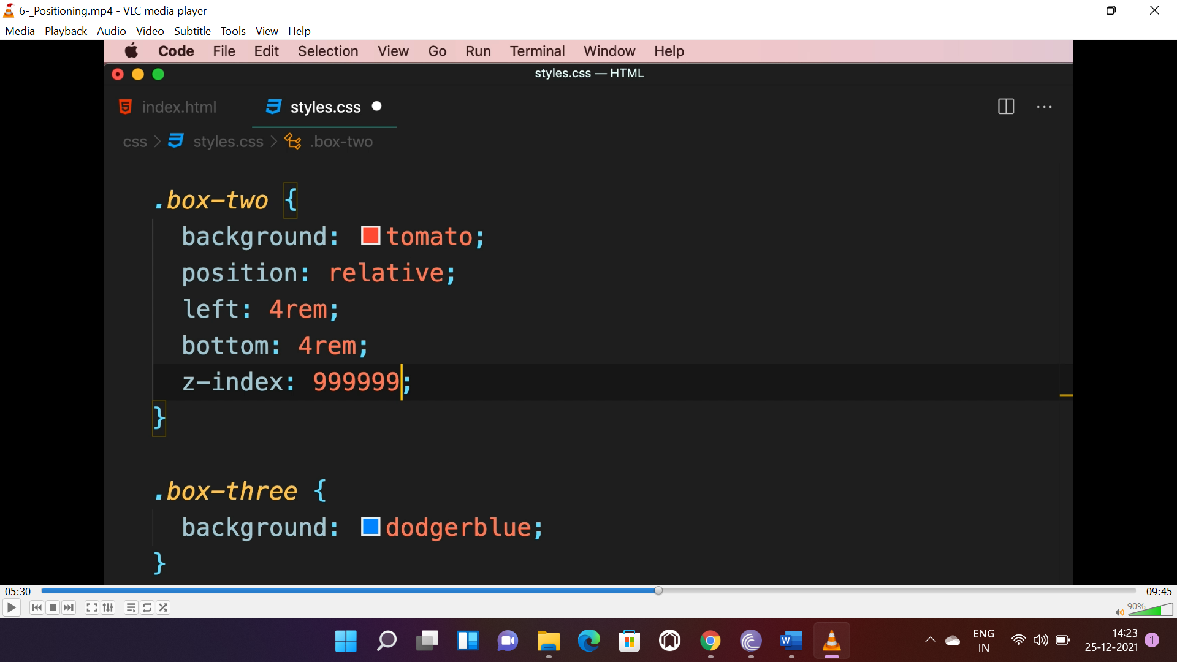

* **Absolute positioning moves the box relative to the container.**
* Absolute positioning removes the box from its original place and boxes will render like the applied style box never existed.

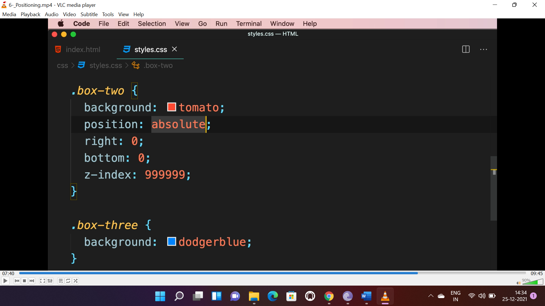

* **Fixed** positioning moves box relative to the **viewport** .
* **Main use case of this is when we create nav-bar fixed at the top, “go-to-top” button etc..**

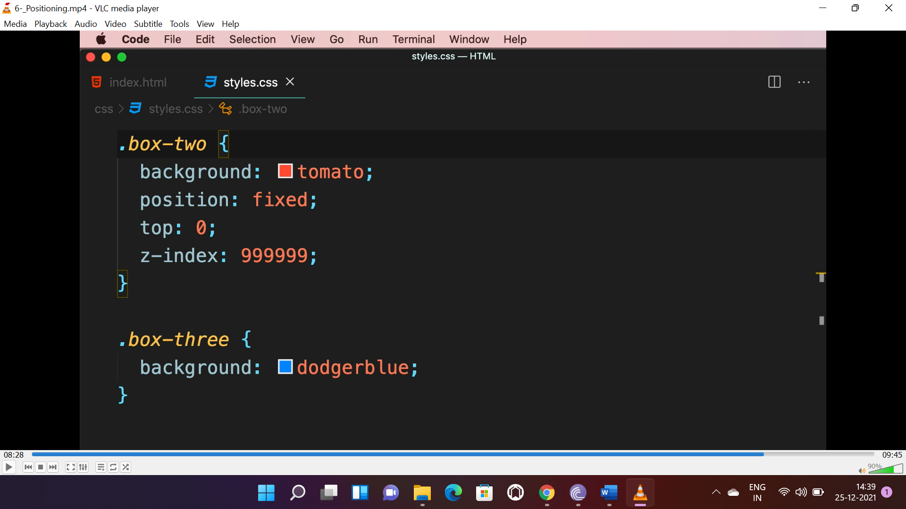

**FLOAT:**

* The element will float to the given direction and all elements will be around it.

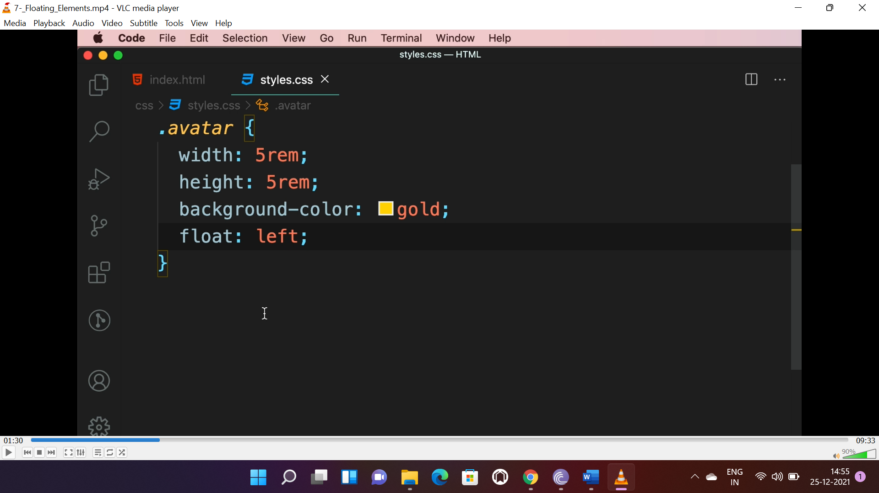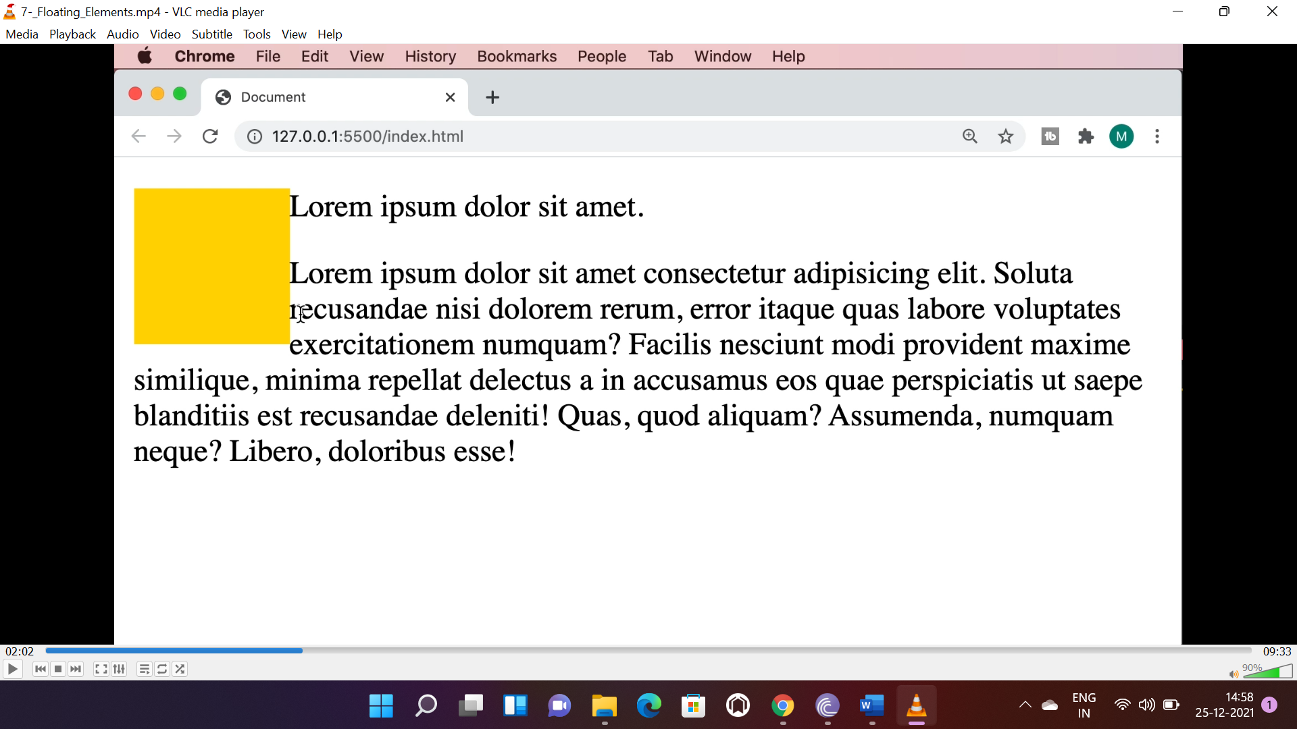

* To clear the floating element from the right or left we use “clear” property.

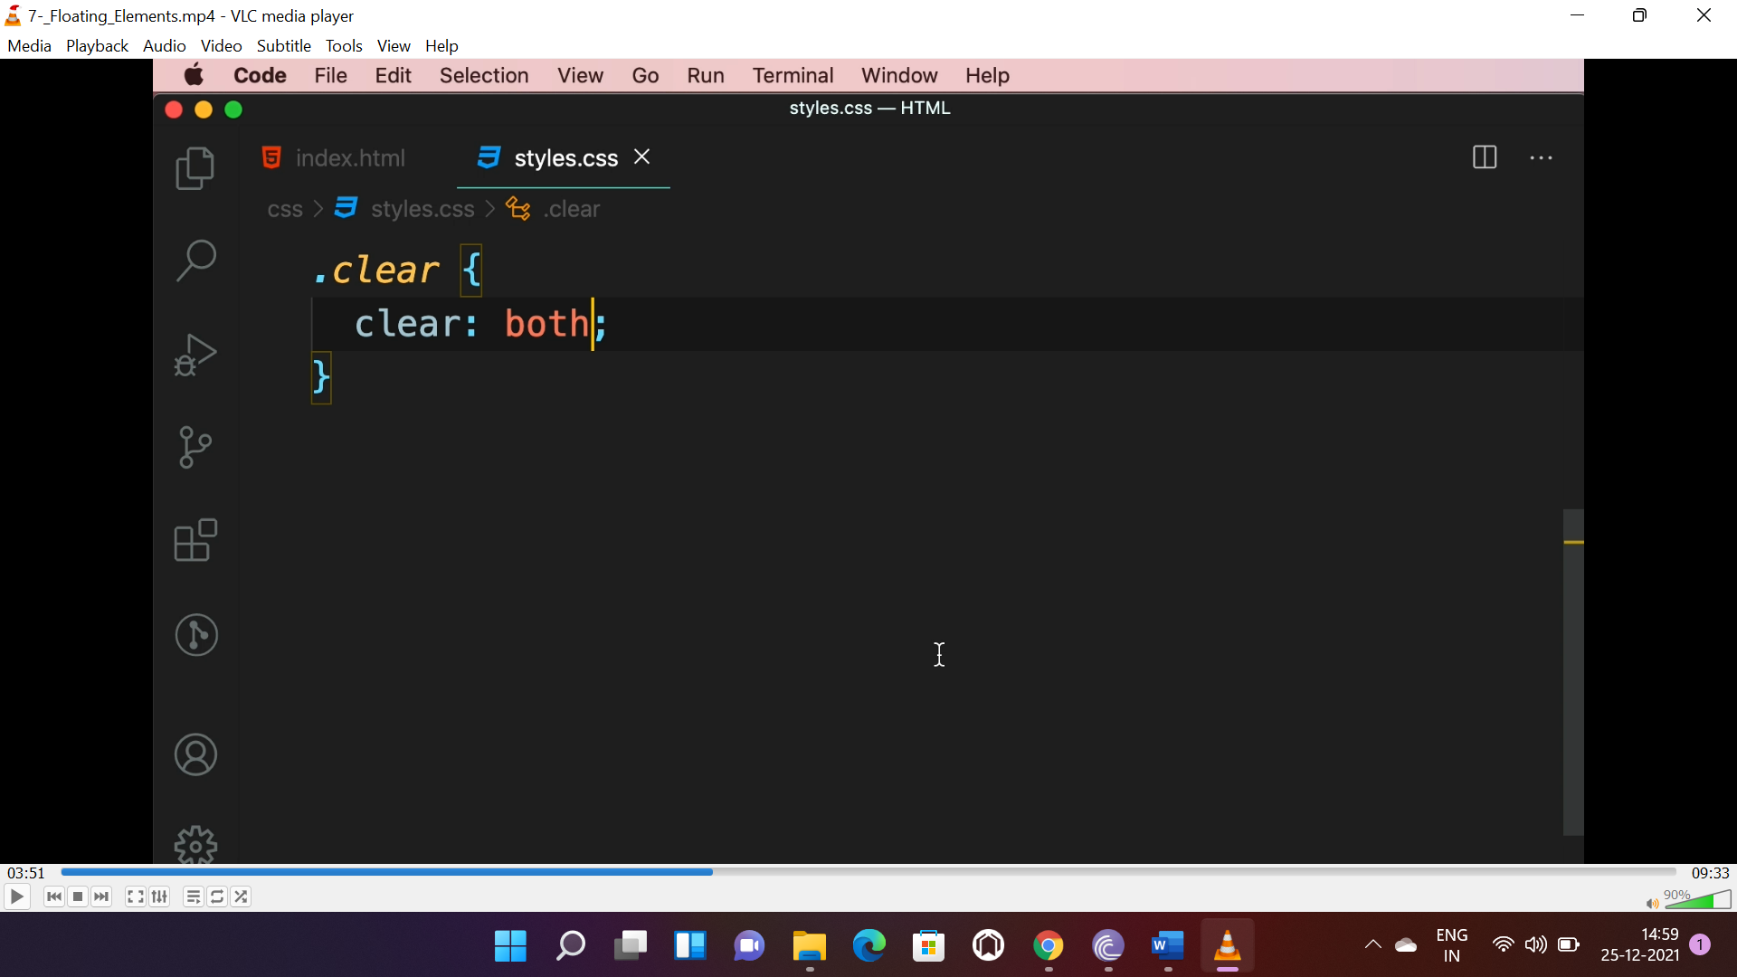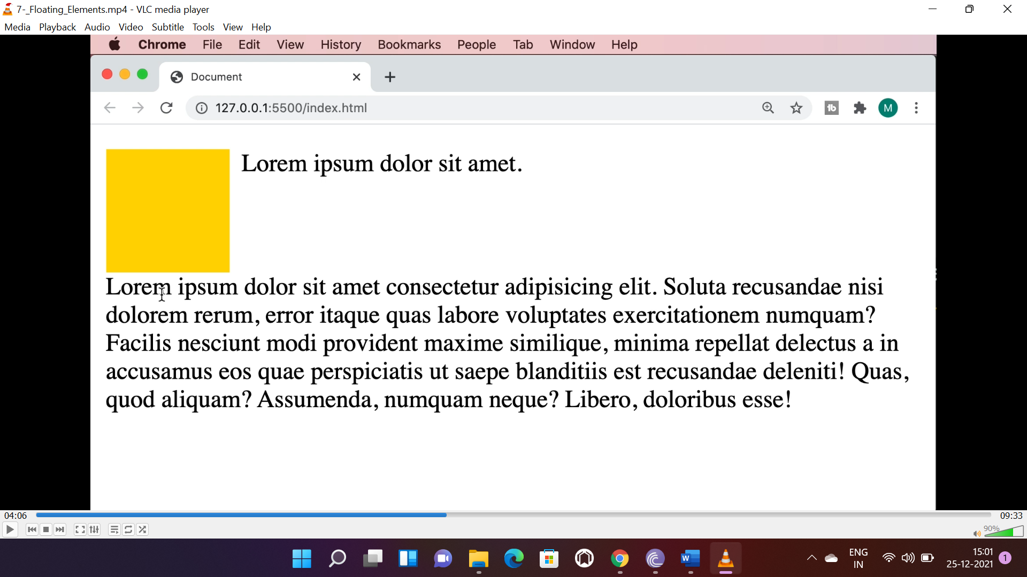

* Parent elements don’t recognize floating elements, in that case the floating element may overflow the container. To resolve that we can use the following or a empty div with “**clear:both;**” below the float element.

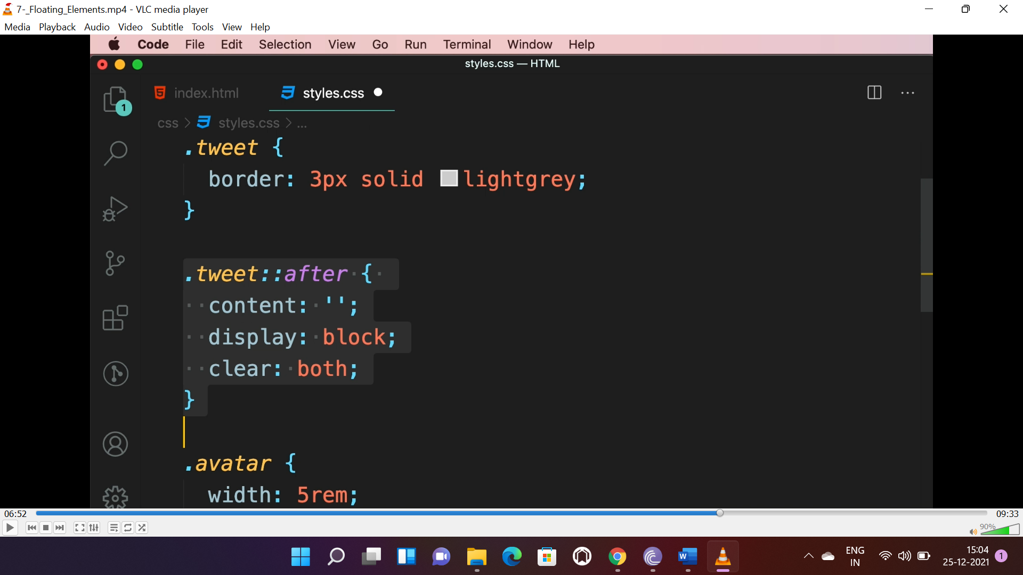or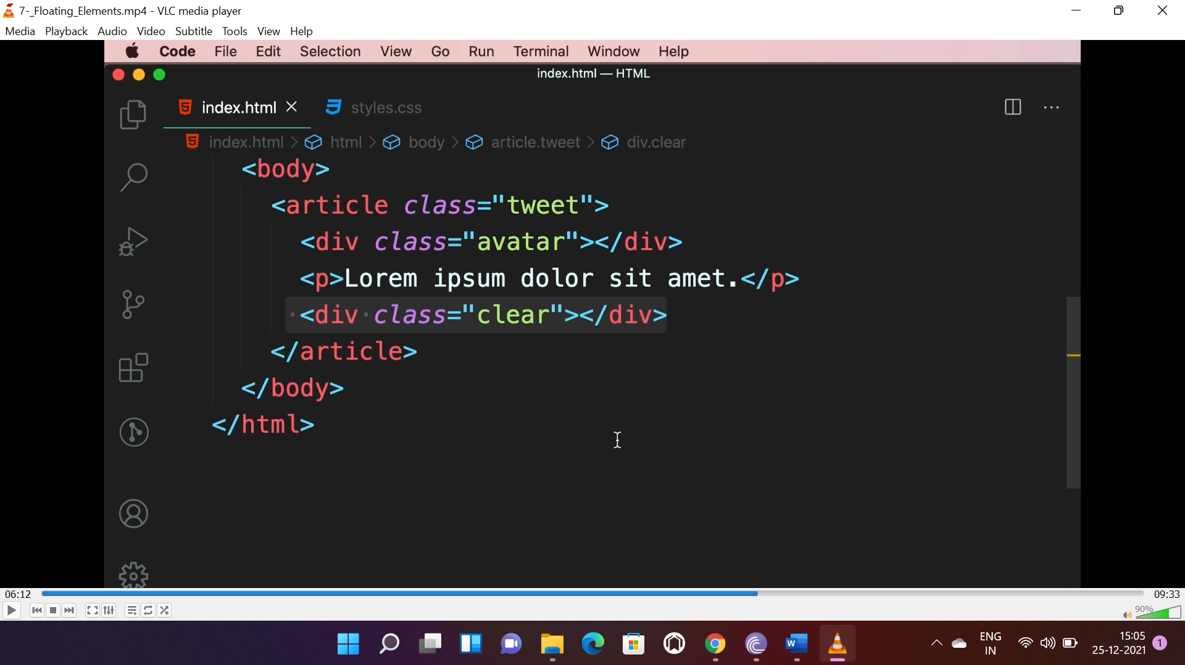

**FLEX BOX:**

* Flex-box is used to align item according to our need.
* The default flex direction is “row”, we can change it to “column”.

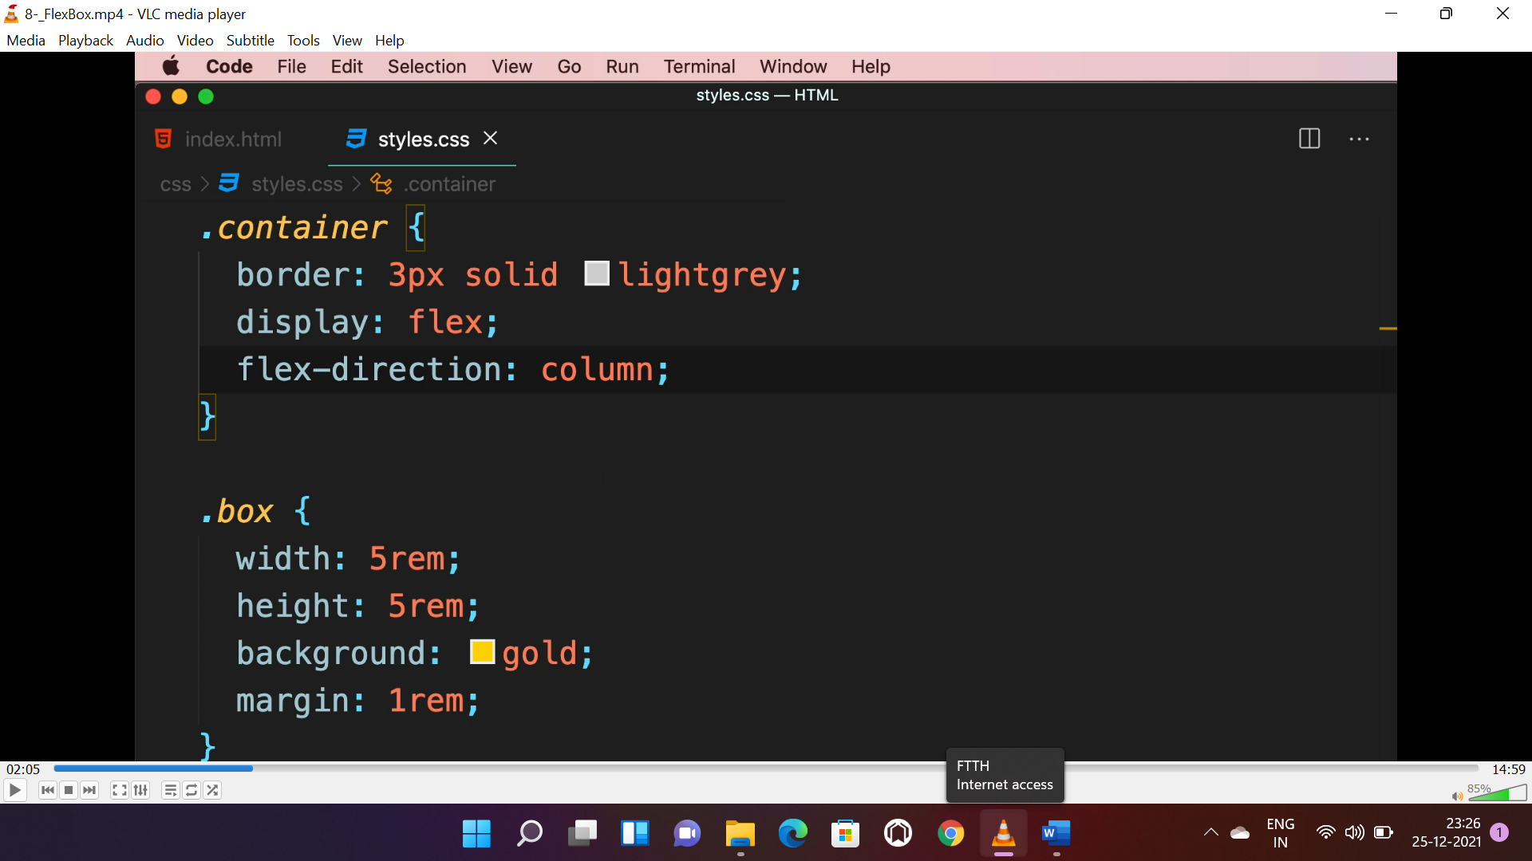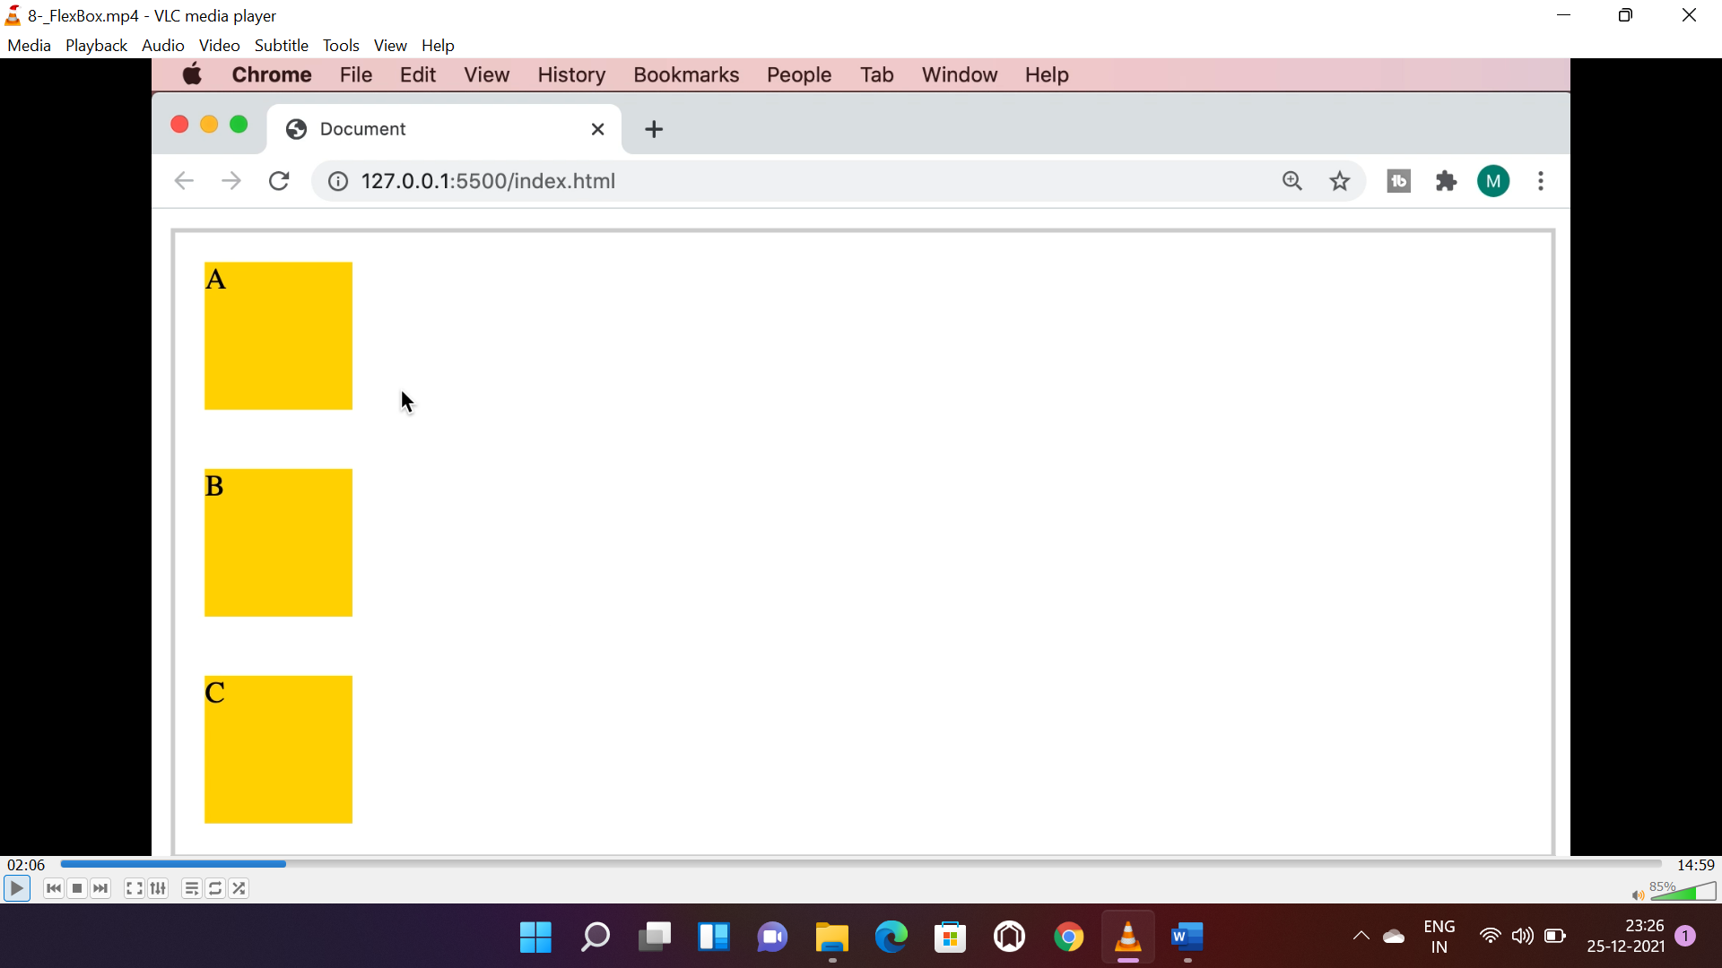

* “column-reverse” and “row-reverse” to reverse column and row items.

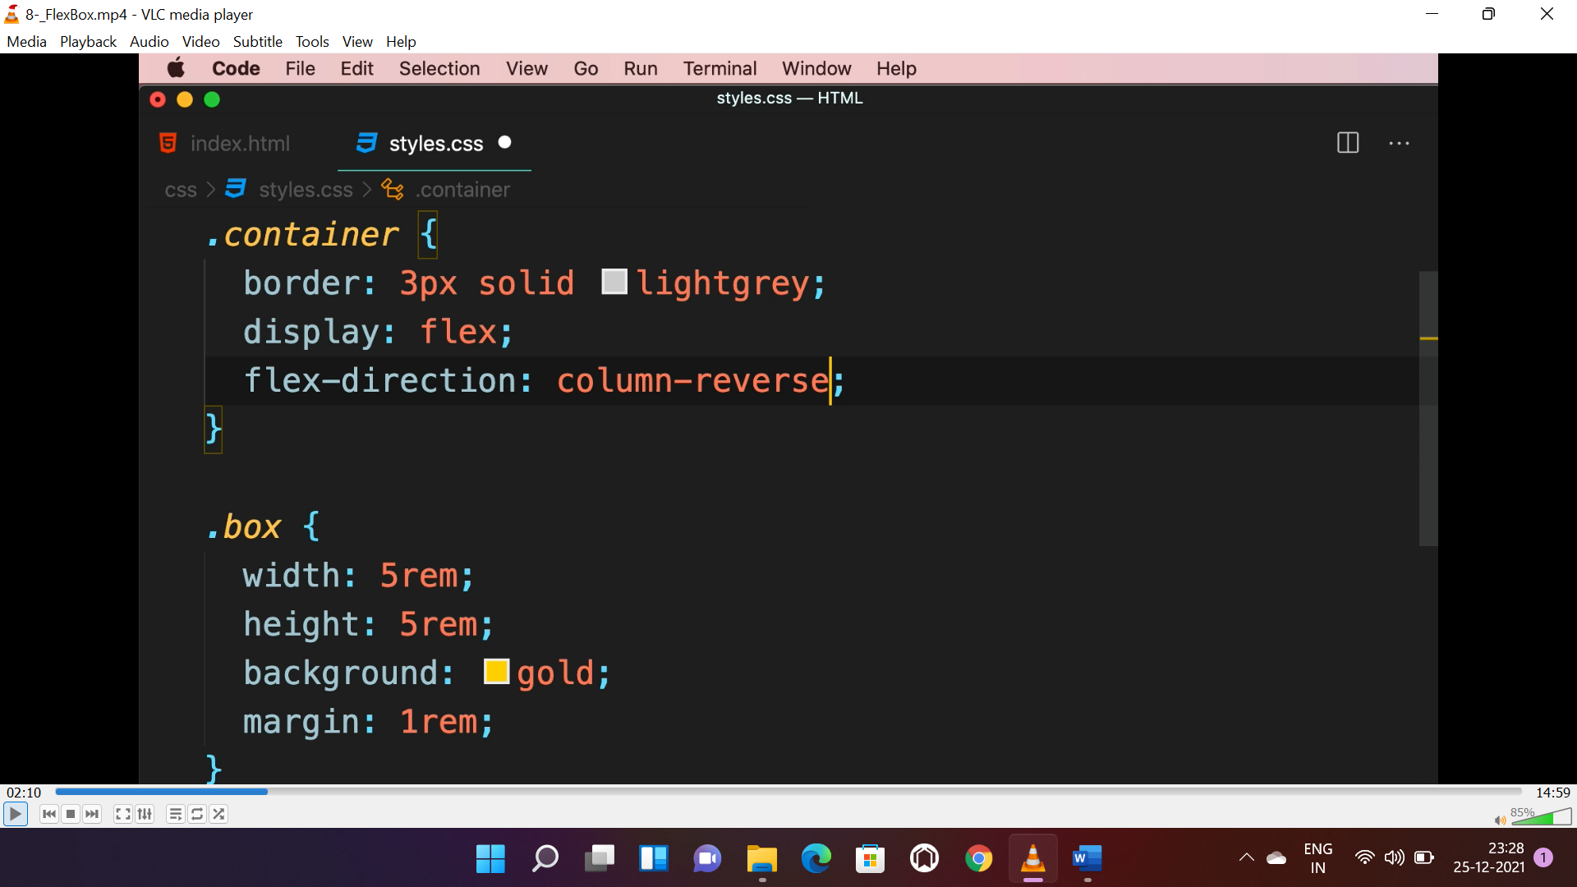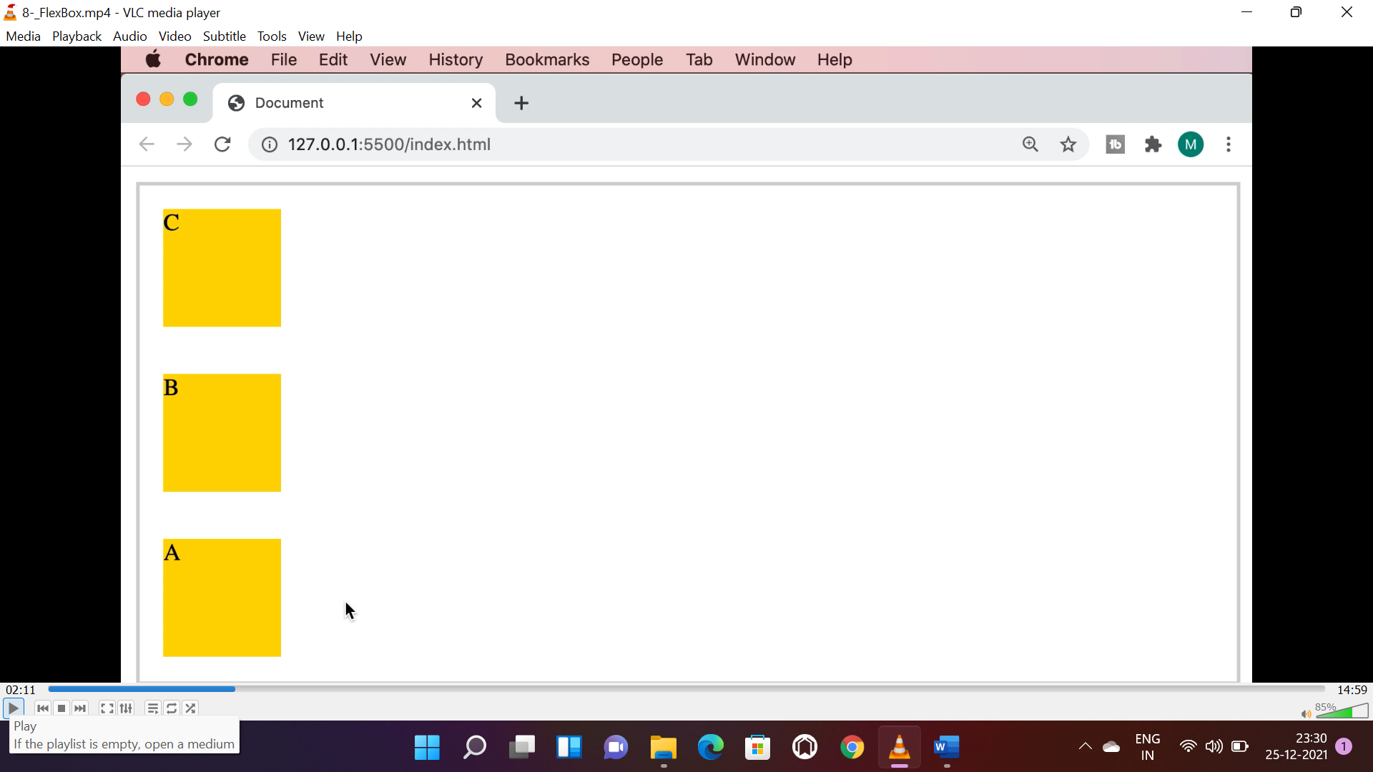

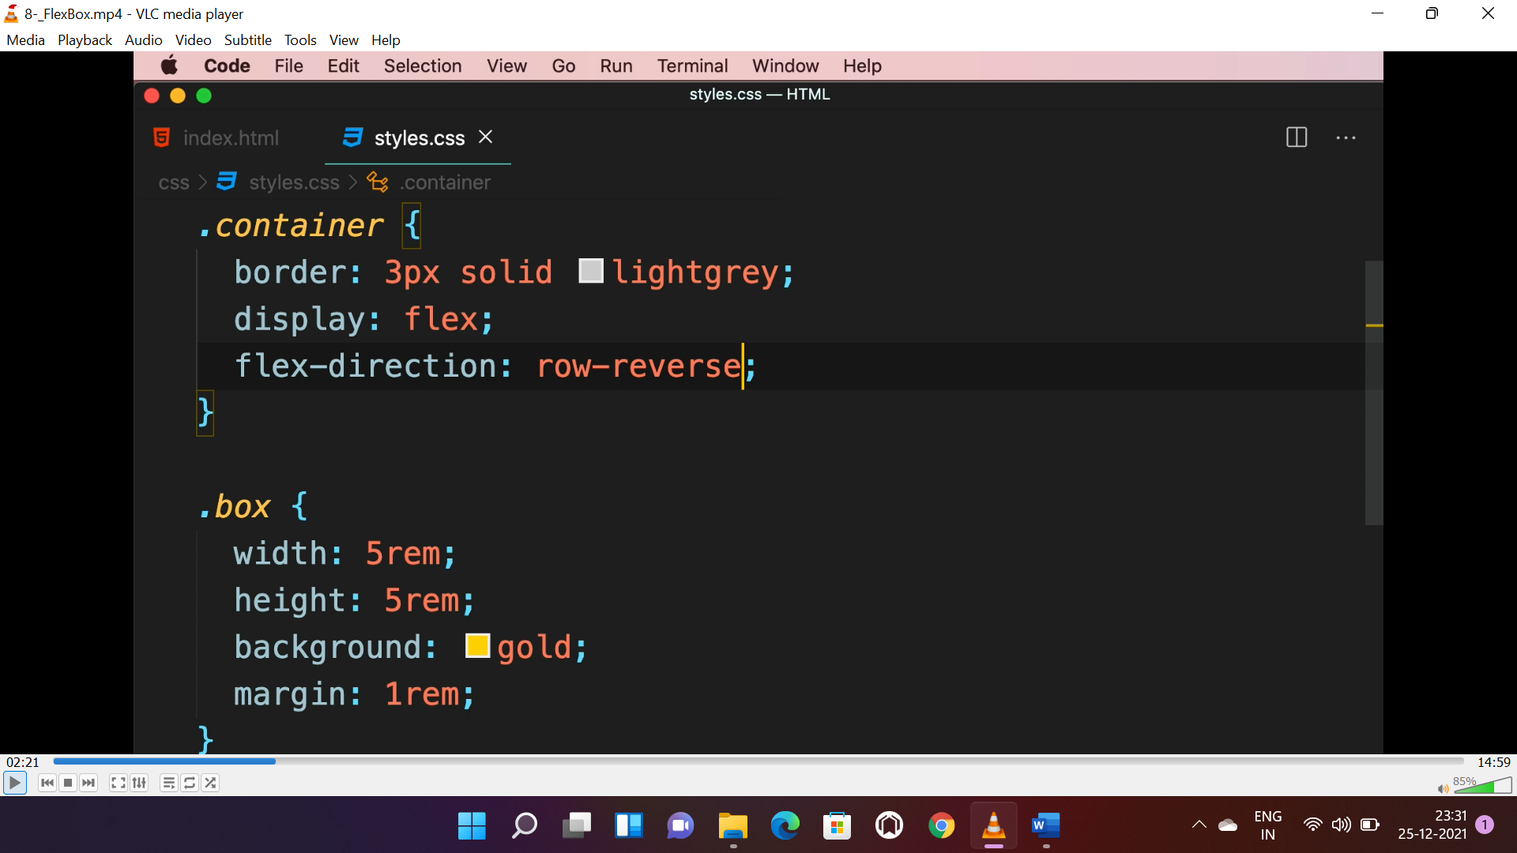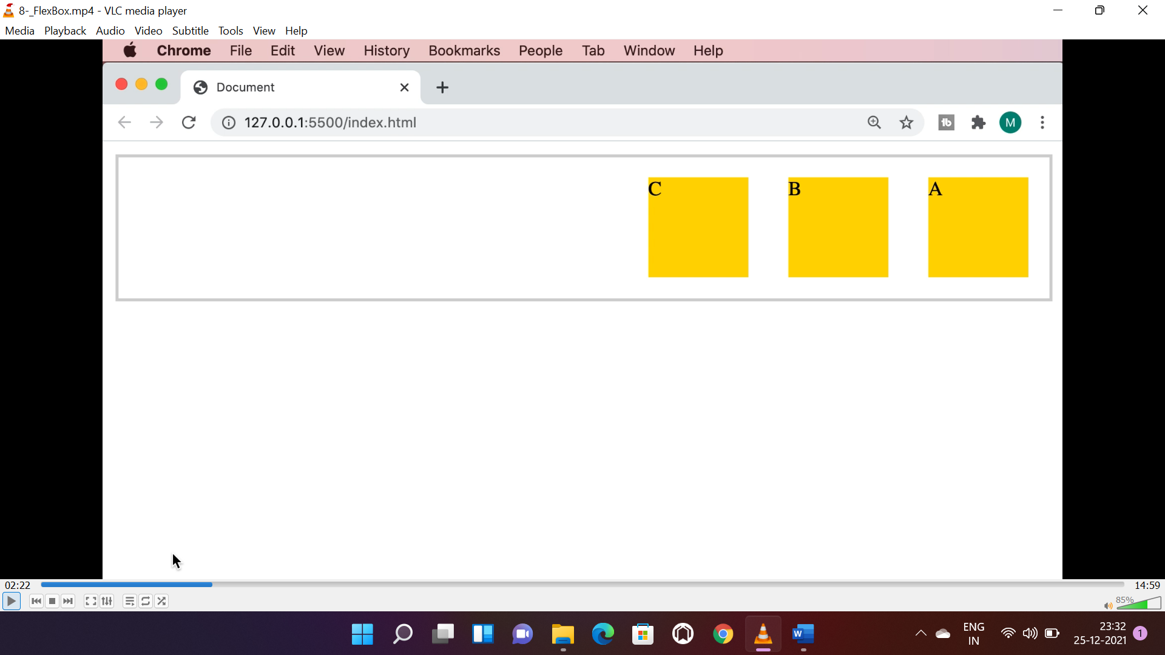

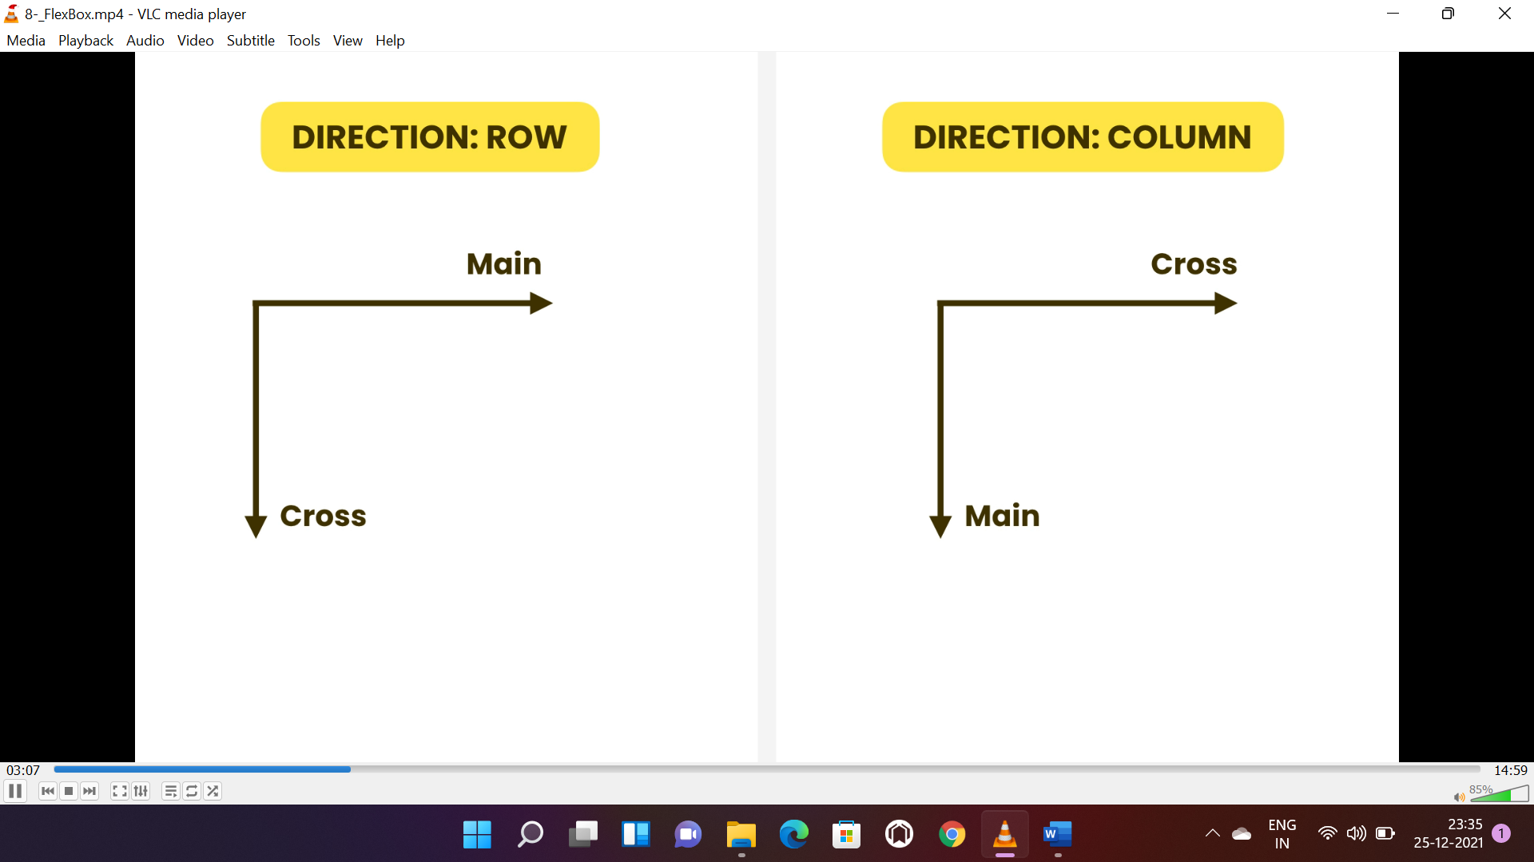

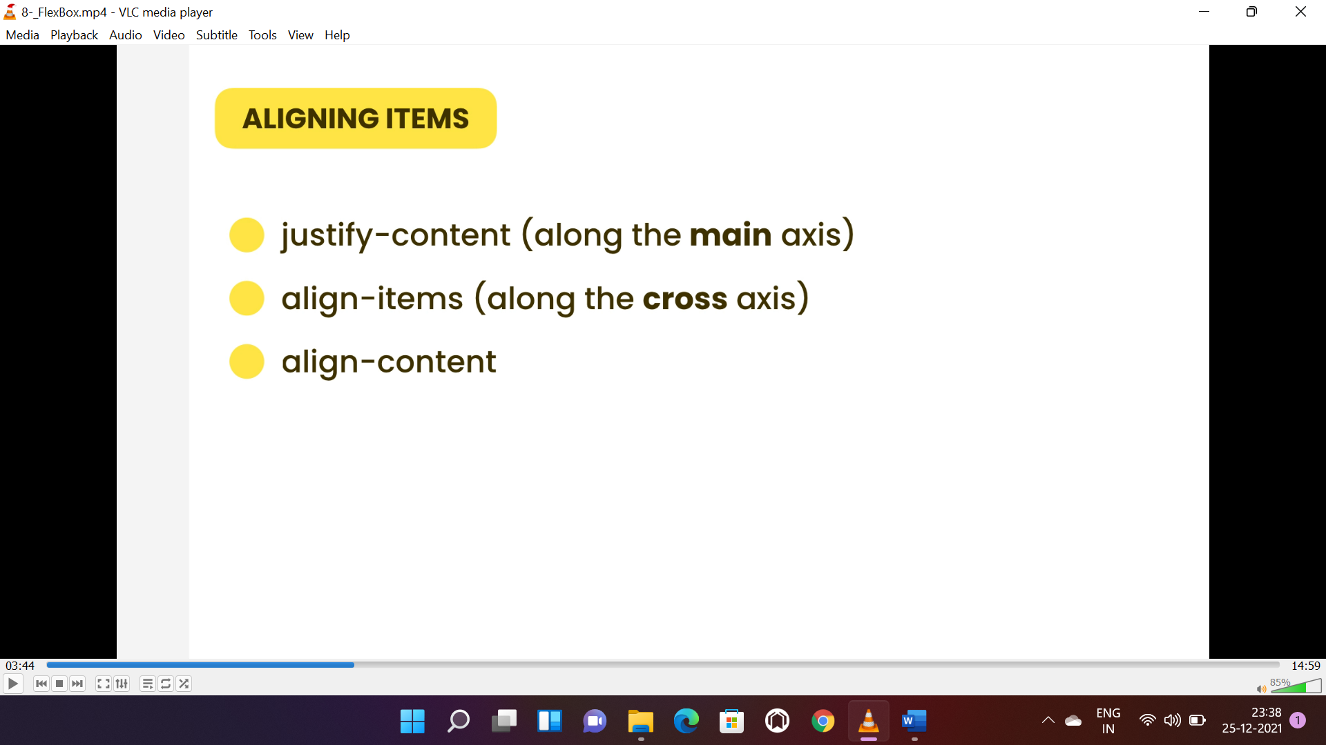

* **“justify-content:flex-end”** is used to move items to flex end.

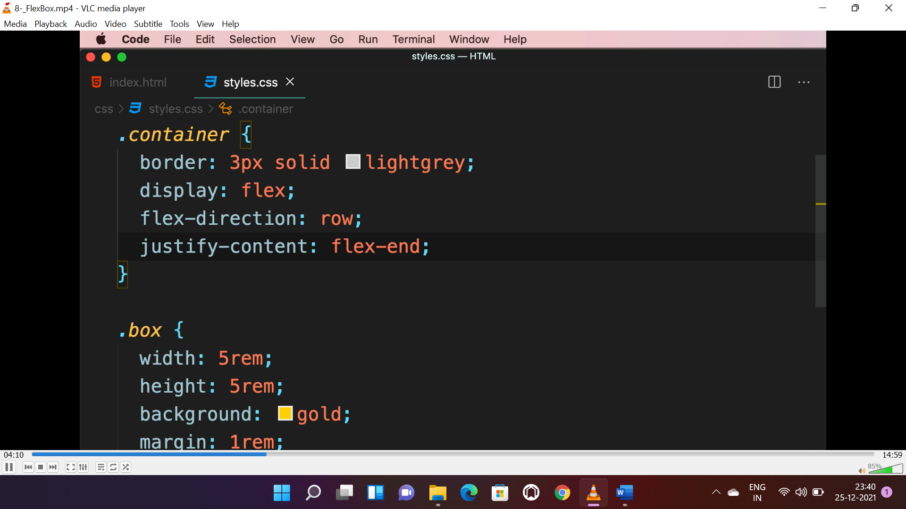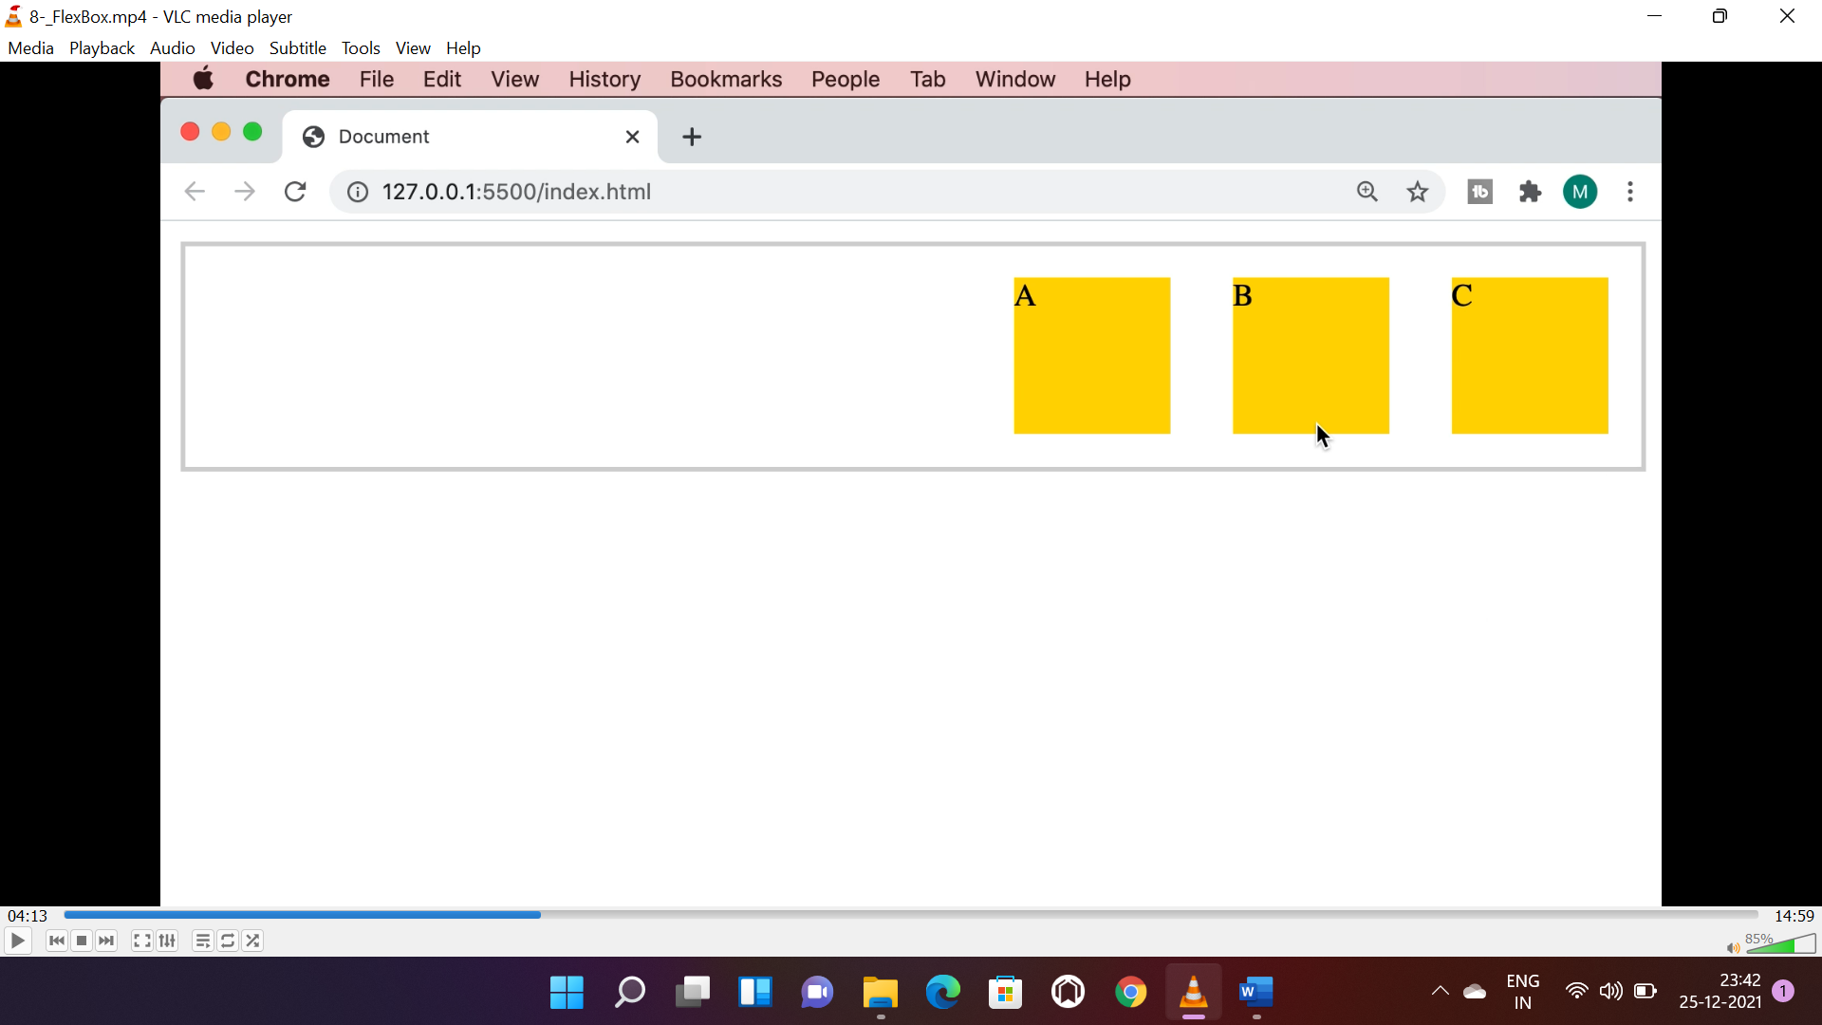

* **“justify-content:center”** is used to move items to center.

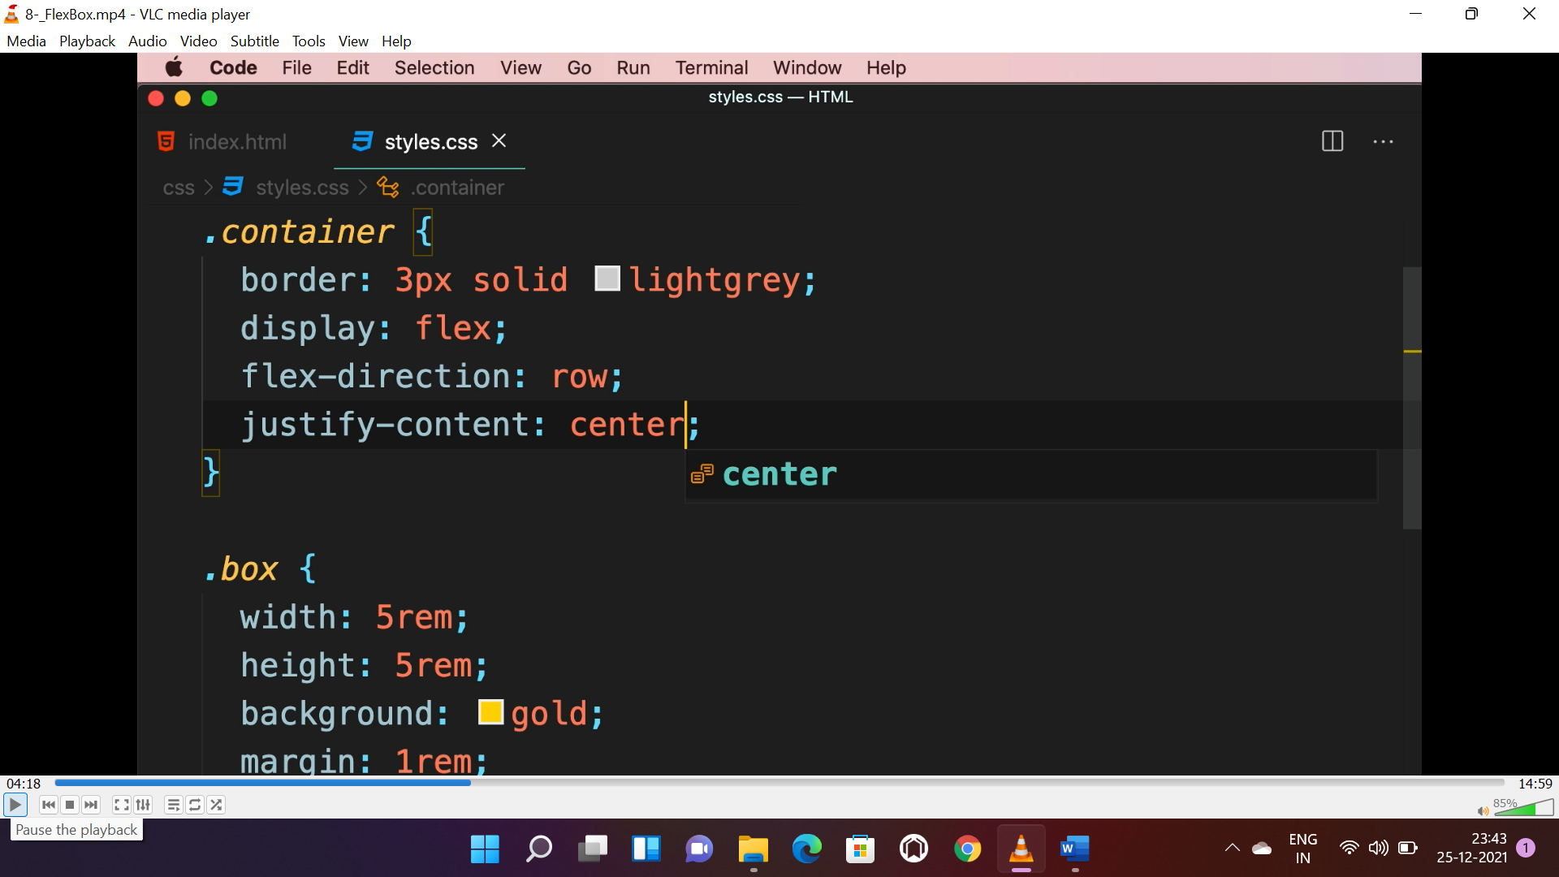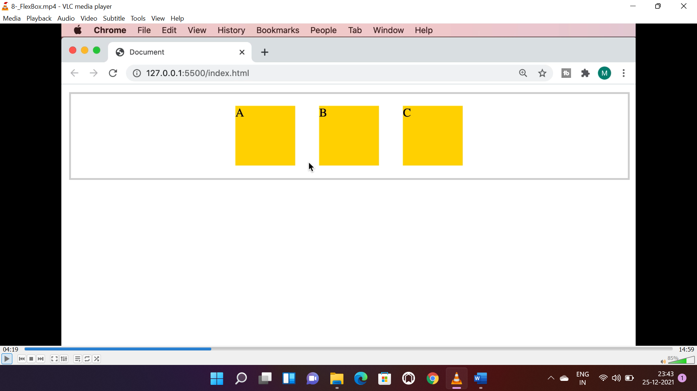

* **“justify-content:space-evenly”** is used to space equally on right and left.

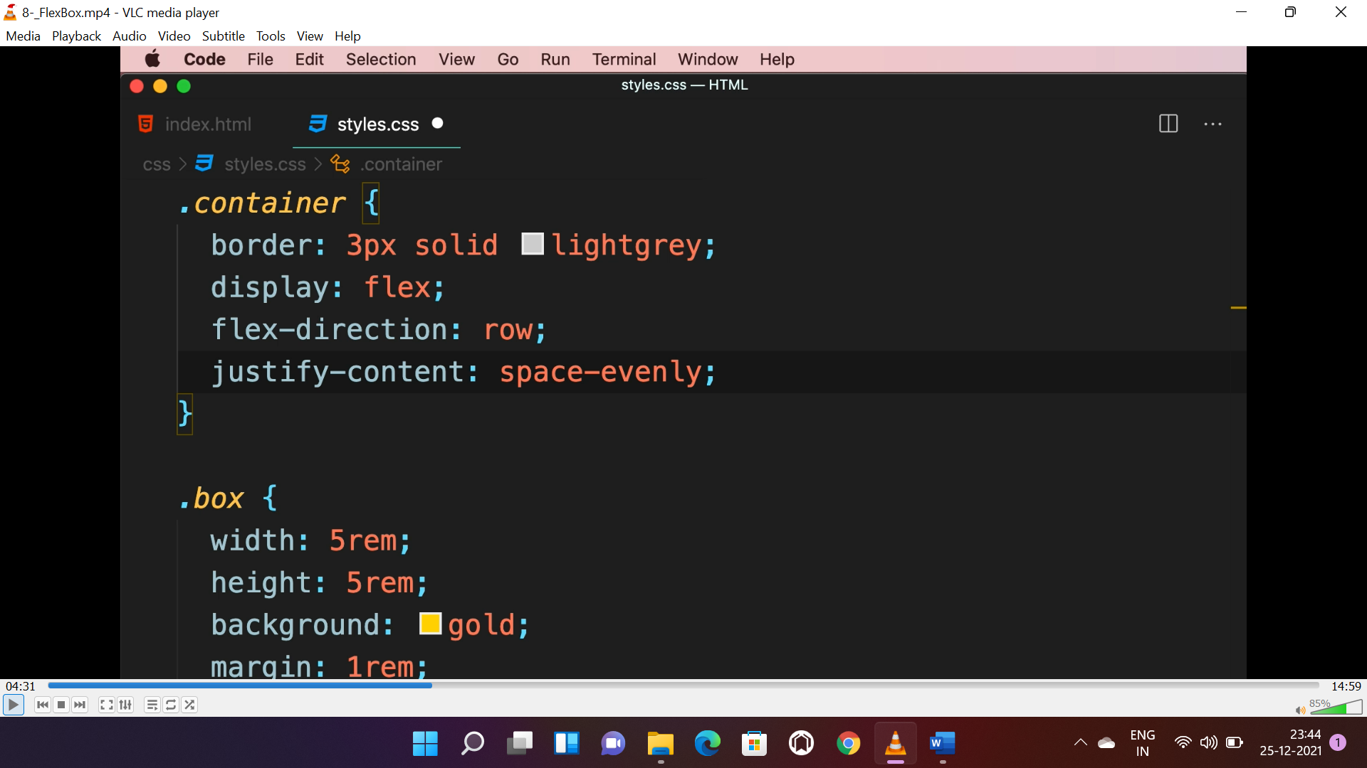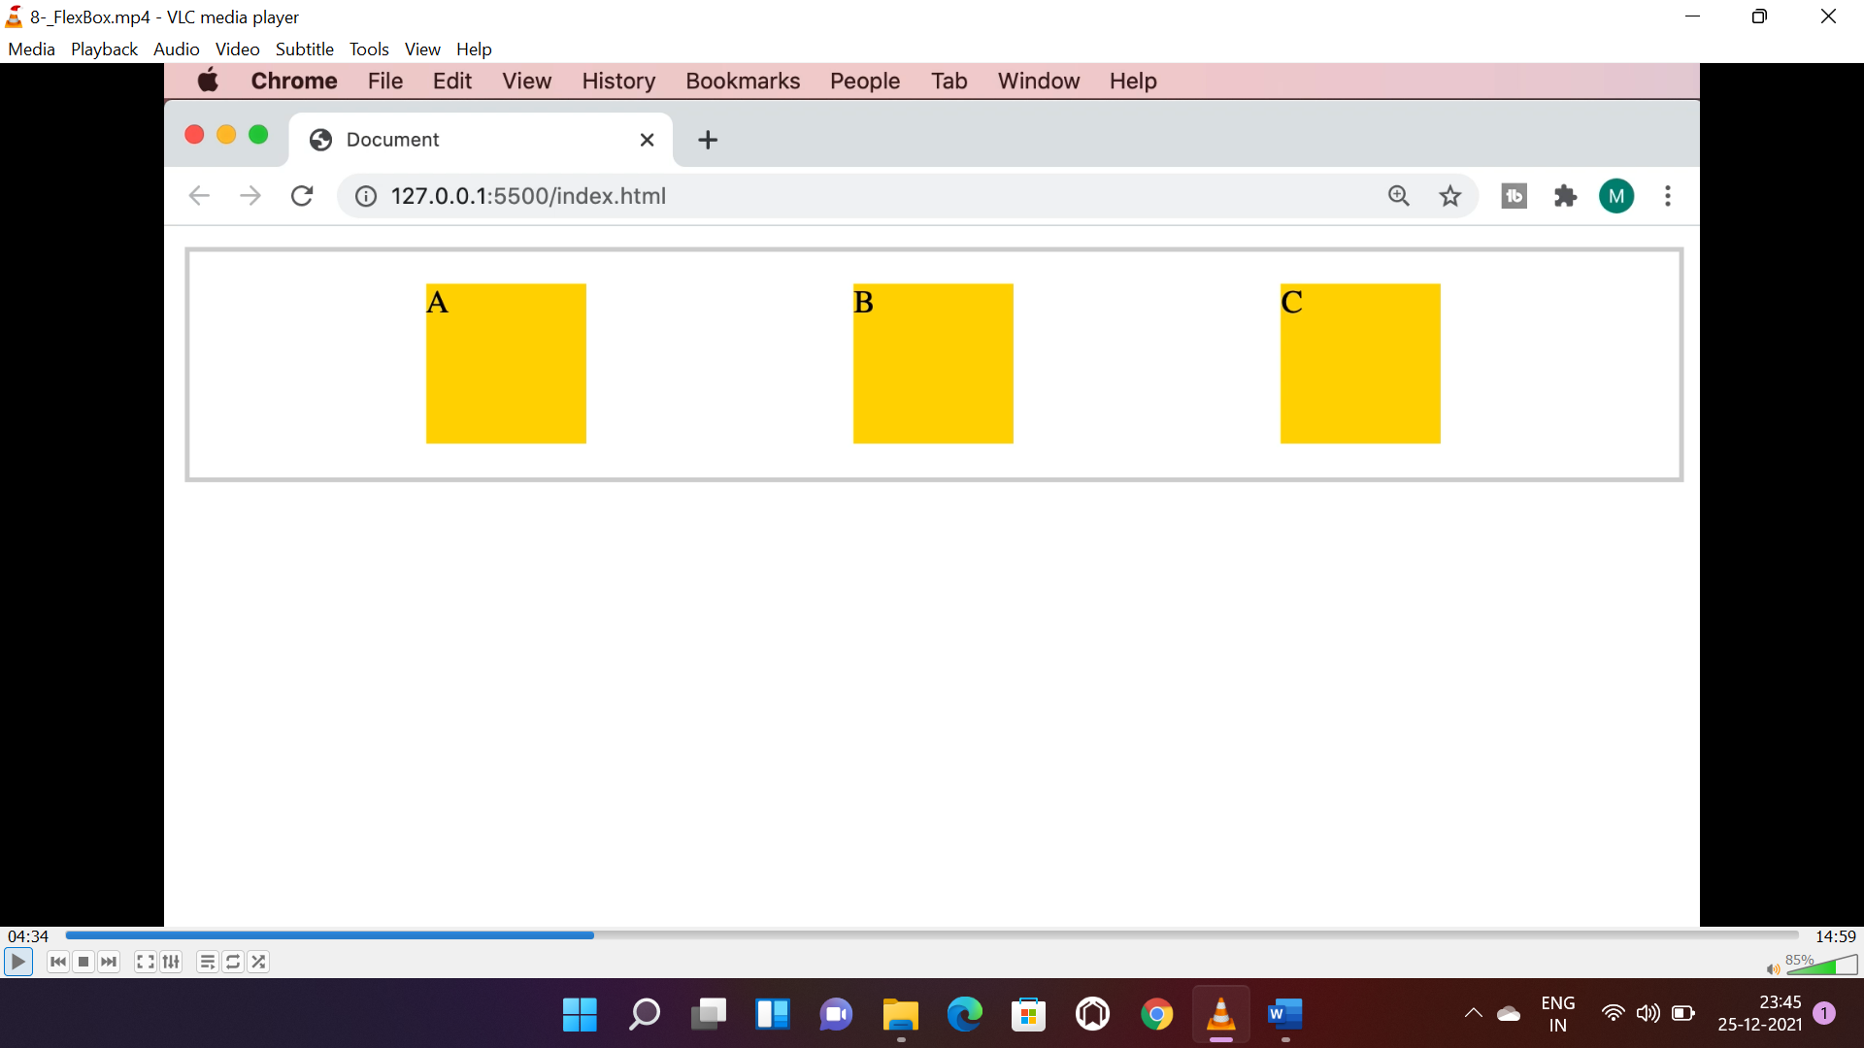

* **“justify-content:space-between”** is used to provide equal space in-between.

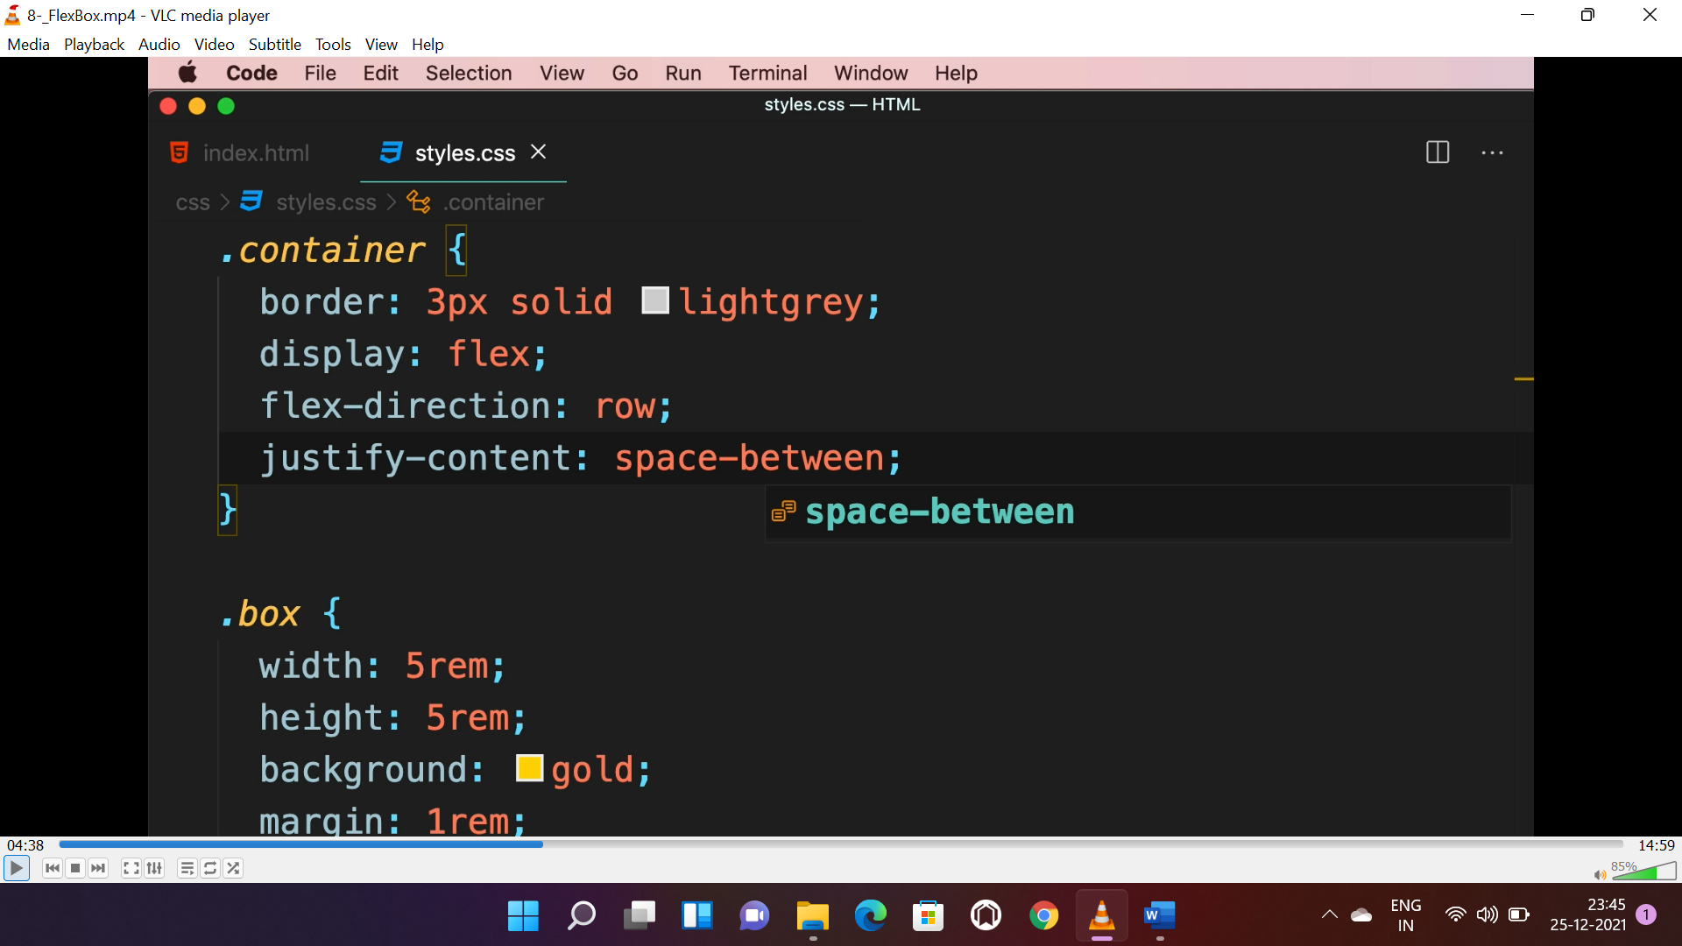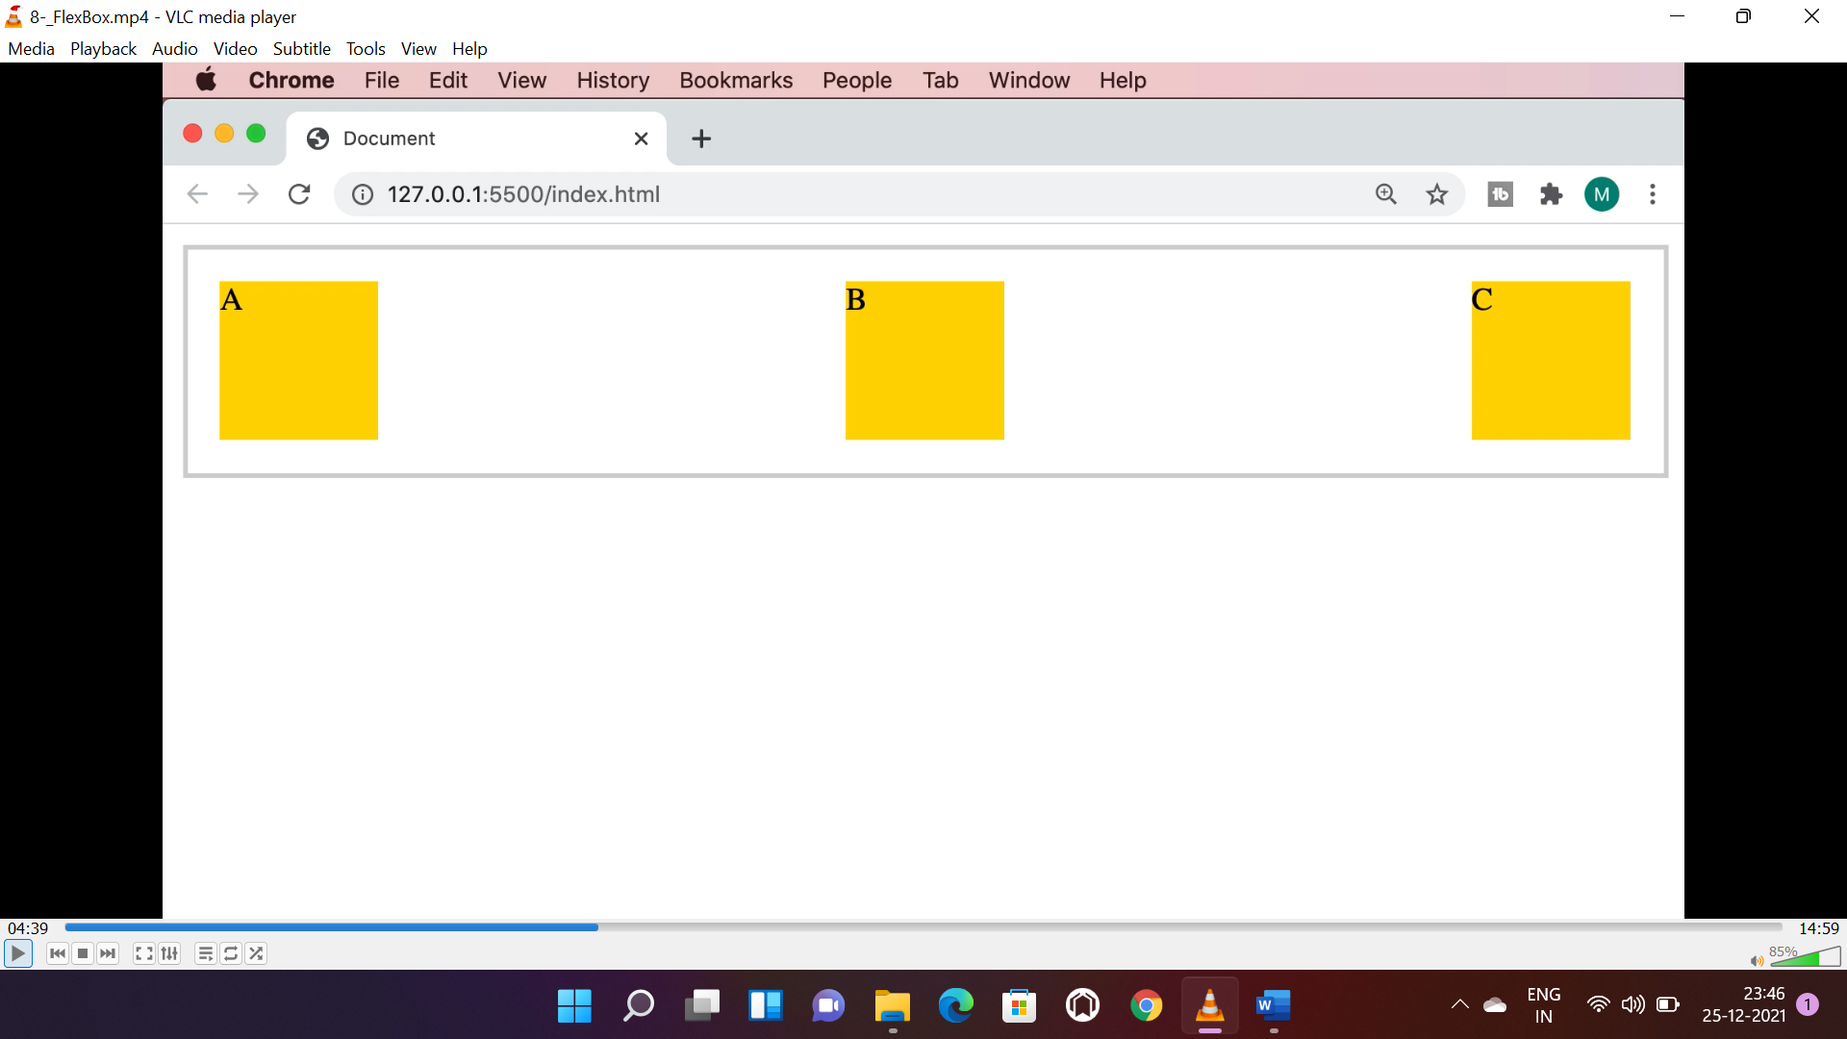

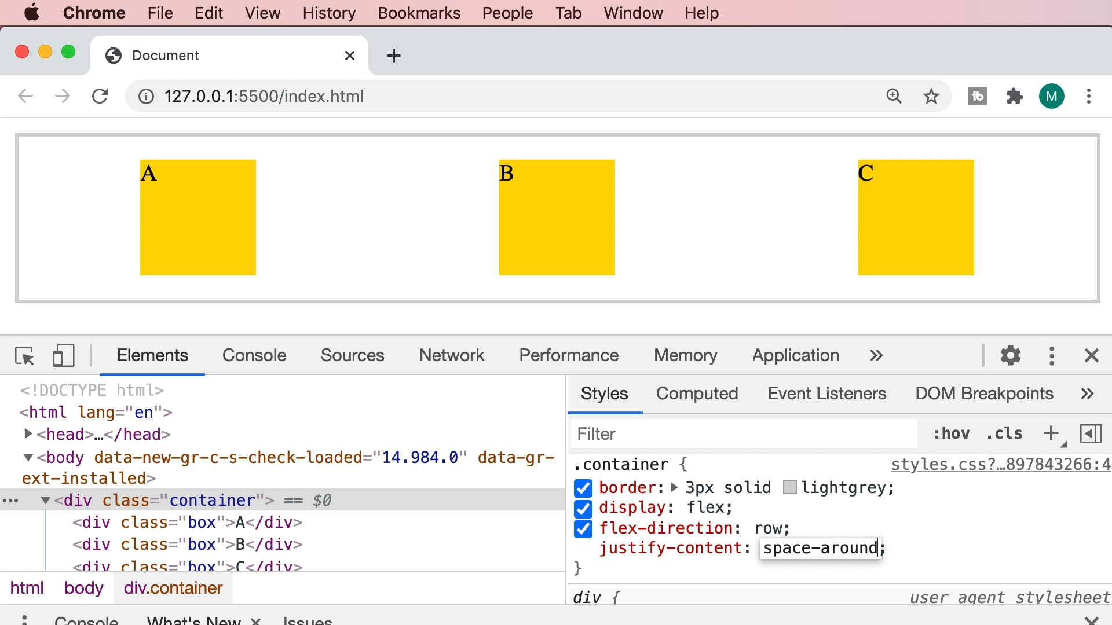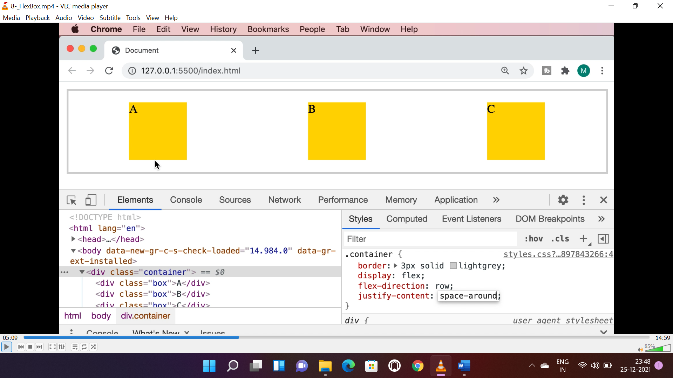

**TO ALIGN IN CROSS AXIS:**

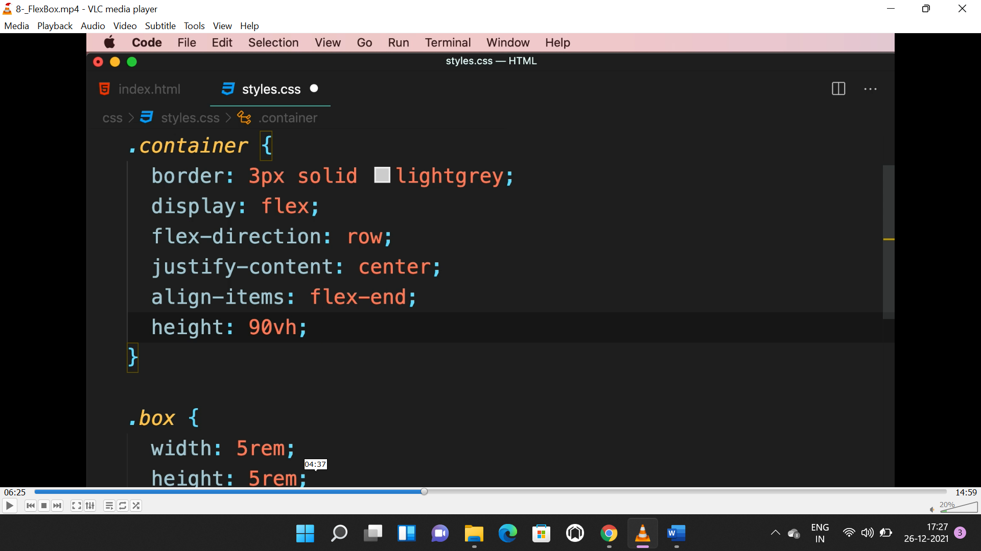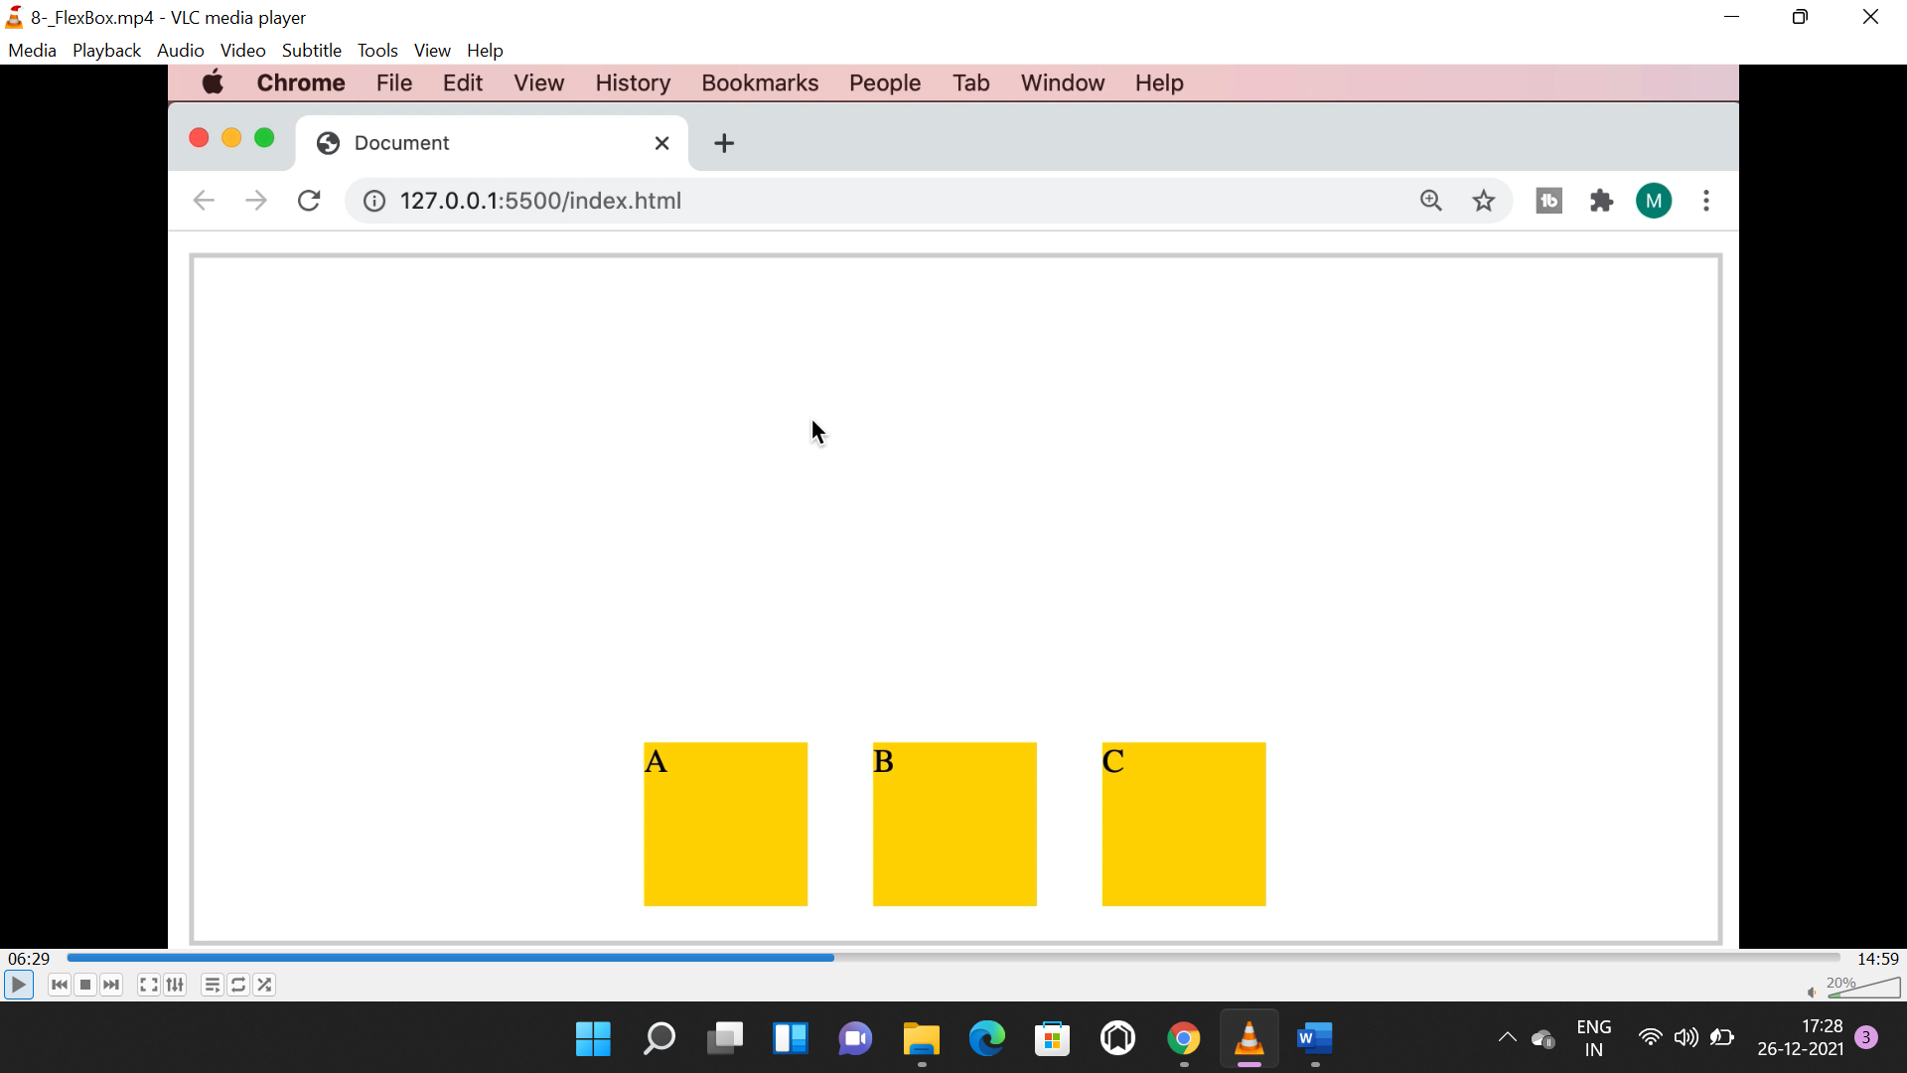

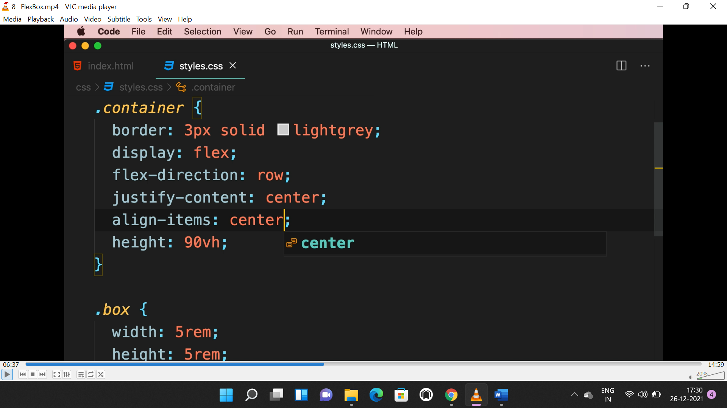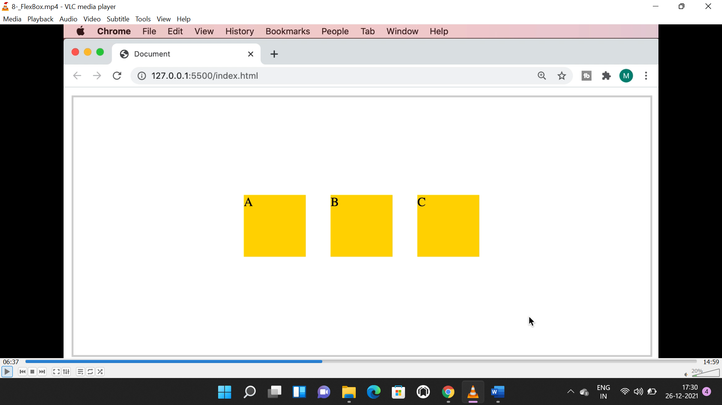

**WRAP:**

* Wrap is used either to wrap elements to the centre or not.
* If “flex-wrap” set to “no-wrap” then all items will be on same line and compressed.

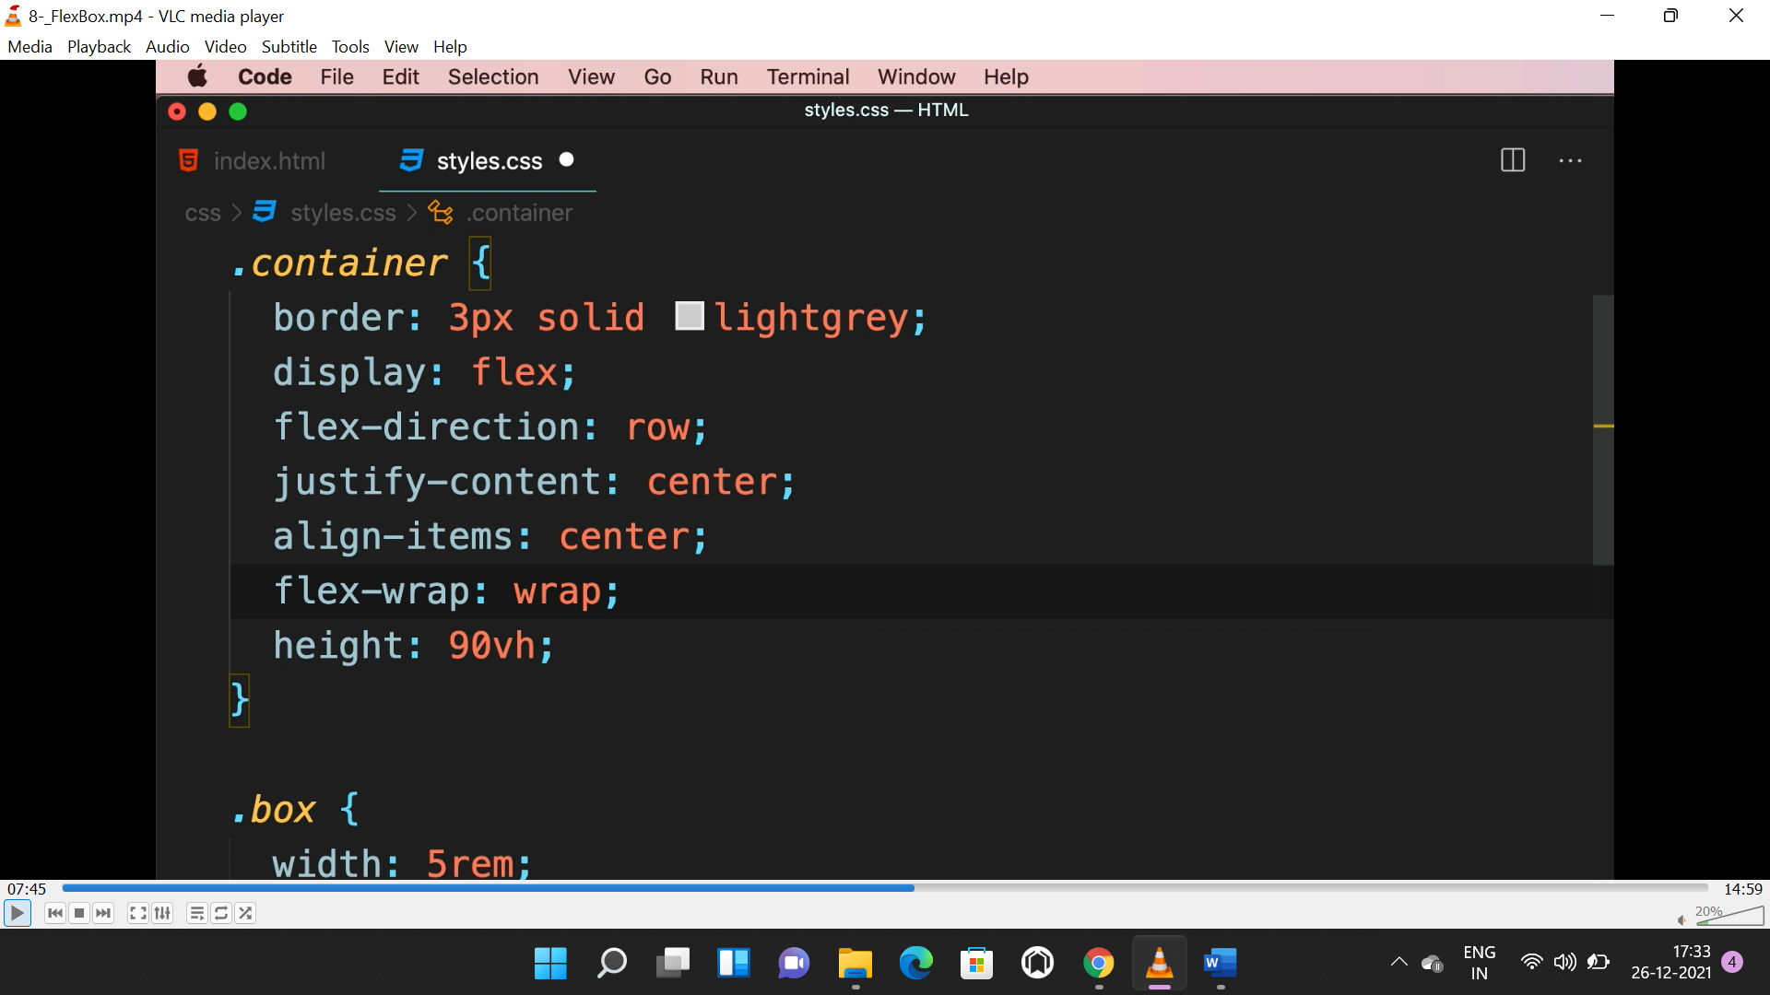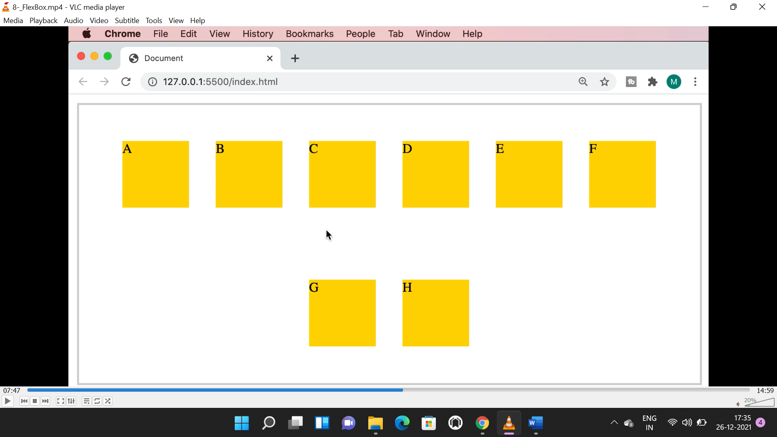

* “align-content” will align all content in whole.

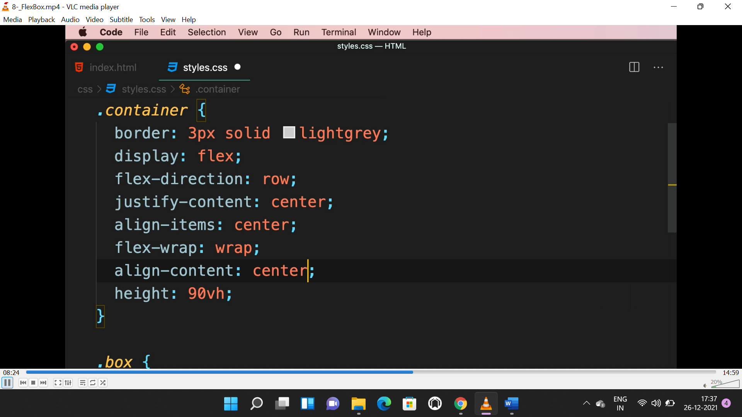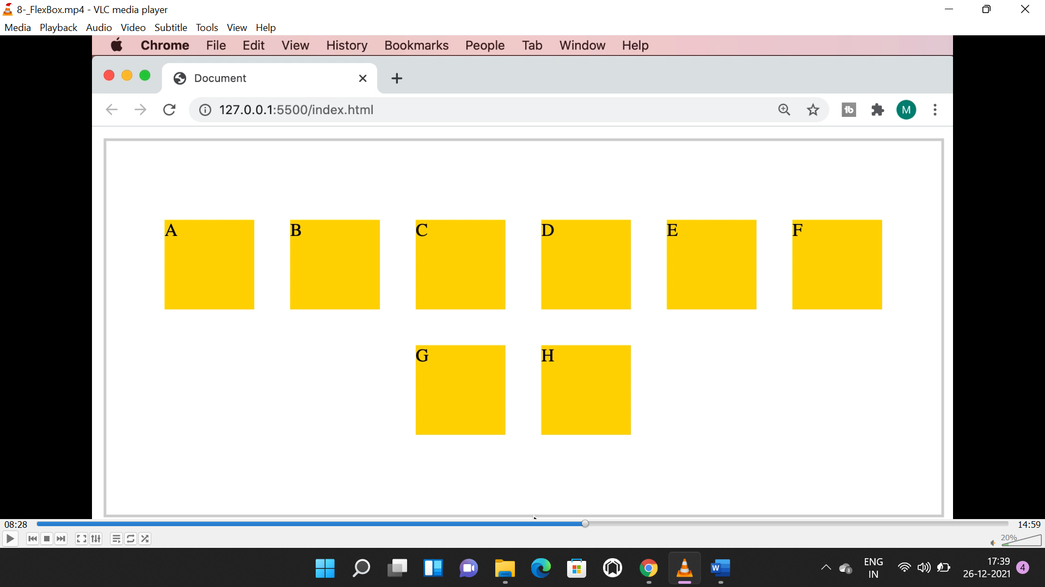

* “**align-self**” is used to align a single item and applied to item not container.

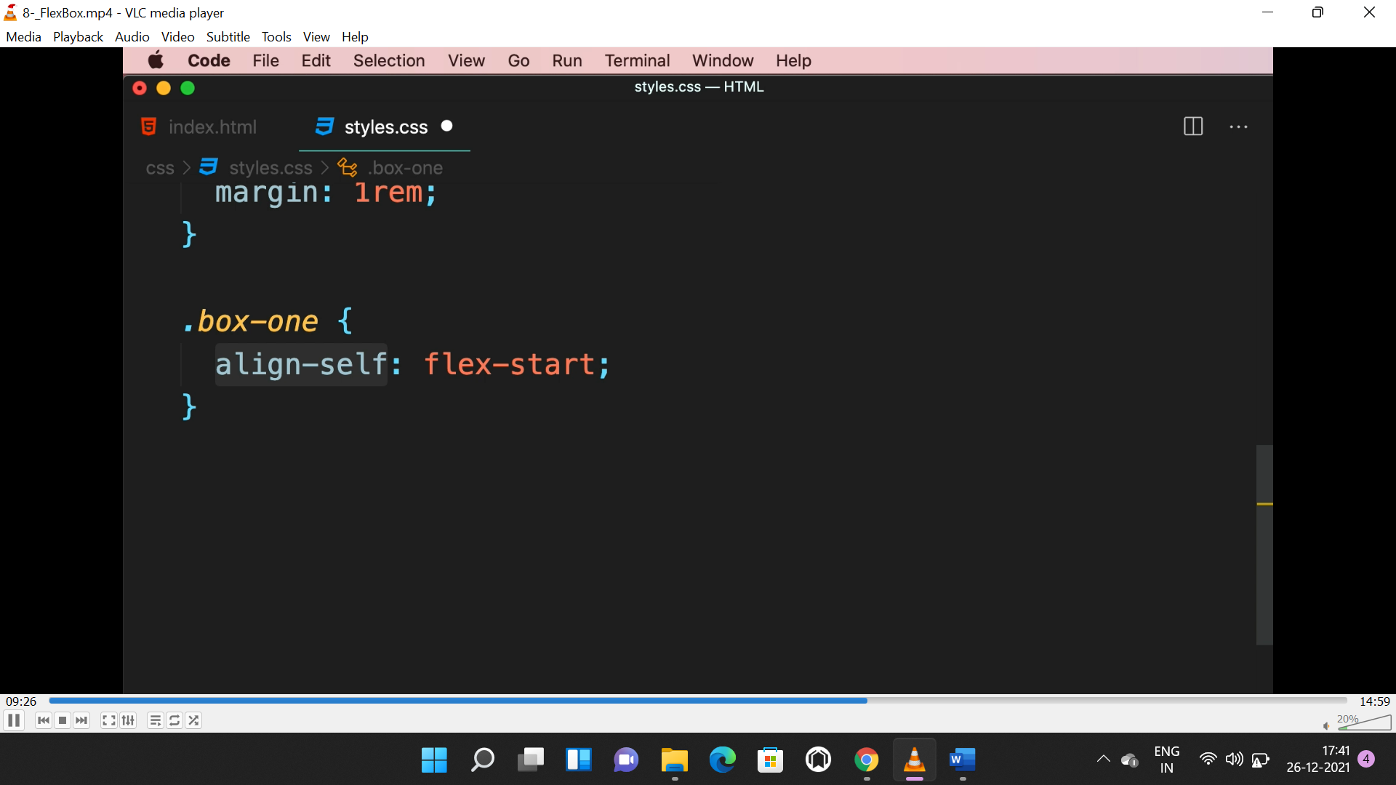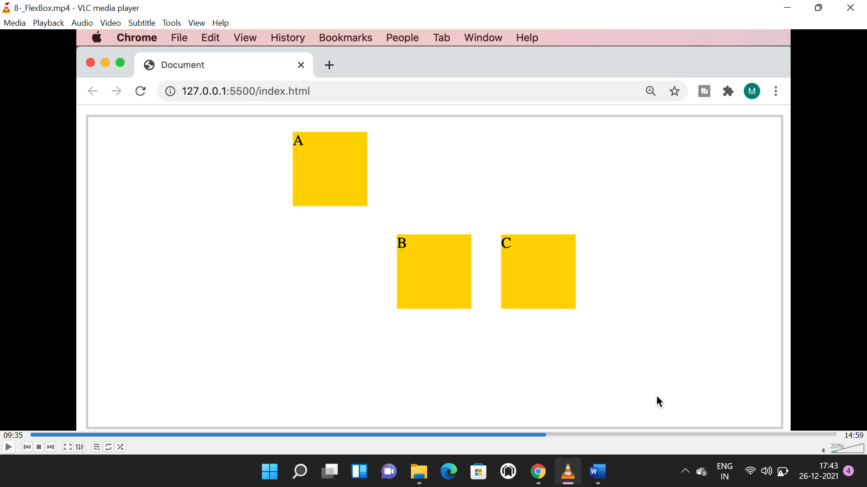

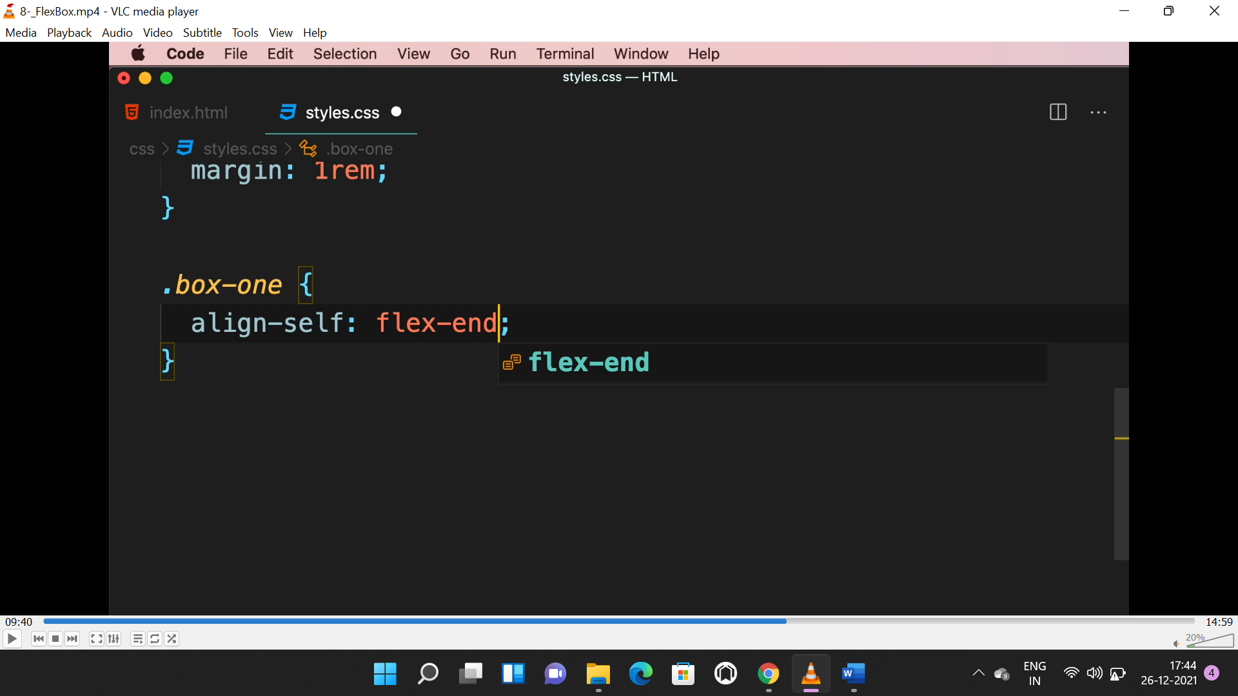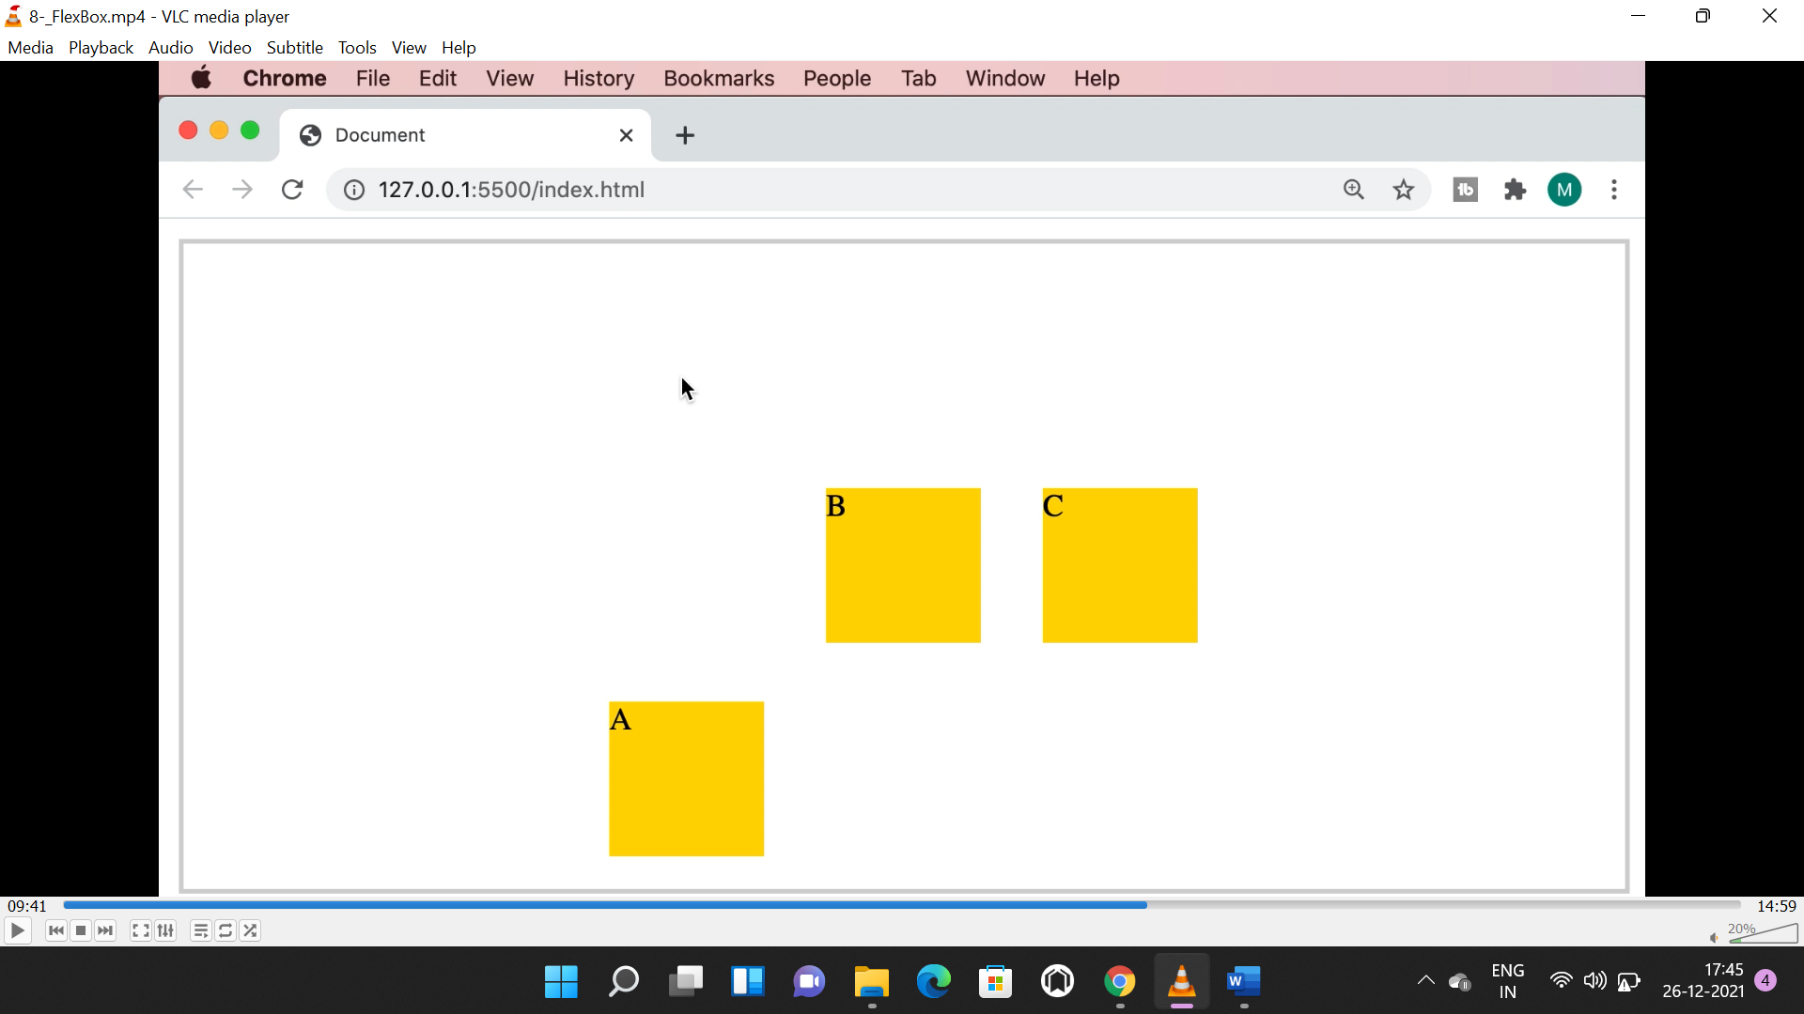

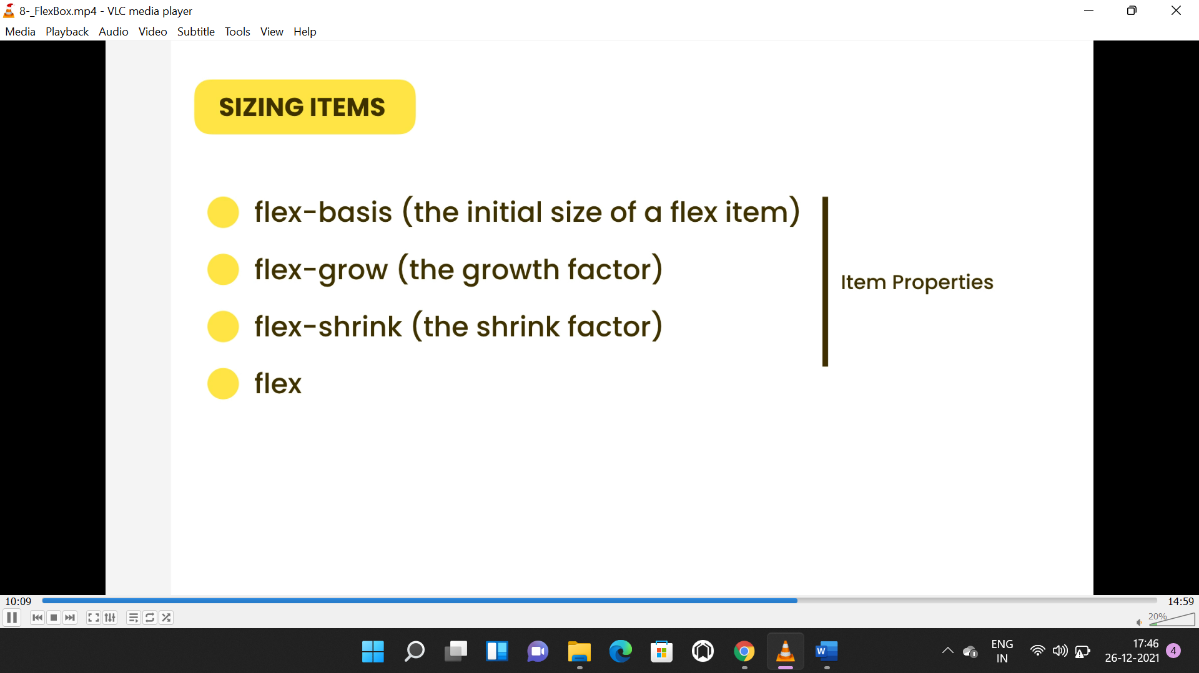

* All the above sizing properties applies to the items only, not container.

**FLEX-BASIS:**

* Flex basis is applied to hight and width.
* If the flex direction is row then “flex-basis” is applied to “width”.
* If the flex direction is column then “flex-basis” is applied to “hight”.
* The below style is applied to the container.

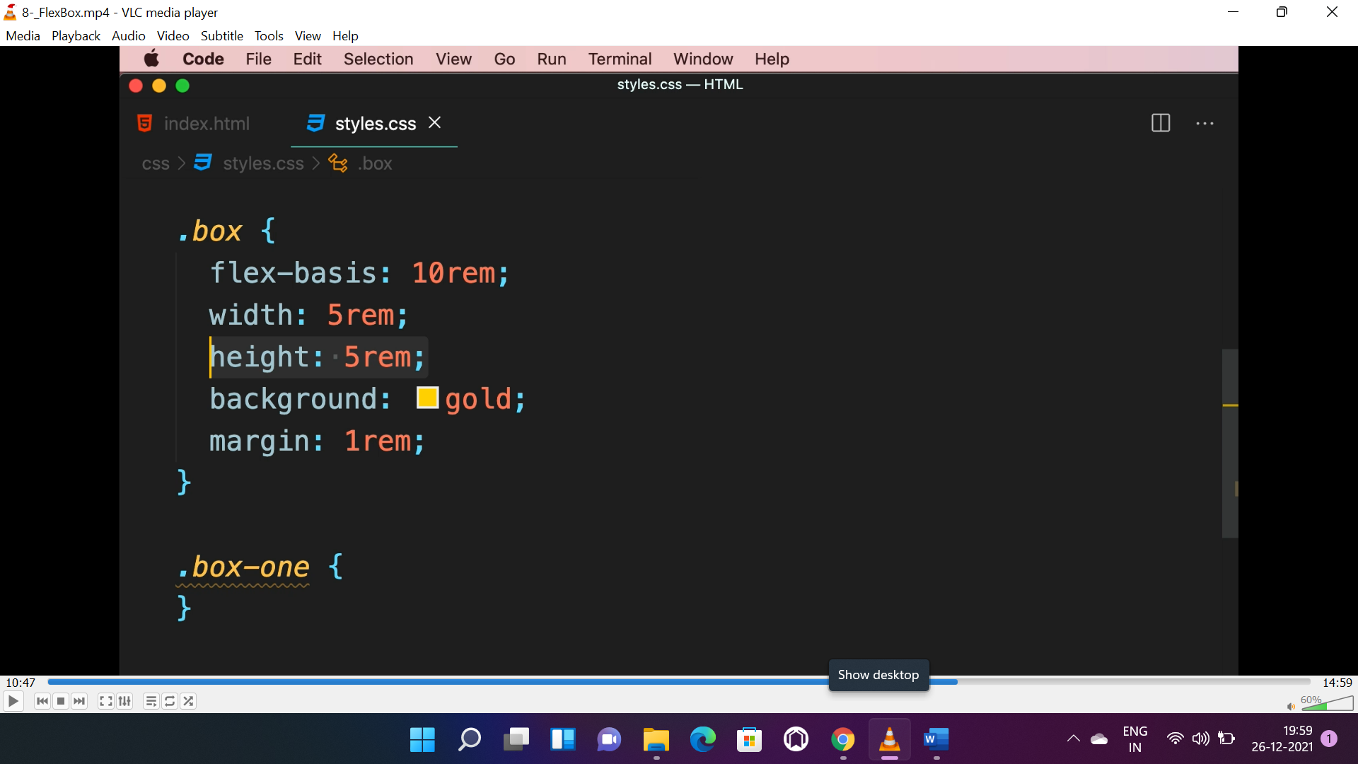 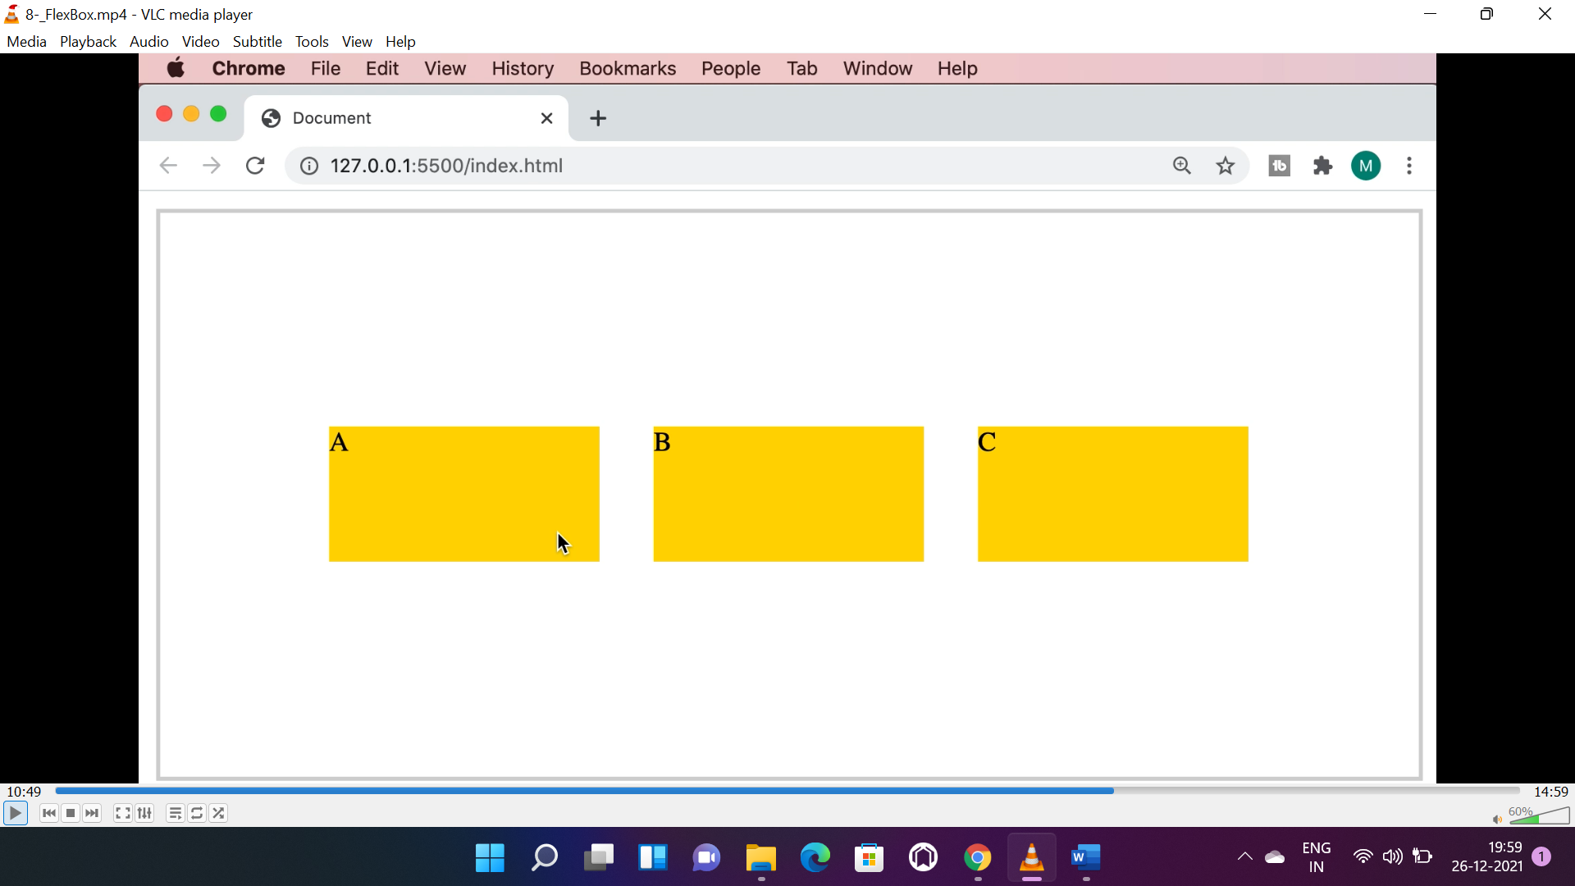

* We can apply it to individual container as well.

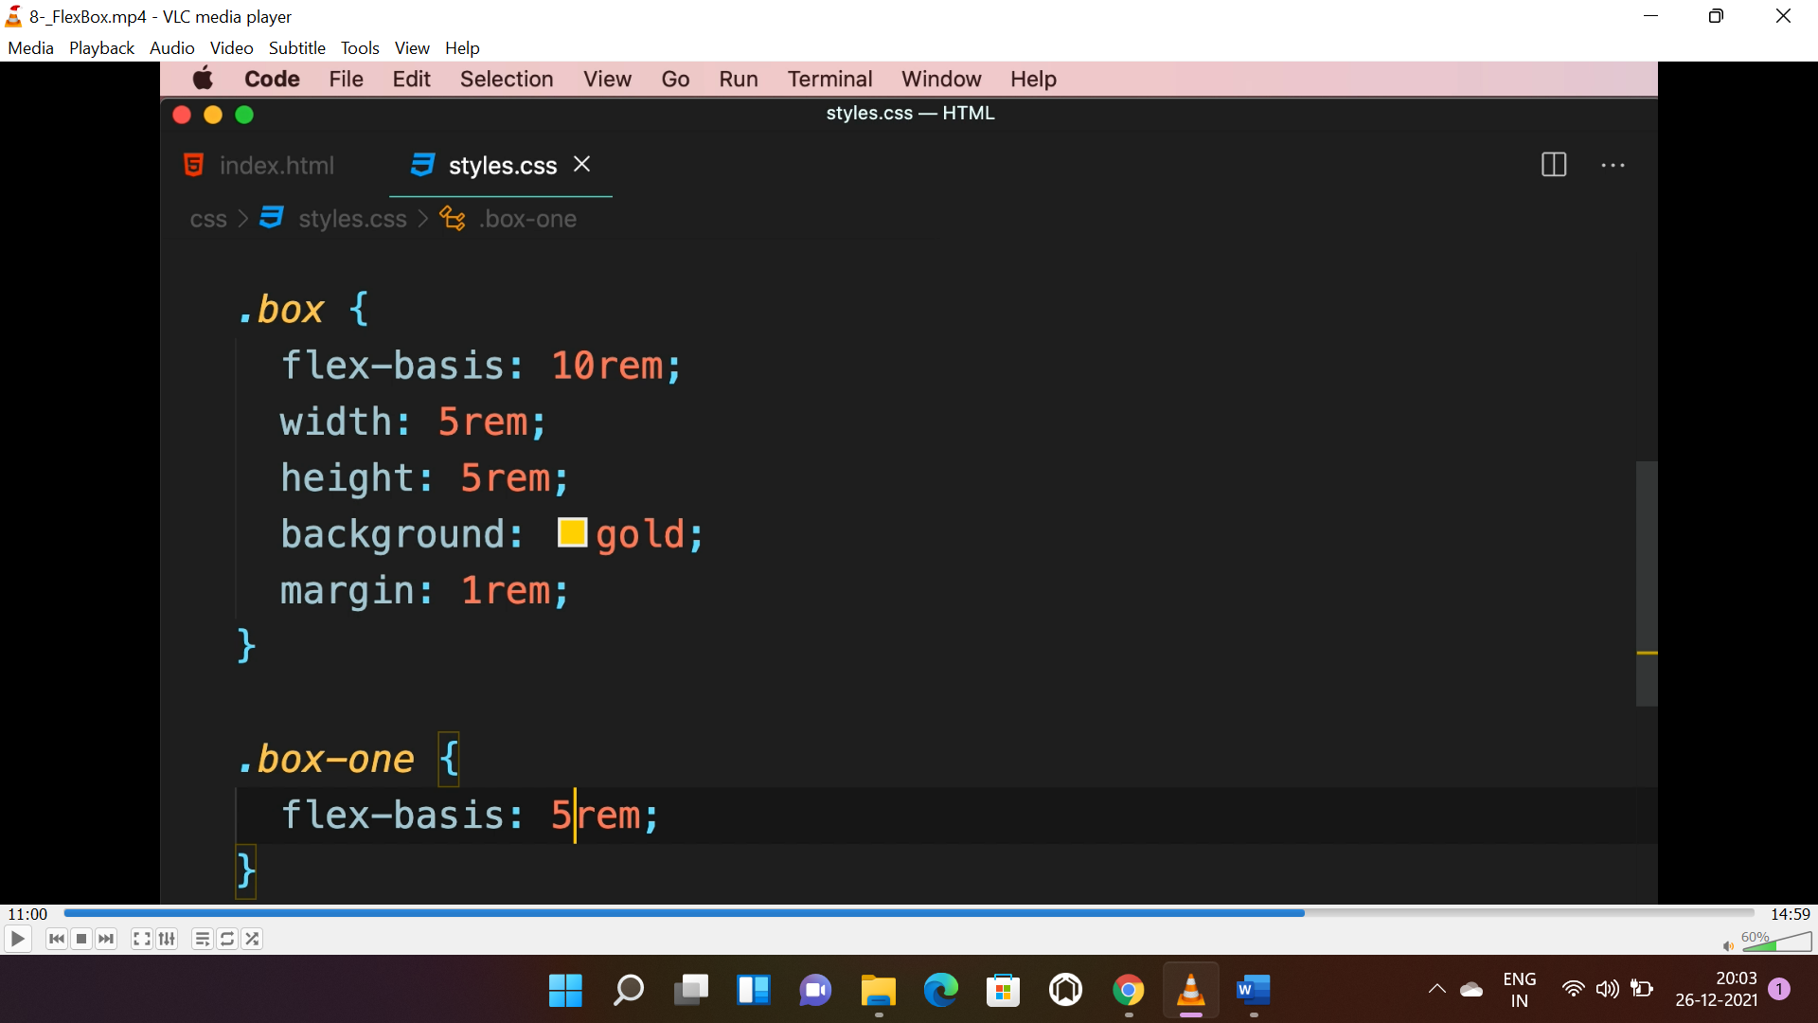 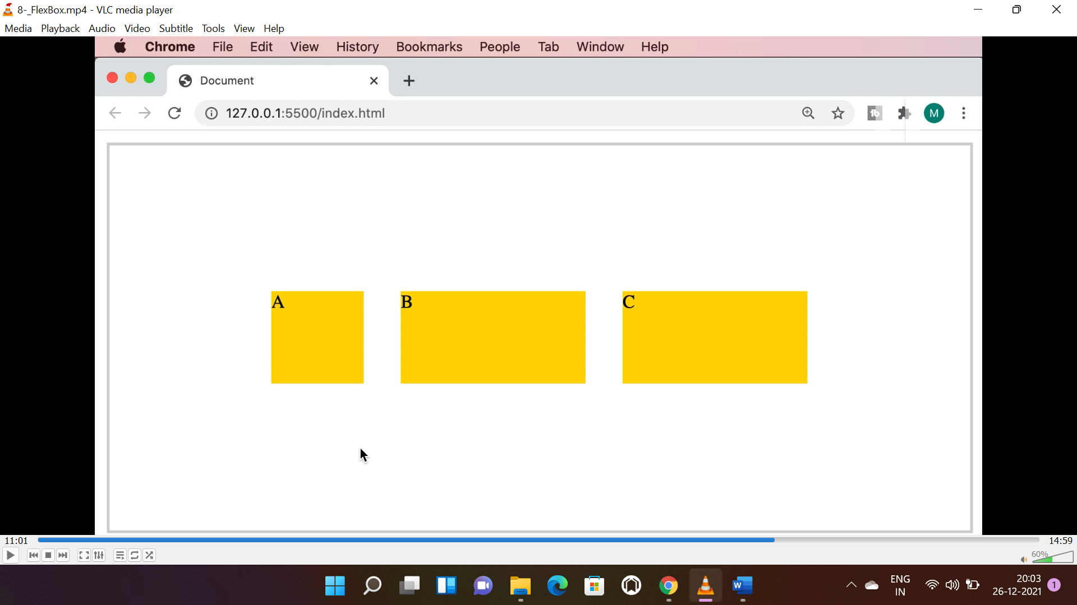

**FLEX GROW:**

* Used to cover the available space.
* By default the value is “0”, we can use value “1” to expand and take entire space.

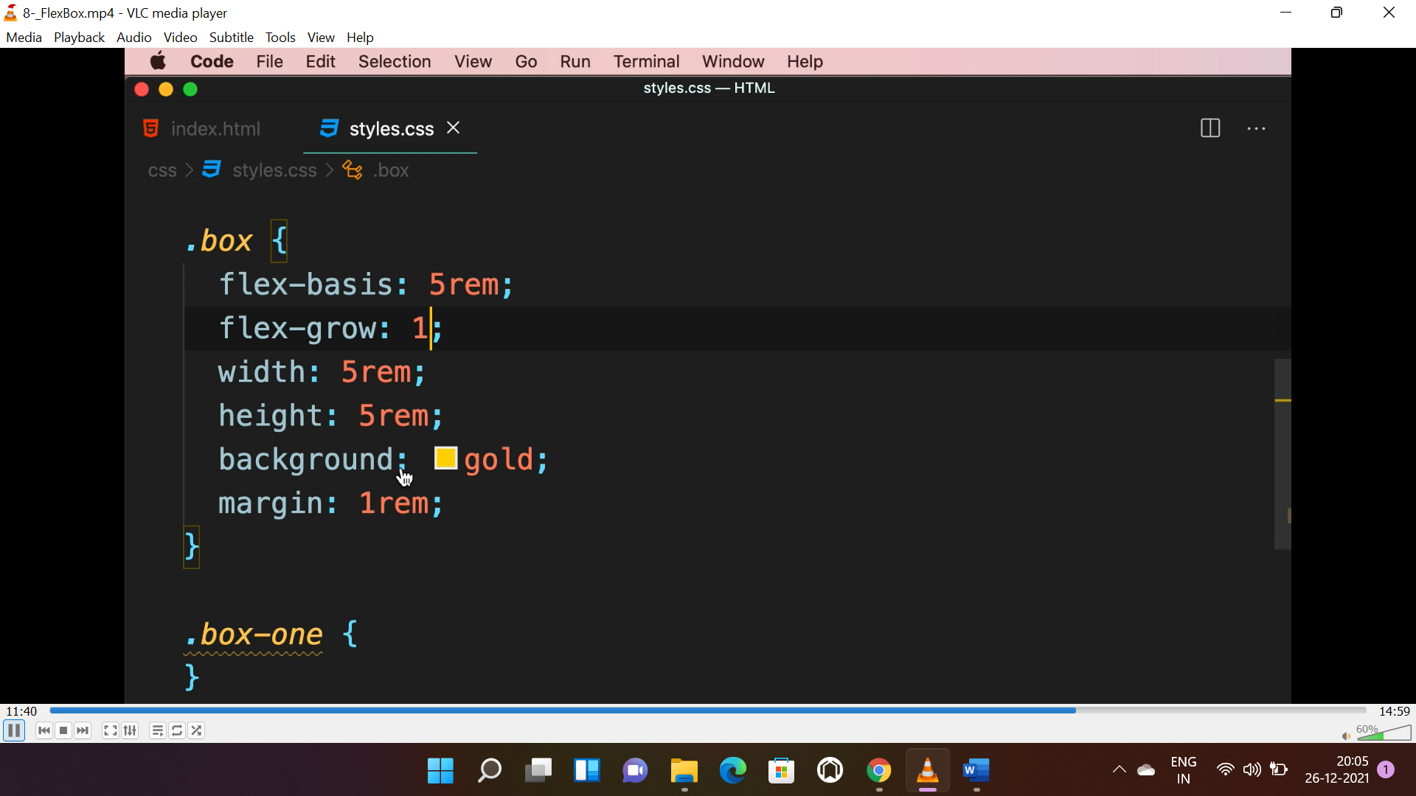 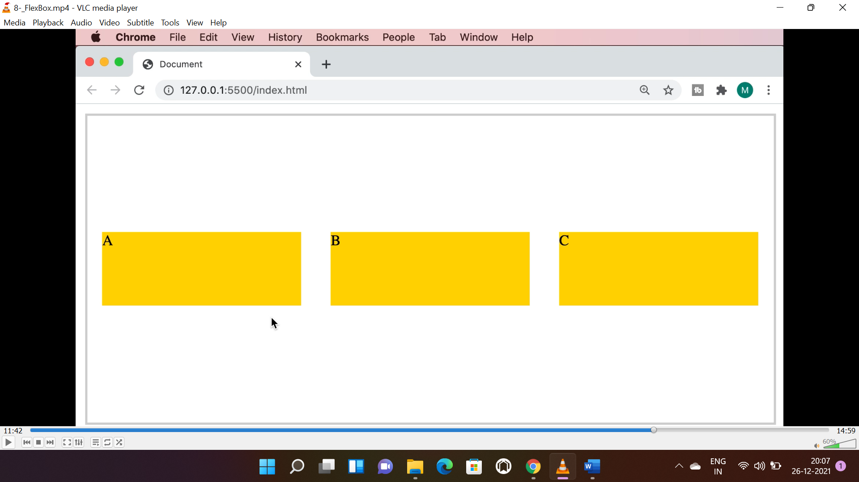

* We can apply it to individual items too.

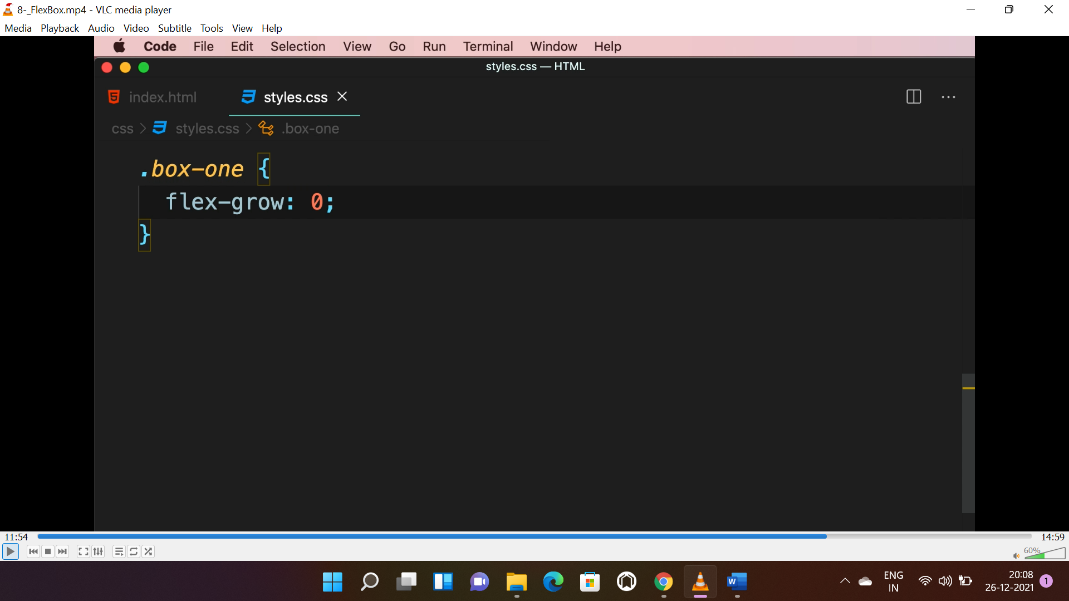 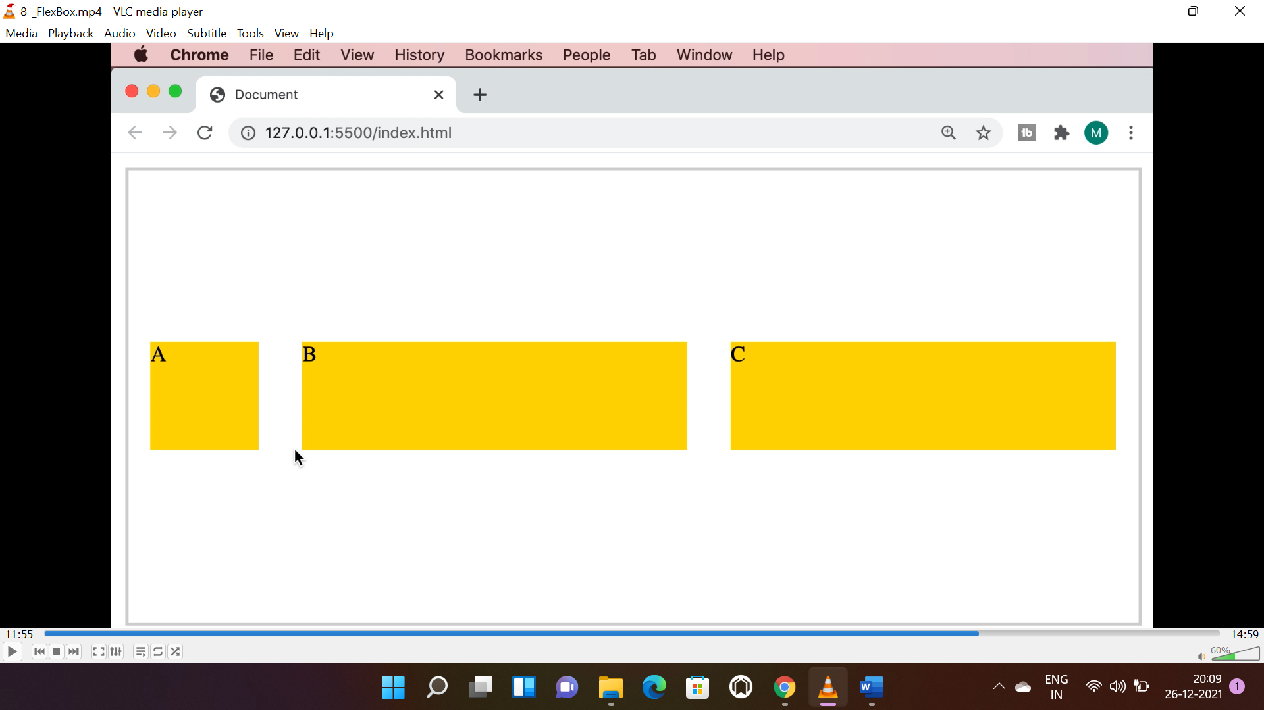

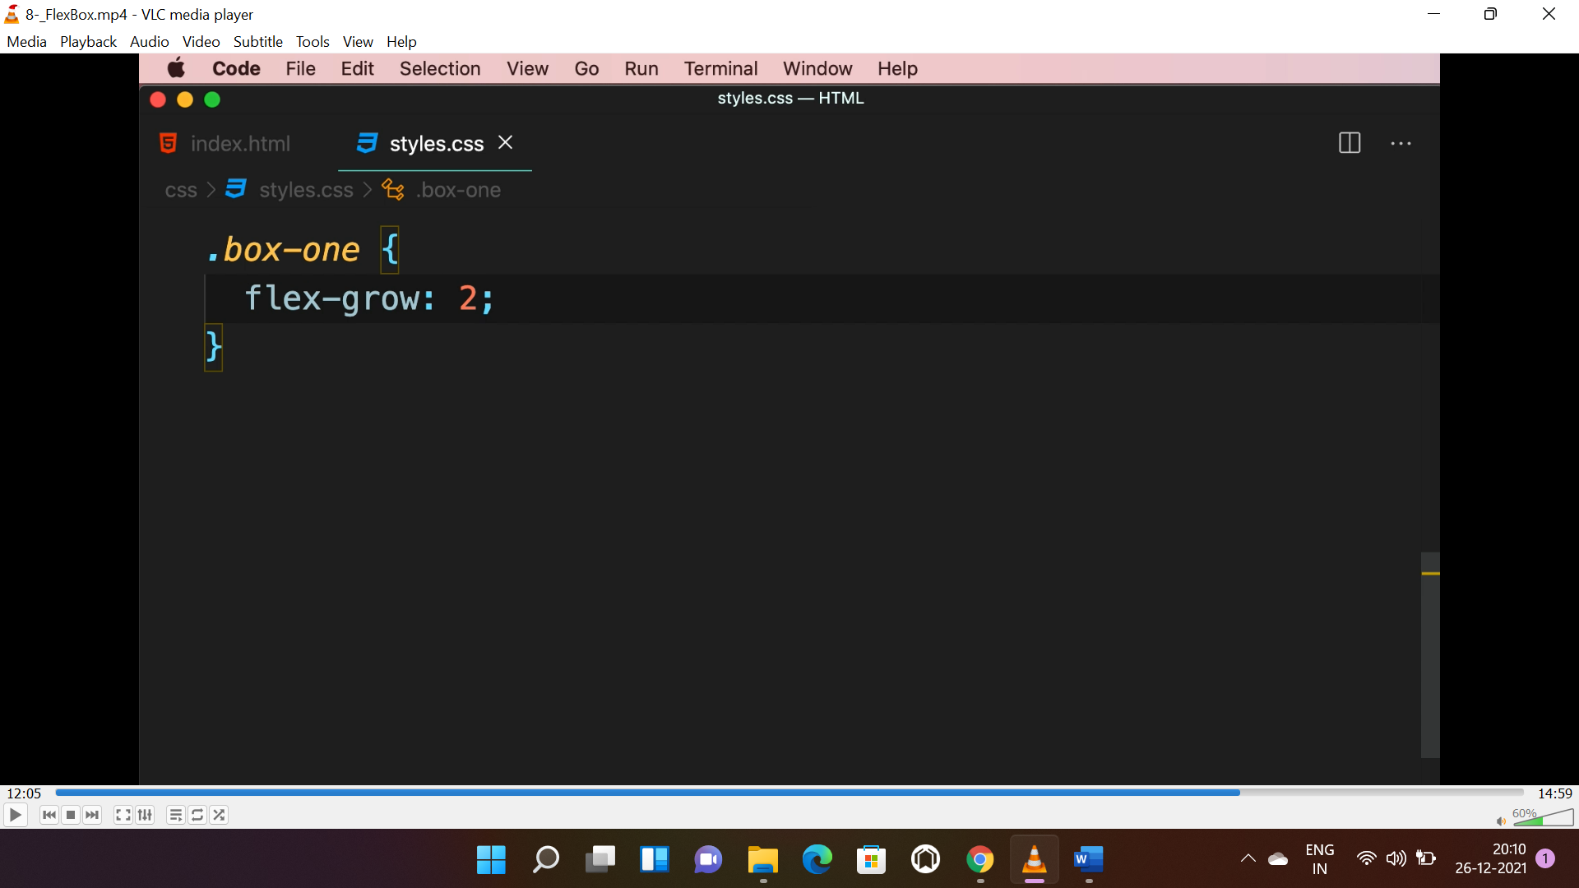 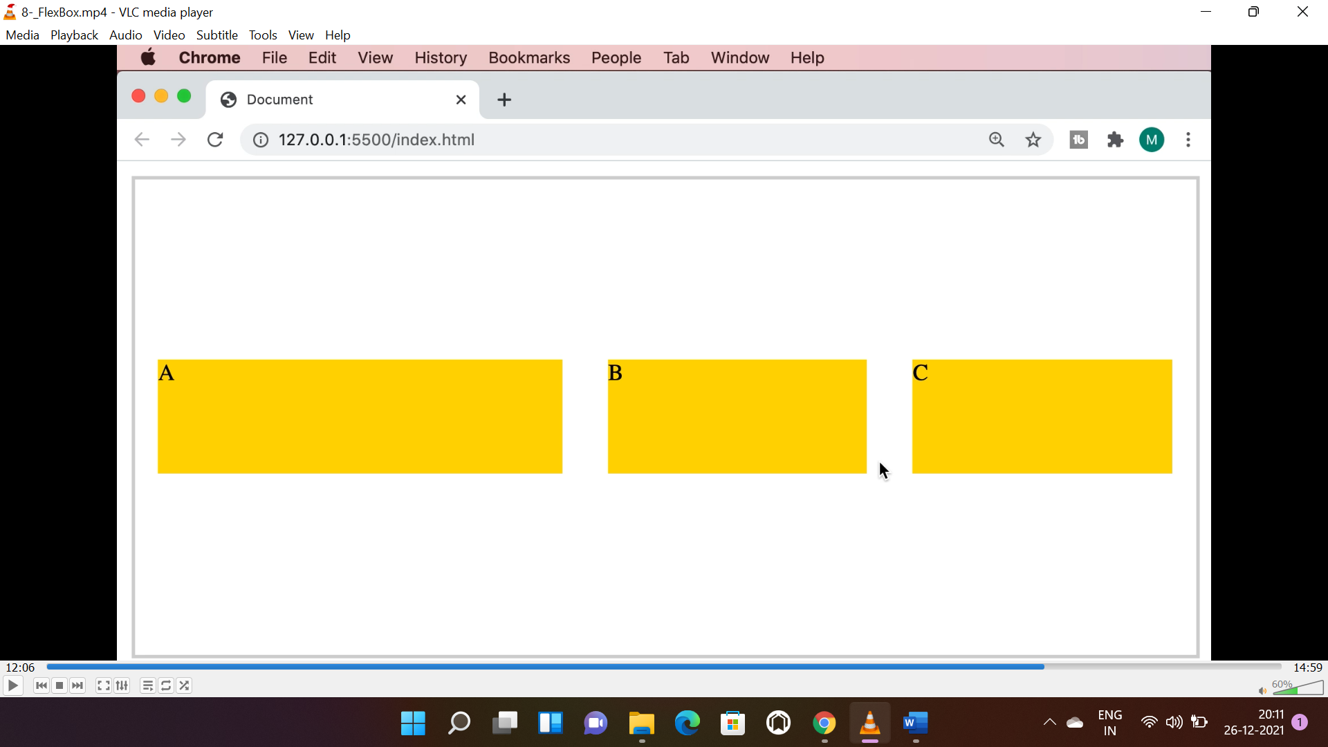

**FLEX-SHRINK:**

* It is opposite of “**flex-grow”.** it shrinks if there is shortage of space.
* Below initially the “flex-basis” property is 15rem, when the browser window shrinks the boxes will automatically shrink.

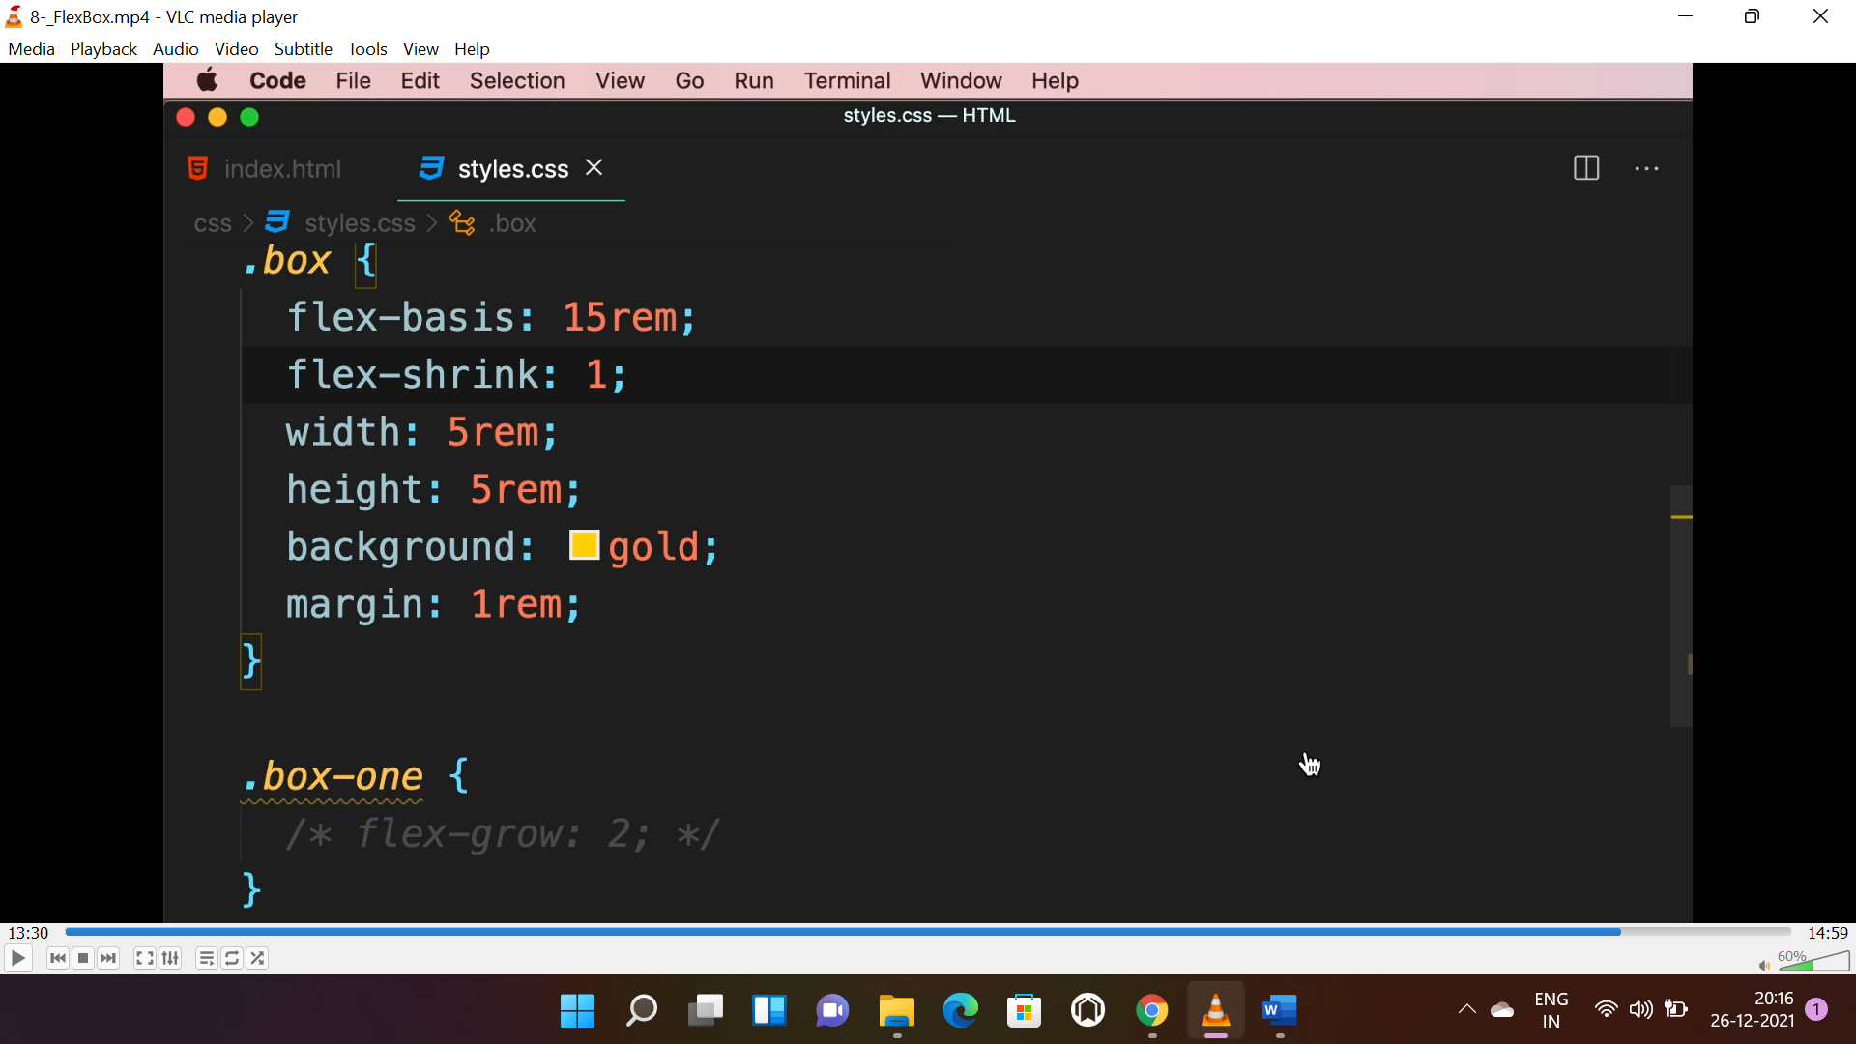 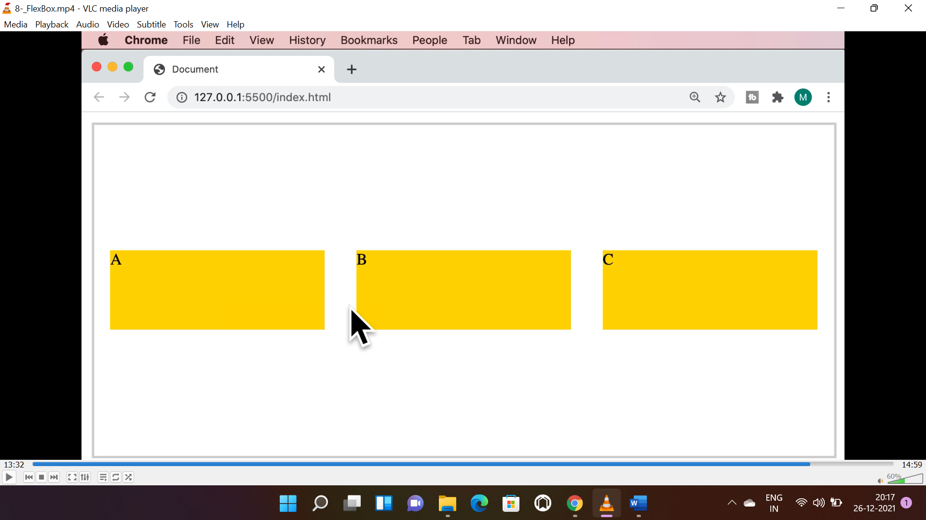

* To prevent shrinking a single element we will apply “0” value to shrink property.

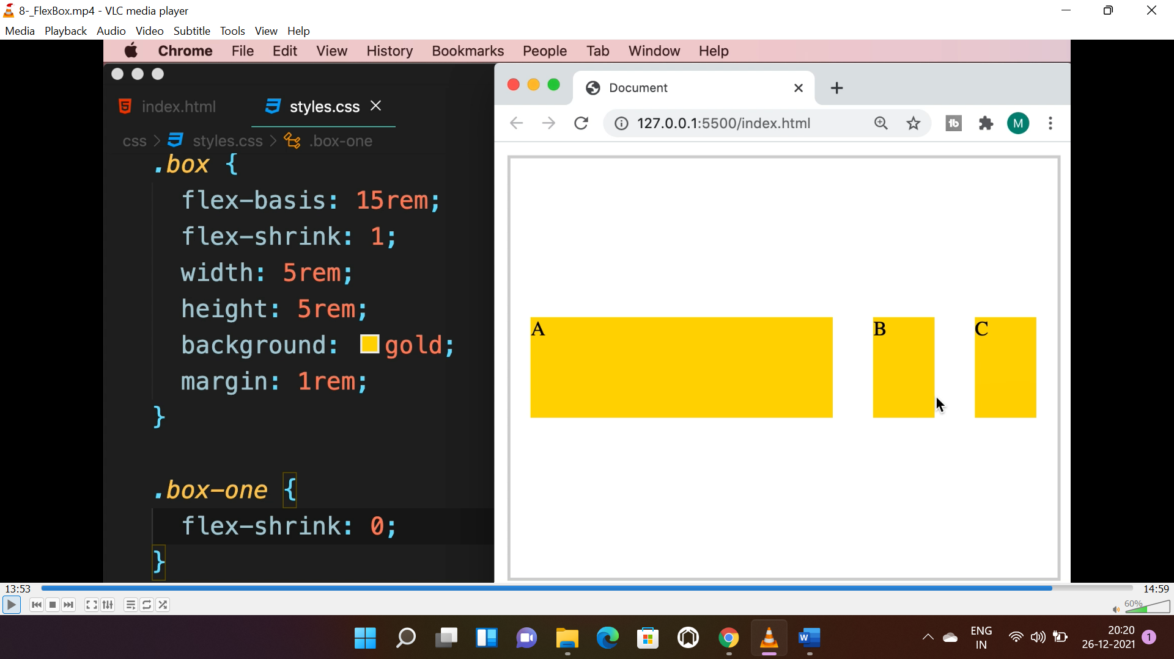

**FLEX:**

* **Flex is combination of “flex-grow”, “flex-shrink” and “flex-basis” respectively.**
* **1st** value is “flex-grow”, 2nd is either “flex-shrink”, if just a number is provided **eg:-2** or “flex-basis”, if unit is provided along with number **eg:-15rem**.

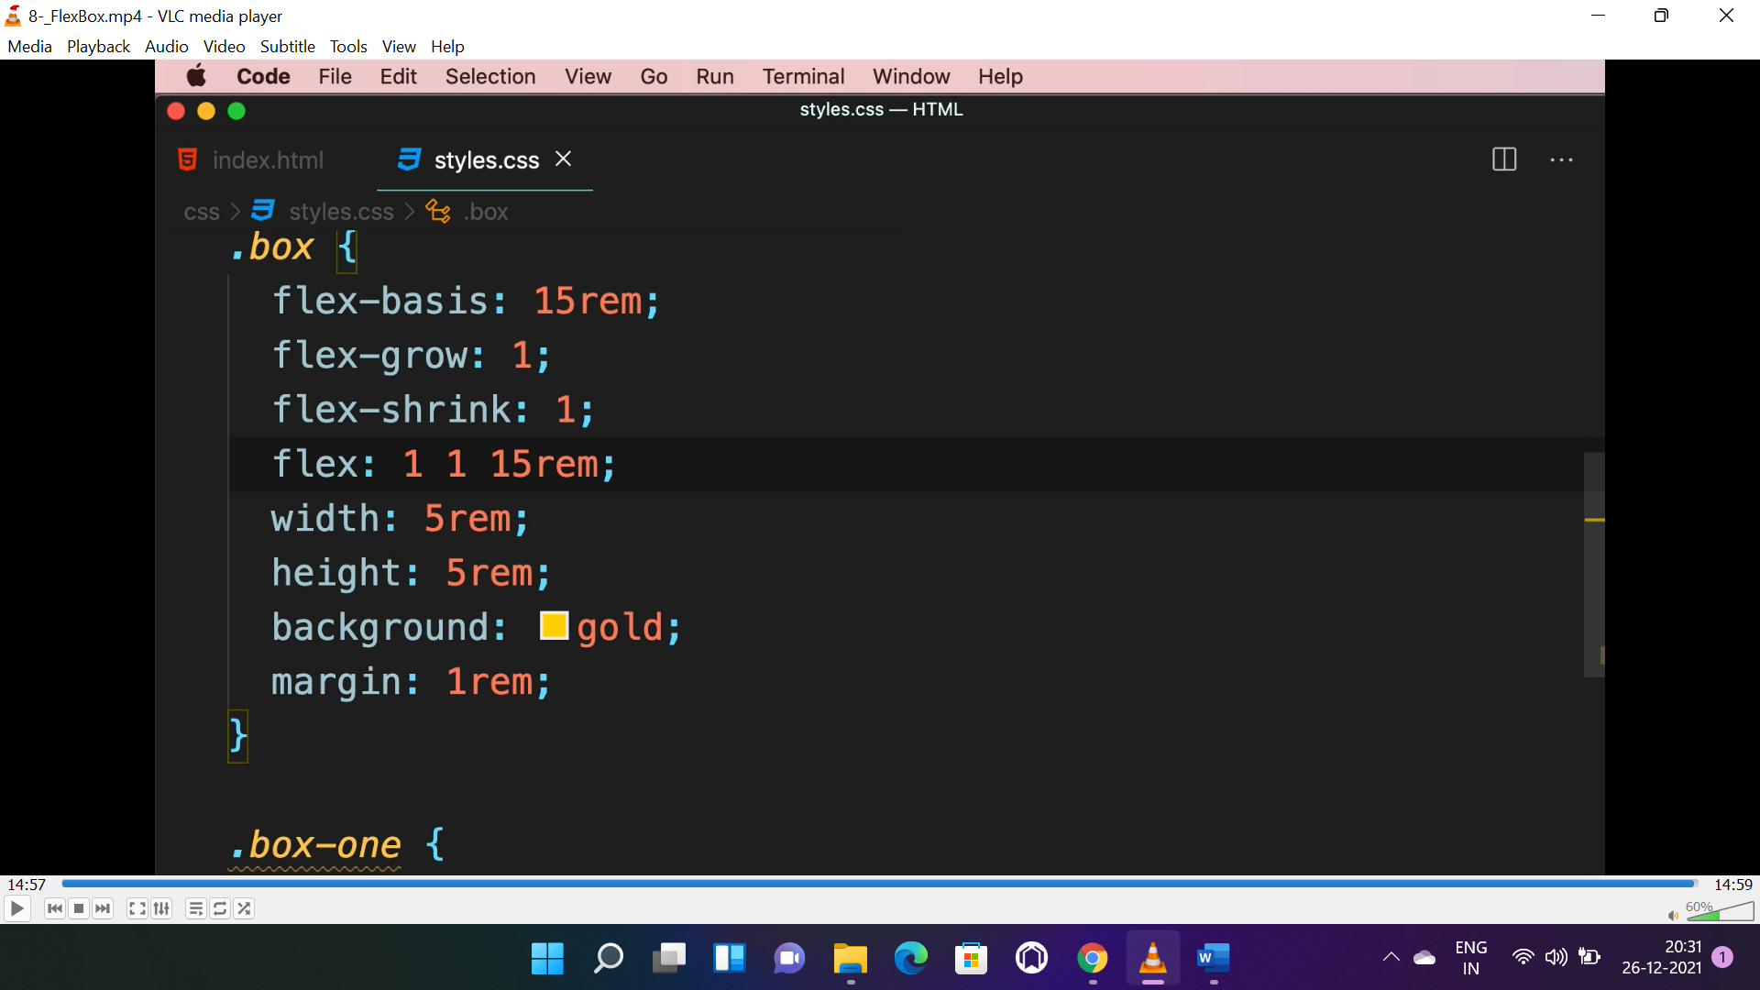

**MEDIA QUERIES:-**

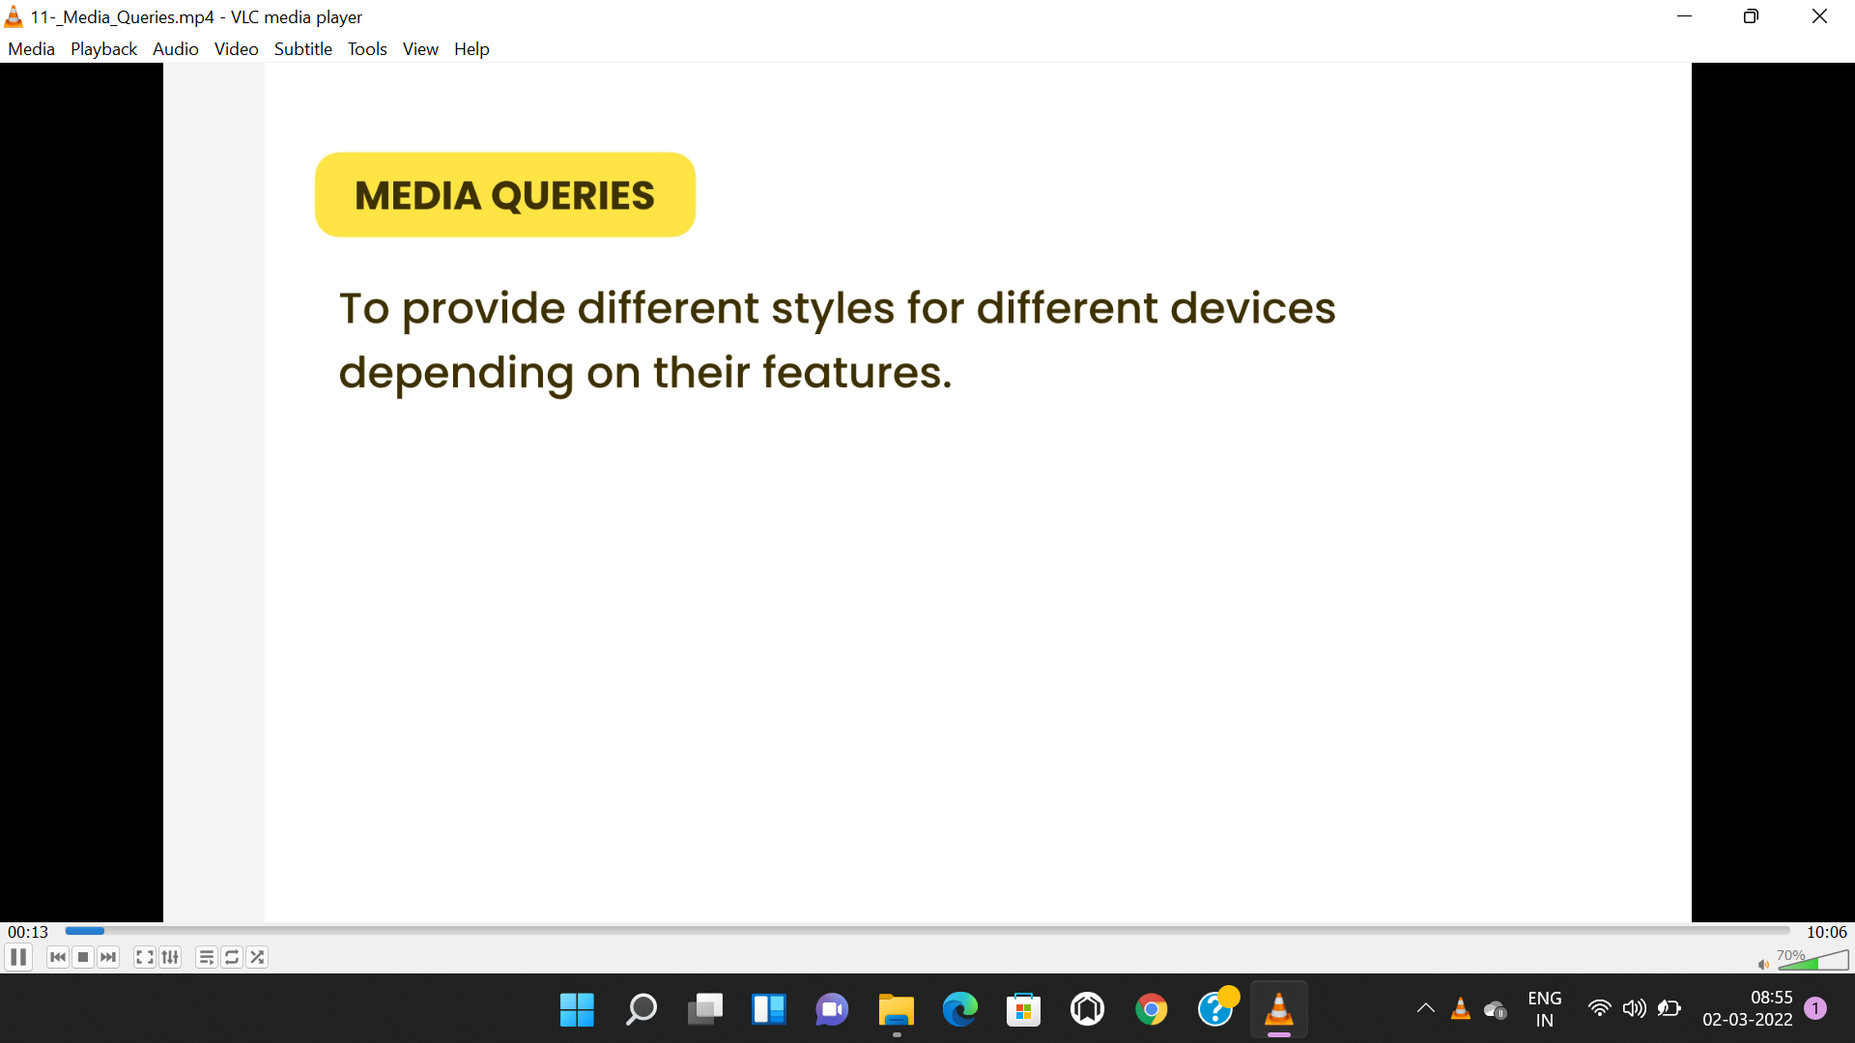

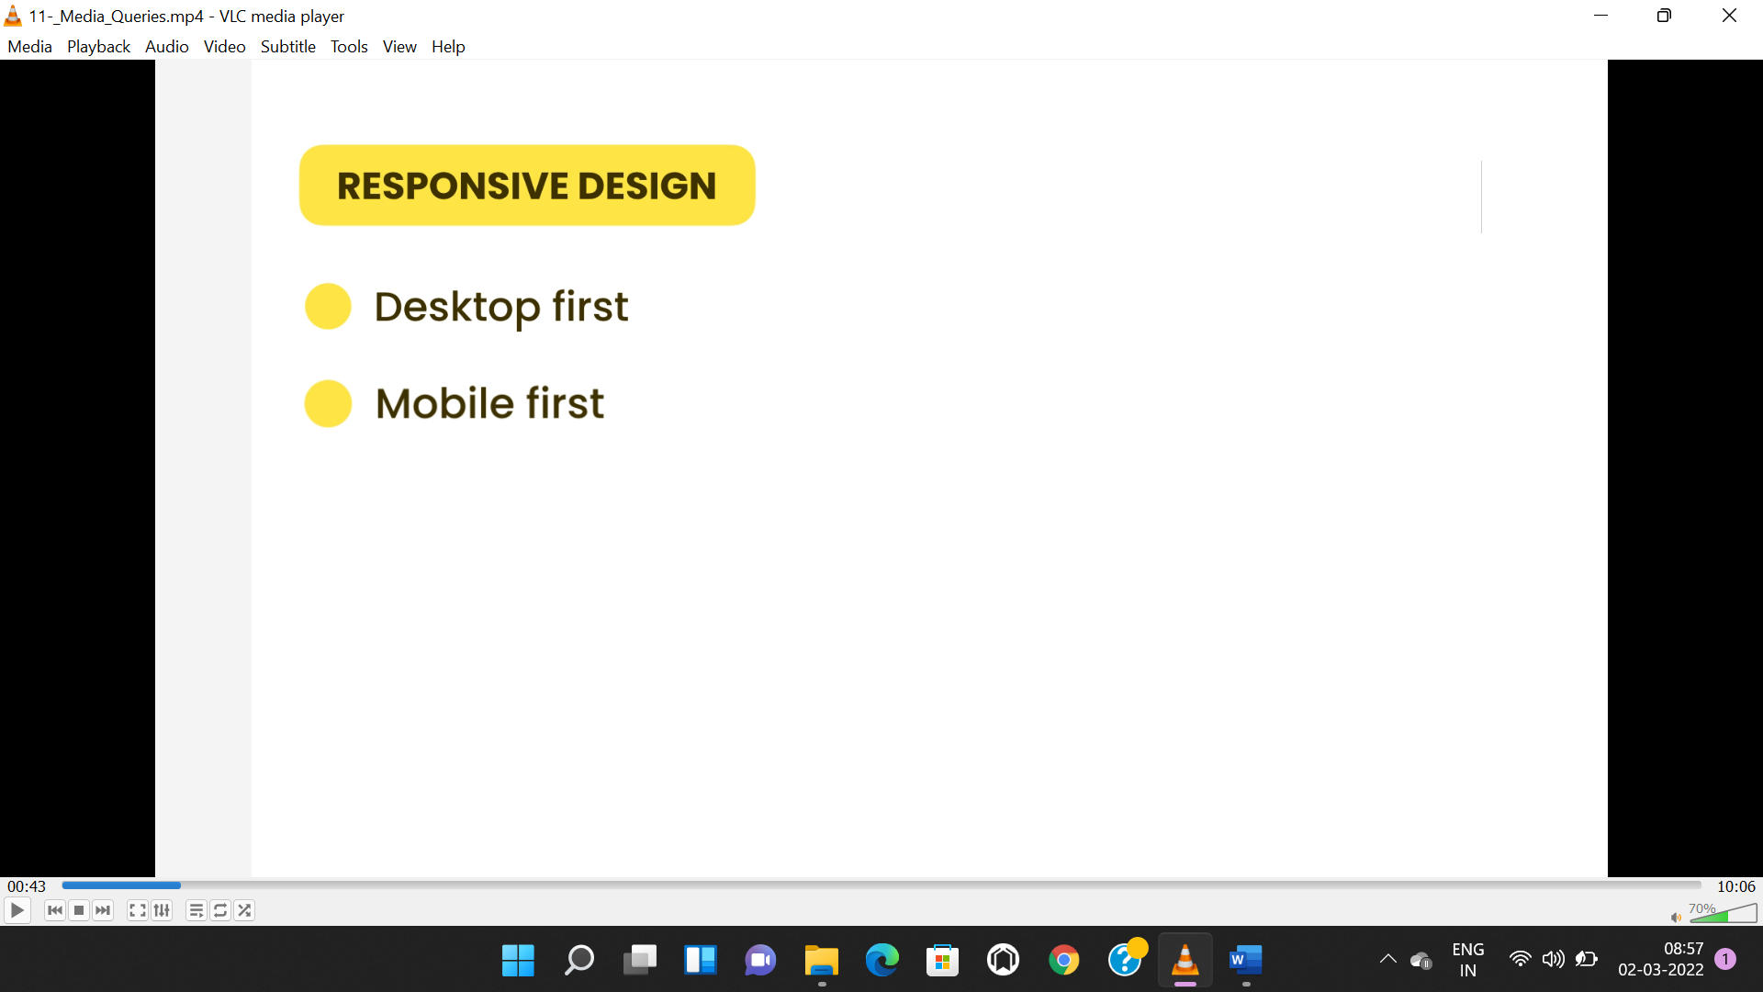

* To apply different style based on the device width “media queries” used.
* Here conditions are written after the media type **(screen or print)** separated by a **“and”** operator.

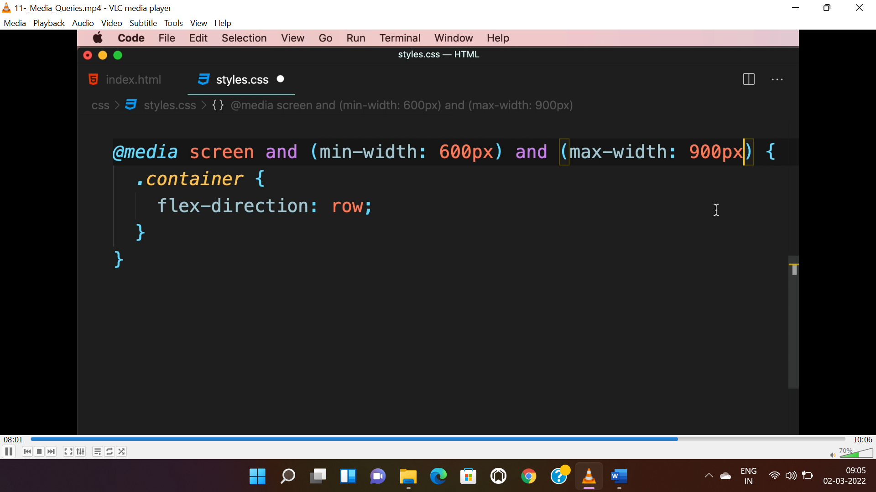

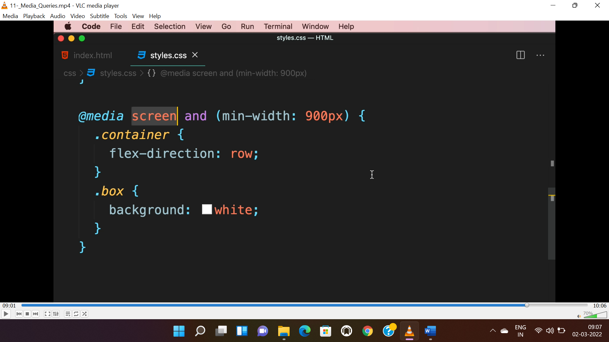

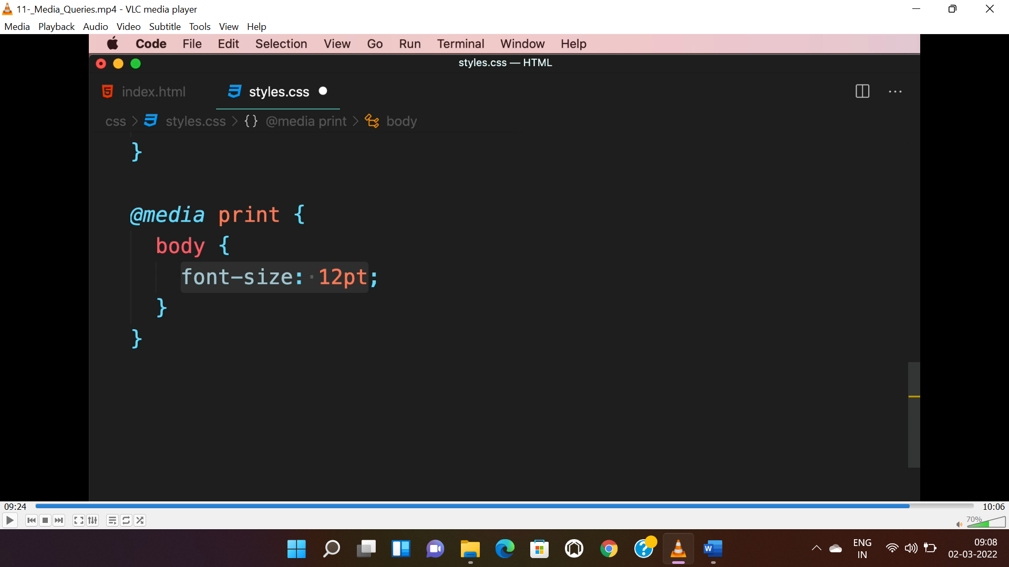

**FONT STYLING:-**

* There are 3 types of fonts.

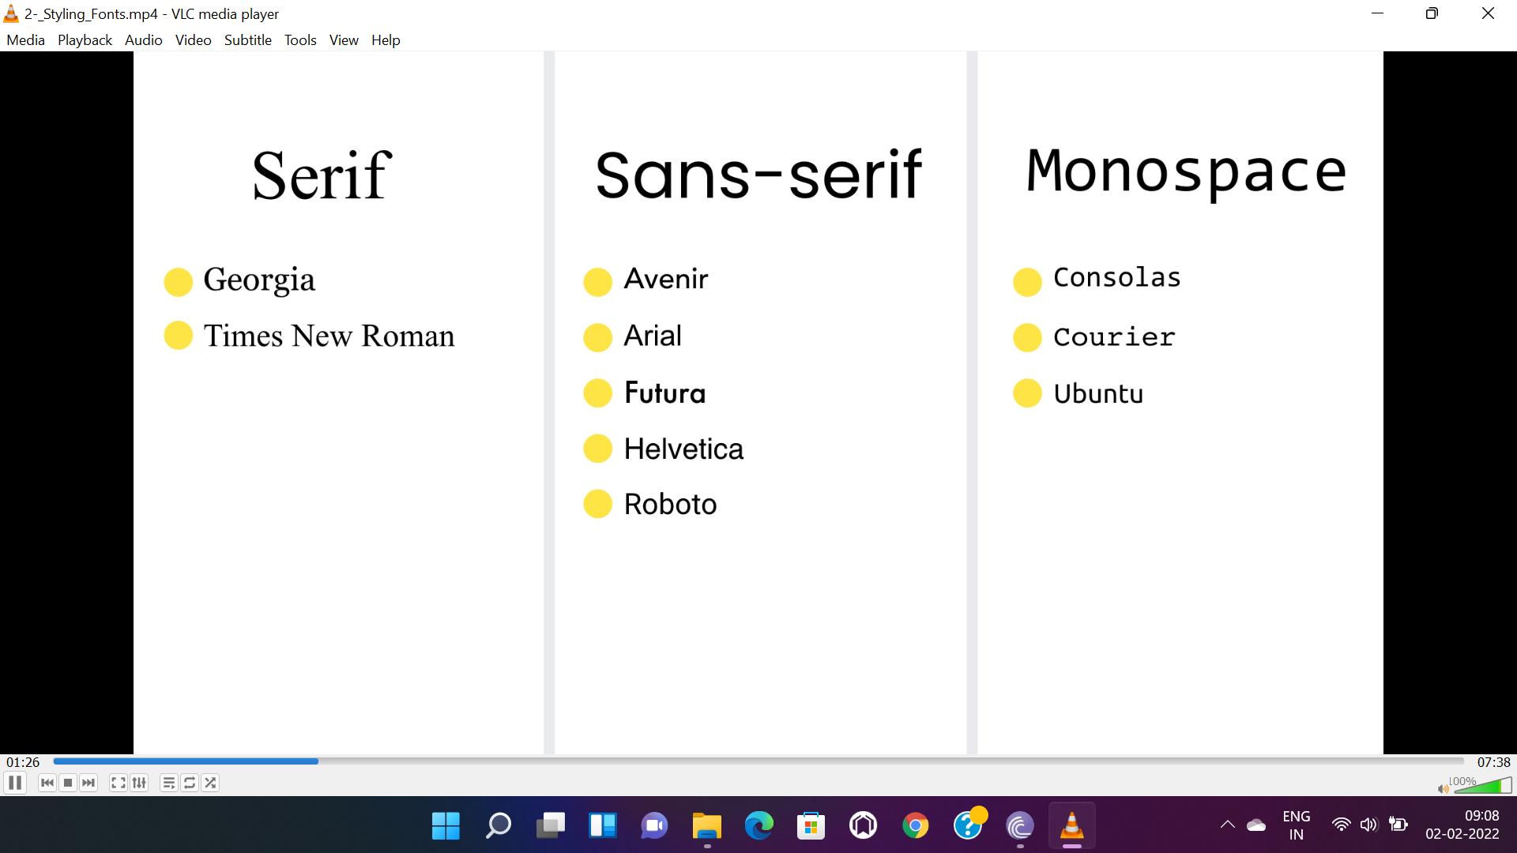

* In a “font-stack” css checks 1st font availability then 2nd the 3rd and generic one.

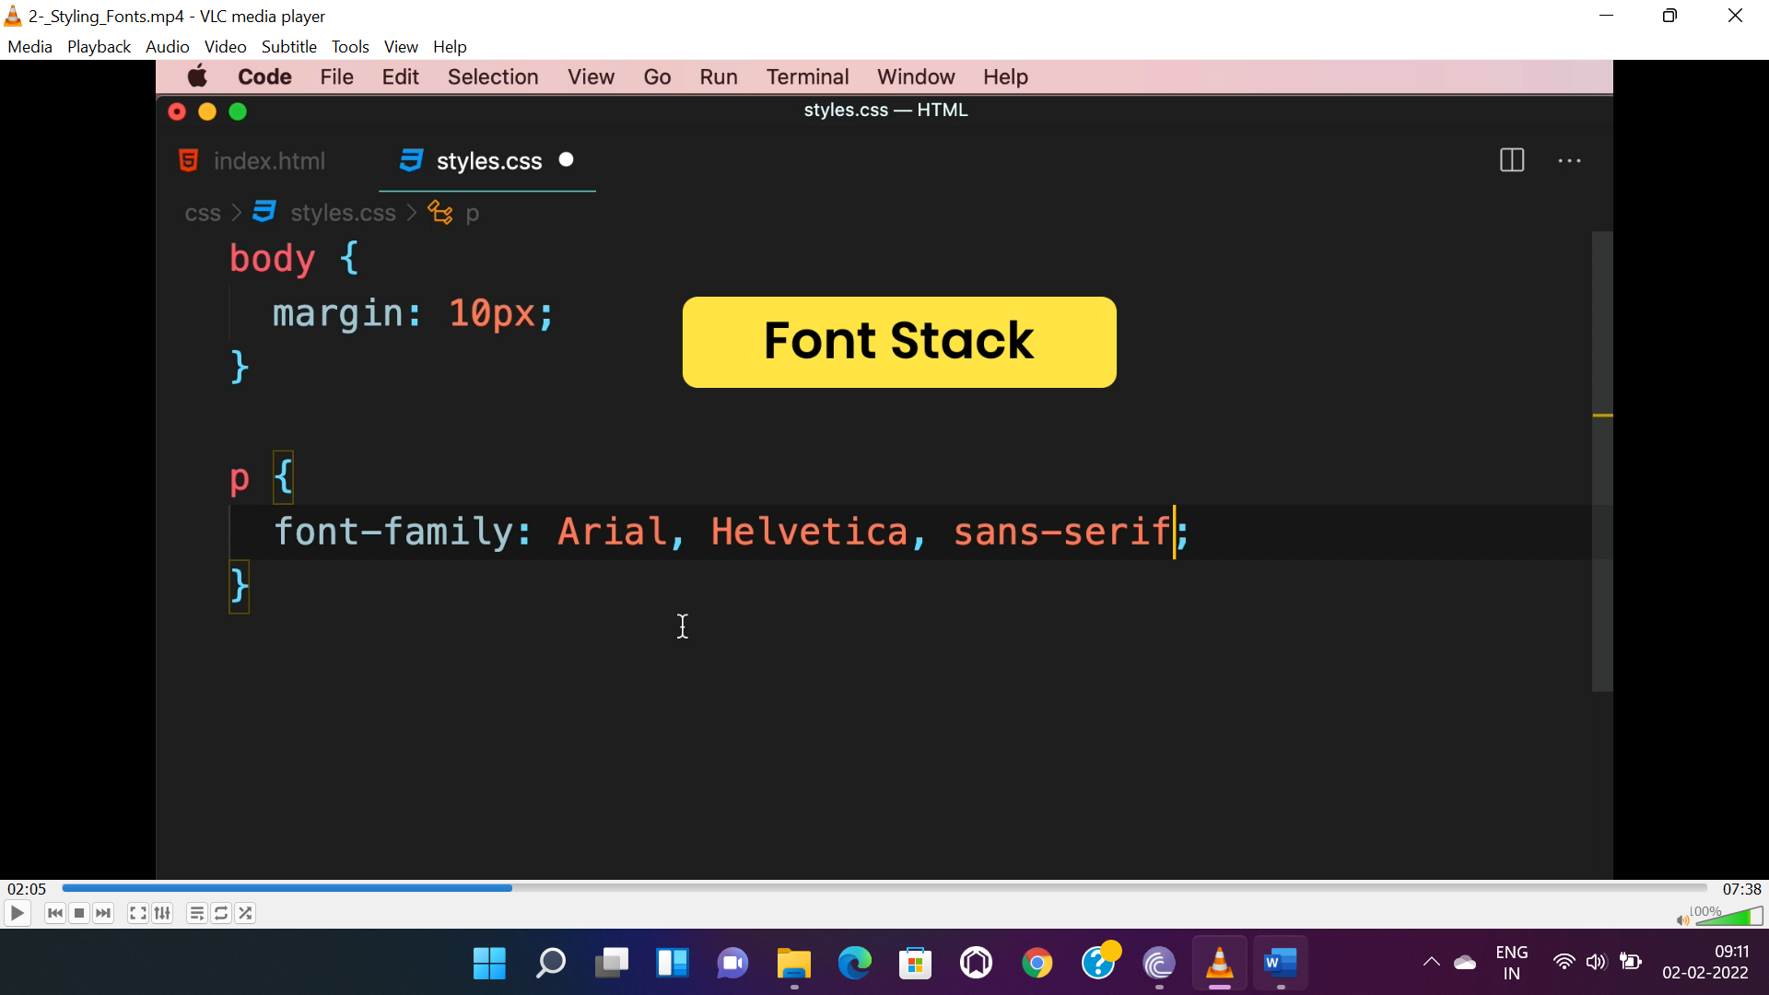

**APPLICATION:-**

* It is recommended to apply the font style in parent or root element, other element will inherit from it. To specify style for a component we need to define it separately.

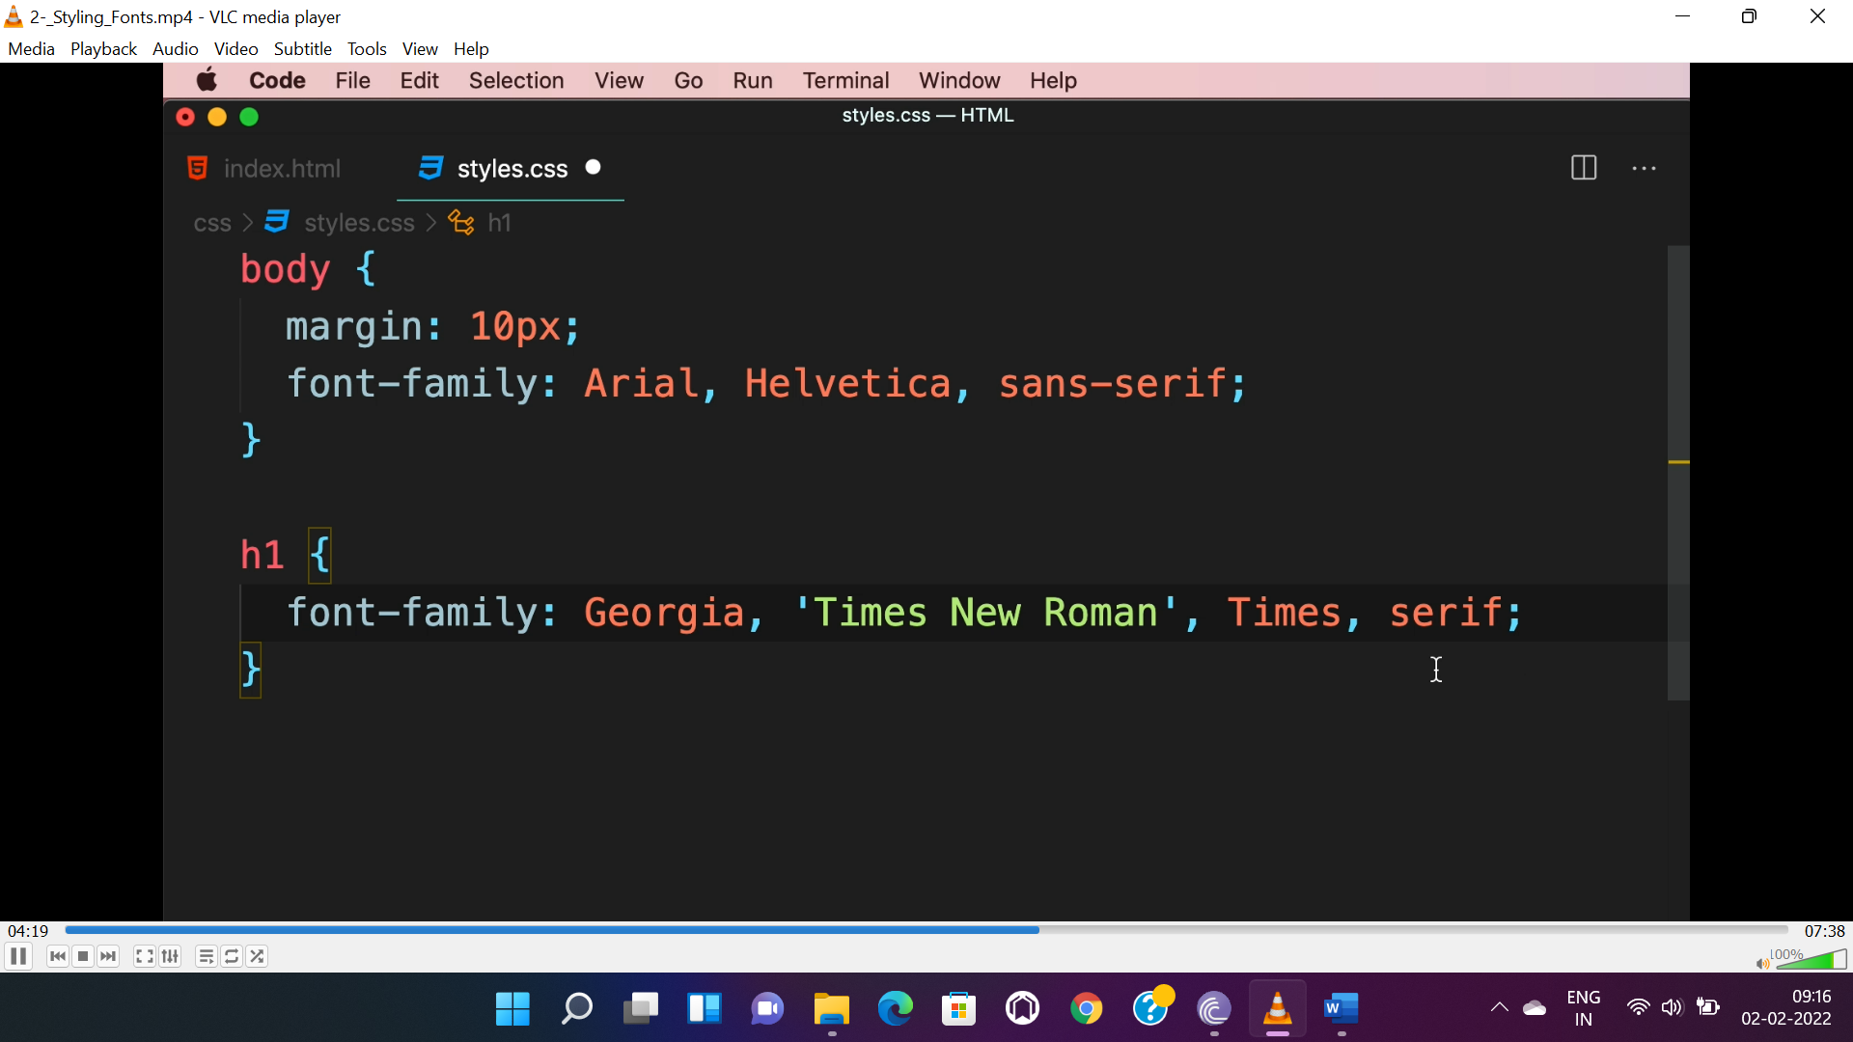

**PROPERTIES:-**

* “font-weight” property is to make font bolder and rangers from 100 to 900.

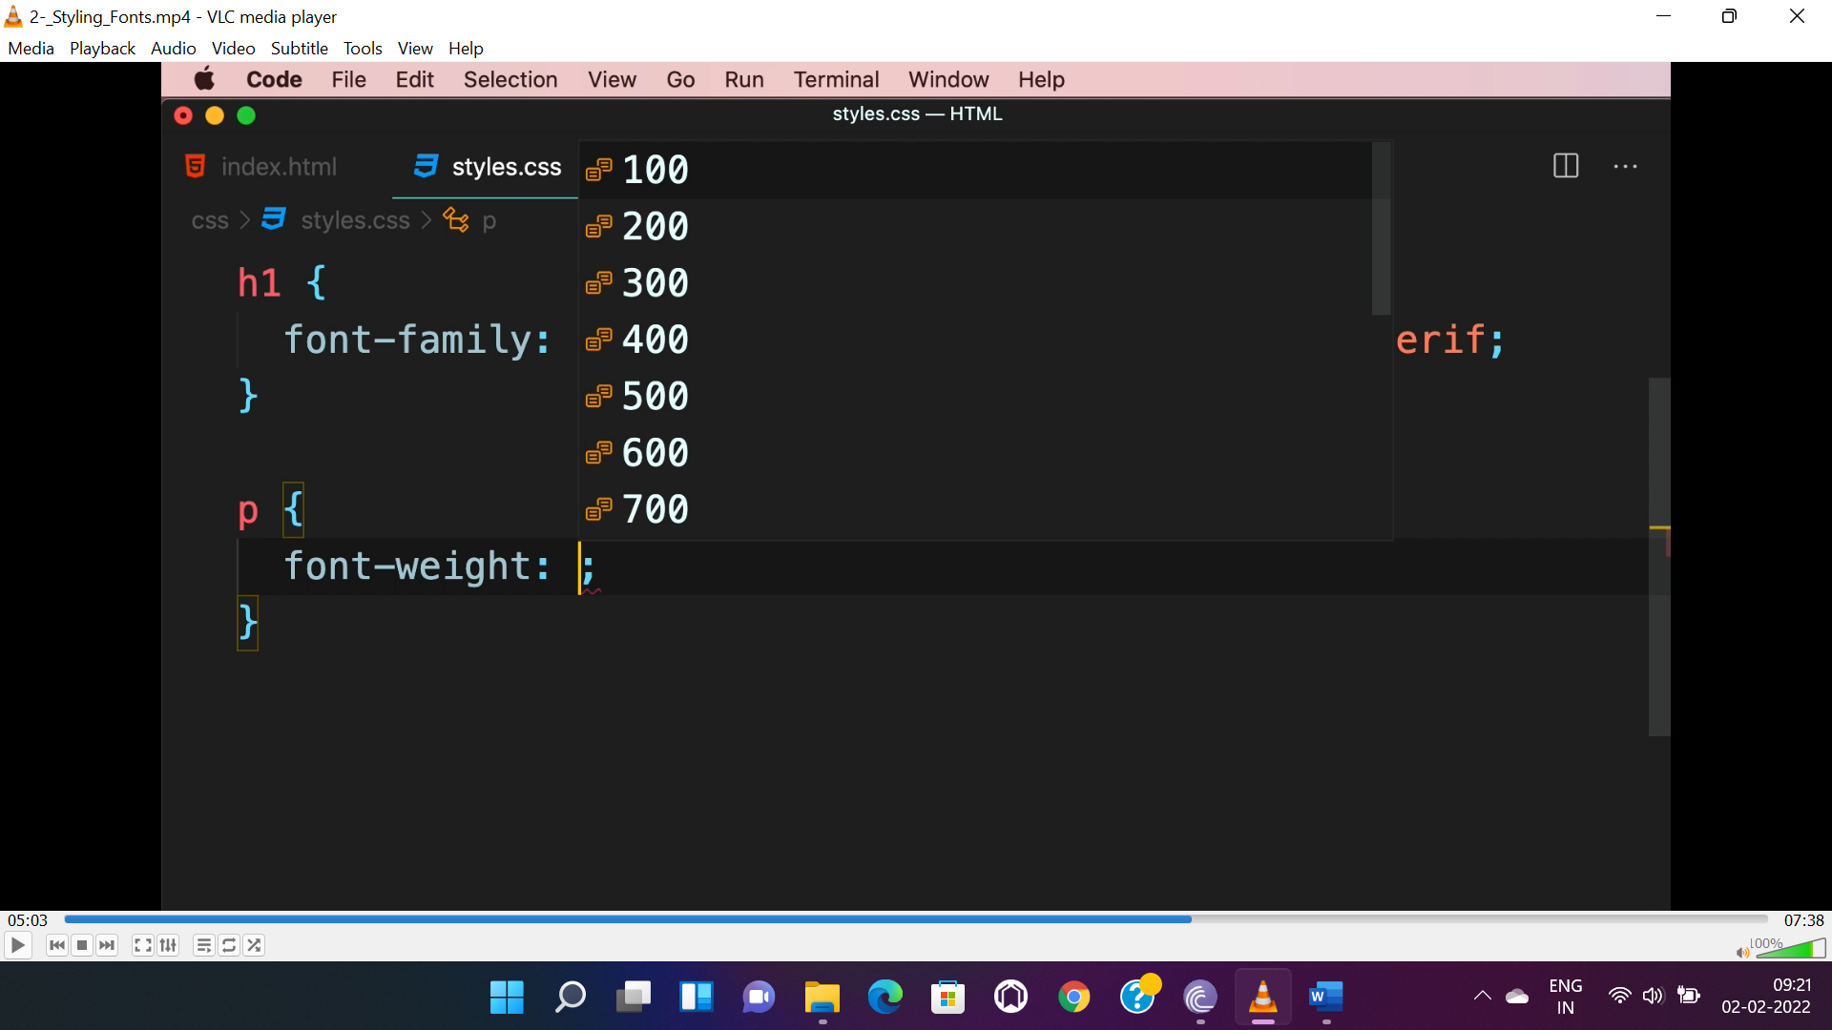

* Font style: either “normal” or ‘’italic”.
* Font size: either “relative value(in rem or %)” or “absolute value(in pixel)”
* Color: either hexadecimal or normal or rgbl or hsla.

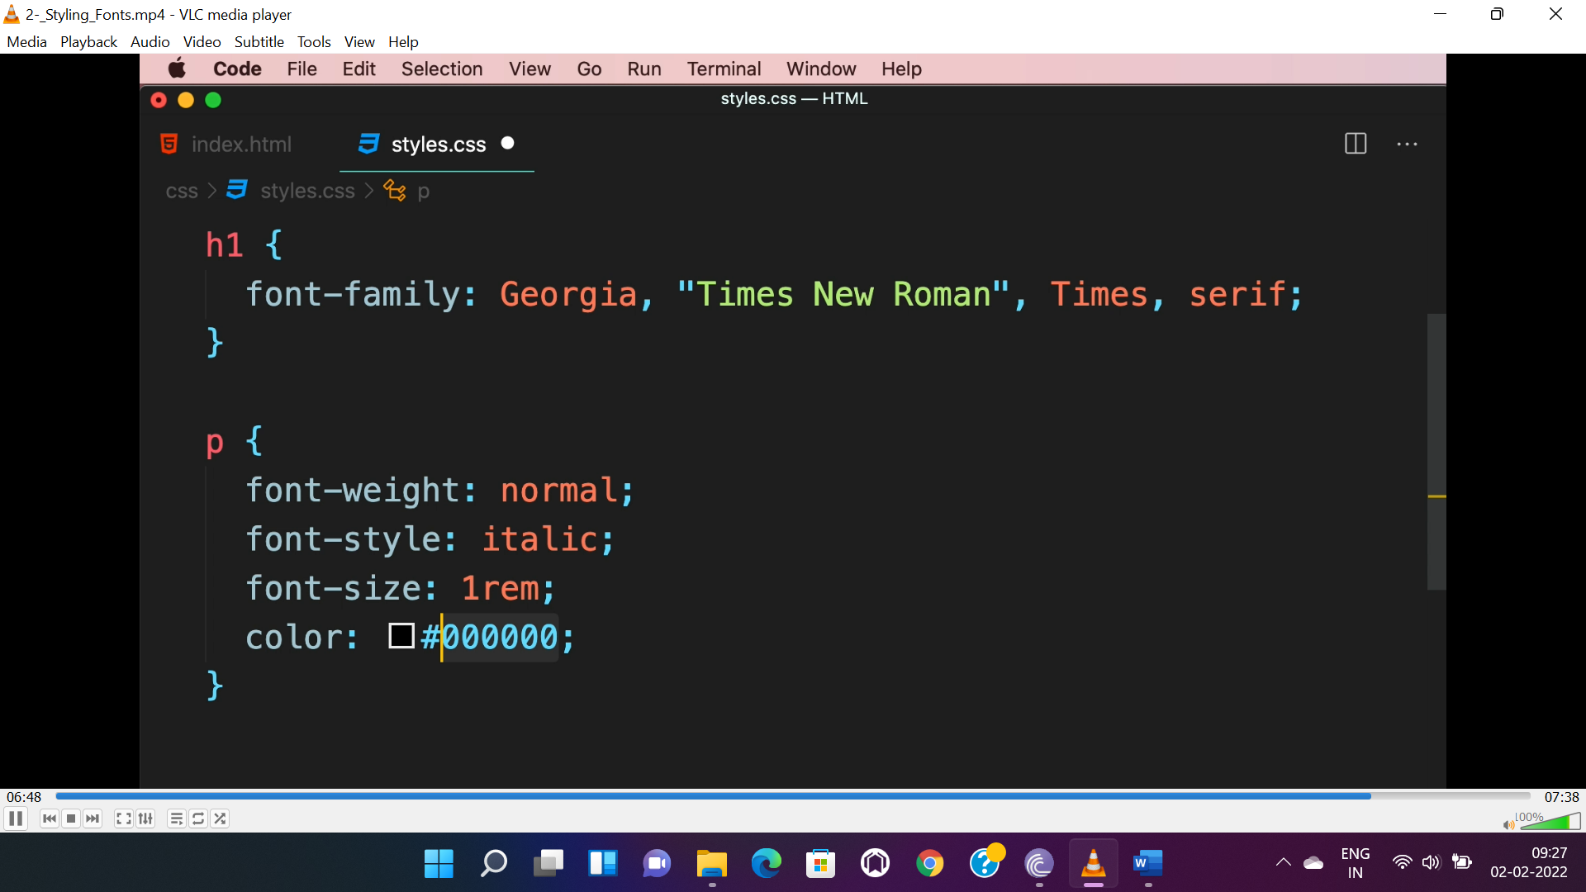

* While sizing fonts it is always recommended to use relative unit **“rem”**.

**HEADING SPACE:-**

* To give space between heading we can use “rem” unit in margin.

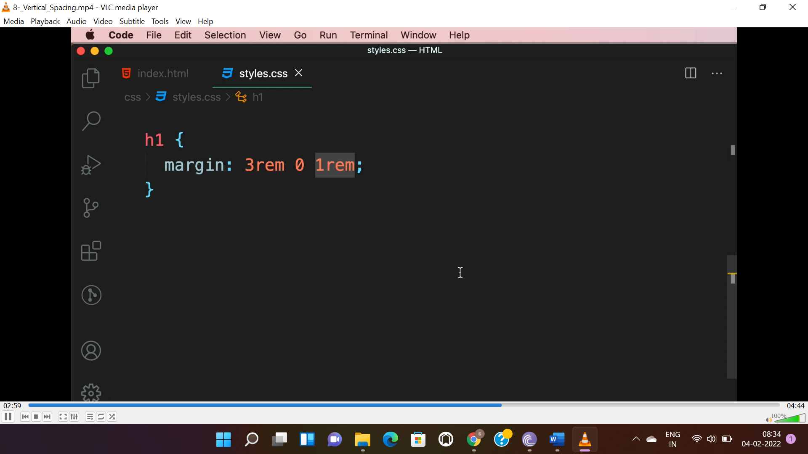

**VERTICAL SPACING:-**

* **Line height** should also given in “rem”, and the ideal line height is “1.5rem”.
* If “line-height” given without a unit then the value multiplies with “font-size”.

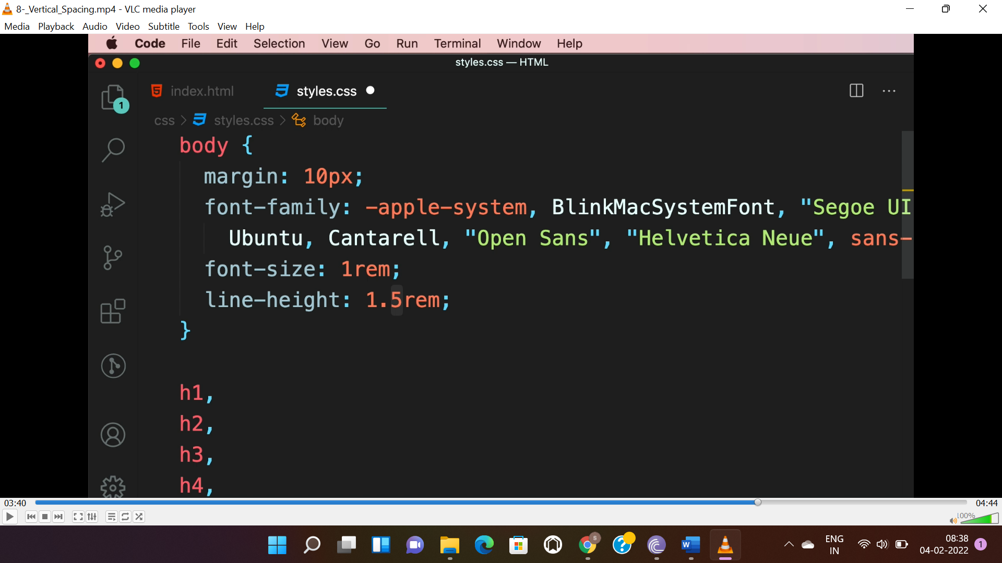

**HORIZONTAL SPACING:-**

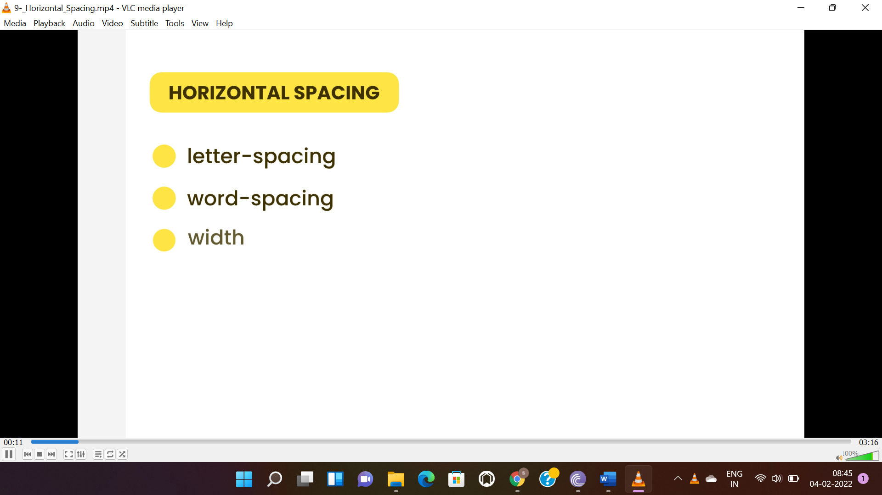

* “rem” is the unit which is used in all font styling.

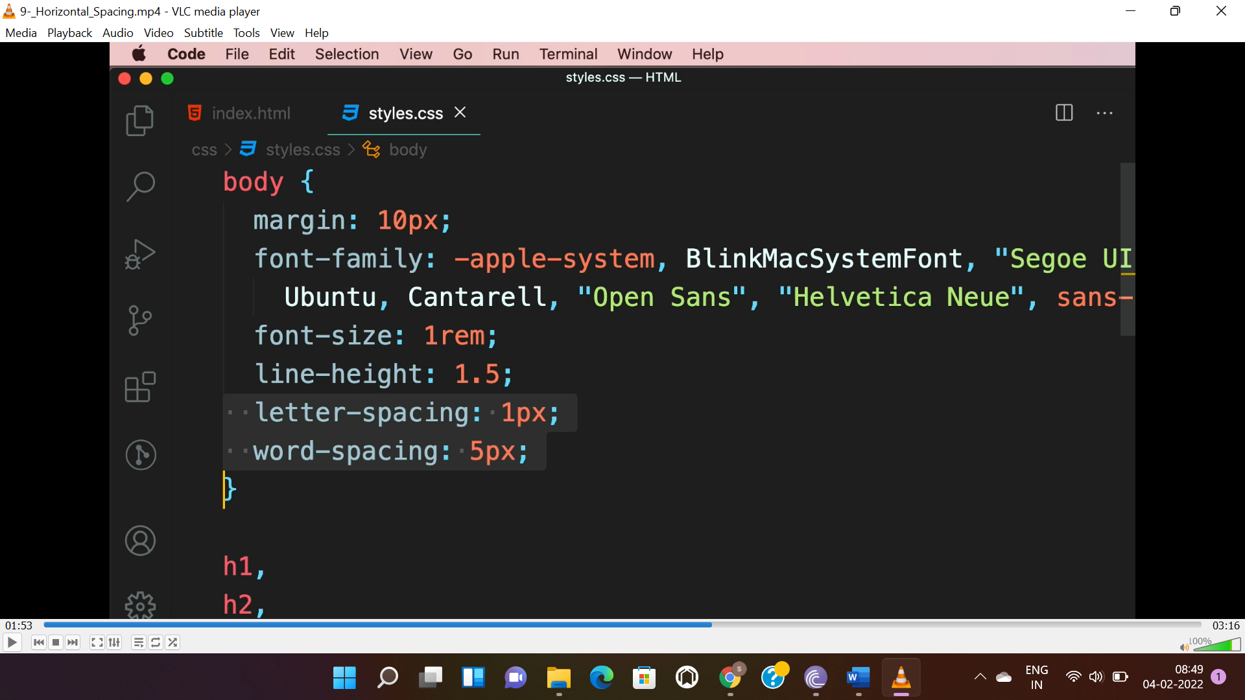

* For setting number of characters to be displayed “ch” unit is used.

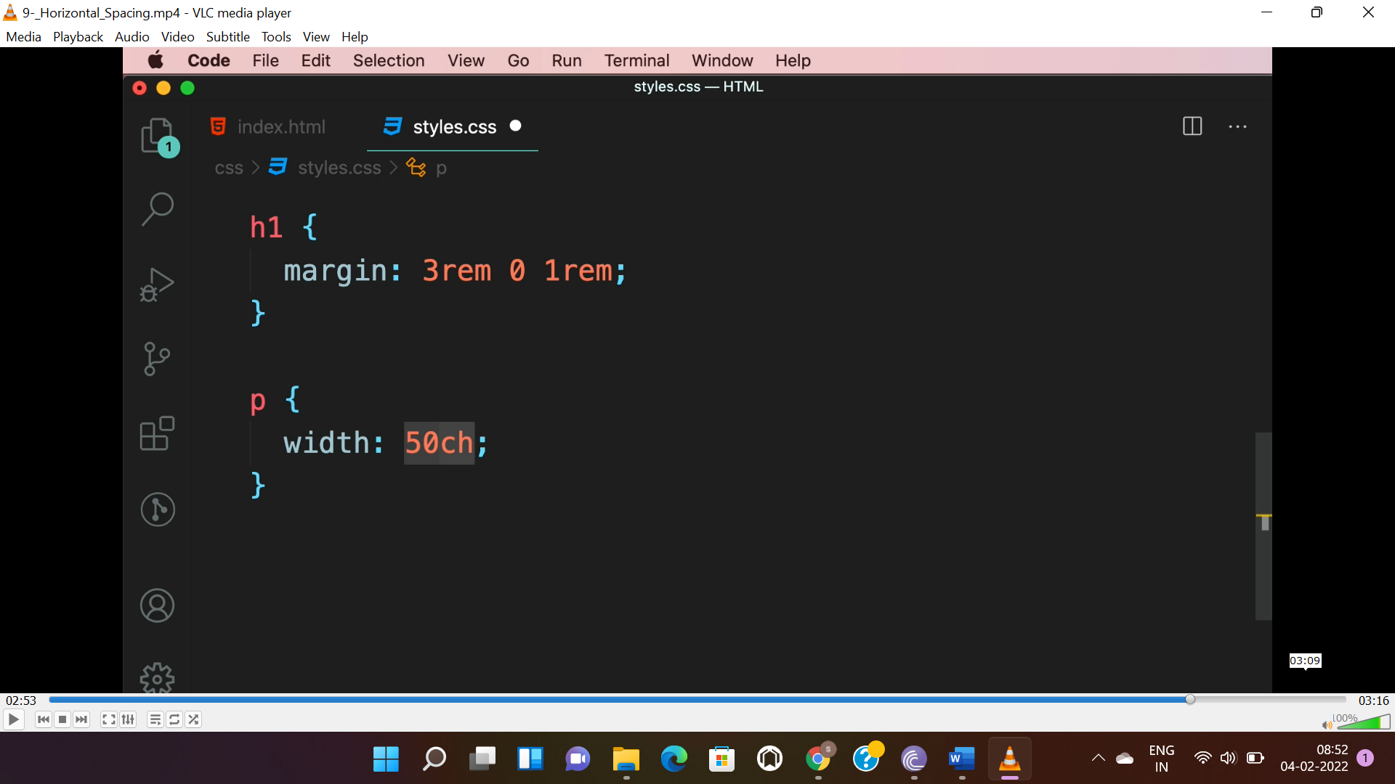

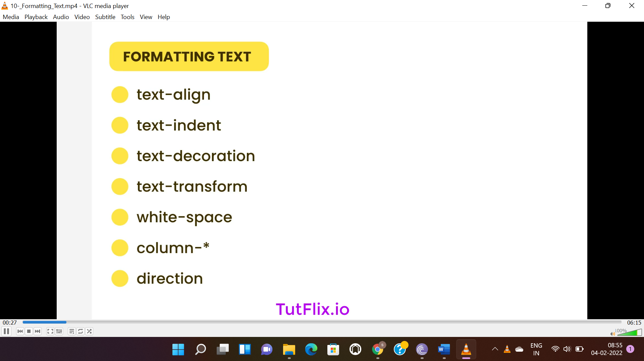

**TEXT ALIGN:-** used to align text horizontally and the values are “left”, “right”, “center” and “justify”.

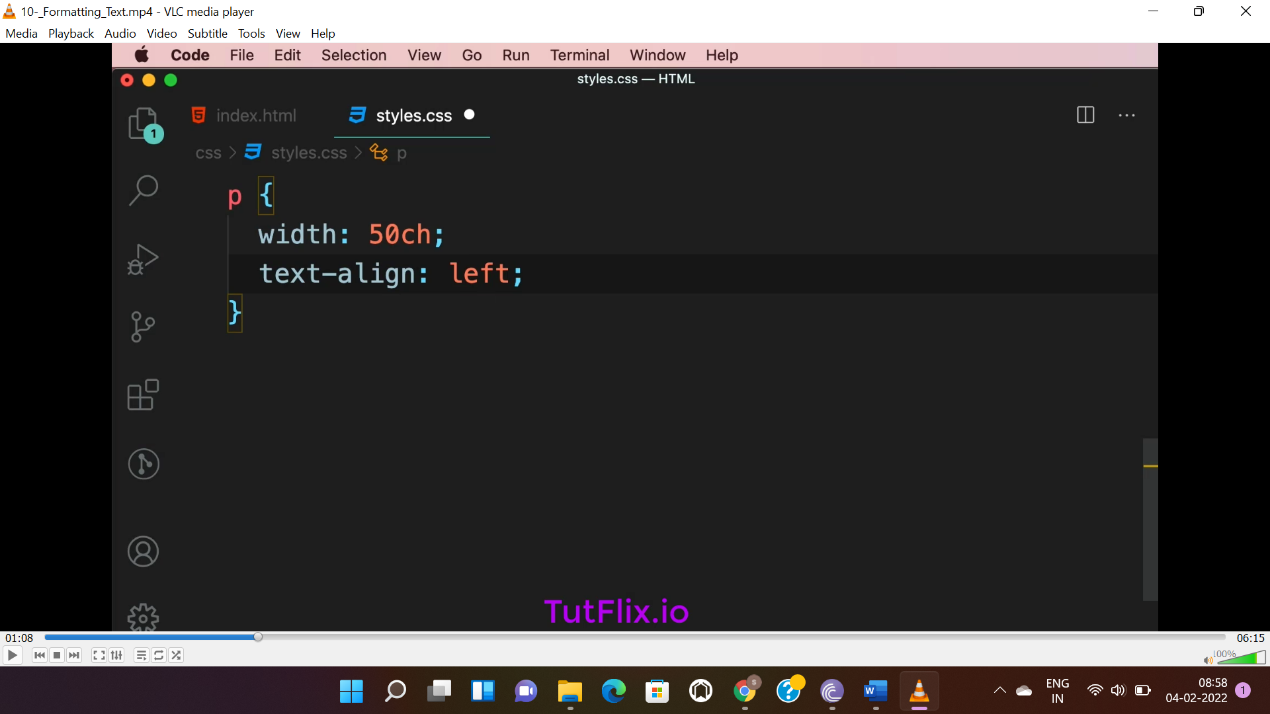

**TEXT INDENTATION:** used to give indent space to 1st line. To use space only after a para the below selector is used.

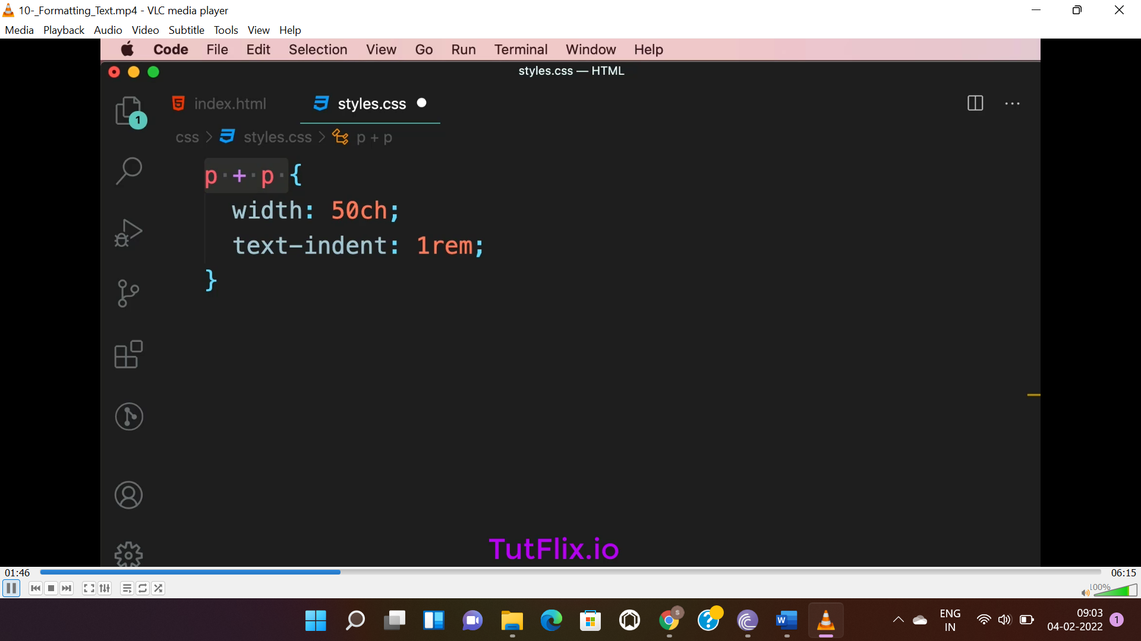

**TEXT DECORATION:** the values are “underline” and “line-through”.

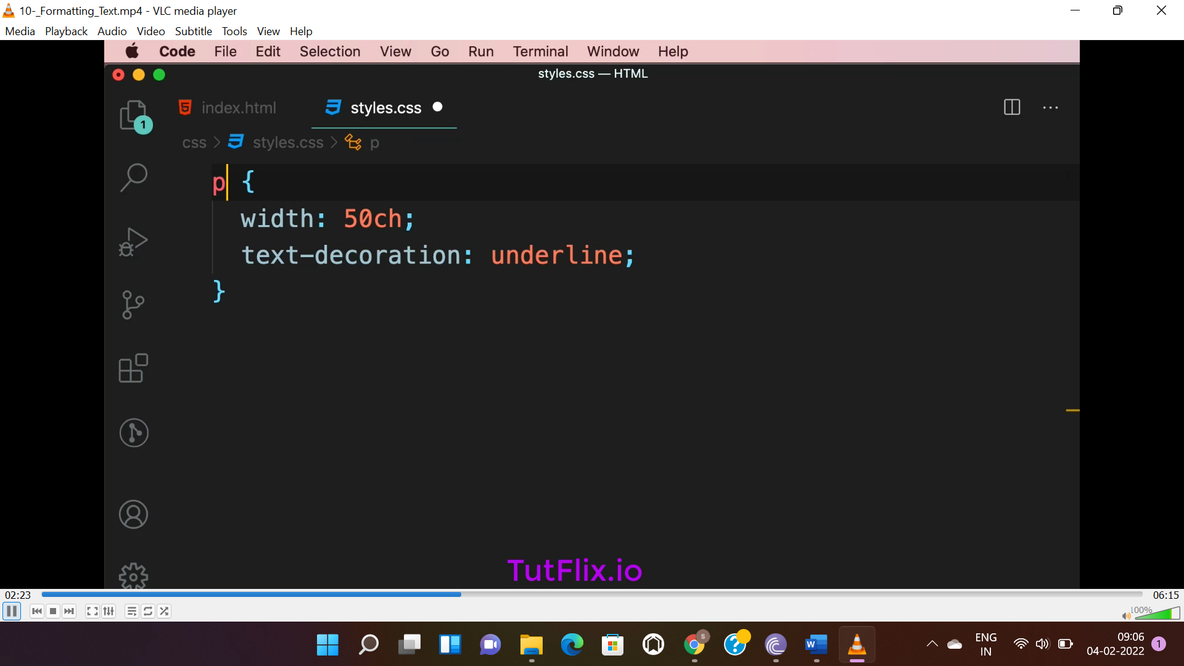

**TEXT TRANSFORM:** to transform text to **“lowercase”, “uppercase” and “capitalize”(will capitalize 1st letter of every word).**

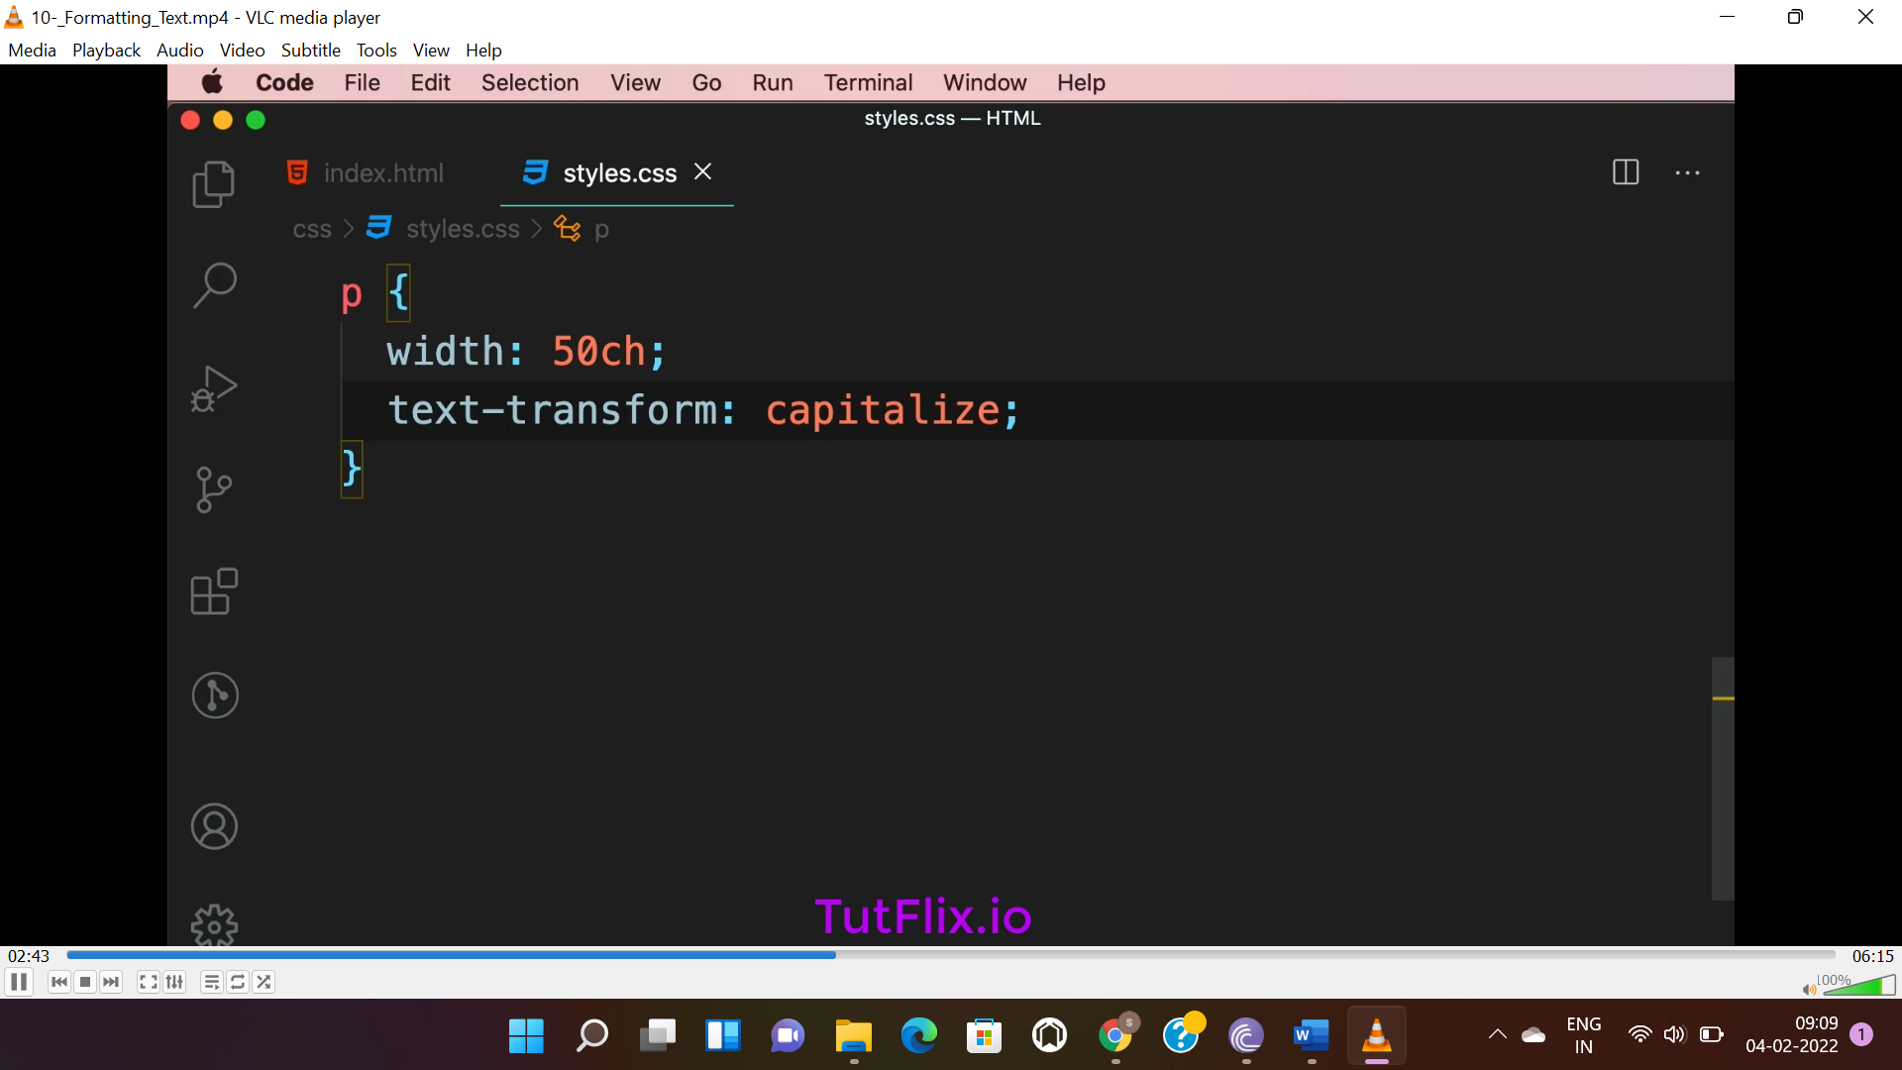

**COLUMN-:** used to show text in column.

Column-count = no. of columns to be added.

Column-gap= gap between columns.

Column rule= line in-between columns.

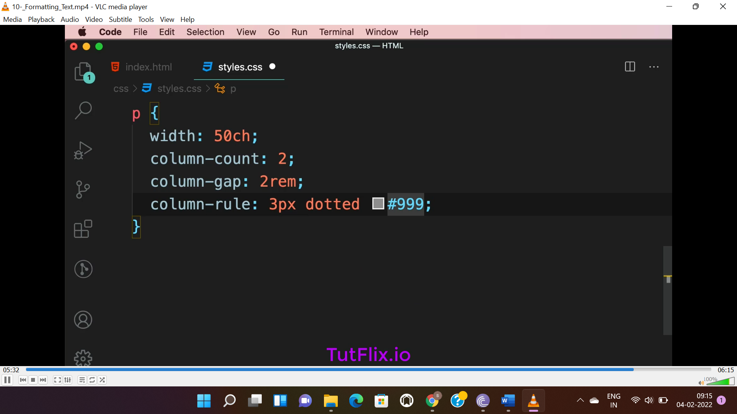

**DIRECTION:** to set direction of the text. Values are “ltr”(left to right) or “rtl”(right to left).

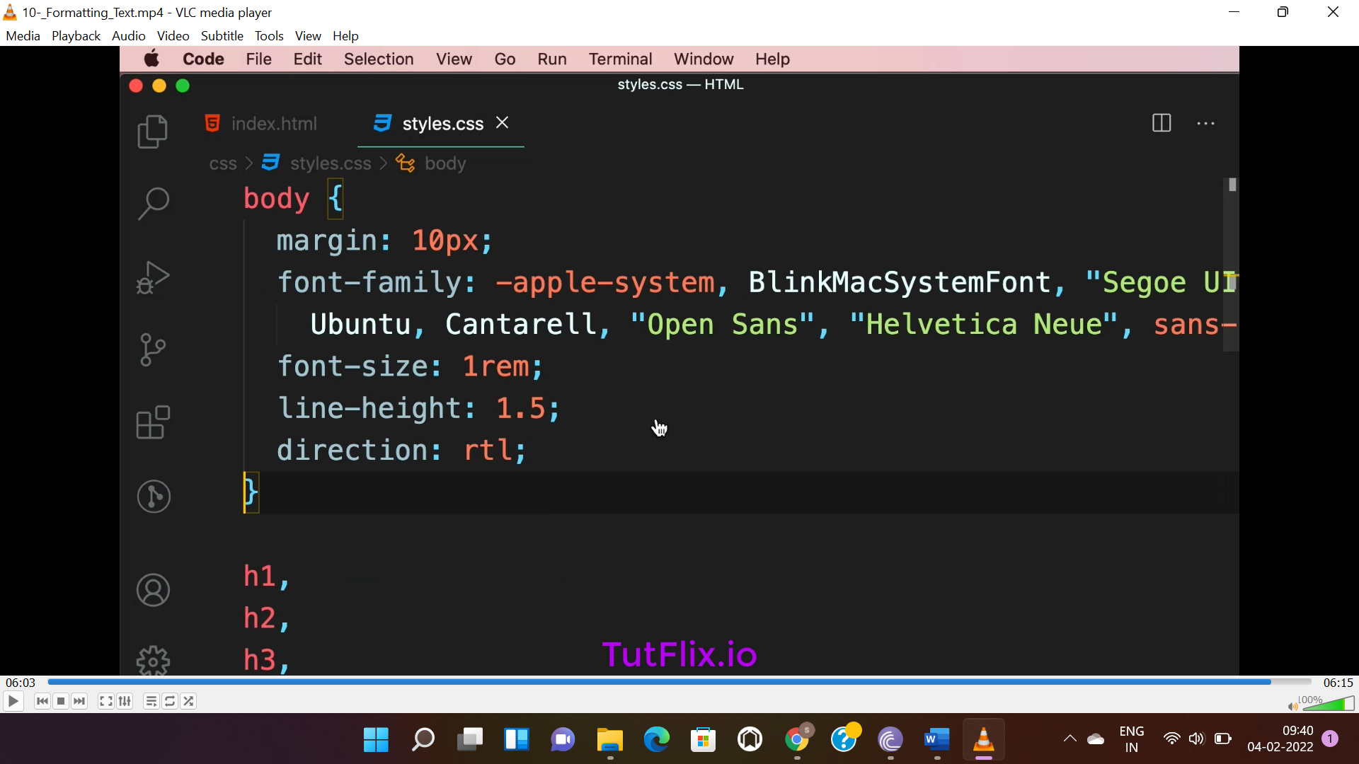

**SUMMARY:-**

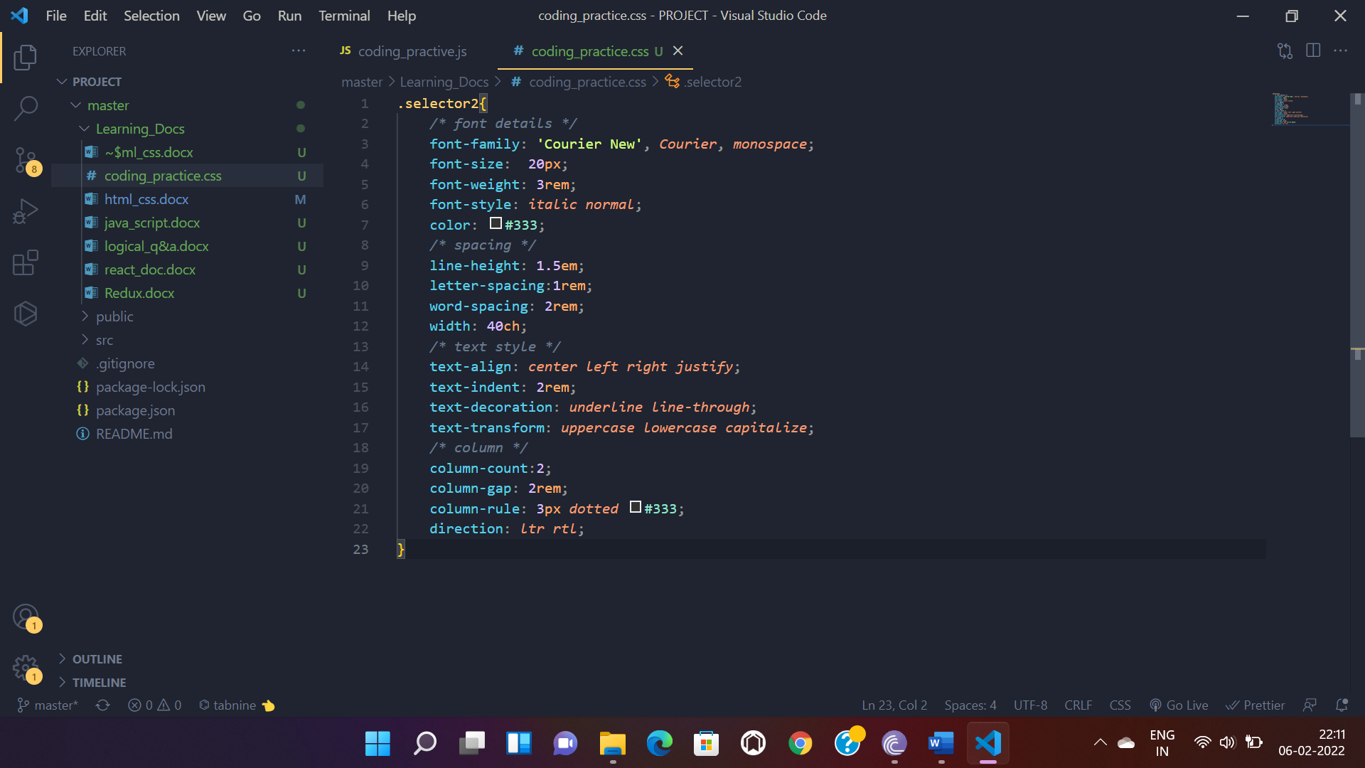

**PAID FONT:-**

* To get better quality fonts paid fonts can be found in the following.

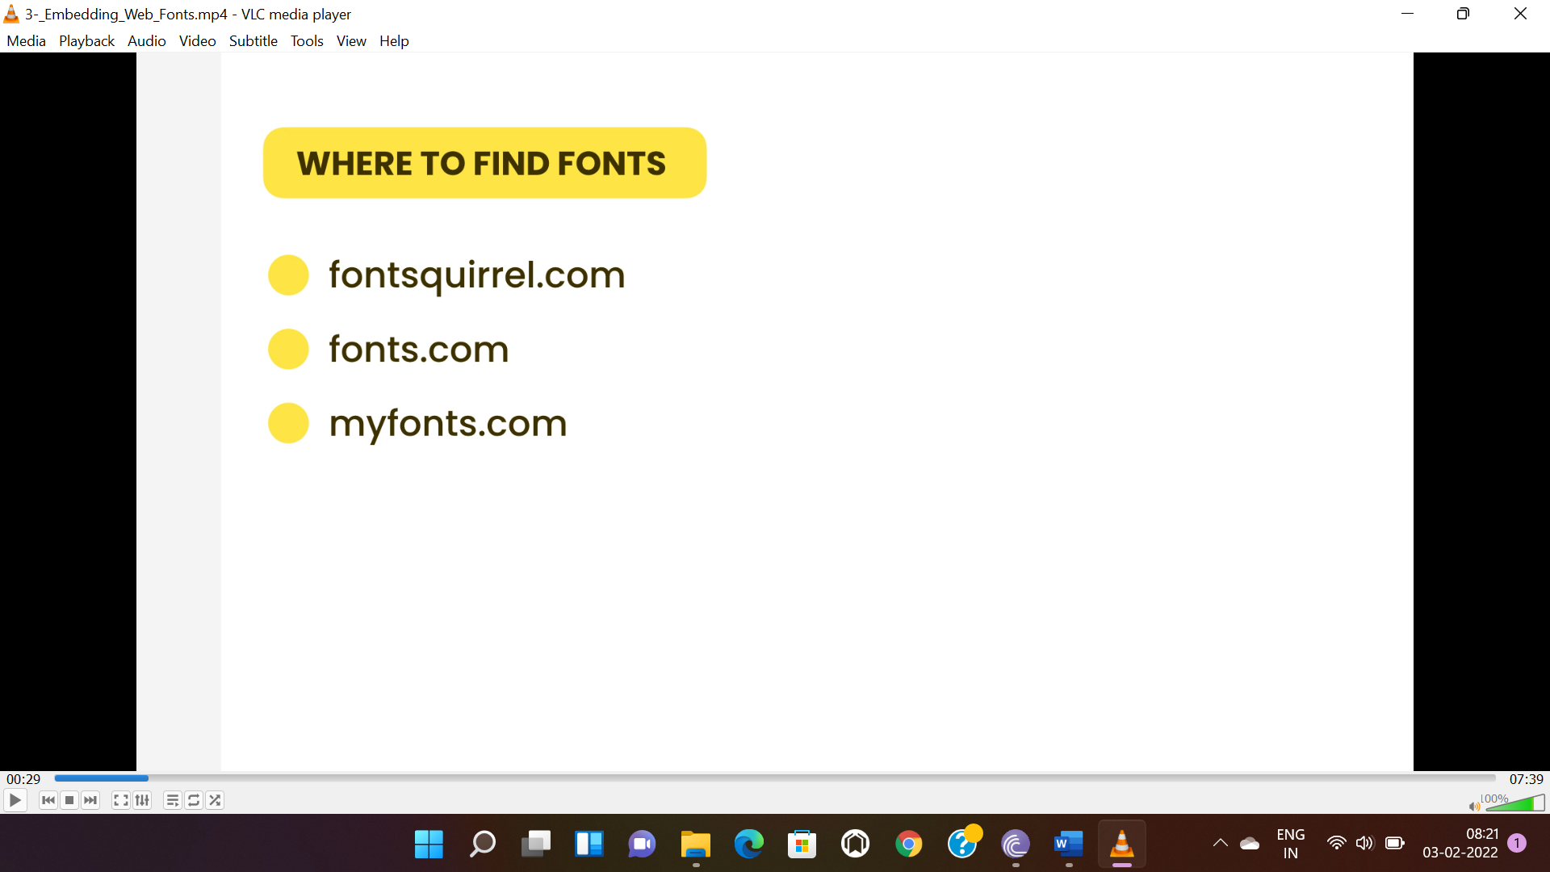

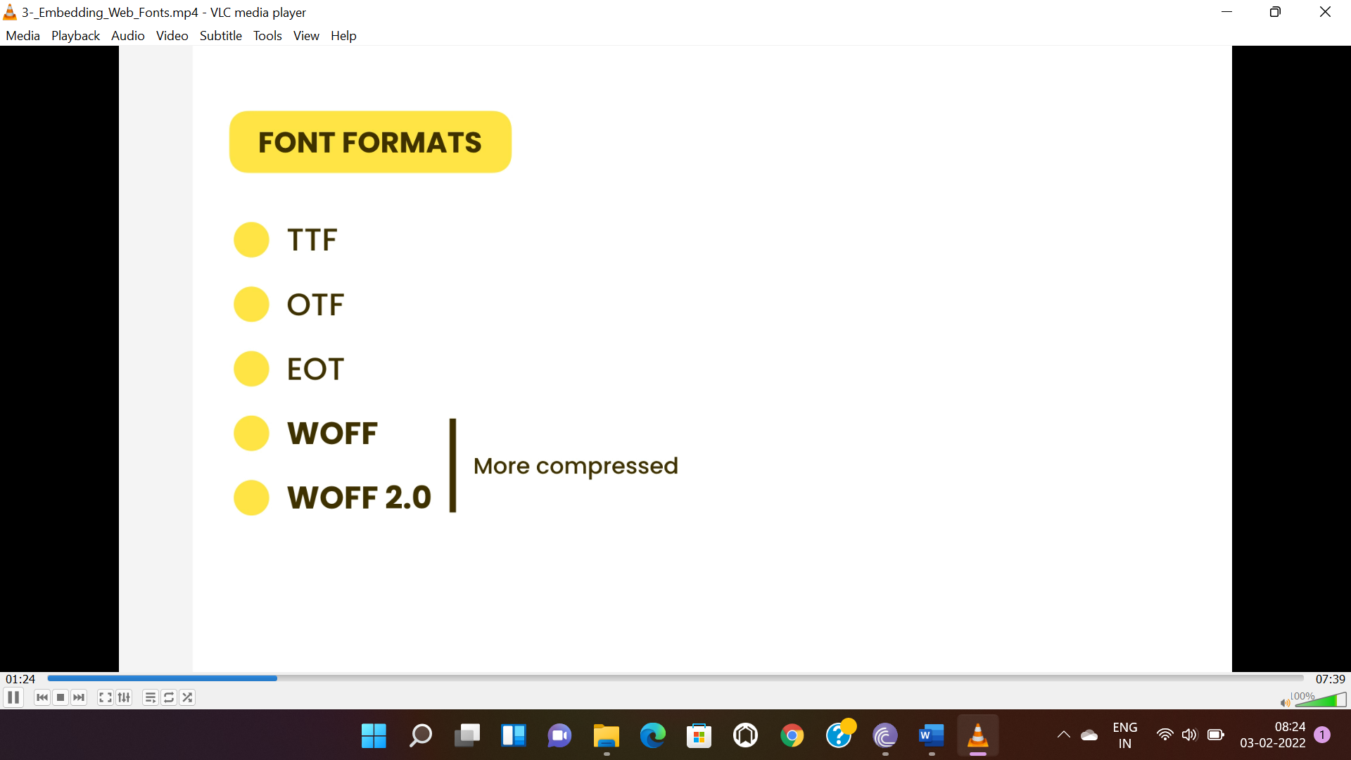

* For web only WOFF and WOFF2.0 is used.
* Extracted “.ttf” file need to be converted into “.woff”(supported by all browser) or “.woff2”.
* Then move file into a folder in project.
* Then copy the code of .css(from font.zip) file into the top of .css (.css file of project) and update the URL of the .css.
* Then use the font at 1st position in your font stack.

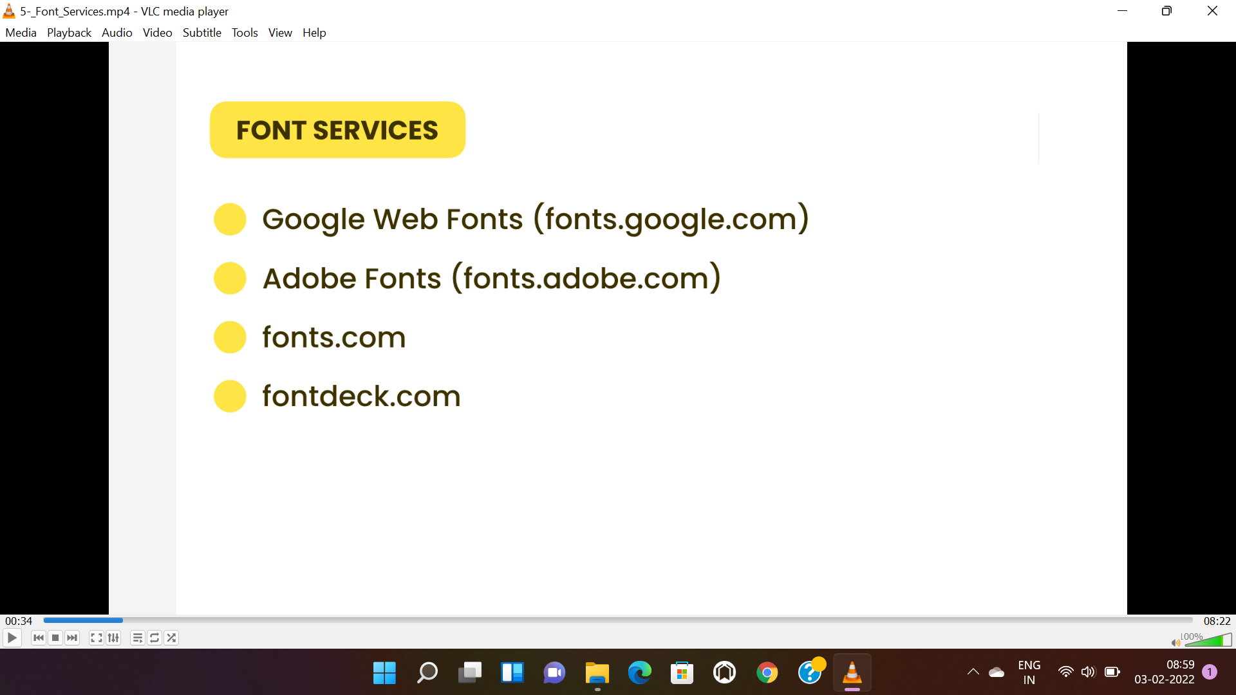

* All of the above provide paid font service.
* To use free fonts from google fonts(fonts.google.com), we need to apply required settings to the fonts in “fonts.google.com” then copy the provided link and paste in the <head> tag.
* Then we can use the font at 1st position in font stack.

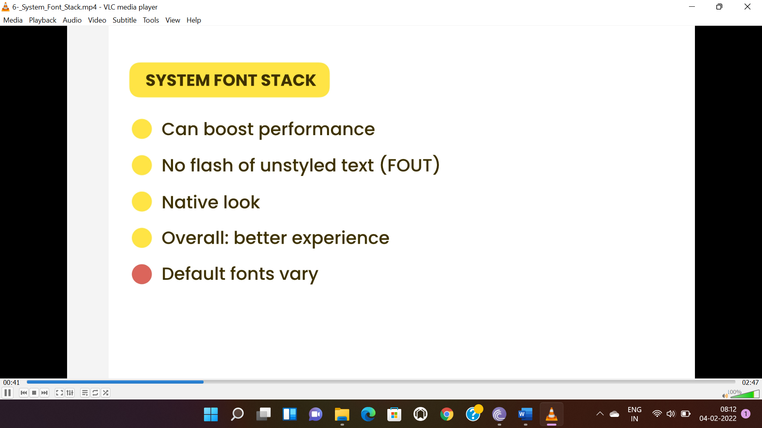

* Problem with system font stack is the default font is different in different OS.

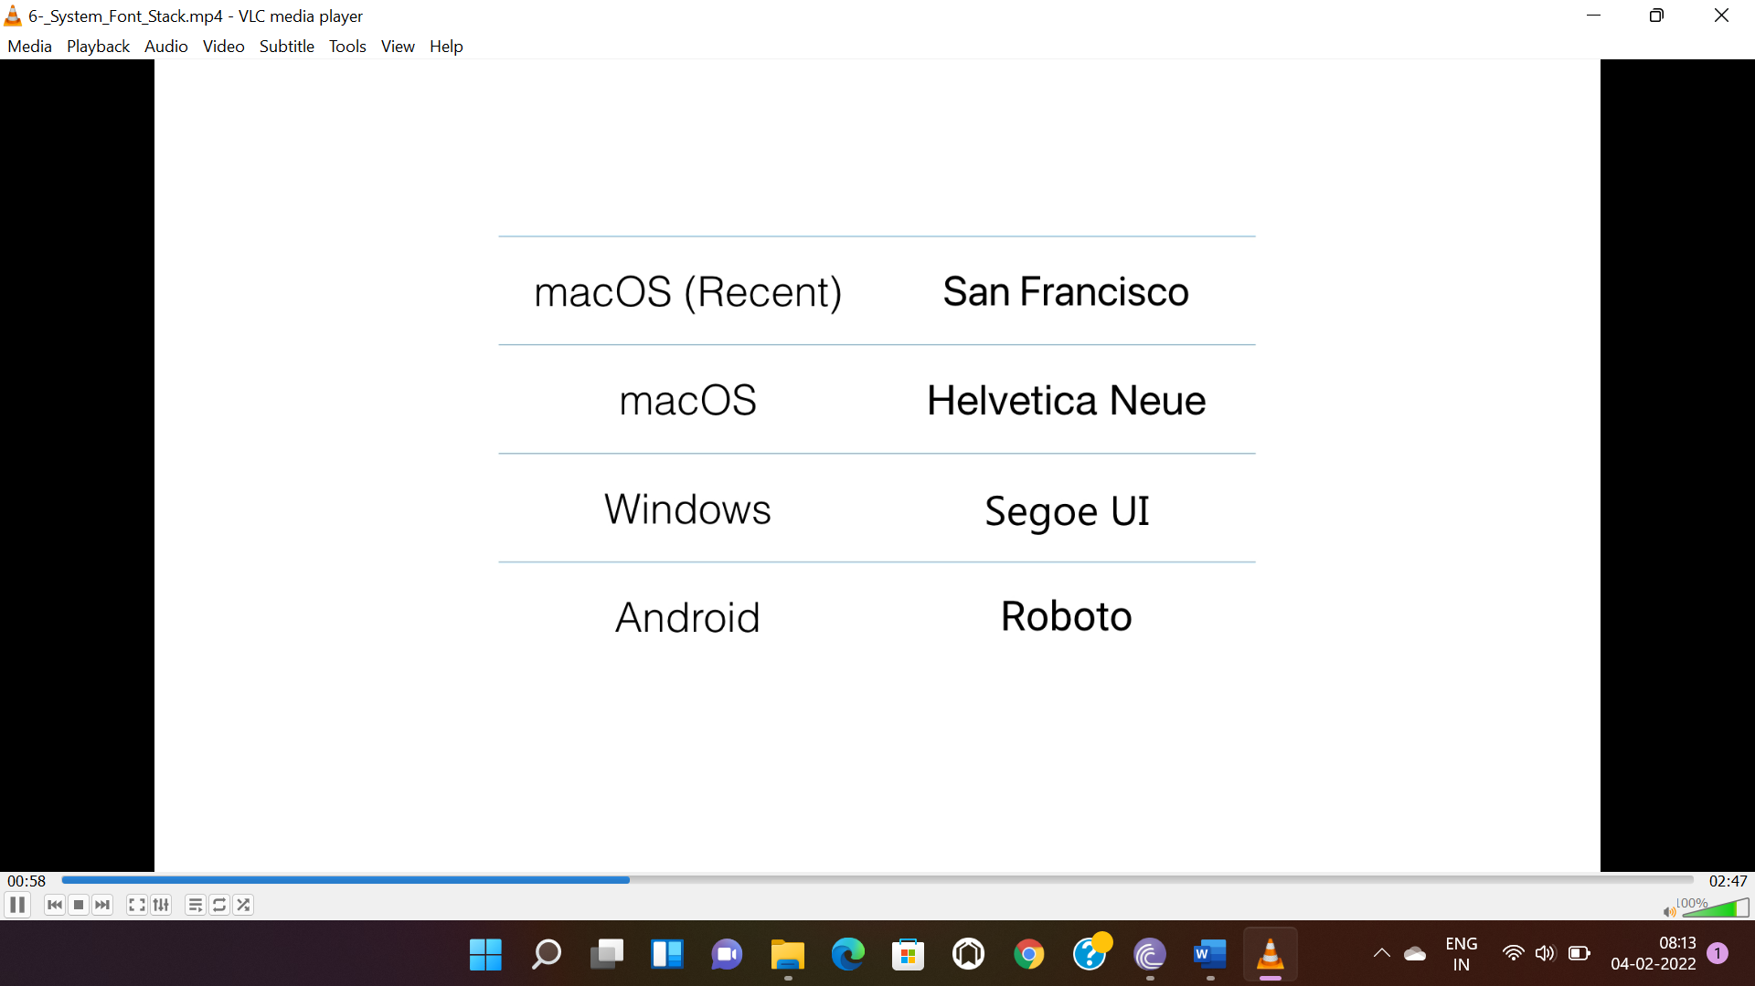

* To use system font use **“-apple-system”** at the beginning of the stack.

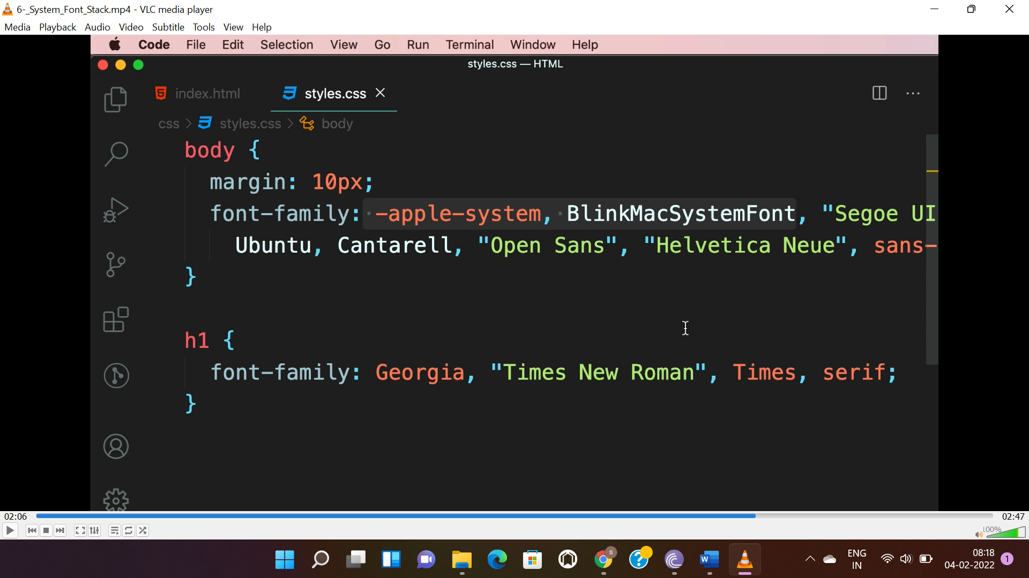

**IMAGES:-**

* Raster images are used as background.

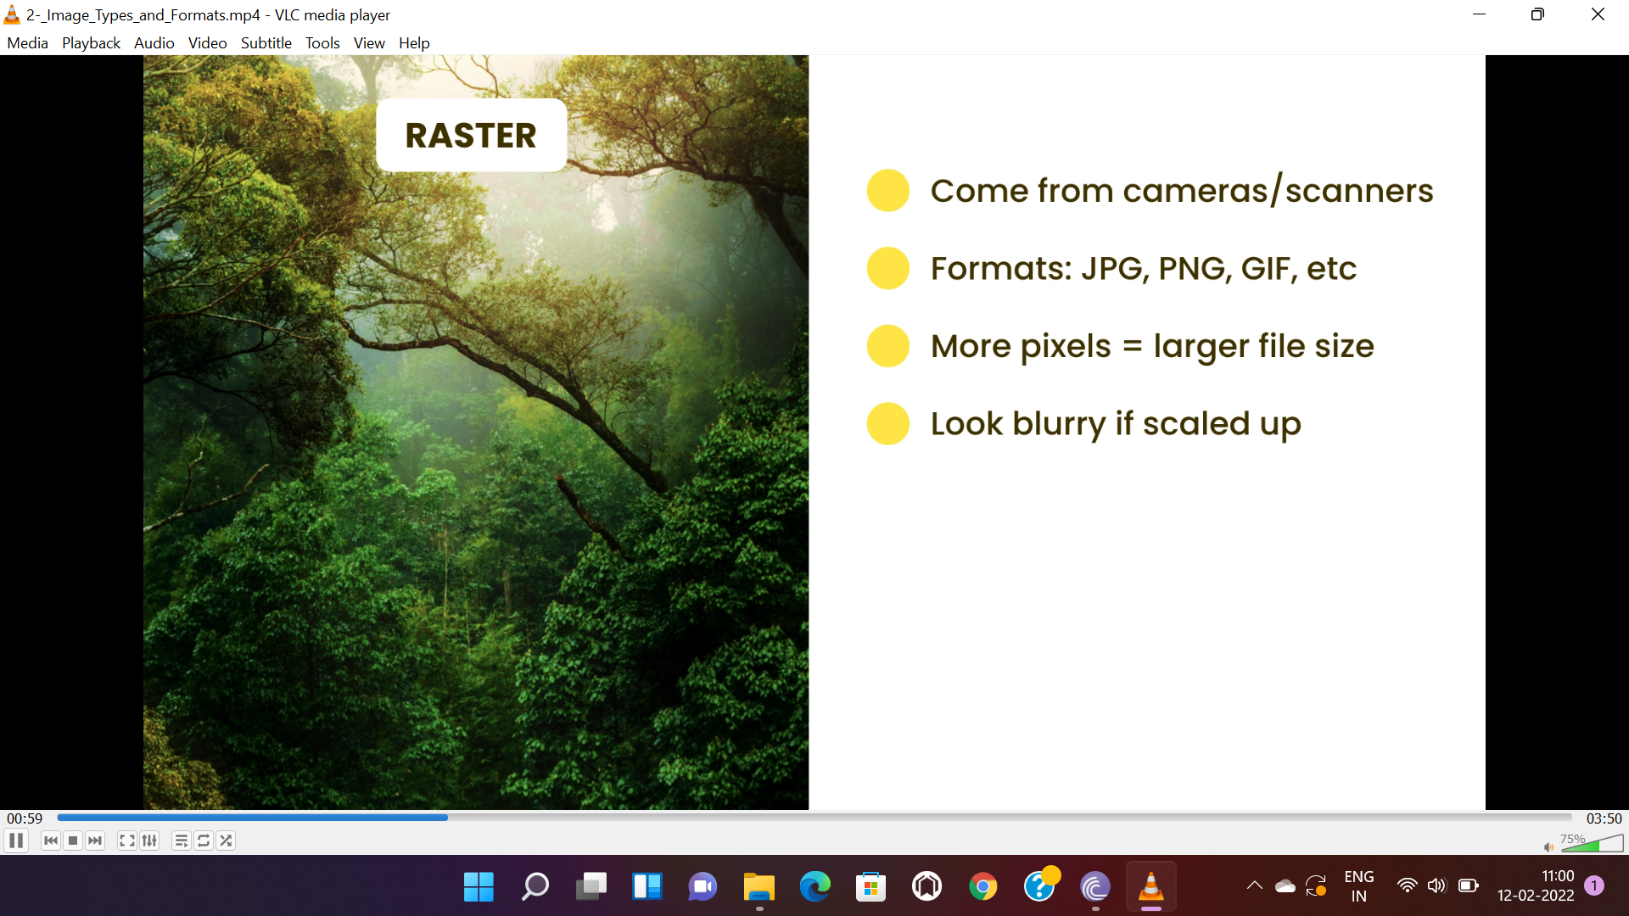

* Vector graphics are created using vector and are sharp at any size.

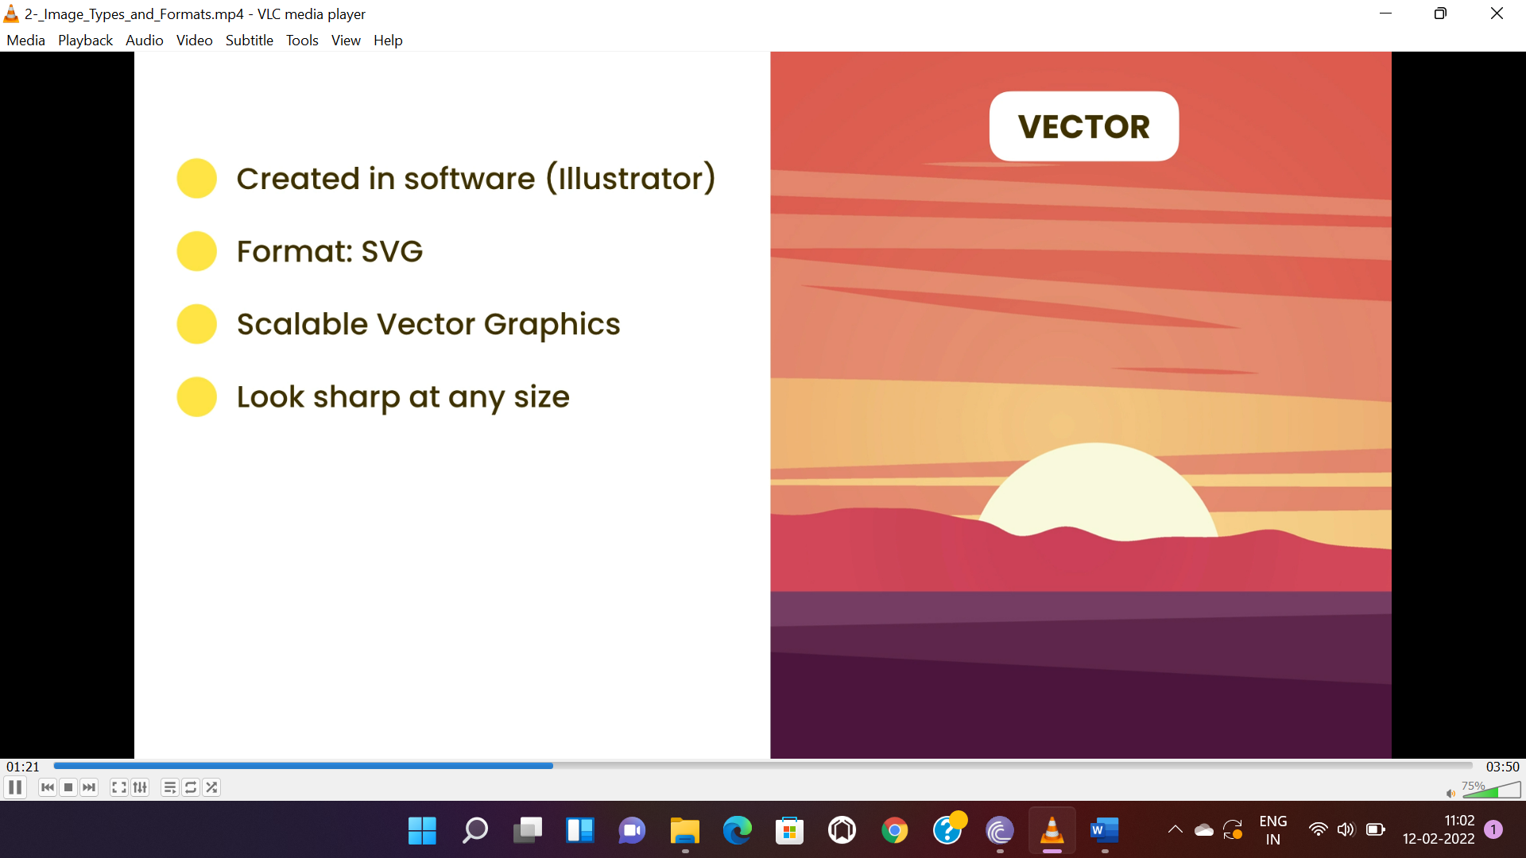

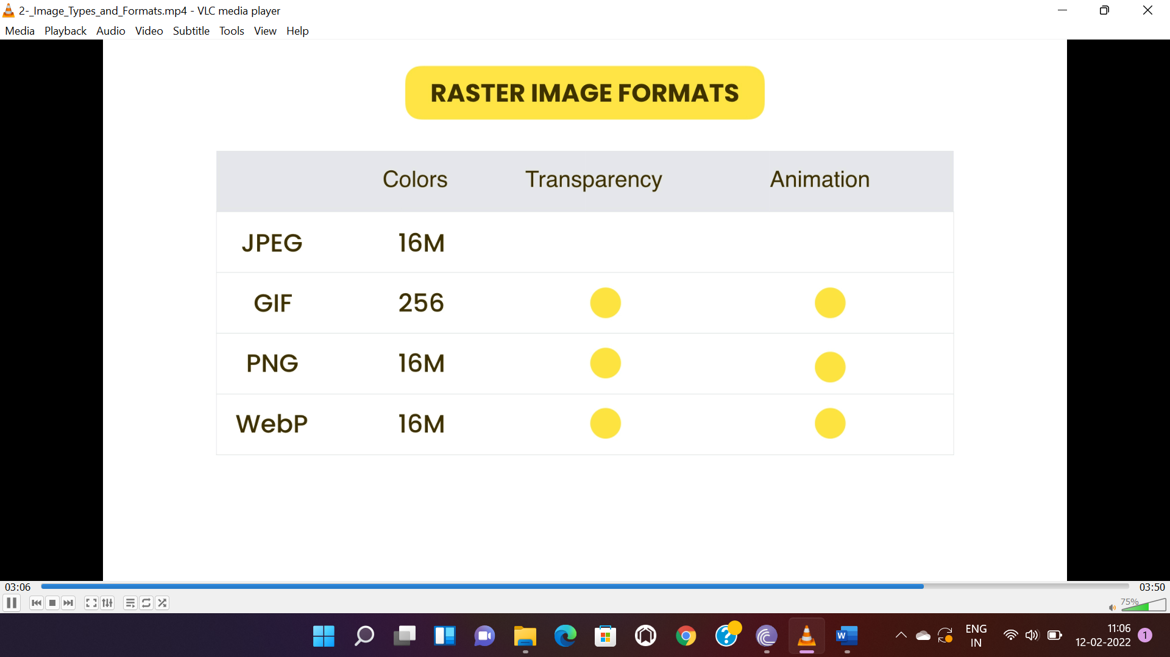

***BACKGROUND:-***

* “background” property is used to set image.
* “background-repeat” is to stop repeat or repeat in x or y direction.
* “background-position” is to move image vertically or horizontally.
* “background-size” is to expand the image.
* “background-attachment” is to fix the image to viewport while scrolling.

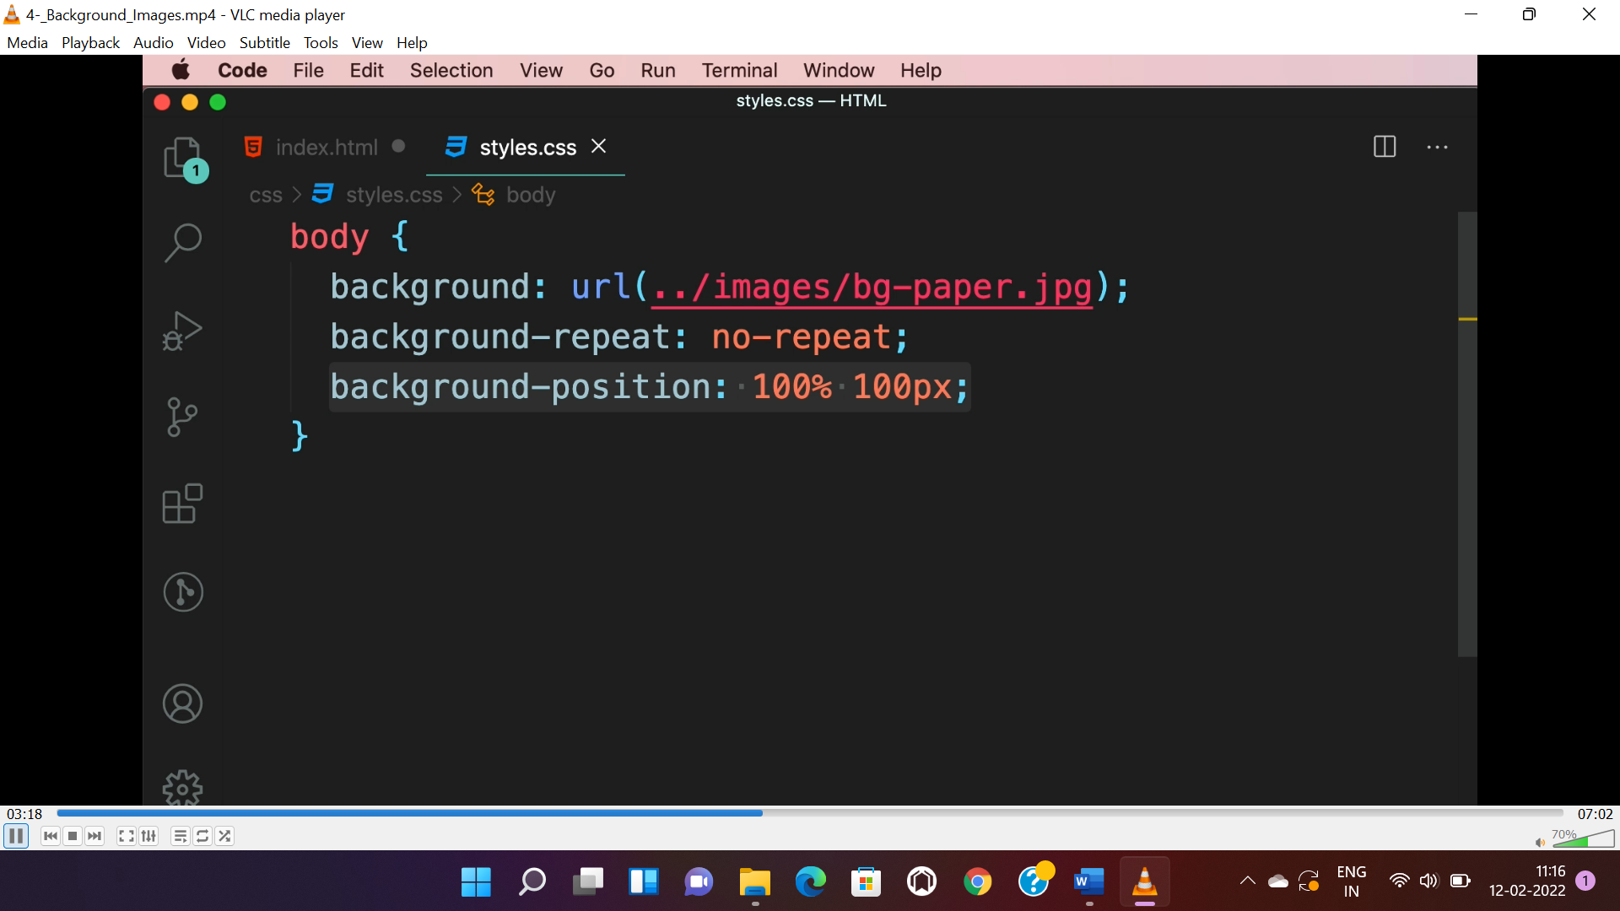

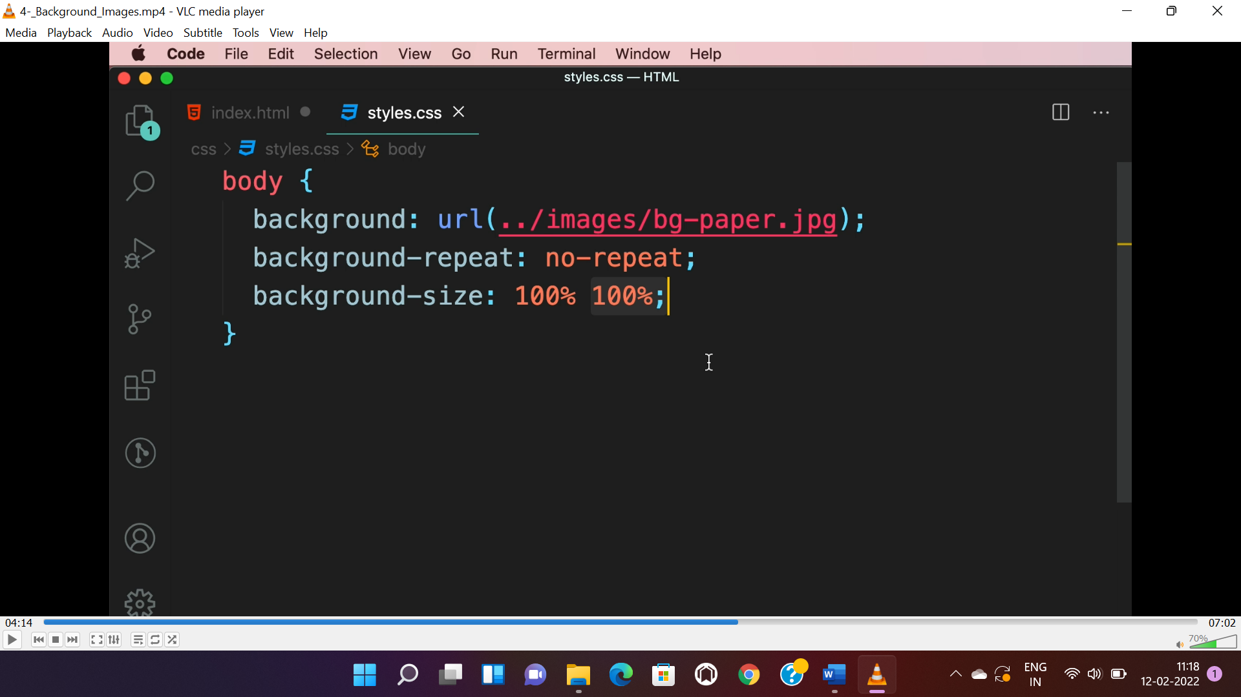

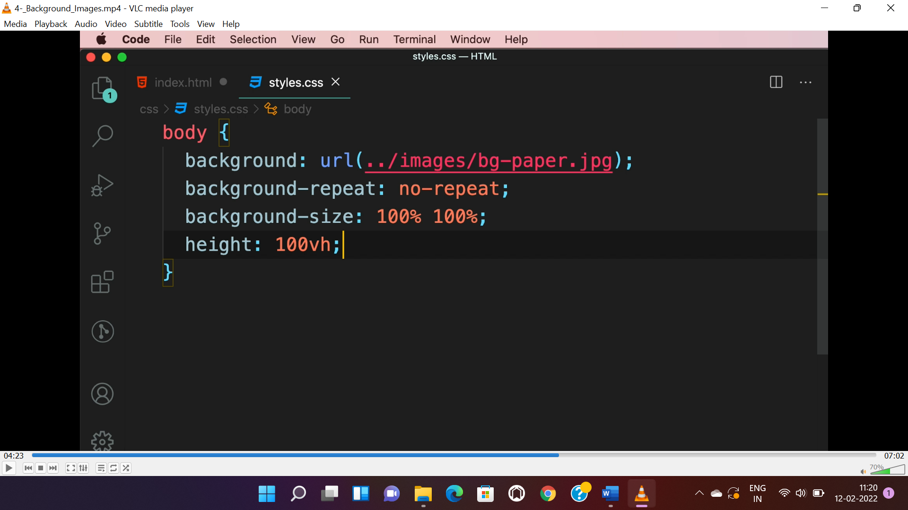

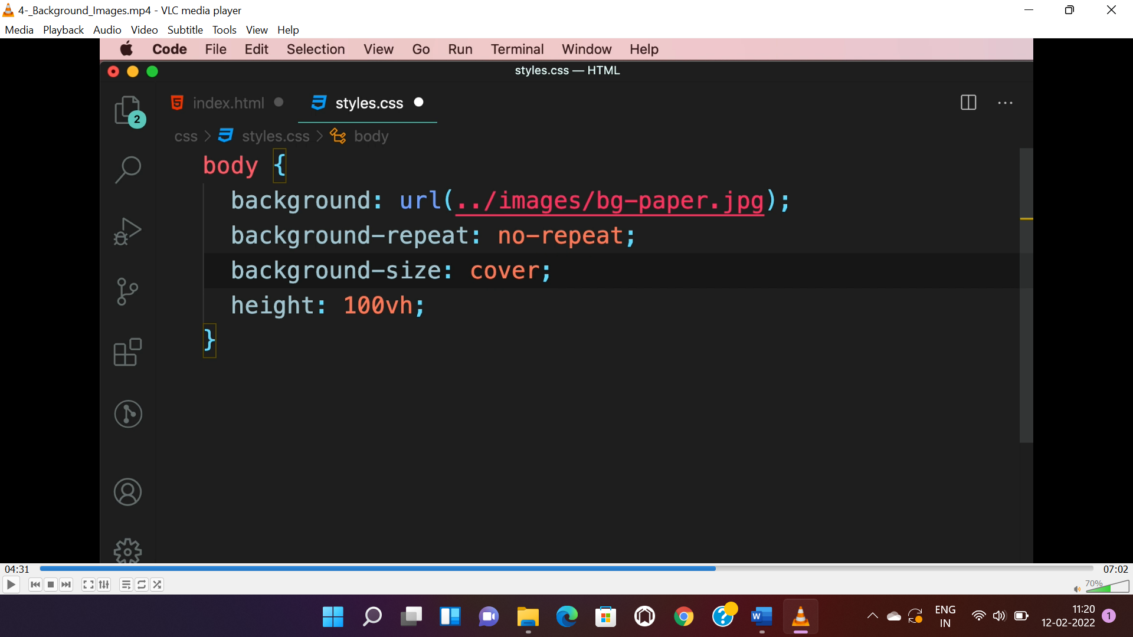

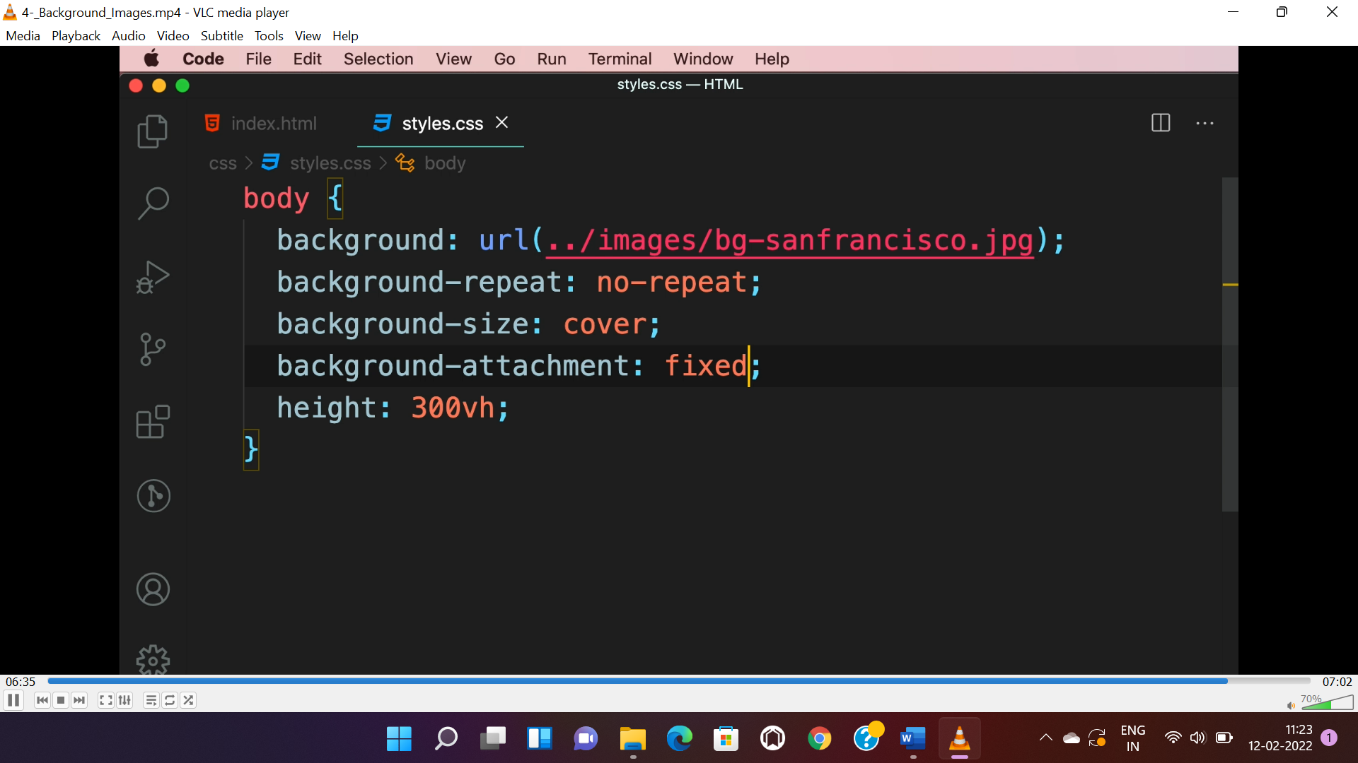

**CSS SPRITE(optimization technique):-**

* Instead of doing multiple request for multiple images, we can do single request for all images by applying “CSS-SPRITE”.
* It combines multiple file into a single file and we can get all In a single request. “Css-sprites” can be done in 3rd party website or cmd tools.
* DISADVANTAGE:- some time file size may get bigger and it is not convenient. So it should be used for small images.

**PROCESS:-**

* Copy the “sprited image” into project and copy the styles present in the “.css” file and update the path of “sprited-image” in it.
* Use the class names based on image names using <div> or <span>.
* Do required changes in the “image-name” based classes.

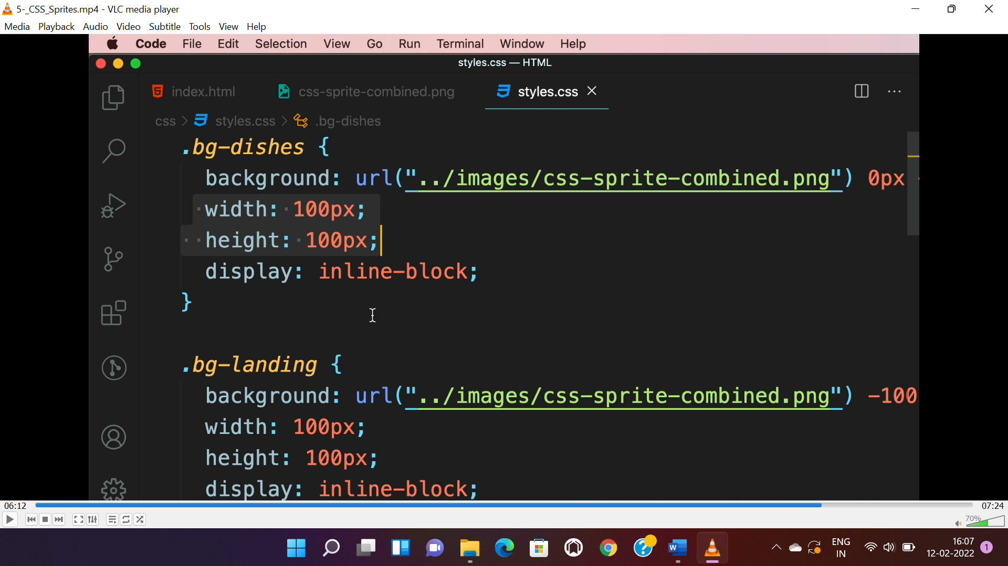

**CLIPPING:-**

* Used to cut image into different shape.
* Search for “css clip generator”, upload image convert to required shape and copy the generated css into “.css” file.

**FILTER:-**

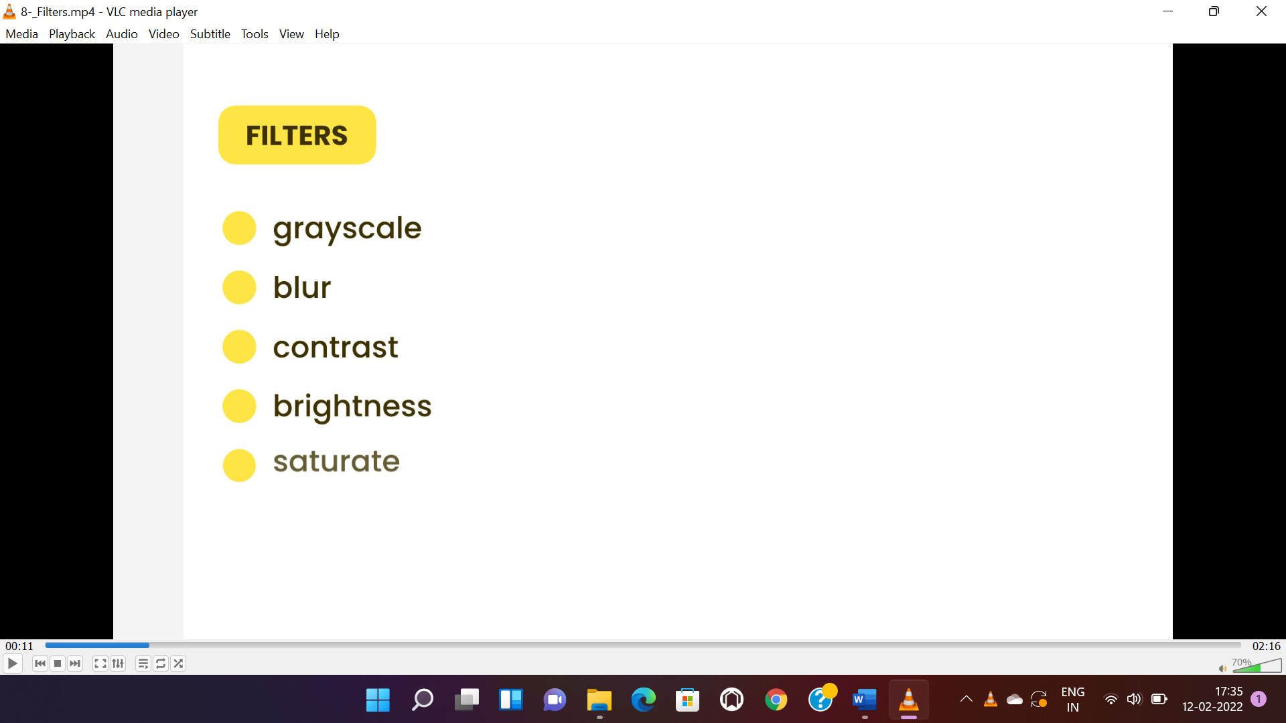

* Filters are functions used to apply colour state like photoshop.
* Search “css filter function” in google to apply various filters.

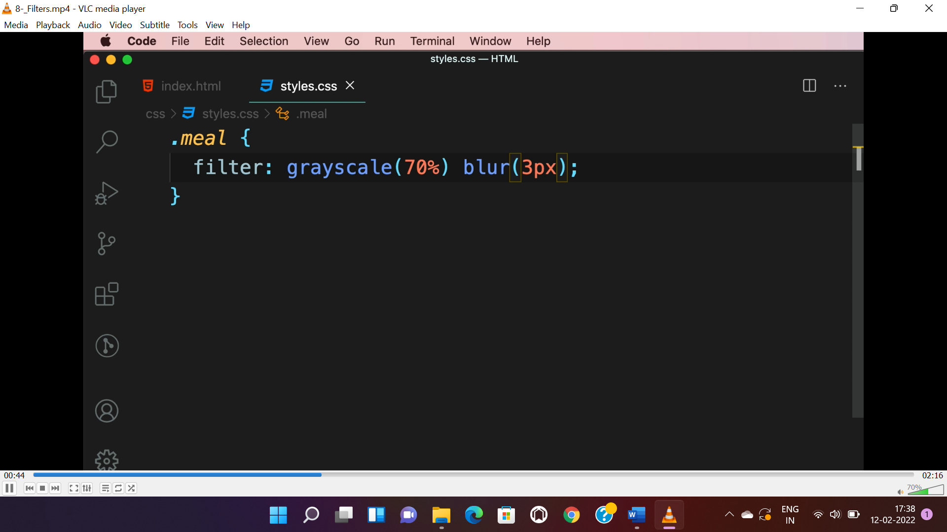

* The below filter applies when we “hover” mouse on the object.

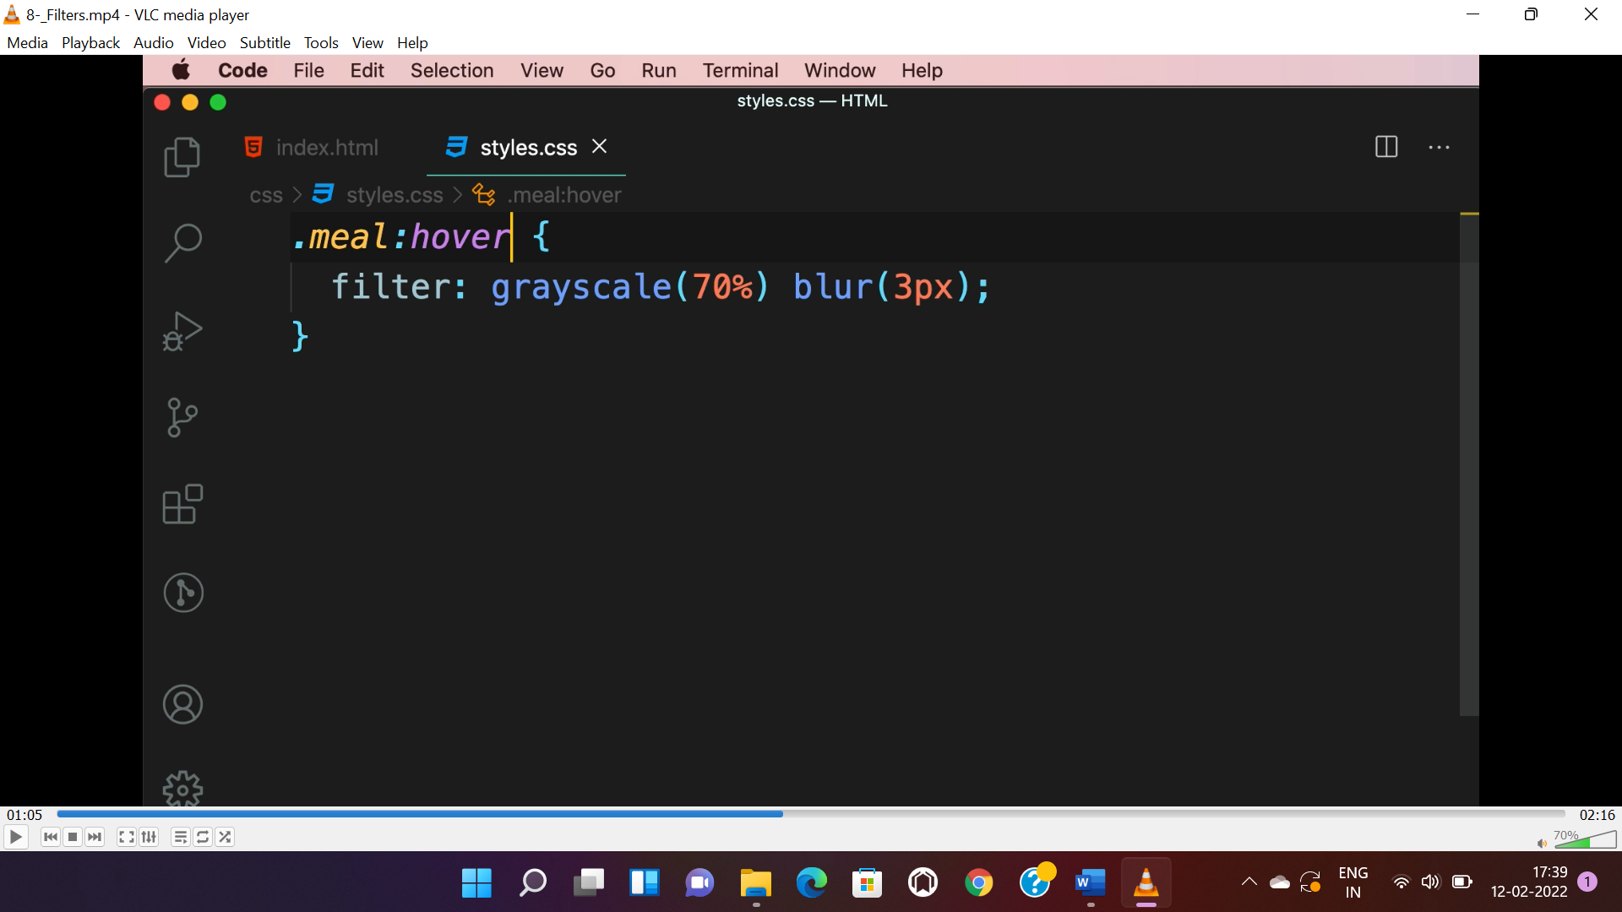

**SUPPORTING HIGH DENSITY SCREEN(RESOLUTION):-**

* To avoid the image being stretch(blurred image) in high density screens(high pixel) we use **“srcset”** attribute to use different image for different resolution.

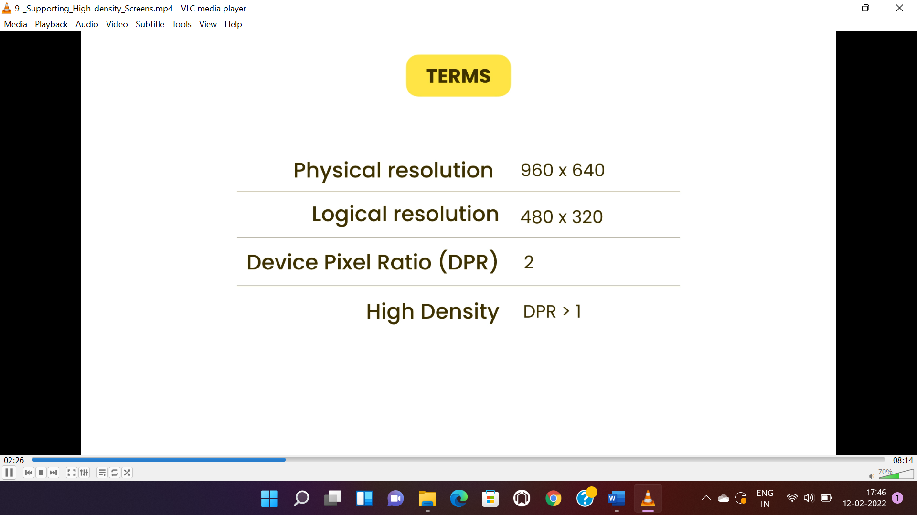

* Below “1x,2x and 3x” is “DPR”. For high DPR high image quality is used.

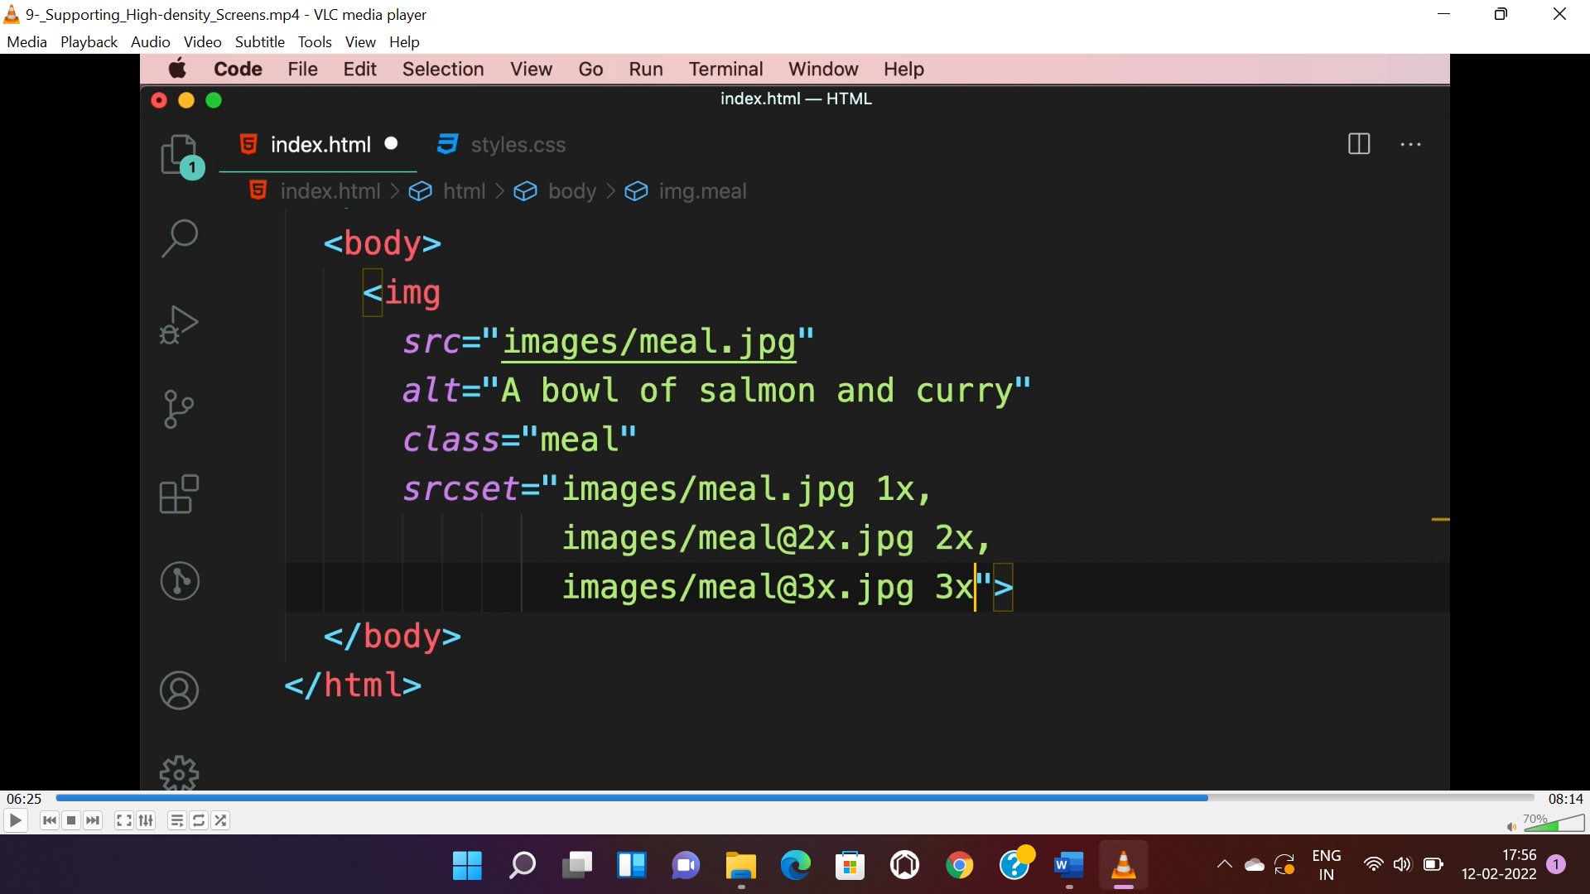

**RESOLUTION SWITCHING:-**

* Here browser pick the image based on the resolution of browser.
* “400w, 800w and 1200w” are width of image.

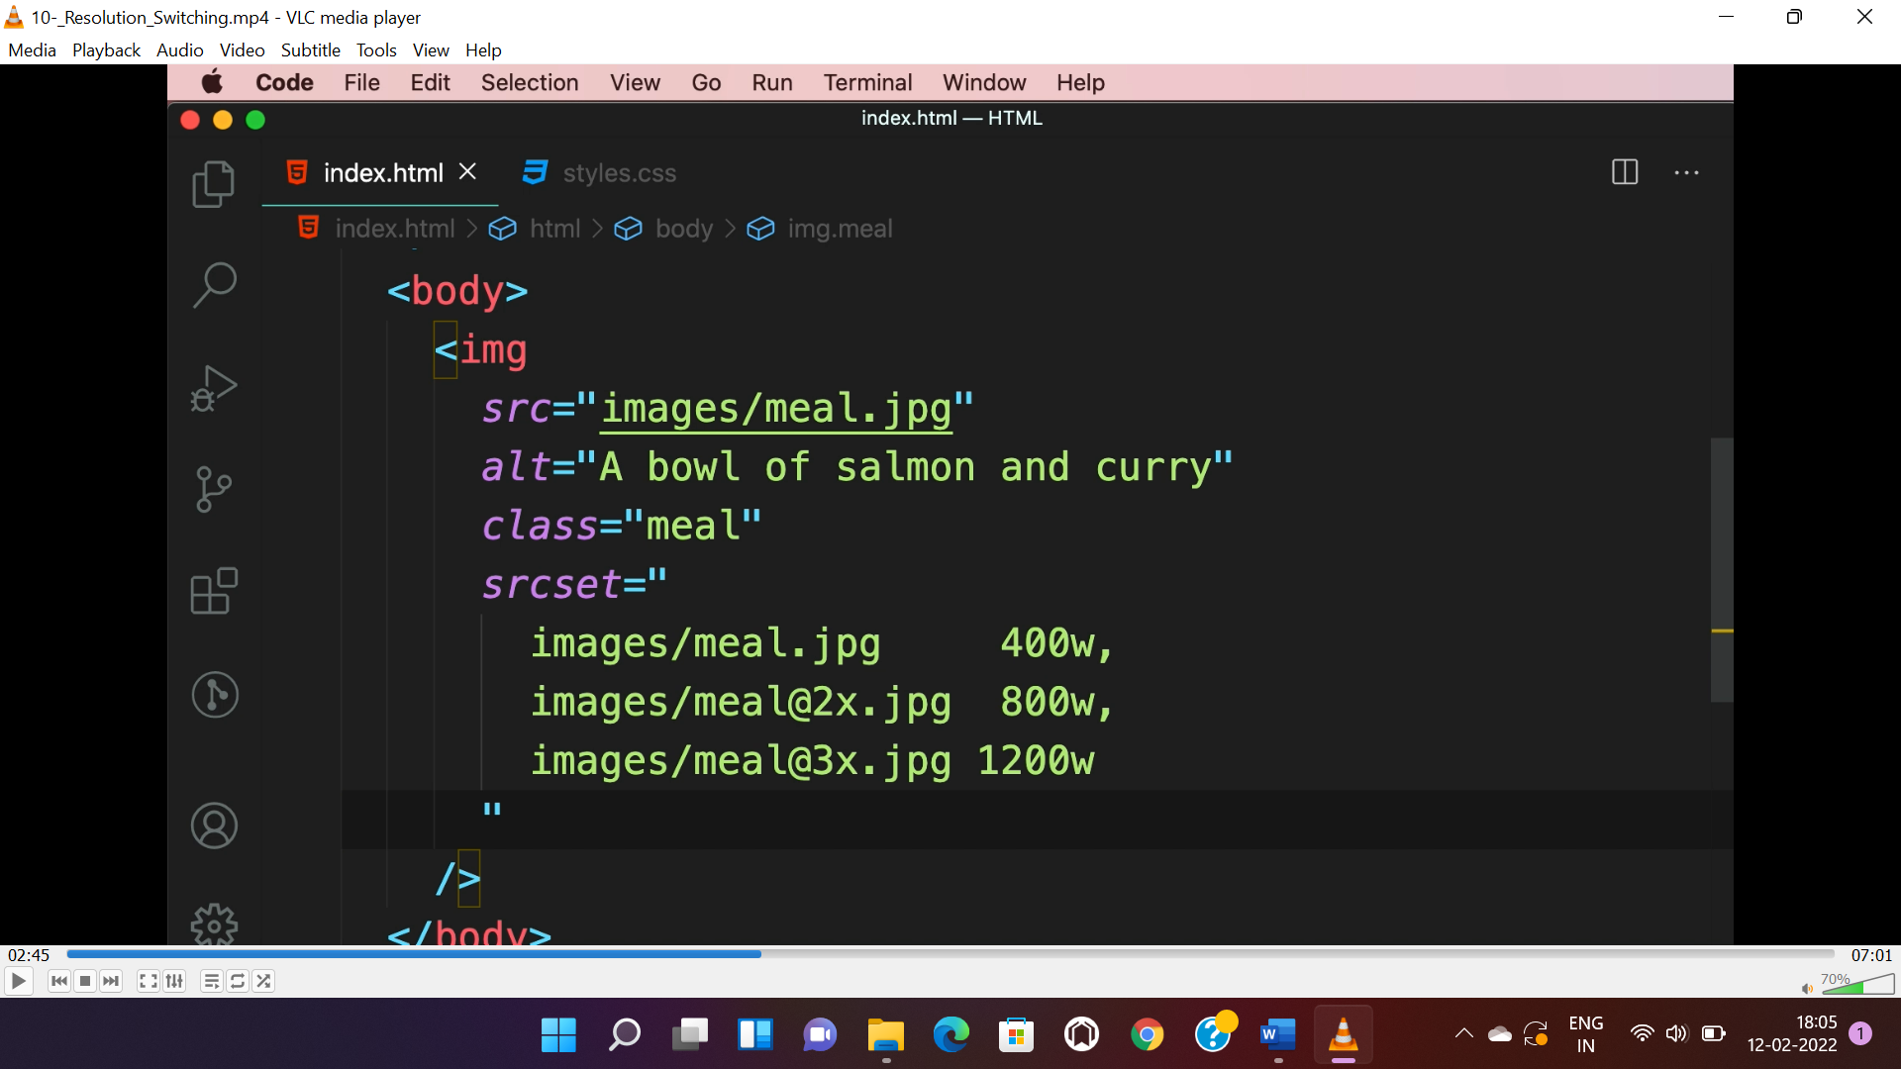

* Like media queries, if we want to apply different size to image based on device resolution.
* “size” attribute is used for media queries.

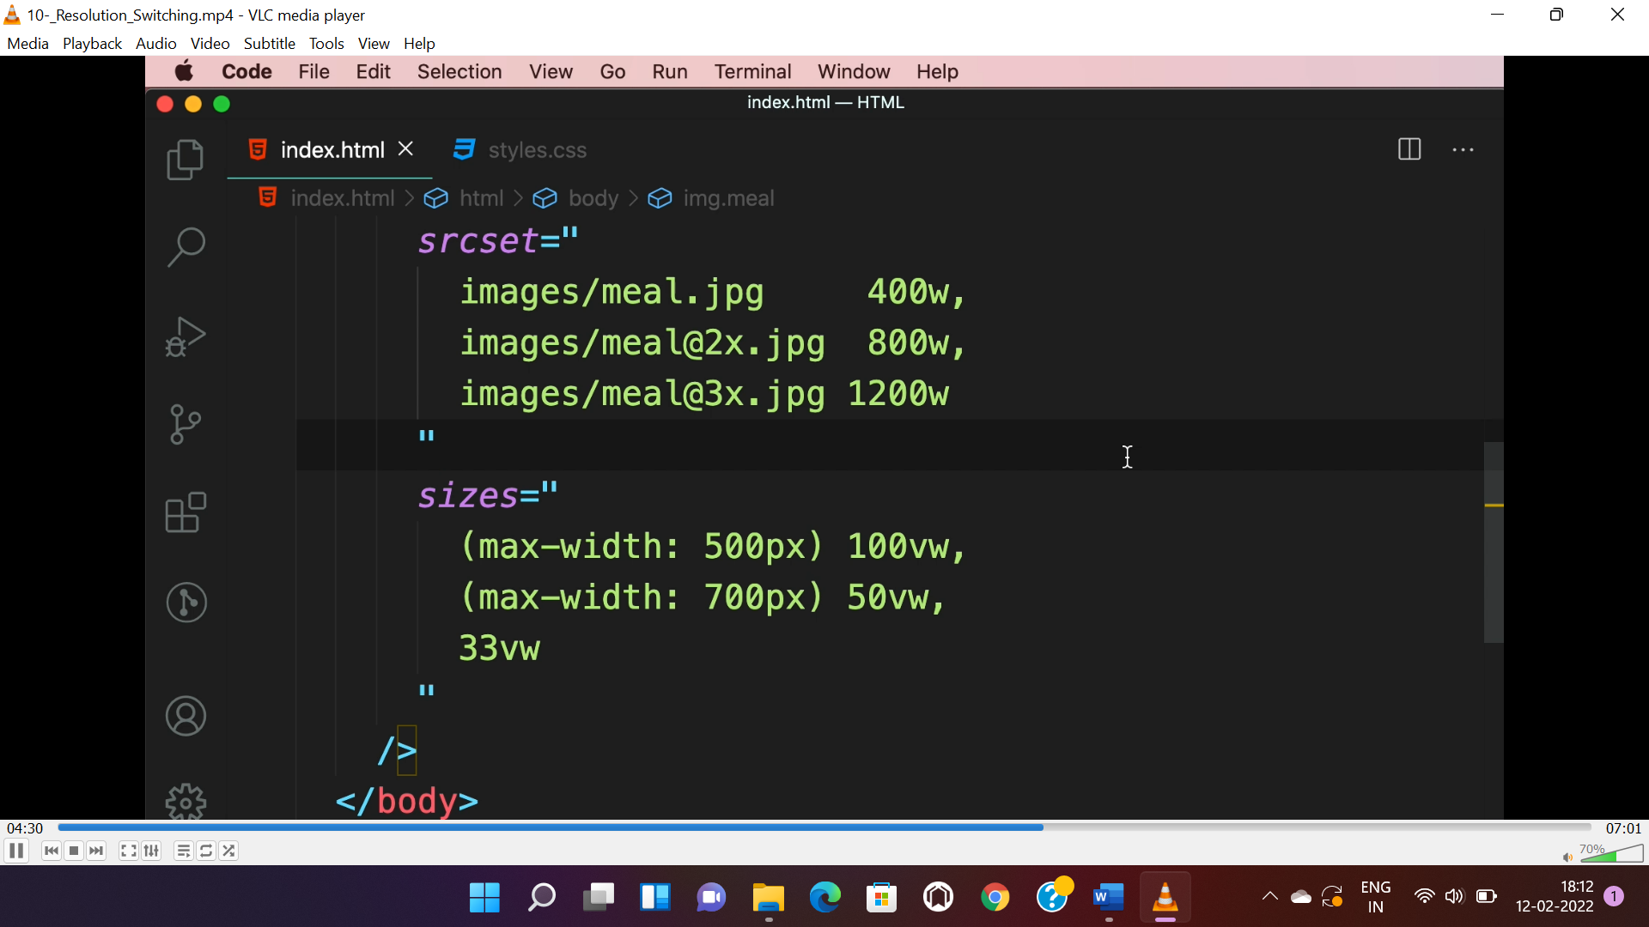

* We can also use <picture> element and “media” attribute instead of “size” attribute in <img>.

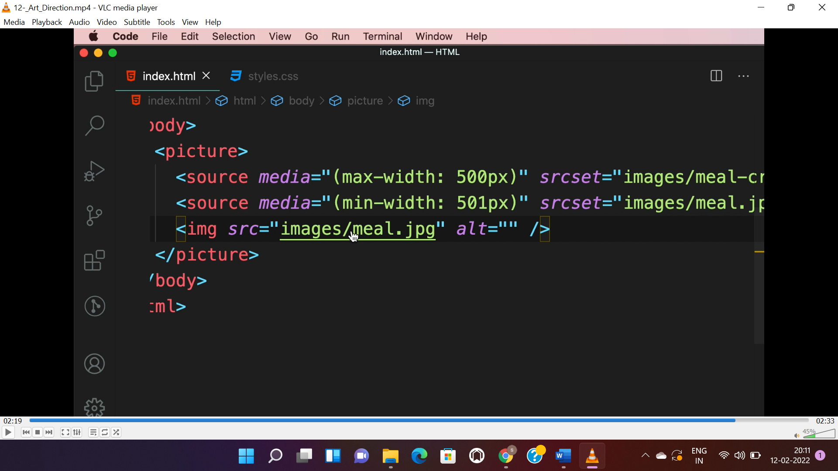

**FONT-ICON:-**

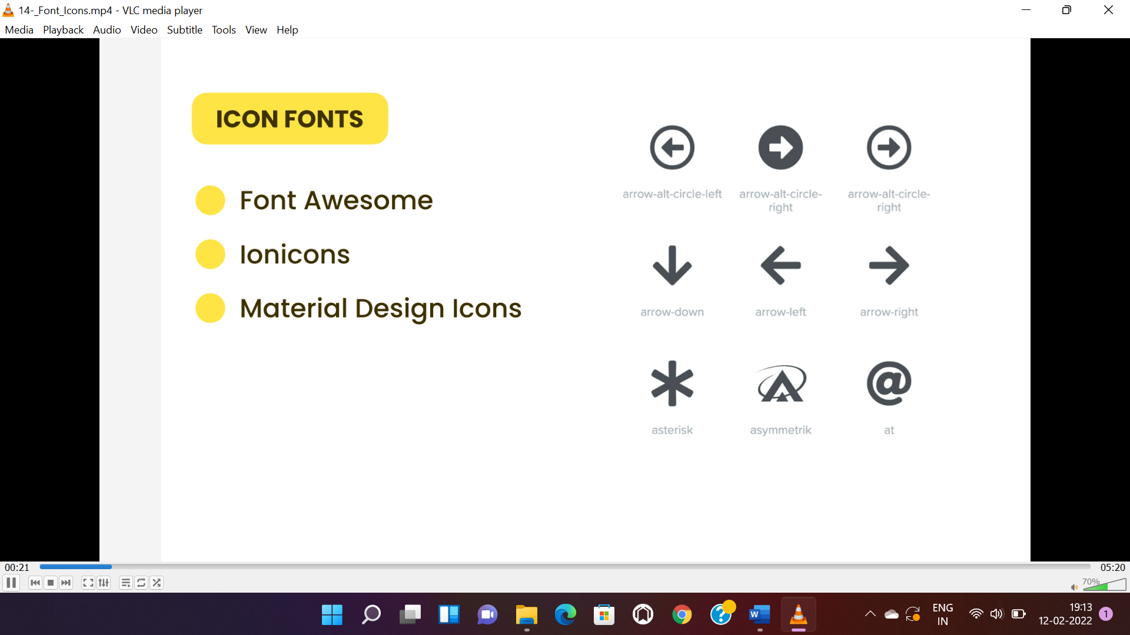

* These are used to add icons and fonts in our project.
* To use font-awesome, we need to install npm package of font awesome.

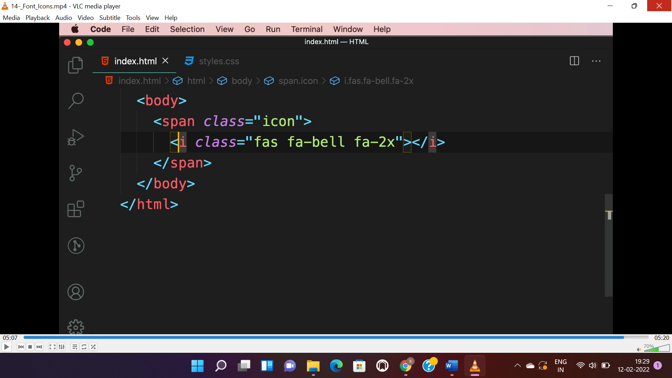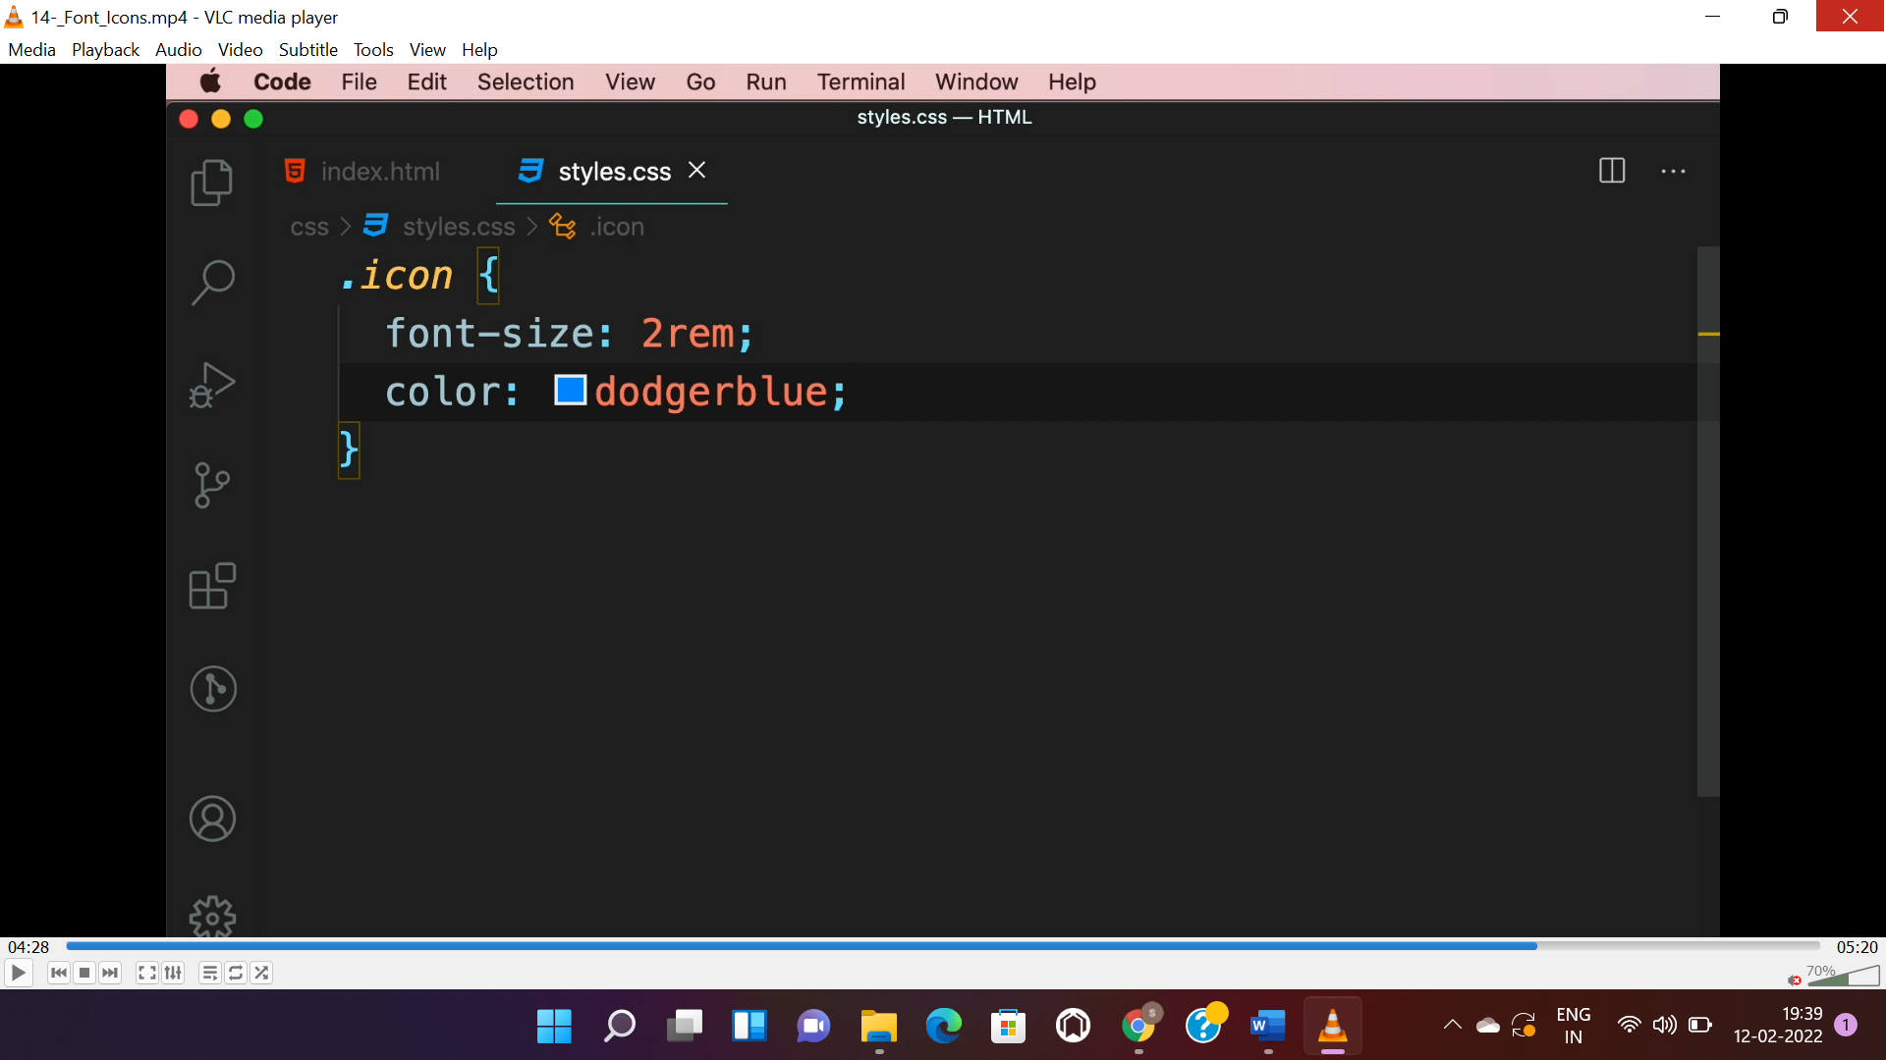

* To apply more style like “color, font-size, etc..” we need to wrap with a <span> and apply a class custom styles and <i> element will inherit it. <span> can be used instead of <i>.
* “2x” for inheriting the parent font size and “2” in “2x” will multiply with parent element font size.

**FORMS:-**

* **Forms should be wrapped with <form> tag. Contains multiple input fields with lebel.**
* **<button> type may be “submit” or “clear”.**
* **<input> types are “number, password, date, email” attributes are “value, readonly, disabled, autofocus, maxlength”.**

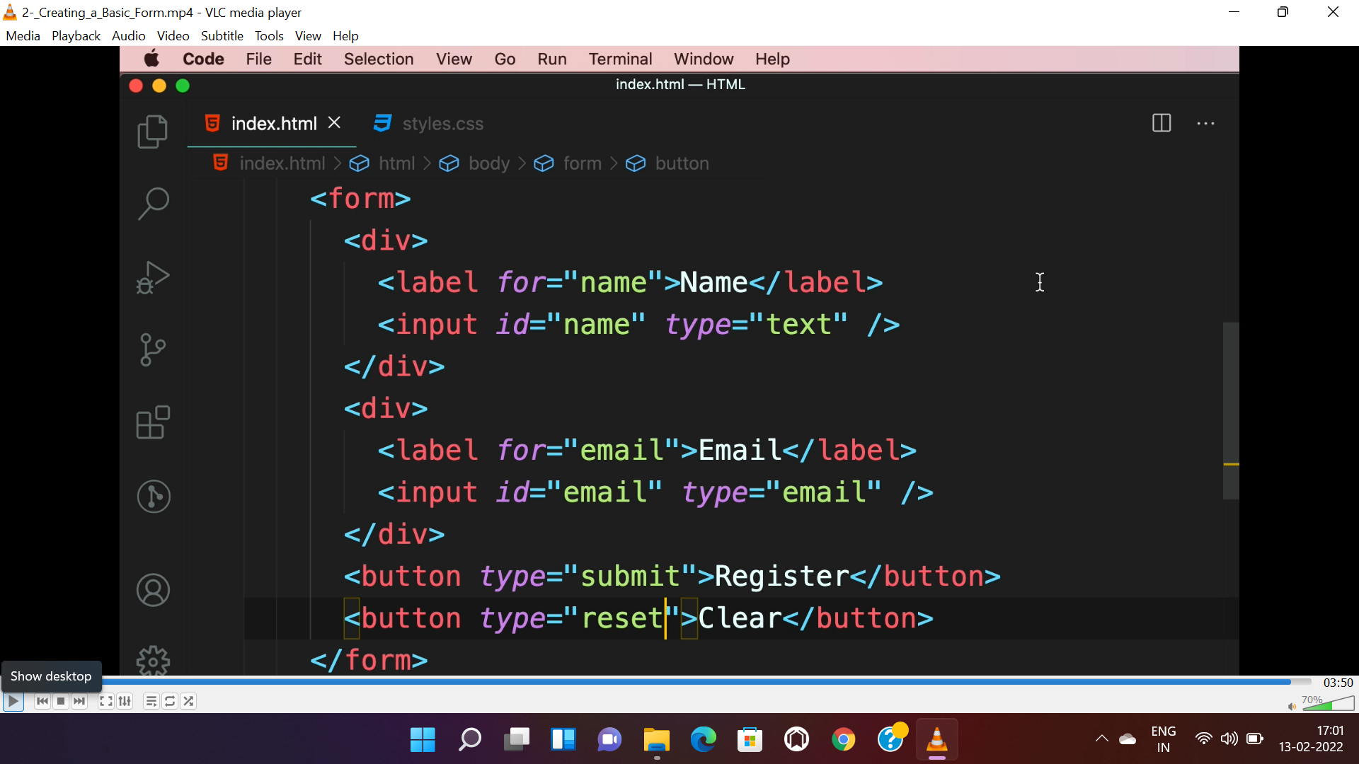

**SUGGESTIONS(DATA LIST):-**

* “data-” before “value” indicates custom attribute.
* <datalist> can also dynamically populated on search in <input> element.

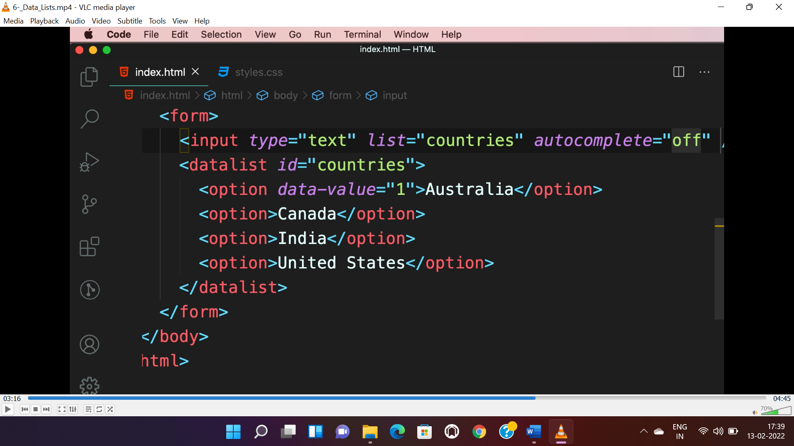

**DROPDOWN:-**

* “selected” attribute is used to select that option bydefualt.

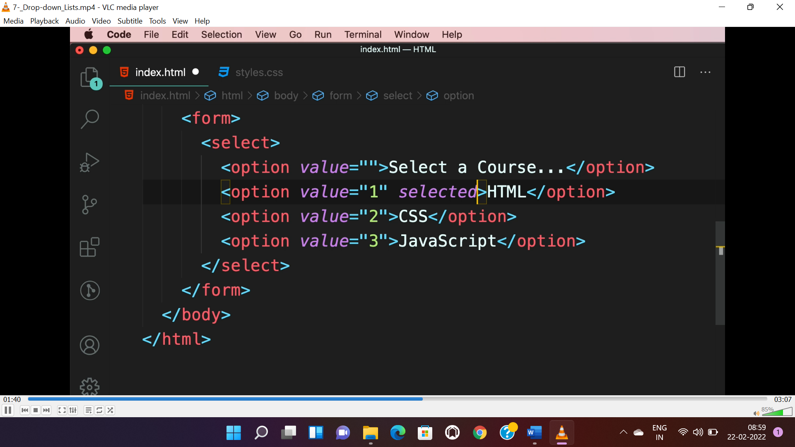

* “multiple” attribute is used to avail multiple option to be selected.

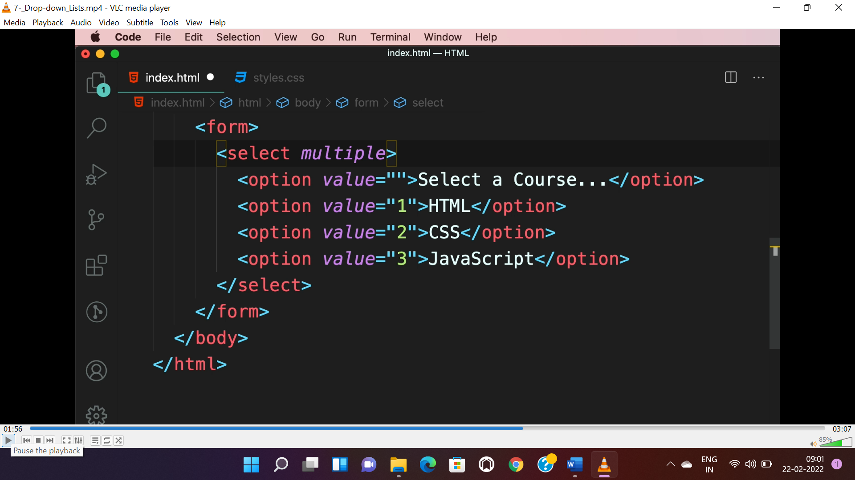

* <optgroup> is used for grouping options in dropdown.

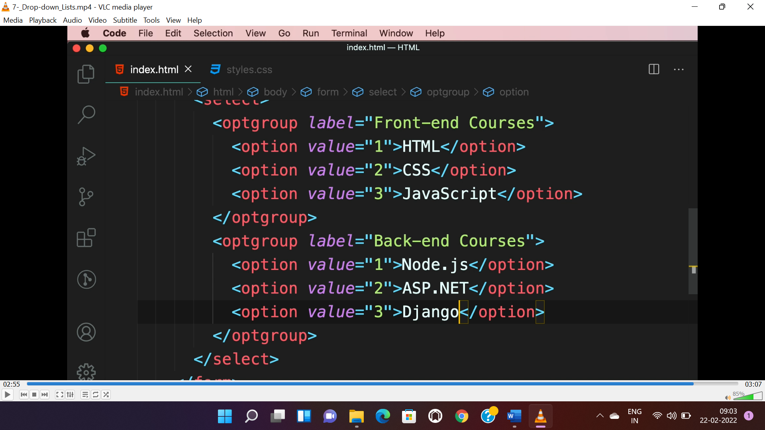

**CHECKBOX:**

* To make a check box selected by default “checked” attribute is used.
* To make it disabled “disabled” attribute is used.

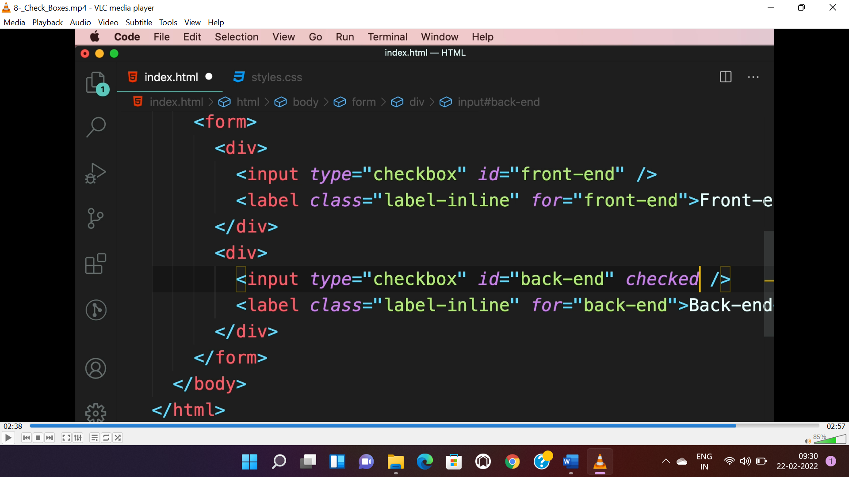

**RADIO BUTTON:**

* To select only one radio button “name” attribute should be same on all radio input.
* Similar to “checkbox” “checked” and “disabled” attribute can be used.

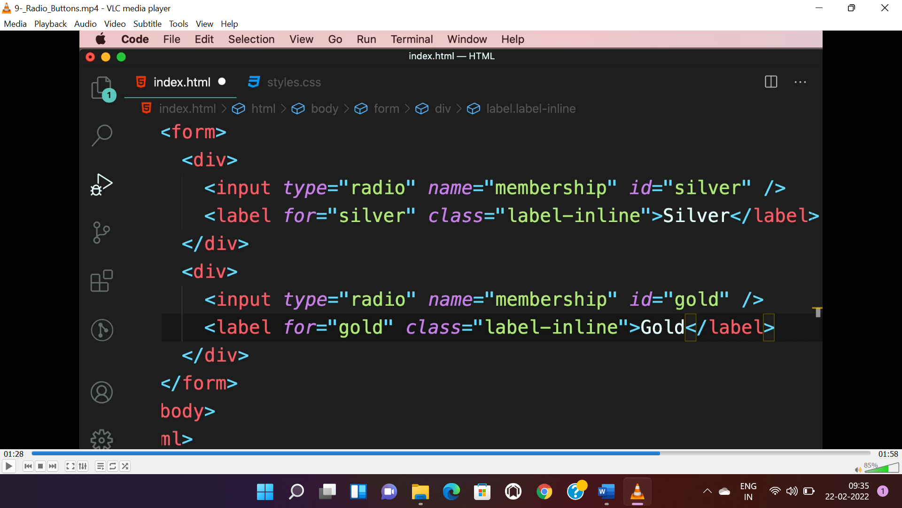

**SLIDERS:**

* “value” is the value of the slider.

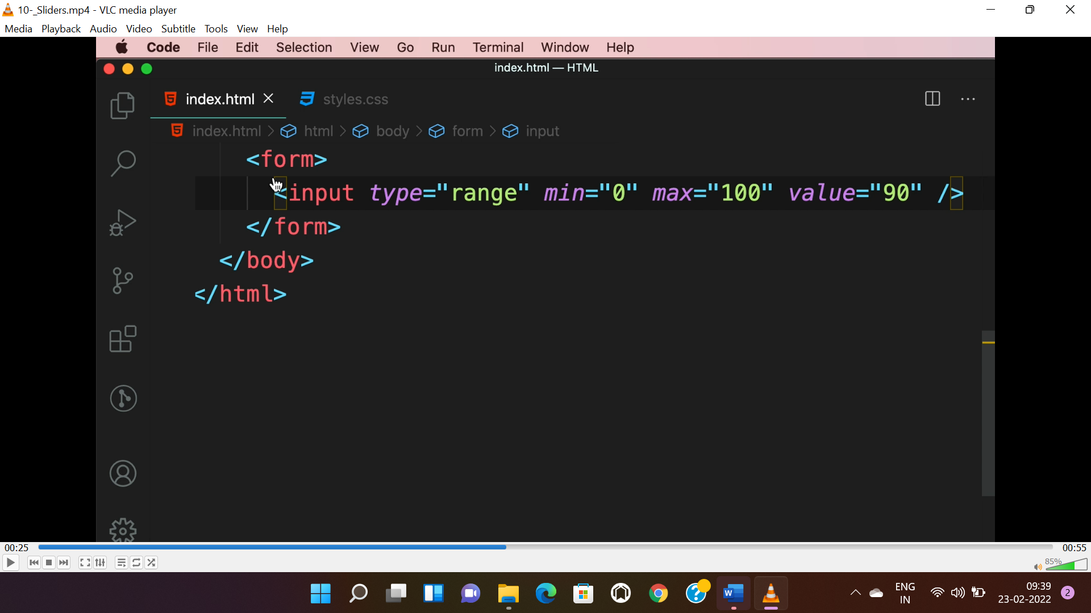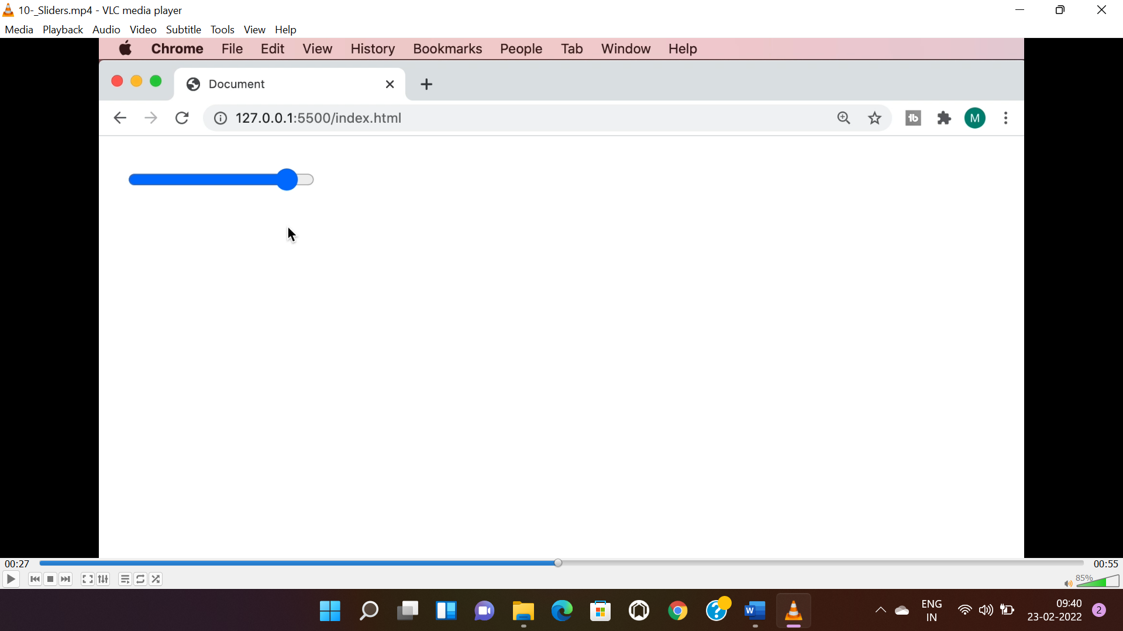

**FILE INPUT:**

* We can select multiple files using “multiple” attribute. Can allow different file type using “accept” attribute.

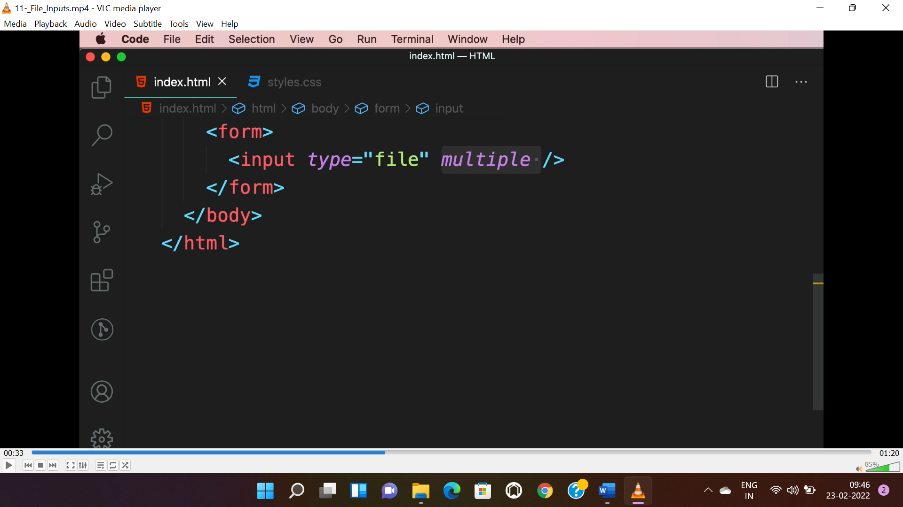

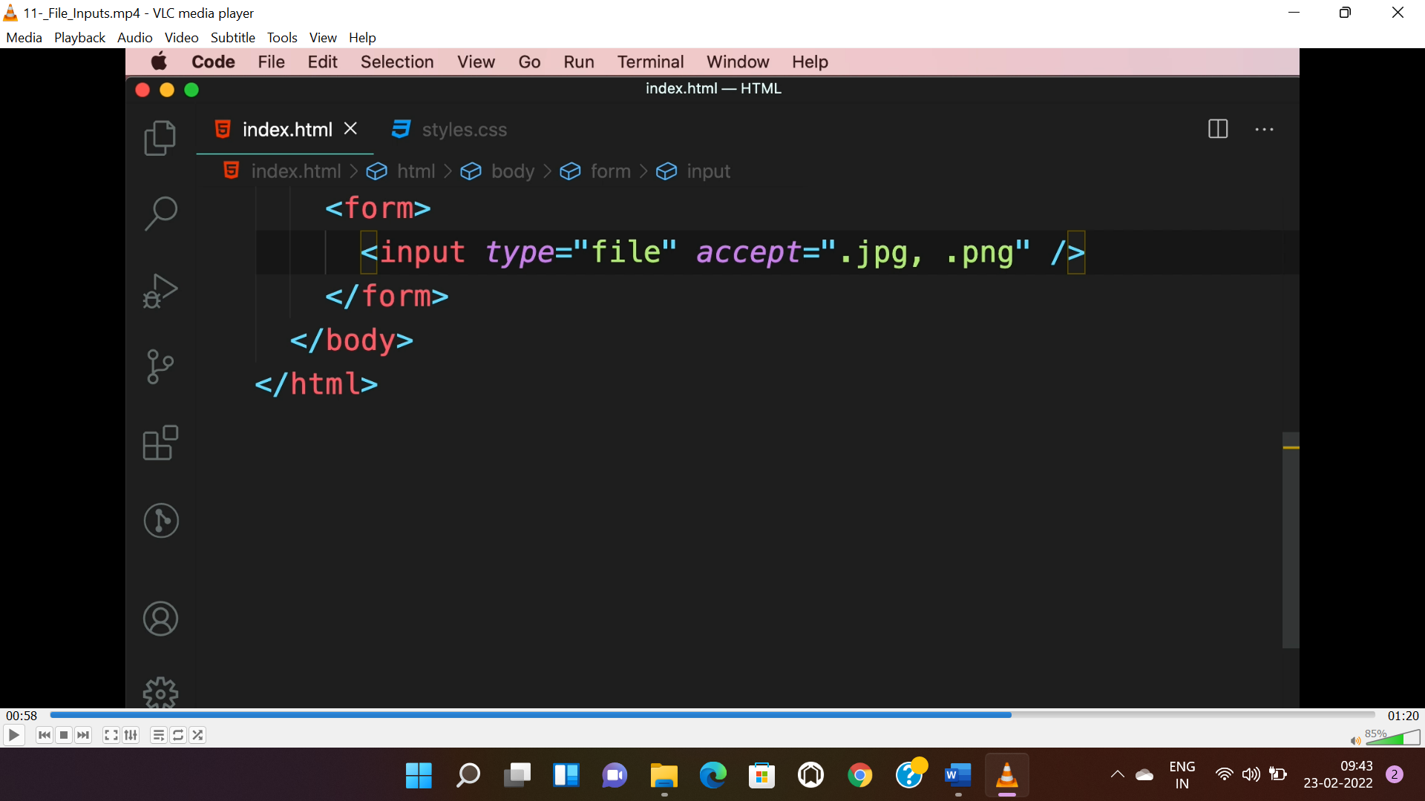

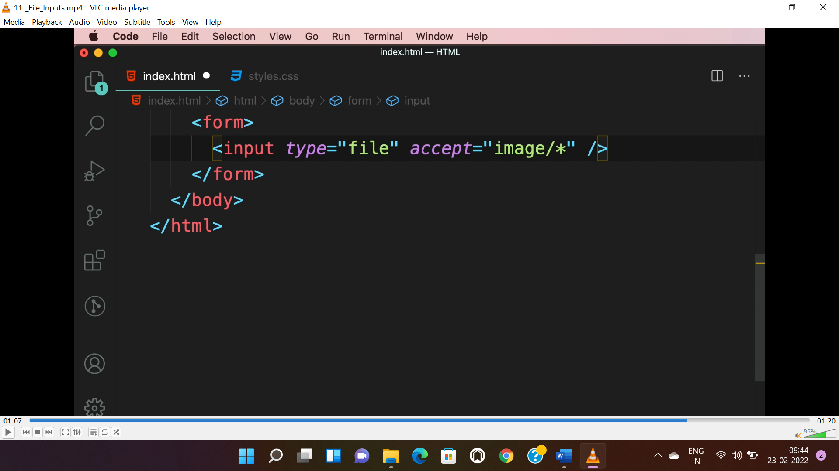

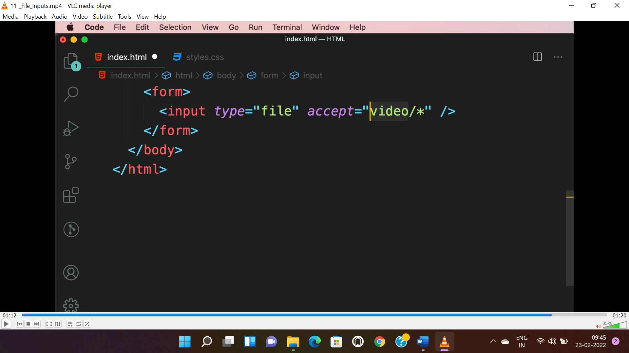

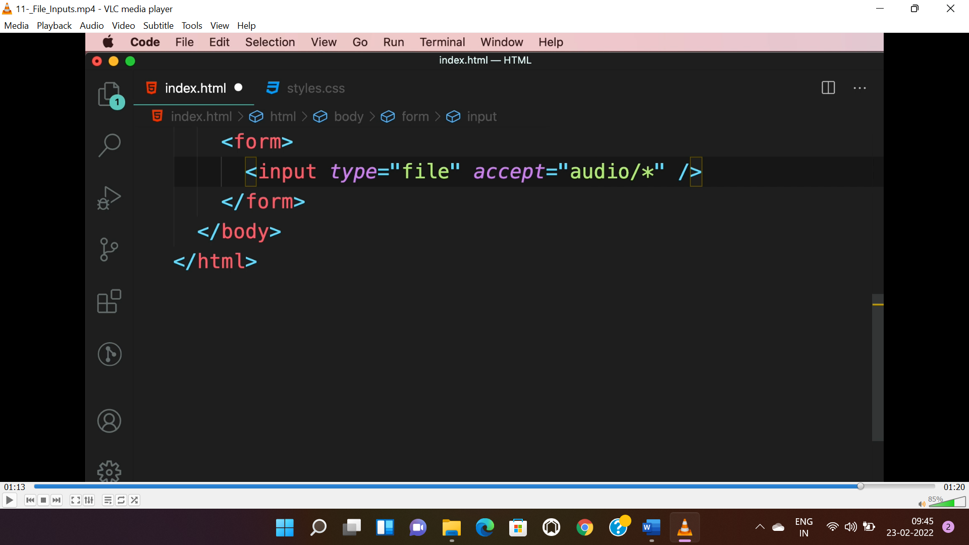

**GROUPING FIELDS:-**

* <fieldset> is used for grouping related fields(<input>). <legend> is used to describe about the field.

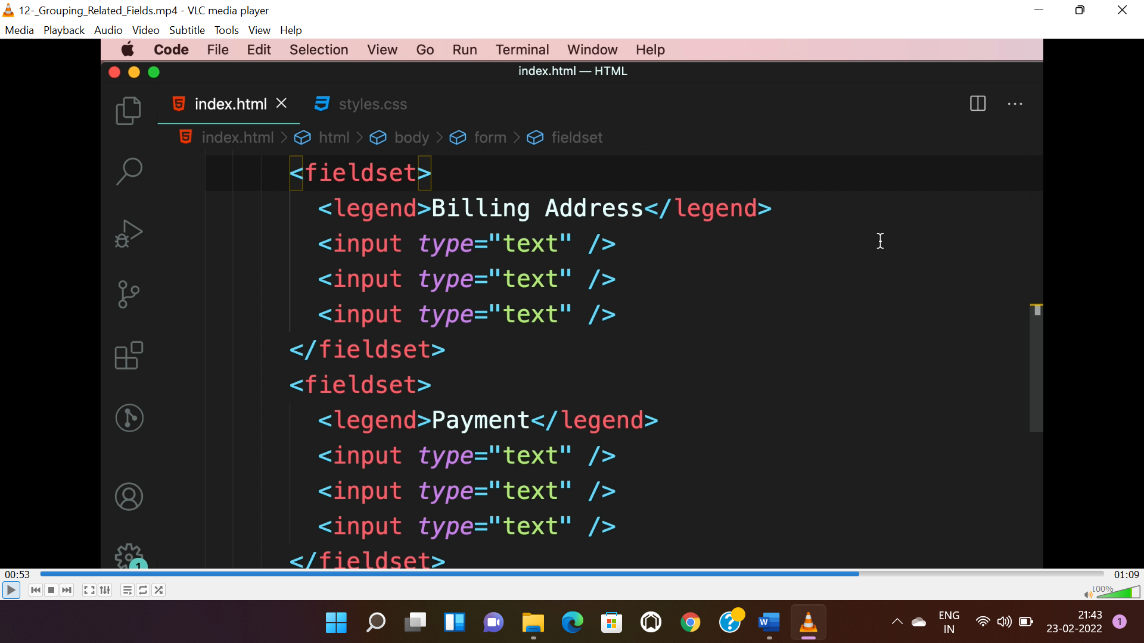

* <section> and <h2> can be used instead.

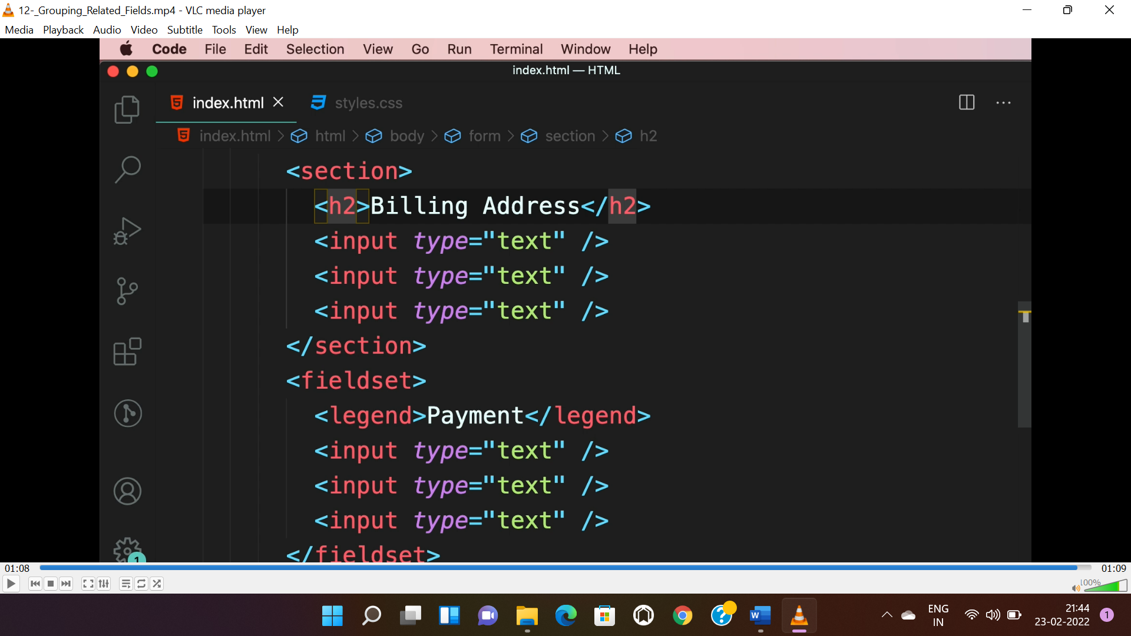

**VALIDATION:**

* “required”, “minlength”, “maxlength”, “min” and “max” attributes are used for validation.

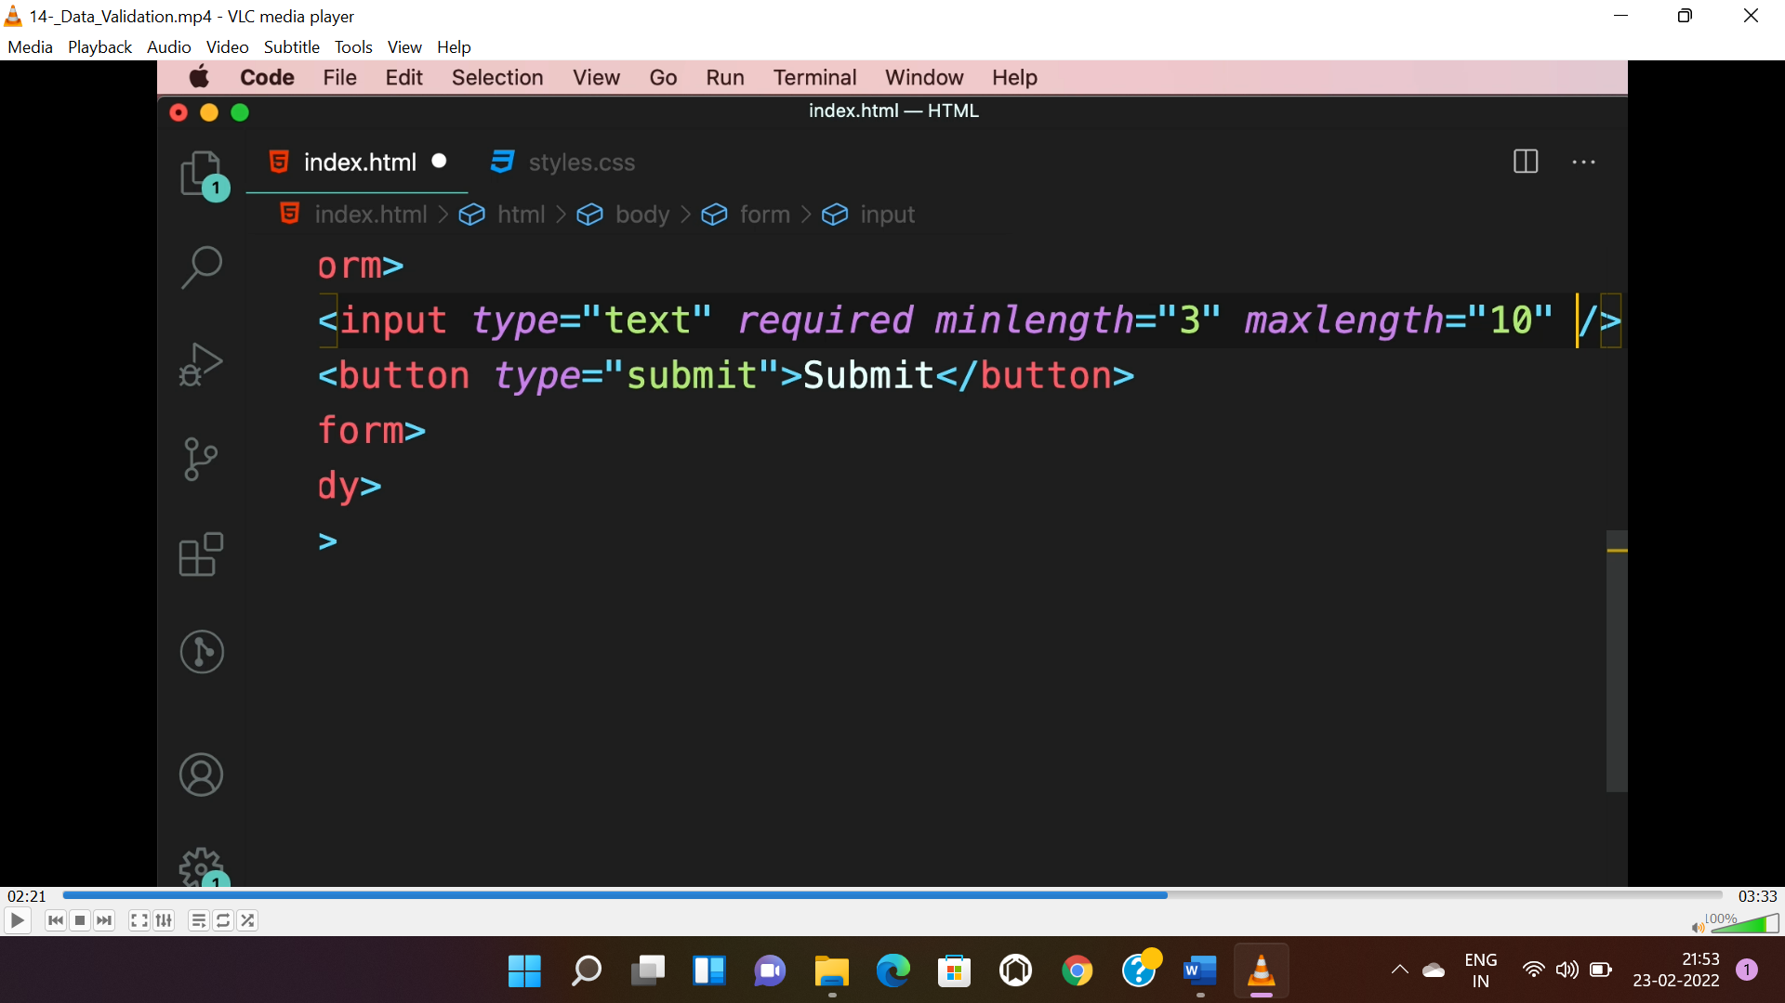

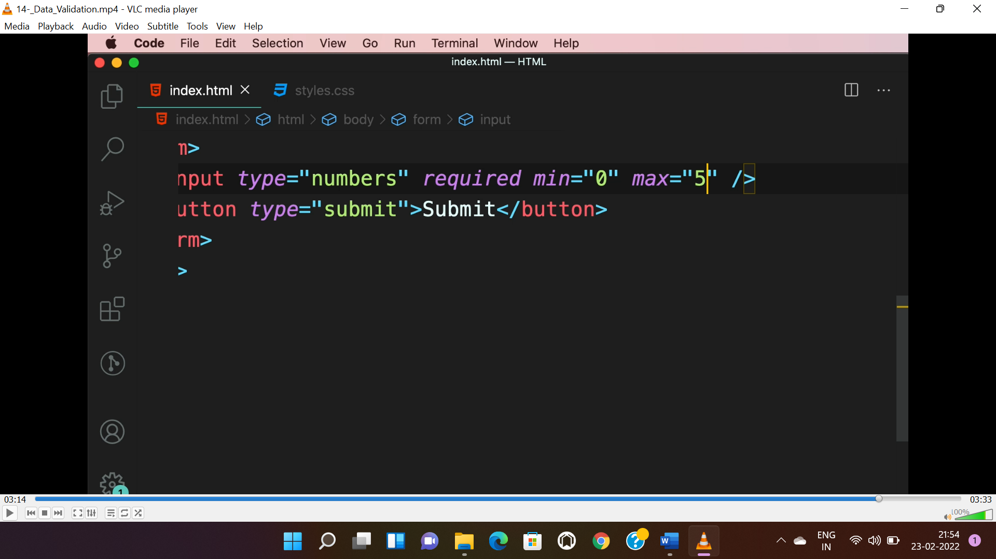

**Notes:**

* Colours can be manipulated through **inspect->select element->computed** in browser.

